MASTER’S SCEINCE P.U COLLEGE, HASSAN, 573201.
TOPIC: PROBABILITY, RANDOM VARIABLE & STATISTICS MARKS: 30

KEY

1 | 2 | 3 | 4 | 5 | 6 | 7 | 8 | 9 | 10 | 11 | 12 | 13 | 14 | 15
D | A | C | B | A | C | A | B | A | D | C | C | C | B | D
16 | 17 | 18 | 19 | 20 | 21 | 22 | 23 | 24 | 25 | 26 | 27 | 28 | 29 | 30
B | C | C | A | B | A | B | D | A | D | D | A | D | A | A

HINTS AND SOLUTIONS

- (d) G.M.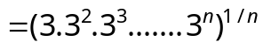 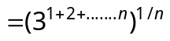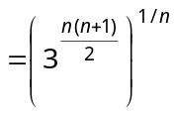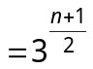.

- (a) Let the mean of the remaining 4 observations be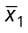.
Then, 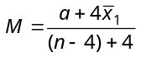⇒ 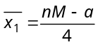.

- (c) Sum of 100 items
Sum of items added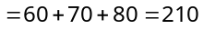
Sum of items replaced
New sum
∴ Correct mean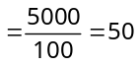.

- (b) For a moderately Skewed distribution,
Mode = 3 median – 2 mean
⇒ 7 = 3 median – 2× 4 ⇒ 15 = 3 median
∴ Median = 5.

- (a) Mean 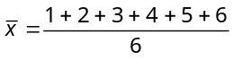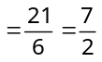
S.D. 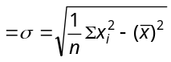
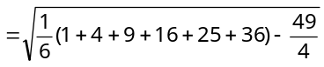
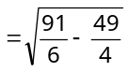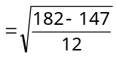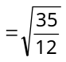.

- (c) Let a, a ...n times and – a, – a, – a, – a ...n times i.e., mean = 0 and S.D.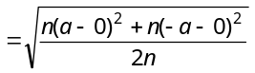
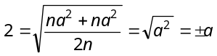. Hence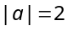.

- (a) Favorable ways 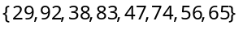
Hence required probability 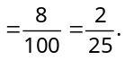

- (b) The sum 2 can be found in one way i.e. 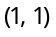
The sum 8 can be found in five ways i.e. 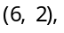 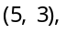 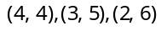. Similarly the sum twelve can be found in one way i.e., 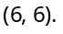
Hence required probability 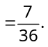

- (a) Required probability is (no ace)
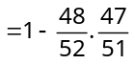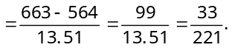

- (d) The probability of students not solving the problem are 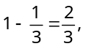 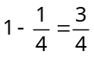 and 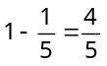
Therefore the probability that the problem is not solved by any one of them 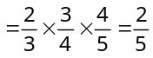
Hence the probability that problem is solved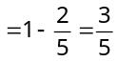.

- (c) (non-occurrence of 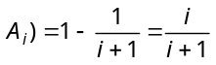
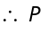(Non-occurrence of any of events)
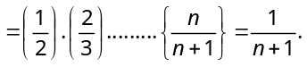

- (c) Second white ball can draw in two ways.
(i) First is white and second is white
Probability 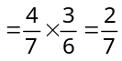
(ii) First is black and second is white
Probability 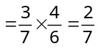
Hence required probability 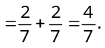

- (c) Person has to miss all times probability of it will be 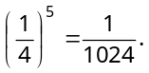

- (b) There are 366 days in a leap year, in which 52 weeks and two days, The combination of 2 days –
Sunday – Monday, Monday – Tuesday, Tuesday – Wednesday, Wednesday – Thursday, Thursday – Friday, Friday – Saturday, Saturday – Sunday
P(53 Fridays) = ; P(53 Saturdays) 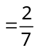, P(53 Fridays and 53 Saturdays) 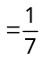
∴ P(53 Fridays or Saturdays) = P(53 Fridays) + P(53 Saturdays) – P(53 Fridays and Saturdays)
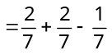 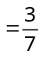.

- (d) Total number of numbers 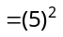
Favorable cases = [12, 24, 32, 44, 52]
∴ Required probability 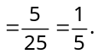

- (b) Required probability 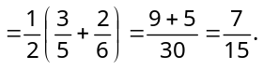

- (c) Total number of ways 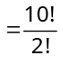
Favorable number of ways for come together is 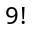
Thus probability that come together
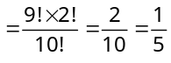.
Hence required probability 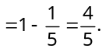

- (c) Required probability 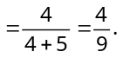

- (a) We have 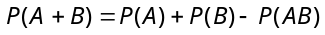
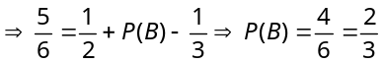
Thus, 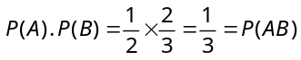
Hence events and are independent.

- (b) 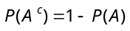 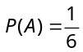
Now
⇒ 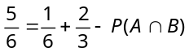 ⇒ 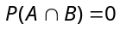
Hence, events A and B are mutually exclusive.

- (a) Consider the following events :
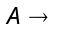 Ball drawn is black; 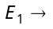 Bag I is chosen;
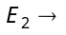 Bag II is chosen and 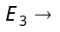 Bag III is chosen.
Then 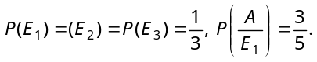
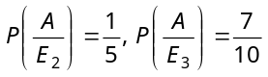
Required probability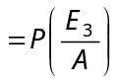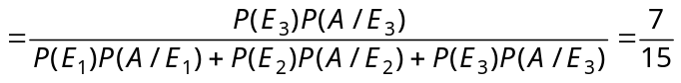.

- (b) Event 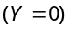 is 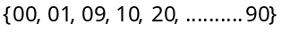
Also 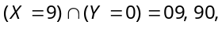 we have
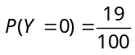 And 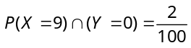
Hence required probability
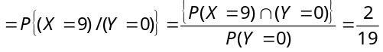.

- (d) Let 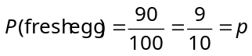
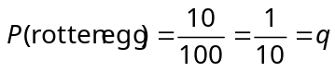; 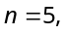
So the probability that none egg is rotten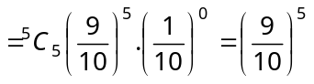.

- (a) Probability of coming ‘six’ in one throw is
Hence required probability is given by
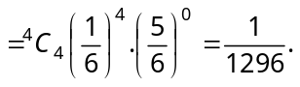

- (d) 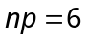 & 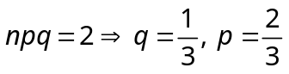 and 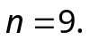
Hence the binomial distribution is 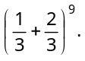

- (d) 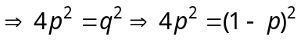
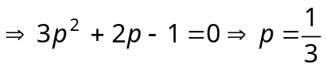.

- (a) 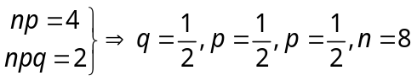 Then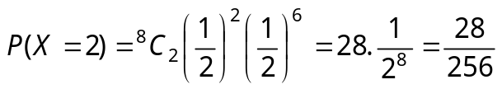.

- (d) We have 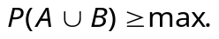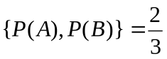
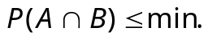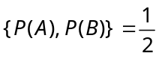
And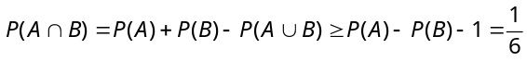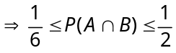
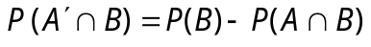
Hence 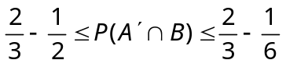 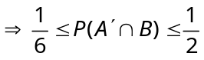.

- (a) 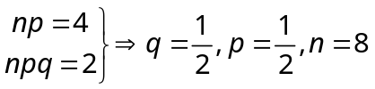
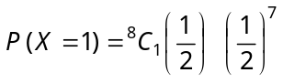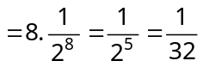.

- (a) 

