MASTER’S SCEINCE P.U COLLEGE, HASSAN, 573201.
TOPIC: PROBABILITY, RANDOM VARIABLE & STATISTICS MARKS: 30
- The G.M. of the numbers 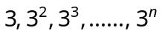 is
(a) 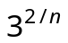 (b) 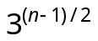 (c) 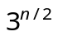 (d) 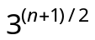

- The A.M. of n observations is M. If the sum of 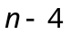 observations is a, then the mean of remaining 4 observations is
(a) 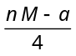 (b) 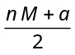 (c) 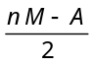 (d) n M + a

- Mean of 100 items is 49. It was discovered that three items which should have been 60, 70, 80 were wrongly read as 40, 20, 50 respectively. The correct mean is
(a) 48 (b) 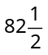 (c) 50 (d) 80

- In a moderately asymmetrical distribution the mode and mean are 7 and 4 respectively. The median is
(a) 4 (b) 5 (c) 6 (d) 7

- The mean and S.D. of 1, 2, 3, 4, 5, 6 is
(a) 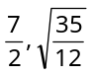 (b) 3, 3 (c) 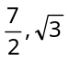 (d) 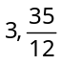

- In a series of 2n observations, half of them equal to a and remaining half equal to –a. If the standard deviation of the observations is 2, then |a| equals
(a) 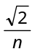 (b) 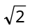 (c) 2 (d)

- From a book containing 100 pages, one page is selected randomly. The probability that the sum of the digits of the page number of the selected page is 11, is
(a) 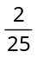 (b) 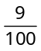 (c) 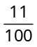 (d) None of these

- Two dice are thrown simultaneously. The probability of getting the sum 2 or 8 or 12 is
(a) 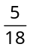 (b) 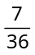 (c) 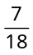 (d) 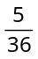

- Two cards are drawn from a pack of 52 cards. What is the probability that at least one of the cards drawn is an ace
(a) 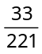 (b) 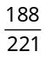 (c) 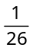 (d) 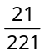

- A problem of mathematics is given to three students whose chances of solving the problem are 1/3, 1/4 and 1/5 respectively. The probability that the question will be solved is
(a) (b) (c) (d)

- For independent events 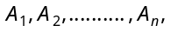 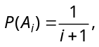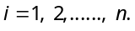 Then the probability that none of the event will occur, is
(a) 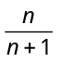 (b) 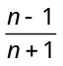 (c) 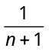 (d) None of these

- A bag contains 3 black and 4 white balls. Two balls are drawn one by one at random without replacement. The probability that the second drawn ball is white, is
(a) 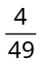 (b) (c) (d) 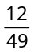

- A person can kill a bird with probability 3/4. He tries 5 times. What is the probability that he may not kill the bird
(a) 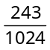 (b) 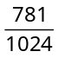 (c) 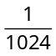 (d) 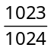

- The probability that a leap year will have 53 Fridays or 53 Saturdays is
(a) (b) (c) (d)

- Find the probability that the two digit number formed by digits 1, 2, 3, 4, 5 is divisible by 4 (while repetition of digit is allowed)
(a) 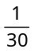 (b) 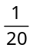 (c) 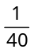 (d) None of these

- A bag x contains 3 white balls and 2 black balls and another bag y contains 2 white balls and 4 black balls. A bag and a ball out of it are picked at random. The probability that the ball is white, is
(a) 3/5 (b) 7/15 (c) ½ (d) None of these

- Word ‘UNIVERSITY’ is arranged randomly. Then the probability that both ‘I’ does not come together, is
(a) (b) (c) (d)

- An event has odds in favour 4 : 5, then the probability that event occurs, is
(a) (b) (c) (d)

- If two events A and B are such that 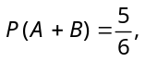 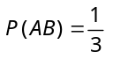and 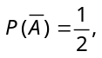 then the events A and B are
(a) Independent (b) Mutually exclusive
(c) Mutually exclusive and independent (d) None of these

- In two events 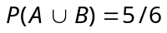, 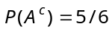, 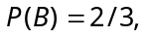 then A and B are
(a) Independent (b) Mutually exclusive
(c) Mutually exhaustive (d) Dependent

- There are 3 bags which are known to contain 2 white and 3 black balls; 4 white and 1 black balls and 3 white and 7 black balls respectively. A ball is drawn at random from one of the bags and found to be a black ball. Then the probability that it was drawn from the bag containing the most black balls is
(a) 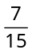 (b) 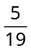 (c) (d) None of these

- One ticket is selected at random from 100 tickets numbered 00, 01, 02, ...... 98, 99. If X and Y denote the sum and the product of the digits on the tickets, then 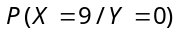 equals
(a) 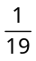 (b) 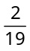 (c) 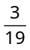 (d) None of these

- In a box containing 100 eggs, 10 eggs are rotten. The probability that out of a sample of 5 eggs none is rotten if the sampling is with replacement is
(a) 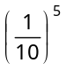 (b) 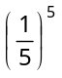 (c) 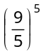 (d) 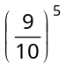

- If x denotes the number of sixes in four consecutive throws of a dice, then 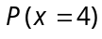is
(a) 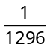 (b) (c) 1 (d) 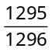

- The binomial distribution for which mean = 6 and variance = 2, is
(a) 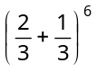 (b) 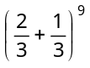 (c) 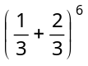 (d) 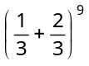

- If X follows a binomial distribution with parameters and and 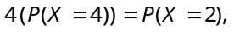 then
(a) (b) (c) (d)

- The mean and the variance of a binomial distribution are 4 and 2 respectively. Then the probability of 2 successes is
(a) 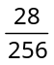 (b) 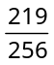 (c) 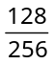 (d) 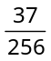

- If A and B are two events such that 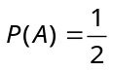and 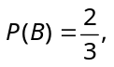 then
(a) 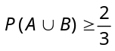 (b) 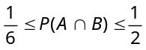 (c) 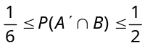 (d) All of the above

- The mean and variance of a random variable X having a binomial distribution are 4 and 2 respectively, then 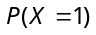 is
(a) 1/32 (b) 1/16 (c) 1/8 (d) ¼

- The value of C for which 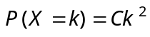can serve as the probability function of a random variable X that takes 0, 1, 2, 3, 4 is
(a) (b) 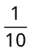 (c) (d) 