MASTER’S SCEINCE P.U COLLEGE, HASSAN, 573201.
TOPIC: APPLICATION OF DERIVATIVES & DIFFERENTIAL EQUASTION MARKS: 30

KEY

1 | 2 | 3 | 4 | 5 | 6 | 7 | 8 | 9 | 10 | 11 | 12 | 13 | 14 | 15
C | C | D | B | D | C | B | C | B | C | B | B | A | B | C
16 | 17 | 18 | 19 | 20 | 21 | 22 | 23 | 24 | 25 | 26 | 27 | 28 | 29 | 30
A | C | B | B | C | C | C | C | B | B | A | A | C | B | C

HINTS AND SOLUTIONS
- (c) 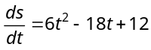 = velocity = 0 (when particle stopped)
⇒ 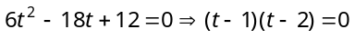 Hence time 1, 2 sec.

- (c) Let 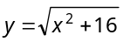 and 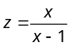
⇒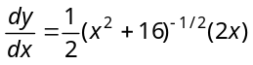&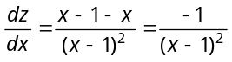
∴ 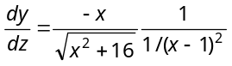 Then 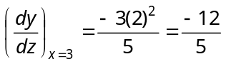.

- (d) 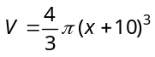 where x is thickness of ice.
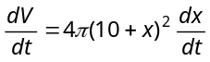
At ,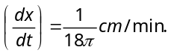

- (b) for the point (2,–1)
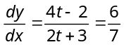for .

- (d) 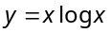 ⇒ 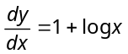
The slope of the normal = 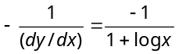
The slope of the line 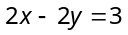 is 1.
∴ 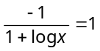 ⇒ 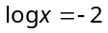 ⇒ 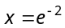 ∴ 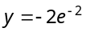
∴ Co-ordinate of the point is 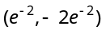.

- (c) Length of normal = 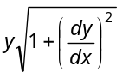
Now, 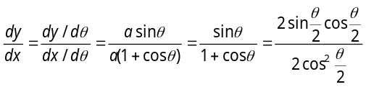
∴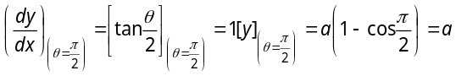
∴ Length of normal = 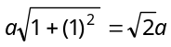.

- (b) Let 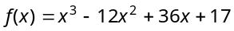
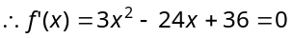 at 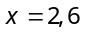
Again 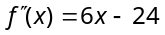 is at
So that 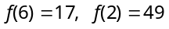
At the end points 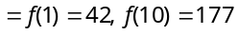
So that 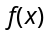 has its maximum value as 177.

- (c) Let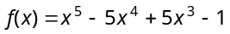
⇒ 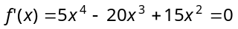
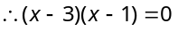 or 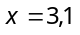
Now 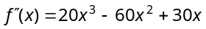
Put and 1, we get 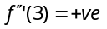and 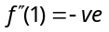 and 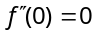. Hence neither maximum nor minimum at .

- (b) Given 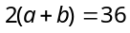,
Area of rectangle 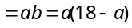
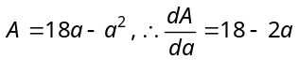
Put 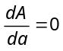 i.e., 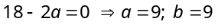.

- (c) Since 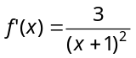is greater than '0' in interval 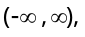 therefore 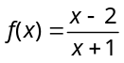 is increasing in interval 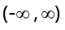 or R.

- (b) 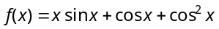
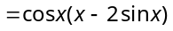
Hence 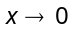 to , then 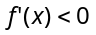
i.e., is decreasing function.

- (b) Here 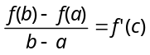
⇒ 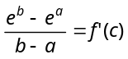⇒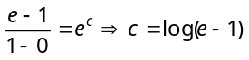.

- (a) , which is given in option (a) only.

- (b) will be monotonically decreasing, if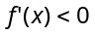.
⇒ 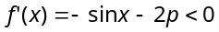⇒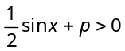⇒ 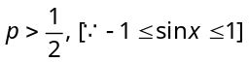.

- (c)
(a cosθ, b sinθ)
(–acosθ, bsinθ)
B
X
Y
(–acosθ, –bsinθ)
D (a cosθ, – b sinθ)
A
C

Area of rectangle ABCD
= 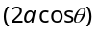. 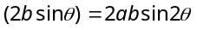
Hence, area of greatest rectangle is equal to , when 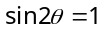.

- (a) Given 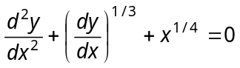
Taking cube, 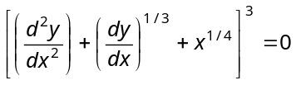
Order of highest derivative
Degree of highest derivative .

- (c) 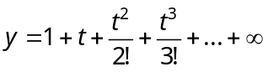 where 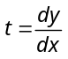
⇒ 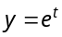, ∴ 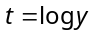 ⇒ 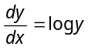. Hence degree is 1.

- (b) Solution is 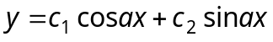
Differentiate it w.r.t. x, we get 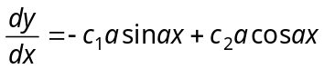

Again 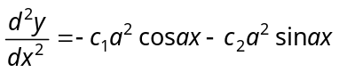
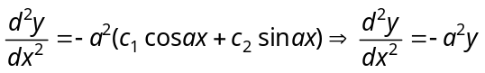or 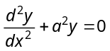.

- (b) 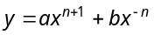
Differentiate with respect to x , 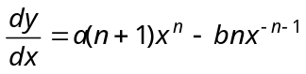
Again differentiate, 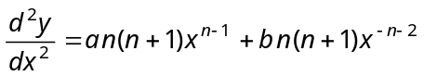
⇒ 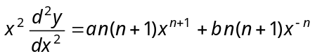 ⇒ 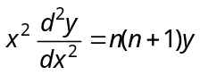.

- (c) 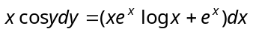⇒ 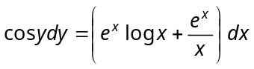
On integrating, 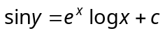.

- (c) 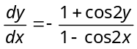 ⇒ 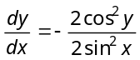⇒ 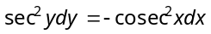

On integrating both sides, we get 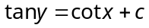 ⇒ 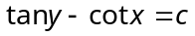.

- (c) Given equation is 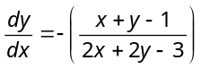
Put 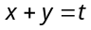⇒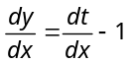
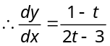⇒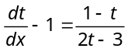 ⇒ 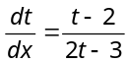
⇒ 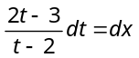. Integrating both sides, we get
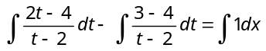
⇒ 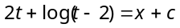 ⇒ 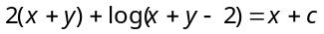 ⇒ 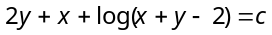.

- (c) The given differential equation is 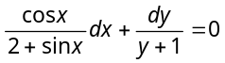⇒ 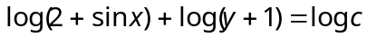
⇒ 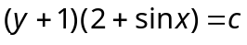 ⇒ 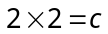 ⇒
Thus, 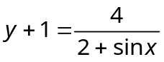⇒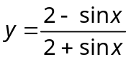 ⇒ 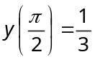.

- (b) 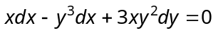Put 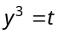 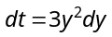
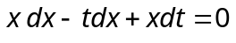 ⇒ 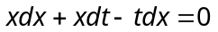 ⇒ 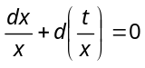
On integration, we get 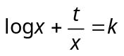 ⇒ 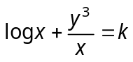.

- (b) 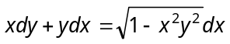 ⇒ 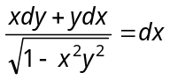
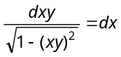. Integrating both side, we get 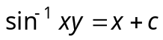 ⇒ 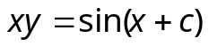.

- (a) 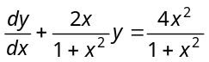 It is linear equation of the form 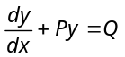
Here 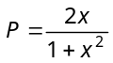and 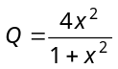 I.F. 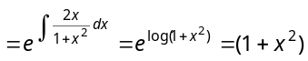
Therefore, solution is given by 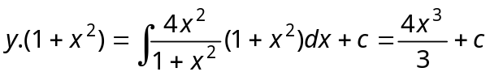.
But it passes through (0,0) therefore , hence the curve is 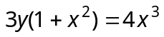.

- (a) 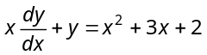 ⇒ 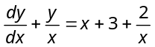
Here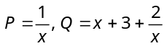, therefore I.F. 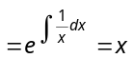
Now solve it.

- (c) Accordingly 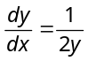⇒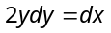 Integrating, we get 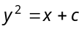
This passes through 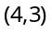, ∴ ⇒
Hence the equation of the curve is 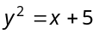.

- (b) 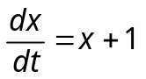 ⇒ 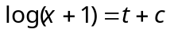 Putting 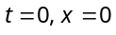, we get 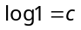 ⇒
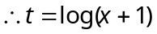. For 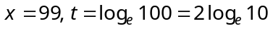.

- (c) 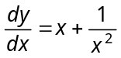 ⇒ 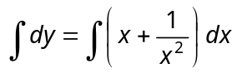 ⇒ 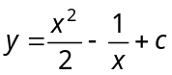
Since it passes through (3, 9), therefore 

