MASTER’S SCEINCE P.U COLLEGE, HASSAN, 573201.
TOPIC: APPLICATION OF DERIVATIVES & DIFFERENTIAL EQUASTIONS MARKS: 30
- The equation of motion of a particle is given by 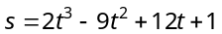,where s and t are measured in cm and sec. The time when the particle stops momentarily is
(a) 1 sec (b) 2 sec (c) 1, 2 sec (d) None of these

- The rate of change of 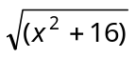 with respect to 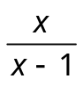 at is
(a) 2 (b) 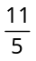 (c) 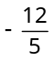 (d) 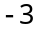

- A spherical iron ball 10 cm in radius is coated with a layer of ice of uniform thickness that melts at a rate of 50 cm³/min. When the thickness of ice is 5 cm, then the rate at which the thickness of ice decreases, is
(a) 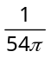cm/min (b) 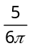 cm/min (c) 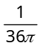 cm/min (d) 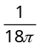 cm/min

- The slope of tangent to the curve 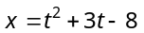, 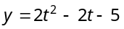 at the point (2, –1) is
(a) 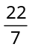 (b) (c) – 6 (d) None of these

- Co-ordinates of a point on the curve 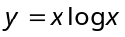 at which the normal is parallel to the line 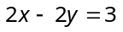 are
(a) (0,0) (b) 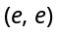 (c) 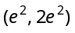 (d) 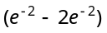

- The length of normal to the curve 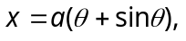 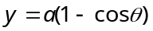 at the point 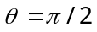is
(a) (b) 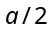 (c) 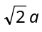 (d) 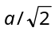

- The maximum value of function 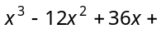17 in the interval [1, 10] is
(a) 17 (b) 177 (c) 77 (d) None of these

- The function 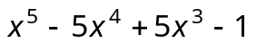is
(a) Maximum at and minimum at (b) Minimum at
(c) Neither maximum nor minimum at (d) Maximum at

- If from a wire of length 36 metre a rectangle of greatest area is made, then its two adjacent sides in metre are
(a) 6, 12 (b) 9, 9 (c) 10, 8 (d) 13, 5

- The function 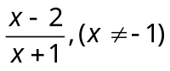is increasing on the interval
(a) 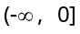 (b) [0, ) (c) R (d) None of these

- If x tends 0 to , then the given function 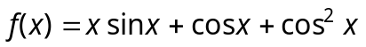 is
(a) Increasing (b) Decreasing
(c) Neither increasing nor decreasing (d) None of these

- For the function 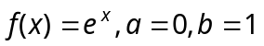, the value of c in mean value theorem will be
(a) log x (b) 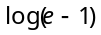 (c) 0 (d) 1

- The function 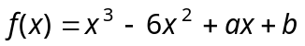 satisfy the conditions of Rolle's theorem in [1, 3]. The values of a and b are
(a) 11, – 6 (b) – 6, 11 (c) –11, 6 (d) 6, –11

- The function 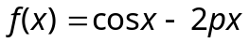 is monotonically decreasing for
(a) 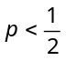 (b) 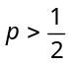 (c) 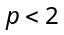 (d) 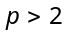

- Area of the greatest rectangle that can be inscribed in the ellipse 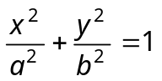 is
(a) 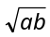 (b) (c) (d)

- The order and degree of the differential equation 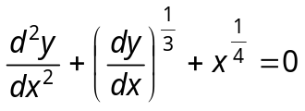 are respectively
(a) 2, 3 (b) 3, 3 (c) 2, 6 (d) 2, 4

- The degree of the differential equation 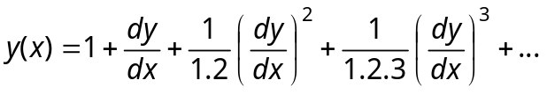 is
(a) 2 (b) 3 (c) 1 (d) None of these

- The differential equation whose solution is 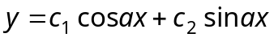 is (Where 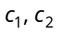are arbitrary constants)
(a) 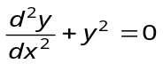 (b) 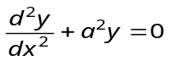 (c) 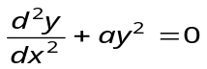 (d) 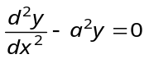

- If 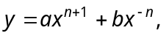 then 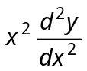 equals to
(a) 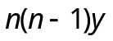 (b) 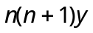 (c) ny (d) n²y

- The solution of the differential equation 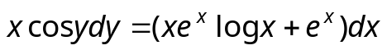 is
(a) 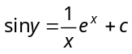 (b) 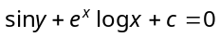
(c) 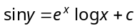 (d) None of these

- The solution of the differential equation 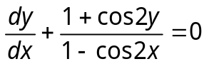
(a) 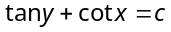 (b) 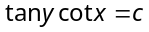 (c) 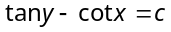 (d) None of these

- Solution of is
(a) 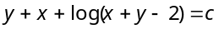 (b) 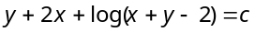
(c) 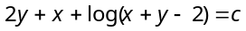 (d) 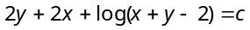

- If 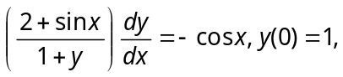 then 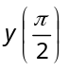=
(a) 1 (b) (c) (d)

- The solution of 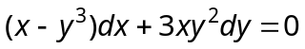 is
(a) 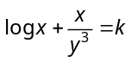 (b) 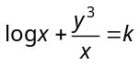 (c) 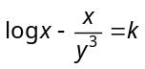 (d) 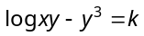

- The solution of the differential equation 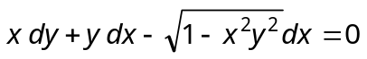 is
(a) 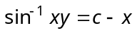 (b) 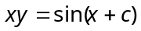 (c) 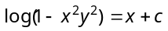 (d) 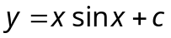

- The equation of the curve passing through the origin and satisfying the equation 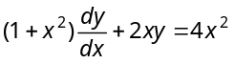 is
(a) 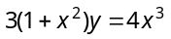 (b) 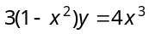 (c) 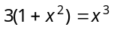 (d) None of these

- The solution of the differential equation 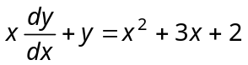 is
(a) 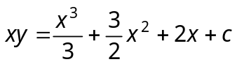 (b) 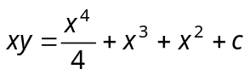
(c) 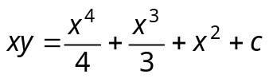 (d) 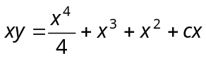

- The slope of a curve at any point is the reciprocal of twice the ordinate at the point and it passes though the point (4, 3). The equation of the curve is
(a) 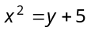 (b) 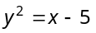
(c) 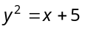 (d) 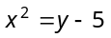
- A particle moves in a straight line with a velocity given by 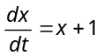(x is the distance described). The time taken by a particle to traverse a distance of 99 metre is
(a) 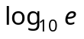 (b) 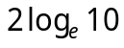 (c) 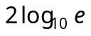 (d) 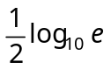
- Equation of curve passing through (3, 9) which satisfies the differential equation 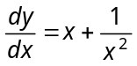, is
(a) 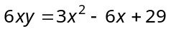 (b) 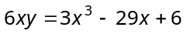 (c) 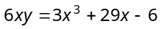 (d) None of these

