- (d) 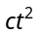 must have dimensions of must have dimensions of 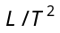 i.e. 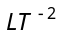.
2. (a)1 C.G.S unit of density = 1000 M.K.S. unit of density 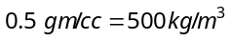
- (c) Impulse = change in momentum so dimensions of both quantities will be same and equal to MLT^{–1}
- (b) 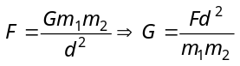 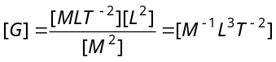
- (a) By principle of dimensional homogenity 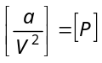 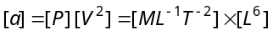 = 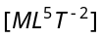
- (c) Let 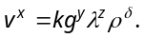Now by substituting the dimensions of each quantities and equating the powers of M, L and T we get 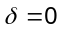 and 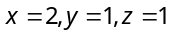 .
- (a) By substituting the dimension of each quantity we get 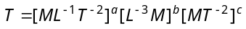
By solving we get a = – 3/2, b = 1/2 and c = 1
- (a) By substituting dimension of each quantity in R.H.S. of option (a) we get 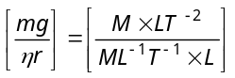=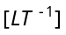.
This option gives the dimension of velocity.
- (b) 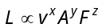 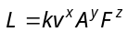
Putting the dimensions in the above relation
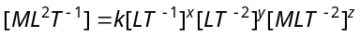
⇒ 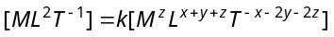
Comparing the powers of 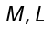 and
…(i)
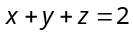 …(ii)
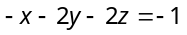 …(iii)
On solving (i), (ii) and (iii) 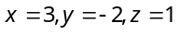
So dimension of in terms of 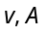 and
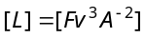
- (b) 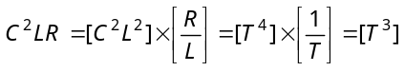 As 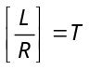 and 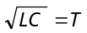
- (c) 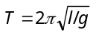 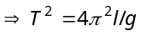 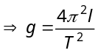
Here % error in l = 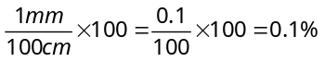 and % error in T =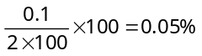
∴ % error in g = % error in l + 2(% error in T)
= 0.2 %
- (b) Number of significant figures are 3, because 10³ is decimal multiplier.
- (b) Here, 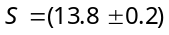m
and 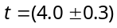 sec
Expressing it in percentage error, we have,
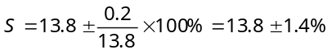
and 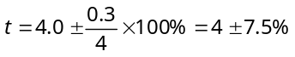
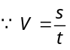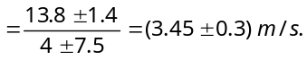
- (a) Since percentage increase in length = 2 %
Hence, percentage increase in area of square sheet
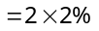 = 4%
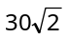
- (c) From figure, 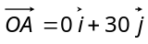, 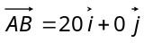
30 m
A
20 m
B
45°
C
O
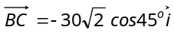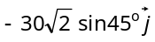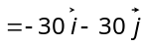
∴ Net displacement, 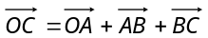 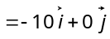
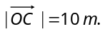
- (c) Distance average speed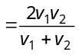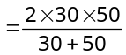 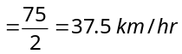
- (d) Average speed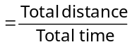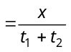 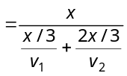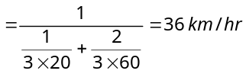
- (c) Total distance to be covered for crossing the bridge
= length of train + length of bridge
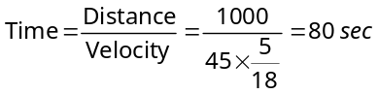
- (c) Initial relative velocity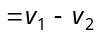, Final relative velocity
From 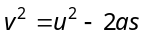⇒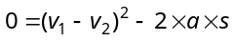
⇒ 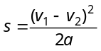
If the distance between two cars is 's' then collision will take place. To avoid collision 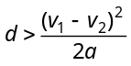
where actual initial distance between two cars.
- (a) 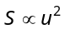 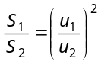⇒ 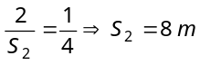
21. (c) 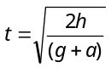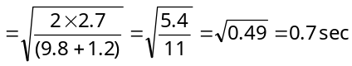
- (c) Let student will catch the bus after t sec. So it will cover distance ut.
Similarly distance travelled by the bus will be 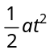 for the given condition
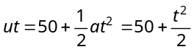 [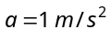]
⇒ u 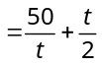
To find the minimum value of u
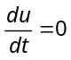, so we get , then 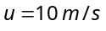

- (a) Effective speed of the bullet
= speed of bullet + speed of police jeep
Speed of thief ’s jeep 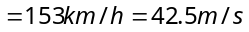
Velocity of bullet w.r.t thief ’s car=150m/s

- (a) Time taken by first stone to reach the water surface from the bridge be t, then
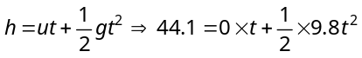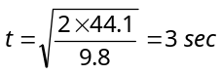
Second stone is thrown 1 sec later and both strikes simultaneously. This means that the time left for second stone 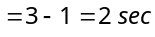
Hence 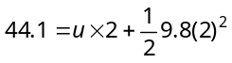
- (d) The separation between the two bodies, two seconds after the release of second body
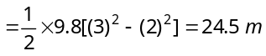
- (d) Let the body after time 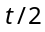be at x from the top, then
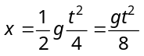 …(i)
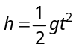 …(ii)
Eliminate t from (i) and (ii), we get 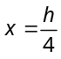
Height of the body from the ground 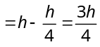

- (a) Height travelled by ball (with balloon) in 2 sec
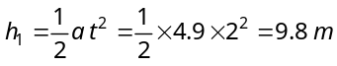
Velocity of the balloon after 2 sec
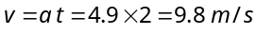
Now if the ball is released from the balloon then it acquire same velocity in upward direction.
Let it move up to maximum height 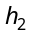
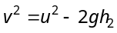 ⇒ 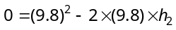=4.9m
Greatest height above the ground reached by the ball 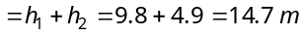
- (b) Distance = Area under v – t graph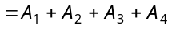

1
2
3
4
0
10
20
30
Velocity (m/s)
Time (Second)
A₁
A₂
A₃
A₄

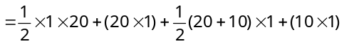
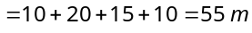
- (d) Maximum acceleration means maximum change in velocity in minimum time interval.
In time interval to
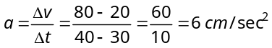
- (c) In part cd displacement-time graph shows constant slope i.e. velocity is constant. It means no acceleration or no force is acting on the body.
- (c) Area of trapezium 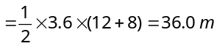
- (a) Displacement = Summation of all the area with sign
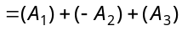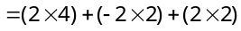
3
0
1
2
3
4
5
1
2
2
4
6
t(sec)
V(m/s)
A₁
A₂
A₃

Displacement = 8 m
Distance =Summation of all the areas without sign
=
Distance = 16 m.
- (d) Diagonal of the hall = 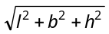
l
b
h
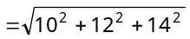
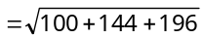
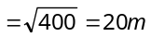
- (d) Total angle = 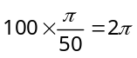
So all the force will pass through one point and all forces will be balanced. i.e. their resultant will be zero.

- (a) Resultant of vectors and
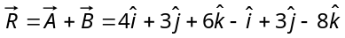
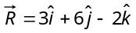
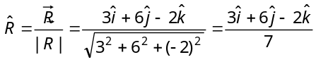
- (d)
- (d) Here all the three force will not keep the particle in equilibrium so the net force will not be zero and the particle will move with an acceleration.
- (a) (given) …(i)
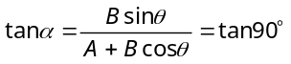
∴ 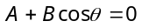⇒ 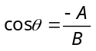 …(ii)
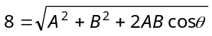 …(iii)
By solving eq. (i), (ii) and (iii) we get 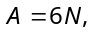
- (c) 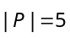, 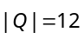 and 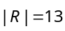
Q
R
P
→
→
→
θ
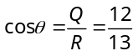
∴ 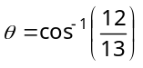

- (c)
V₁
V₂
V_{net}
→
→
→

According to problem 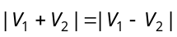
⇒ 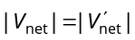
So 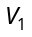 and 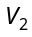 will be mutually perpendicular.

- (c) 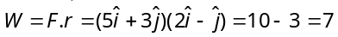J.

- (b) 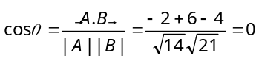 ∴ 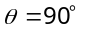
- (d) 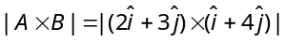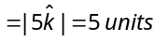
- (c) 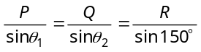
150º

P

Q

R

θ₁

θ₂

