- Two wires A and B of same length, same area of cross-section having the same Young's modulus are heated to the same range of temperature. If the coefficient of linear expansion of A is 3/2 times of that of wire B. The ratio of the forces produced in two wires will be
(a) 2/3 (b) 9/4
(c) 4/9 (d) 3/2
- A wire of area of cross-section 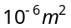is increased in length by 0.1%. The tension produced is 1000 N. The Young's modulus of wire is
(a) 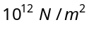 (b) 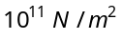
(c) 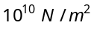 (d) 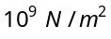
- To break a wire of one meter length, minimum 40 kg wt. is required. Then the wire of the same material of double radius and 6 m length will require breaking weight
(a) 80 kg-wt (b) 240 kg-wt
(c) 200 kg-wt (d) 160 kg-wt
- The breaking stress of a wire of length L and radius r is 5 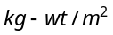. The wire of length 2l and radius 2r of the same material will have breaking stress in
(a) 5 (b) 10
(c) 20 (d) 80
- The increase in length on stretching a wire is 0.05%. If its Poisson's ratio is 0.4, then its diameter
(a) Reduce by 0.02% (b) Reduce by 0.1%
(c) Increase by 0.02% (d) Decrease by 0.4%
- If Poission's ratio is 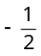 for a material, then the material is
(a) Uncompressible (b) Elastic fatigue
(c) Compressible (d) None of the above

- If the breaking force for a given wire is F, then the breaking force of two wires of same magnitude will be
(a) F (b) 4F
(c) 8F (d) 2F
- If the thickness of the wire is doubled, then the breaking force in the above question will be
(a) 6F (b) 4F
(c) 8F (d) F
- On all the six surfaces of a unit cube, equal tensile force of F is applied. The increase in length of each side will be (Y = Young's modulus, = Poission's ratio)
(a) 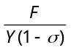 (b) 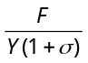 (c)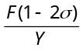 (d)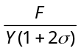
- The mass and length of a wire are M and L respectively. The density of the material of the wire is d. On applying the force F on the wire, the increase in length is l, then the Young's modulus of the material of the wire will be
(a) 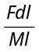 (b) 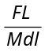 (c)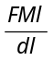 (d)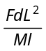
- Two exactly similar wires of steel and copper are stretched by equal forces. If the difference in their elongations is 0.5 cm, the elongation (l) of each wire is
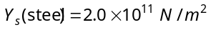
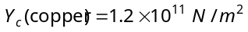
(a) 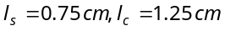 (b) 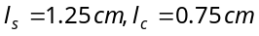
(c) 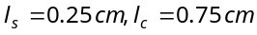 (d) 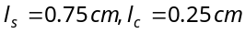
- If the compressibility of water is per unit atmospheric pressure, then the decrease in volume V due to P atmospheric pressure will be
(a) 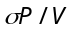 (b) 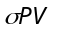 (c)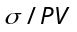 (d)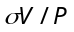
- A rectangular block of size 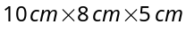 is kept in three different positions P, Q and R in turn as shown in the figure. In each case, the shaded area is rigidly fixed and a definite force F is applied tangentially to the opposite face to deform the block. The displacement of the upper face will be
5
8
10
(Q)
8
10
5
(P)
8
5
10
(R)

(a) Same in all the three cases
(b) Maximum in P position
(c) Maximum in Q position
(d) Maximum in R position

- A 5 metre long wire is fixed to the ceiling. A weight of 10 kg is hung at the lower end and is 1 metre above the floor. The wire was elongated by 1 mm. The energy stored in the wire due to stretching is
(a) Zero (b) 0.05 joule
(c) 100 joule (d) 500 joule
- If the force constant of a wire is K, the work done in increasing the length of the wire by l is
(a) Kl/2 (b) Kl
(c) 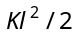 (d) 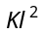
- A soap film of surface tension 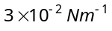 formed in rectangular frame, can support a straw. The length of the film is 10 cm. Mass of the straw the film can support is
(a) 0.06 gm (b) 0.6 gm
(c) 6 gm (d) 60 gm
- Energy required to form a soap bubble of diameter 20 cm will be (Surface tension for soap solution is 30 dynes/cm)
(a) 12000 π ergs (b) 1200 π ergs
(c) 2400 π ergs (d) 24000 π ergs
- If the work done in blowing a bubble of volume V is W, then the work done in blowing the bubble of volume 2V from the same soap solution will be
(a) W/2 (b) 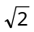W
(c) 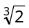W (d) 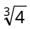W
- Surface tension of soap solution is 2 ×10⁻² N/m. The work done in producing a soap bubble of radius 2 cm is
(a) 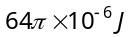 (b) 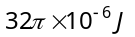
(c) 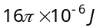 (d) 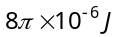
- Excess pressure inside a soap bubble is three times that of the other bubble, then the ratio of their volumes will be
(a) 1 : 3 (b) 1 : 9
(c) 1 : 27 (d) 1 : 81
- When a capillary tube is dipped in water it rises upto 8 cm in the tube. What happens when the tube is pushed down such that its end is only 5 cm above the outside water level
(a) The radius of the meniscus increases and therefore water does not overflow
(b) The radius of the meniscus decreases and therefore water does not overflow
(c) The water forms a droplet on top of the tube but does not overflow
(d) The water start overflowing
- A bubble of 8 mm diameter is formed in the air. The surface tension of soap solution is 30 dynes/cm. The excess pressure inside the bubble is
(a) 150 dynes/cm² (b) 300 dynes/cm² (c)3 × 10^{–3} dynes/cm² (d) 12 dynes/cm²
- The height upto which water will rise in a capillary tube will be
(a) Maximum when water temperature is 4°C
(b) Maximum when water temperature is 0°C
(c) Minimum when water temperature is 4°C
(d) Same at all temperatures
- Water rises to a height of 10 cm in capillary tube and mercury falls to a depth of 3.112 cm in the same capillary tube. If the density of mercury is 13.6 and the angle of contact for mercury is 135°, the ratio of surface tension of water and mercury is
(a) 1 : 0.15 (b) 1 : 3 (c)1 : 6 (d) 1.5 : 1
- The angle of contact between glass and water is 0º and it rises in a capillary upto 6 cm when its surface tension is 70 dynes/cm. Another liquid of surface tension 140 dynes/cm, angle of contact 60º and relative density 2 will rise in the same capillary by
(a) 12 cm (b) 24 cm
(c) 3 cm (d) 6 cm
- A drop of water breaks into two droplets of equal size. In this process, which of the following statement is correct
(a) The sum of temperature of the two droplets together is
equal to the original temperature of the drop
(b) The sum of masses of the two droplets is equal to the original mass of the drop
(c) The sum of the radii of two droplets is equal to the radius of the original drop
(d) The sum of the surface areas of the two droplets is equal to the surface area of the original drop
- A soap bubble of radius R is blown. After heating the solution a second bubble of radius 2R is blown. The work required to blow the second bubble in comparison to that required for the first bubble is
(a) Double
(b) Slightly less than double
- (c) Slightly less than four times
(d) Slightly more than four times
- A false statement is
(a) Angle of contact 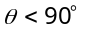, if cohesive force < adhesive force
(b) Angle of contact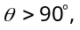, if cohesive force > adhesive force
(c) Angle of contact = 90°, if cohesive force = adhesive force
(d) If the radius of capillary is reduced to half, the rise of liquid column becomes four times
- The diameter of rain-drop is 0.02 cm. If surface tension of water be 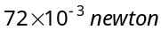per metre, then the pressure difference of external and internal surfaces of the drop will be
(a) 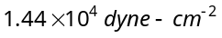
(b) 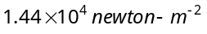
(c) 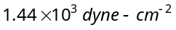
(d) 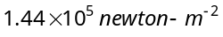
- Water rises to a height of 16.3 cm in a capillary of height 18 cm above the water level. If the tube is cut at a height of 12 cm
(a) Water will come as a fountain from the capillary tube
(b) Water will stay at a height of 12 cm in the capillary tube
(c) The height of the water in the capillary will be 10.3 cm
(d) Water will flow down the sides of the capillary tube

