- (d) 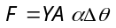
If Y, A and Δθ are constant then 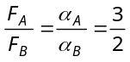
- (a) 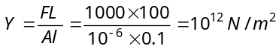
- (d) Breaking force = Breaking stress × Area of cross
section of wire
∴ Breaking force ∝ r² (Breaking distance is constant)
If radius becomes doubled then breaking force will become 4 times i.e. 40 × 4 = 160 kg wt
- (a) Breaking stress depends on the material of wire.
- (a) Poisson’s ratio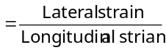
Lateral strain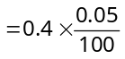
So reduced by 0.02%.
- (a) 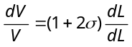
if 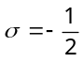 then 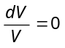i.e. K = ∞
- (d) Breaking force ∝ Area of cross section
If area is double then breaking force will become two times.
- (b) Breaking force ∝ 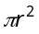
If thickness (radius) of wire is doubled then breaking force will become four times.

- (c) Tensile strain on each face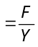
Lateral strain due to the other two forces acting on perpendicular faces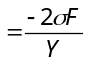
Total increase in length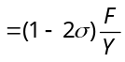
- (d) 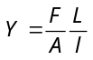 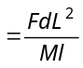
As M = volume × density ∴ 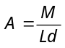
- (a) 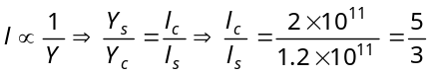 …(i)
Also 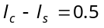 …(ii)
On solving (i) and (ii) 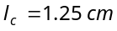 and 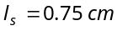.
- (b) Compressibility = 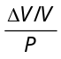 ⇒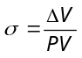⇒ 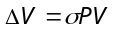
- (d) 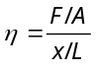⇒ 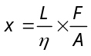
If η and F are constant then 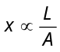
For maximum displacement area at which force applied should be minimum and vertical side should be maximum, this is given in the R position of rectangular block.
- (b) 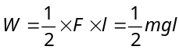
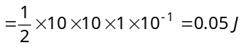
- (c) 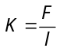and 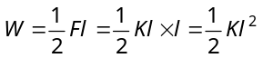(b) The weight of straw will be balanced by the force of surface tension ∴ 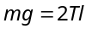⇒ 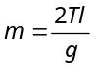
- 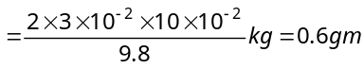
- (d) 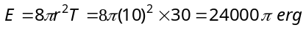
- (d) Work done to form a soap bubble
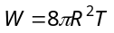 (As 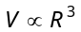∴ 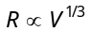)
∴ 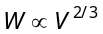
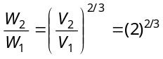⇒ 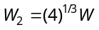
- (a) 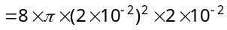 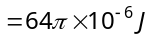
- (c) 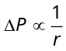⇒ 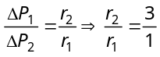
∴ 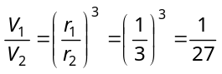
- (a) 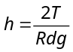⇒ 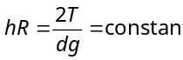
When h decreases, R increases.
- (b) 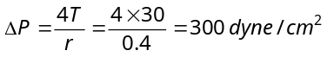.
- (c) 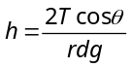. For water, density is maximum at 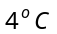, so the height is minimum at .
- (c) 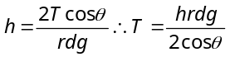
⇒ 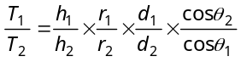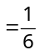
- (c) 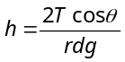∴ 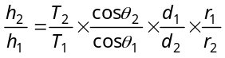
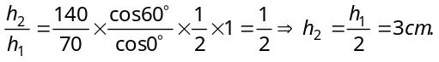
- (b)
- (c) Work done to form a bubble of radius R
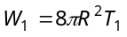
Work done to form a bubble of radius 2R
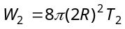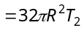 ∴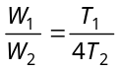
If surface tension of soap solution is same then
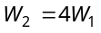
But in the problem temperature of solution is increased so its surface tension decreases.
∴ 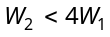

- (d) If radius of capillary is reduced to half, the rise of liquid column will be two times. 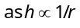
- (a) 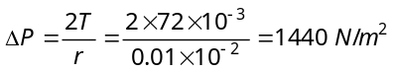
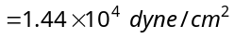
- (b) Because if the length available is less than required, then water will rise upto available height and adjust its radius of curvature.

