- (a) 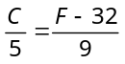 ⇒ 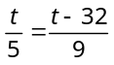 ⇒ 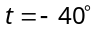
- (a) 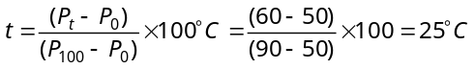
- (a) Temperature on any scale can be converted into other scale by 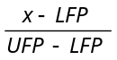 = Constant for all scales 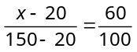 ⇒
- (d) 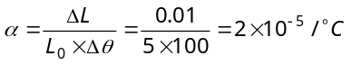
- (a) 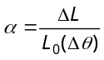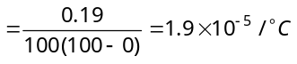
- (c) Given 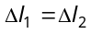 or 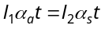 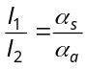 or 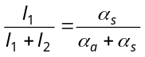.
- (a) Heat taken by ice to melt at 0°C is 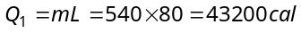
Heat given by water to cool upto 0°C is
Hence heat given by water is just sufficient to melt the whole ice and final temperature of mixture is 0°C.
Short trick : For these type of frequently asked questions you can remember the following formula
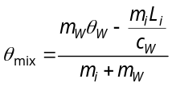 (See theory for more details) If 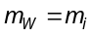 then 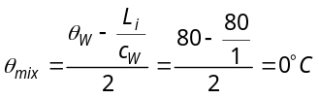
- (a) If m gm ice melts then
Heat lost = Heat gain 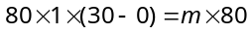 ⇒ 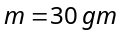
- c) Since specific heat of lead is given in Joules, hence use 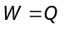 instead of 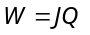. ⇒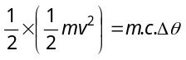⇒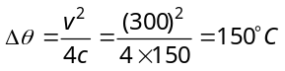.
- (d) Temperature of mixture 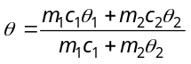 ⇒ 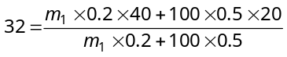⇒ 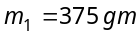
11. (a) 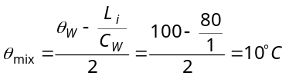

- (a) It is given that 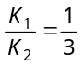 ⇒ 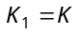 then 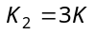
the temperature of the junction in contact
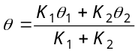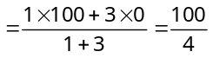= 25°C

- (a) 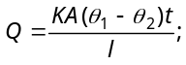 in both the cases , A, l and 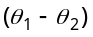 are same so Kt = constant ⇒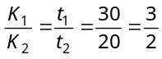= 1.5.
- (b) 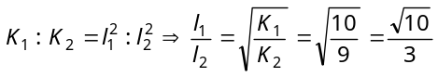
- (a) Temperature of interface 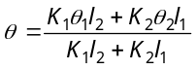
It is given that 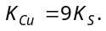 So if 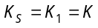 then 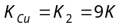 ⇒ θ 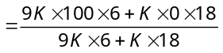=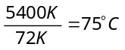
- (a) Temperature gradient 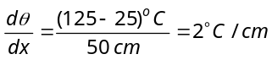
- (d) Temperature of interface 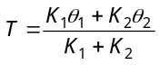
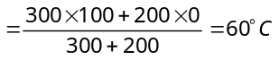

- (c) Let θ be temperature middle point C and in series rate of heat flow is same ⇒ 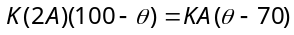
⇒ 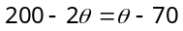 ⇒ 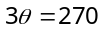⇒ 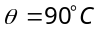

- (c) 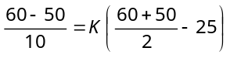 …..(i)
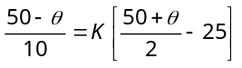 …..(ii) On dividing, we get 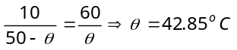
- (b) 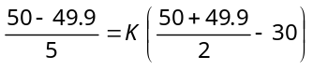 …..(i)
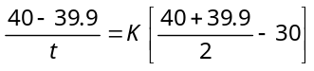 …..(ii)
from equations (i) and (ii) we get t ≈ 10 sec.
- (b) In first case 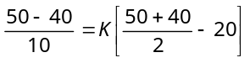 ….(i)
In second case 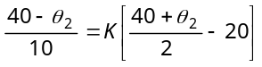 ….(ii) By solving 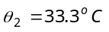.
- (b) Let the temperature of junction be θ. Since roads B and C are parallel to each other (because both having the same temperature difference). Hence given figure can be redrawn as follows
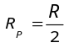
R
R
R
0°
θ
90°
90°
R
R/2
0°
90°
θ
C
A
B
Q
l
l

 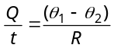 and 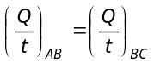
⇒ 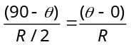 ⇒ 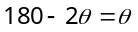 ⇒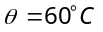

- (a) 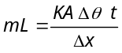 ⇒ 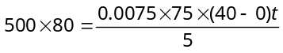 ⇒ t = 8.9 × 10³ sec = 2.47 hr.
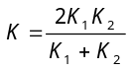
- (c) The given arrangement of rods can be redrawn as follows
H
H
H₁
H₁
H₂
l
l
K₁
K₂
K₃

It is given that H₁ = H₂
⇒ 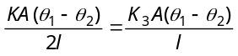⇒ 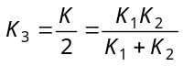
- (b) For no current flow between C and D
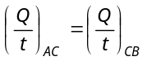⇒ 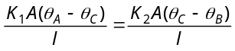
⇒ 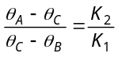 ...(i)
Also 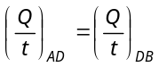⇒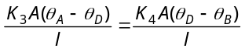
⇒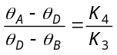 ...(ii)
It is given that 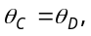 hence from equation (i) and (ii) we get 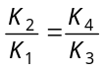 ⇒ 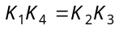
- (d) 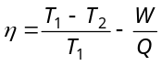⇒ 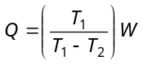 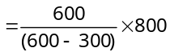=1600 J
- (c) Coefficient of performance 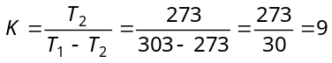
- (d) 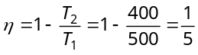 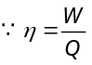 ⇒ 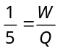 ⇒ 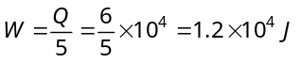
- b) 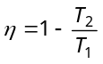⇒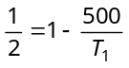⇒ 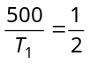 …..(i)
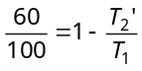⇒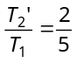 …..(ii)
Dividing equation (i) by (ii), 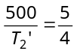⇒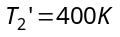
- (c) Coefficient of performance
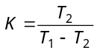⇒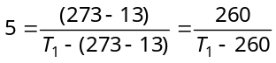 ⇒ 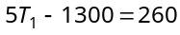⇒ 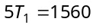 ⇒ 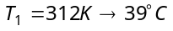
- (a) Work done = Area enclosed by triangle ABC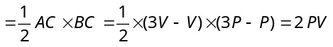
- (a) Initial and final states are same in all the process.
Hence Δ U = 0; in each case.
By FLOT; ΔQ = ΔW = Area enclosed by curve with volume axis.
(Area)₁ < (Area)₂ < (Area)₁ ⇒ Q₁ < Q₂ < Q₃ .

- (a) By adjoining graph 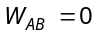 and
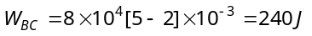
∴
Now, From FLOT 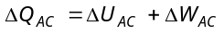 ⇒ 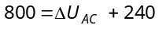 ⇒ 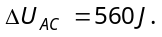
- (b) The cyclic process 1 is clockwise where as process 2 is anticlockwise. Clockwise area represents positive work and anticlockwise area represents negative work. Since negative area (2) > positive area (1), hence net work done is negative.
- (d) Work done 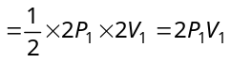
- (c) In a cyclic, ΔU = 0
From FLOT, Δ Q = ΔU + ΔW = 0 + ΔW = Area of closed curve ⇒ ΔQ = πr² 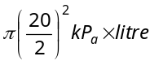
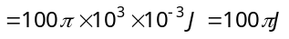
- (c) Work done = Area of PV graph (here trapezium)
