- At what temperature the centigrade (Celsius) and Fahrenheit, readings are the same
(a) – 40° (b) + 40° (c) 36.6° (d) – 37°

- A constant volume gas thermometer shows pressure reading of 50cm and 90cm of mercury at 0°C and 100°C respectively. When the pressure reading is 60 cm of mercury, the temperature is
(a) 25°C (b) 40°C (c) 15°C (d) 12.5°C

- If a thermometer reads freezing point of water as 20°C and boiling point as 150°C, how much thermometer read when the actual temperature is 60°C
(a) 98°C (b) 110°C (c) 40°C (d) 60°C

- If on heating liquid through 80°C, the mass expelled is (1/100)^{th} of mass still remaining, the coefficient of apparent expansion of liquid is
(a) 1.25 × 10^{–4}/°C (b) 12.5 × 10^{–4}/°C (c) 1.25 × 10^{–5}/°C (d) None of these

- The length of a metallic rod is 5m at 0°C and becomes 5.01 m, on heating upto 100°C. The linear expansion of the metal will be
(a) 2.33 × 10^{–5} /°C (b) 6.0 × 10^{–5} /°C (c) 4.0 × 10^{–5} /°C (d) 2.0 × 10^{–5} /°C

- Two rods, one of aluminum and the other made of steel, having initial length and are connected together to form a single rod of length 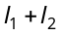. The coefficients of linear expansion for aluminum and steel are 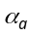 and 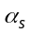 respectively. If the length of each rod increases by the same amount when their temperature are raised by 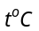, then find the ratio 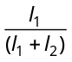
(a) 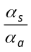 (b) 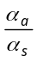 (c) 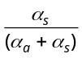 (d) 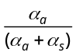

- 540 g of ice at 0°C is mixed with 540 g of water at 80°C. The final temperature of the mixture is
(a) 0°C (b) 40°C (c)80°C (d)Less than 0°C

- 80 gm of water at 30°C are poured on a large block of ice at 0°C. The mass of ice that melts is
(a) 30 gm (b) 80 gm (c) 1600 gm (d) 150 gm

- A lead bullet of 10 g travelling at 300 m/s strikes against a block of wood and comes to rest. Assuming 50% of heat is absorbed by the bullet, the increase in its temperature is
(Specific heat of lead = 150J/kg, K)
(a) 100°C (b) 125°C (c) 150°C (d) 200°C

- How many grams of a liquid of specific heat 0.2 at a temperature 40°C must be mixed with 100 gm of a liquid of specific heat of 0.5 at a temperature 20°C, so that the final temperature of the mixture becomes 32°C
(a) 175 gm (b) 300 g (c) 295 gm (d) 375 g

- 50 gm ice at 0°C in insulator vessel, 50g water of 100°C is mixed in it, then final temperature of the mixture is (neglect the heat loss)
(a) 10°C (b) 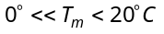 (c) 20°C (d) Above 20°C

- Two rectangular blocks A and B of different metals have same length and same area of cross-section. They are kept in such a way that their cross-sectional area touch each other. The temperature at one end of A is 100°C and that of B at the other end is 0°C. If the ratio of their thermal conductivity is 1 : 3, then under steady state, the temperature of the junction in contact will be
(a) 25°C (b) 50°C (c) 75°C (d) 100°C

- Two vessels of different materials are similar in size in every respect. The same quantity of ice filled in them gets melted in 20 minutes and 30 minutes. The ratio of their thermal conductivities will be
(a) 1.5 (b) 1 (c) 2/3 (d) 4

- If the ratio of coefficient of thermal conductivity of silver and copper is 10 : 9, then the ratio of the lengths upto which wax will melt in Ingen Hausz experiment will be
(a) 6 : 10 (b) 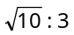 (c) 100 : 81 (d) 81 : 100

- The coefficient of thermal conductivity of copper is nine times that of steel. In the composite cylindrical bar shown in the figure. What will be the temperature at the junction of copper and steel
Copper
Steel
0ºC
100ºC
6 cm
18 cm
(a) 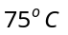
(b) 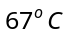
(c) 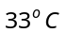
(d) 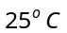

- The heat is flowing through a rod of length 50 cm and area of cross-section 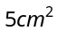. Its ends are respectively at and 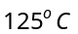. The coefficient of thermal conductivity of the material of the rod is 0.092 kcal/m×s×ºC. The temperature gradient in the rod is
(a) 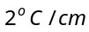 (b) 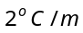 (c) 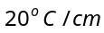 (d) 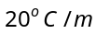

- Two metal cubes and of same size are arranged as shown in the figure. The extreme ends of the combination are maintained at the indicated temperatures. The arrangement is thermally insulated. The coefficients of thermal conductivity of and are 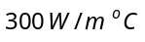 and 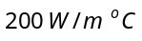, respectively. After steady state is reached, the temperature of the interface will be
(a) 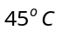
100ºC
0ºC
A
B
(b) 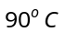
(c) 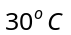
(d) 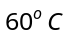

- A metal rod of length 2m has cross sectional areas 2A and A as shown in figure. The ends are maintained at temperatures 100°C and 70°C. The temperature at middle point C is
(a) 80°C
100°C
C
70°C
A
2A
1m
1m
(b) 85°C
(c) 90°C
(d) 95°C

- A body cools from to 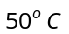 in 10 minutes. If the room temperature is 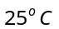 and assuming Newton's law of cooling to hold good, the temperature of the body at the end of the next 10 minutes will be
(a) 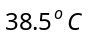 (b) 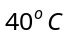 (c) 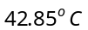 (d)

- A body cools from 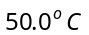 to 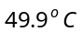 in 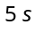. How long will it take to cool from 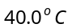 to 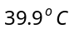? Assume the temperature of surroundings to be 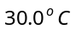 and Newton's law of cooling to be valid
(a) 2.5 s (b) 10 s (c) 20 s (d) 5 s

- The temperature of a body falls from 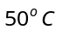to in 10 minutes. If the temperature of the surroundings is 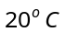Then temperature of the body after another 10 minutes will be
(a) 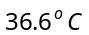 (b) 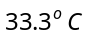 (c) 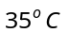 (d)

- Three rods made of the same material and having the same cross section have been joined as shown in the figure. Each rod is of the same length. The left and right ends are kept at 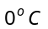 and 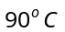 respectively. The temperature of the junction of the three rods will be
(a)
0ºC
90ºC
90ºC
A
B
C
(b) 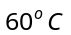
(c)
(d)

- The only possibility of heat flow in a thermos flask is through its cork which is 75 cm² in area and 5 cm thick. Its thermal conductivity is 0.0075 cal/cmsecºC. The outside temperature is 40ºC and latent heat of ice is 80 cal g^{–1}. Time taken by 500 g of ice at 0ºC in the flask to melt into water at 0ºC is

(a) 2.47 hr
(b) 4.27 hr
(c) 7.42 hr
(d) 4.72 hr

- Three rods of same dimensions are arranged as shown in figure they have thermal conductivities 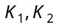 and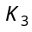 The points P and Q are maintained at different temperatures for the heat to flow at the same rate along PRQ and PQ then which of the following option is correct
R
P
Q
K₁
K₂
K₃
(a) 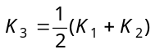
(b) 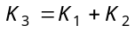
(c) 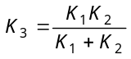
(d) 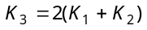
- Five rods of same dimensions are arranged as shown in the figure. They have thermal conductivities K₁, K₂, K₃, K₄ and K₅. When points A and B are maintained at different temperatures, no heat flows through the central rod if
C
A
B
D
K₁
K₂
K₄
K₅
K₃
(a) 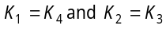
(b) 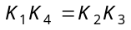
(c) 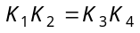
(d) 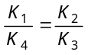
- A Carnot engine working between 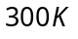 and 600K has work output of 800 J per cycle. What is amount of heat energy supplied to the engine from source per cycle
(a) 1800 J/cycle (b) 1000 J/cycle (c) 2000 J/cycle (d) 1600 J/cycle

- The coefficient of performance of a Carnot refrigerator working between 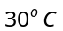and 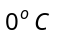 is
(a) 10 (b) 1 (c) 9 (d) 0

- An ideal gas heat engine operates in a Carnot's cycle between 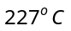 and 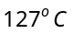. It absorbs 6 × 10⁴ J at high temperature. The amount of heat converted into work is ....
(a) 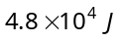 (b) 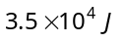 (c) 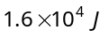 (d) 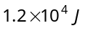

- Efficiency of a Carnot engine is 50% when temperature of outlet is 500 K. In order to increase efficiency up to 60% keeping temperature of intake the same what is temperature of outlet (a)200 K (b)400 K (c) 600 K (d) 800 K

- An ideal refrigerator has a freezer at a temperature of The coefficient of performance of the engine is 5. The temperature of the air (to which heat is rejected) will be
(a) 325°C (b) 325K (c) 39°C (d) 320°C

- An ideal gas is taken around ABCA as shown in the above P-V diagram. The work done during a cycle is
B
C
(P, 3V)
P
E
D
V
A
(P,V)
(3P, 3V)
(a) 2PV
(b) PV
(c) 1/2PV
(d) Zero

- An ideal gas of mass m in a state A goes to another state B via three different processes as shown in figure. If 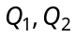 and 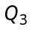 denote the heat absorbed by the gas along the three paths, then
V
1
2
3
B
A
P

(a) 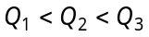
(b) 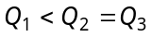
(c) 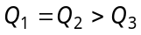
(d) 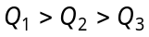
- A thermodynamic process is shown in the figure. The pressures and volumes corresponding to some points in the figure are : 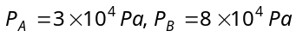 and 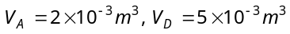
In process AB, 600 J of heat is added to the system and in process BC, 200 J of heat is added to the system. The change in internal energy of the system in process AC would be
V
P
D
A
B
C
O
(a) 560 J
(b) 800 J
(c) 600 J
(d) 640 J

- In the following indicator diagram, the net amount of work done will be
1
2
P
V
(a) Positive
(b) Negative
(c) Zero
(d) Infinity

- An ideal gas is taken around the cycle ABCA as shown in the P-V diagram. The net work done by the gas during the cycle is equal to
3V₁
P
V₁
P₁
3P₁
B
A
C
(a) 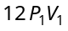
(b) 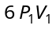
(c) 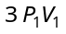
(d) 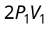

- Heat energy absorbed by a system in going through a cyclic process shown in figure is
(a) 10⁷ π J
30
10
10
30
P (kPa)
V (litre)
(b) 10⁴ π J
(c) 10²π J
(d) 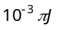

- A system changes from the state 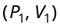 to 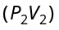 as shown in the figure. What is the work done by the system
V(m³)
5 × 10⁵
1 × 10⁵
(P₂, V₂)
(P₁, V₁)
1
2
3
4
5
P(N/m²)

(a) 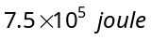
(b) 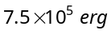
(c) 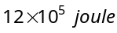
(d) 