- A particle is oscillating according to the equation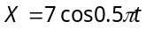, where t is in second. The point moves from the position of equilibrium to maximum displacement in time
(a) 4.0 sec (b) 2.0 sec (c)1.0 sec (d)0.5 sec

- Two simple harmonic motions are represented by the equations 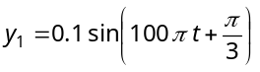and 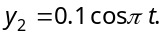 The phase difference of the velocity of particle 1 with respect to the velocity of particle 2 is
(a) 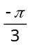 (b) 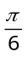 (c) 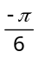 (d) 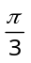

- A simple harmonic oscillator has a period of 0.01 sec and an amplitude of 0.2 m. The magnitude of the velocity in 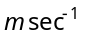 at the centre of oscillation is
(a) 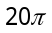 (b) 100 (c) 40π (d) 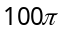

- A body is executing S.H.M. When its displacement from the mean position is 4 cm and 5 cm, the corresponding velocity of the body is 10 cm/sec and 8 cm/sec. Then the time period of the body is
(a) 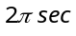 (b) 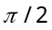sec (c) 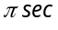 (d)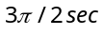

- If the displacement of a particle executing SHM is given by 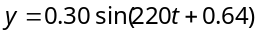 in metre, then the frequency and maximum velocity of the particle is
(a) 35 Hz, 66 m / s (b) 45 Hz, 66 m / s (c) 58 Hz, 113 m / s (d) 35 Hz, 132 m / s

- A particle executing simple harmonic motion has an amplitude of 6 cm. Its acceleration at a distance of 2 cm from the mean position is 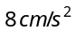. The maximum speed of the particle is
(a) 8 cm/s (b) 12 cm/s (c) 16 cm/s (d) 24 cm/s

- Two particles P and Q start from origin and execute Simple Harmonic Motion along X-axis with same amplitude but with periods 3 seconds and 6 seconds respectively. The ratio of the velocities of P and Q when they meet is
(a) 1 : 2 (b) 2 : 1 (c) 2 : 3 (d) 3 : 2

- The displacement equation of a particle is The amplitude and maximum velocity will be respectively (a) 5, 10 (b) 3, 2 (c) 4, 2 (d) 3, 4

- The displacement of an oscillating particle varies with time (in seconds) according to the equation y (cm) = sin 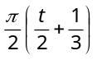. The maximum acceleration of the particle is approximately
(a) 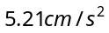 (b) 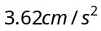 (c) 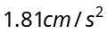 (d) 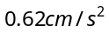

- A 0.10 kg block oscillates back and forth along a horizontal surface. Its displacement from the origin is given by: 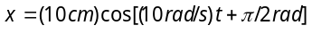. What is the maximum acceleration experienced by the block
(a) 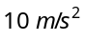 (b) 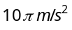 (c) 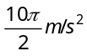 (d) 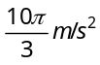

- A particle executes linear simple harmonic motion with an amplitude of 2 cm. When the particle is at 1 cm from the mean position the magnitude of its velocity is equal to that of its acceleration. Then its time period in seconds is
(a) 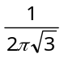 (b) 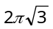 (c) 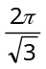 (d) 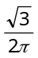

- A body is executing Simple Harmonic Motion. At a displacement x its potential energy is 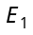 and at a displacement y its potential energy is 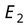. The potential energy E at displacement 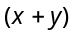 is
(a) 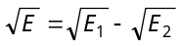 (b) 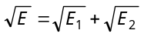 (c) 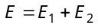 (d)

- A tunnel has been dug through the centre of the earth and a ball is released in it. It will reach the other end of the tunnel after
(a) 84.6 minutes (b) 42.3 minutes (c)1 day (d)Will not reach the other end

- The motion of a particle executing S.H.M. is given by 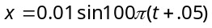, where x is in metres and time is in seconds. The time period is
(a) 0.01 sec (b) 0.02 sec (c) 0.1 sec (d) 0.2 sec

- The kinetic energy of a particle executing S.H.M. is 16 J when it is in its mean position. If the amplitude of oscillations is 25 cm and the mass of the particle is 5.12 kg, the time period of its oscillation is
(a) 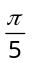sec (b) 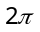sec (c) sec (d) 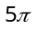sec

- If a simple harmonic oscillator has got a displacement of 0.02 m and acceleration equal to 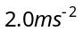 at any time, the angular frequency of the oscillator is equal to
(a) 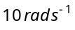 (b) 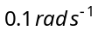 (c)  (d) 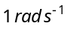

- The bob of a pendulum of length l is pulled aside from its equilibrium position through an angle and then released. The bob will then pass through its equilibrium position with a speed v, where v equals
(a) 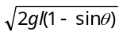 (b) 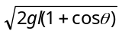 (c) 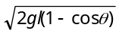 (d) 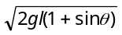

- A pendulum bob has a speed of 3 m/s at its lowest position. The pendulum is 0.5 m long. The speed of the bob, when the length makes an angle of 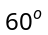 to the vertical, will be (If 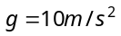)
(a) 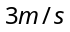 (b) 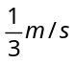 (c) 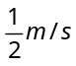 (d) 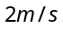

- A simple pendulum is executing simple harmonic motion with a time period T. If the length of the pendulum is increased by 21%, the percentage increase in the time period of the pendulum of increased length is
(a) 10% (b) 21% (c) 30% (d) 50%
- Two pendulums begin to swing simultaneously. If the ratio of the frequency of oscillations of the two is 7 : 8, then the ratio of lengths of the two pendulums will be
(a) 7 : 8 (b) 8 : 7 (c) 49 : 64 (d) 64 : 49

- The period of a simple pendulum measured inside a stationary lift is found to be T. If the lift starts accelerating upwards with acceleration of 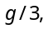then the time period of the pendulum is
(a) 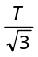 (b) 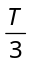 (c) 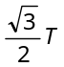 (d) 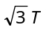
- The time period of a simple pendulum of length L as measured in an elevator descending with acceleration is
(a) 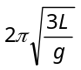 (b) 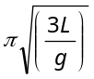 (c) 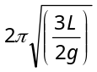 (d) 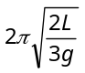

- What is the velocity of the bob of a simple pendulum at its mean position, if it is able to rise to vertical height of 10cm (g = 9.8 m/s²)
M
B
A
(a) 2.2 m/s
(b) 1.8 m/s
(c) 1.4 m/s
(d) 0.6 m/s

- A mass m is suspended by means of two coiled spring which have the same length in unstretched condition as in figure. Their force constant are k₁ and k₂ respectively. When set into vertical vibrations, the period will be
m
A
B
k₂
k₁

(a) 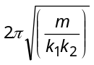 (b) 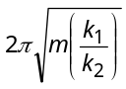
(c) 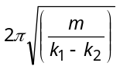 (d) 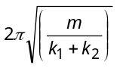

- In arrangement given in figure, if the block of mass m is displaced, the frequency is given by

(a) 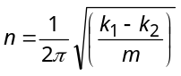 (b) 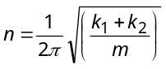
m
K₁
K₂
A
B
(c) 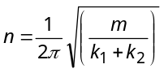 (d) 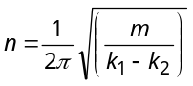

- A mass M is suspended from a spring of negligible mass. The spring is pulled a little and then released so that the mass executes simple harmonic oscillations with a time period T. If the mass is increased by m then the time period becomes 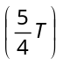. The ratio of 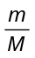 is
(a) 9/16 (b) 25/16 (c) 4/5 (d) 5/4

- A weightless spring which has a force constant oscillates with frequency n when a mass m is suspended from it. The spring is cut into two equal halves and a mass 2m is suspended from it. The frequency of oscillation will now become
(a) (b) (c) 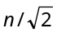 (d) 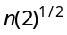

- A mass M is suspended from a light spring. An additional mass m added displaces the spring further by a distance x. Now the combined mass will oscillate on the spring with period
(a) 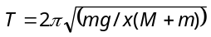 (b) 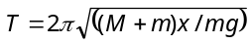
(c) 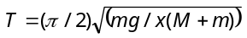 (d) 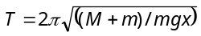

- A mass m performs oscillations of period T when hanged by spring of force constant K. If spring is cut in two parts and arranged in parallel and same mass is oscillated by them, then the new time period will be
m
K
m
(a) 2T
(b) T
(c) 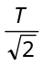 (d) 
- A mass m is suspended separately by two different springs of spring constant K₁ and K₂ gives the time-period and respectively. If same mass m is connected by both springs as shown in figure then time-period t is given by the relation
m
(a) 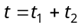
(b) 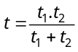
(c) 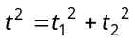
(d) 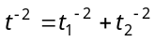

- Two springs of force constants K and 2K are connected to a mass as shown below. The frequency of oscillation of the mass is
(a) 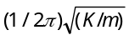 (b) 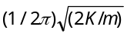
K
2K
m
(c) 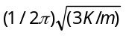 (d) 