Wave nature and Interference of light :
- The ratio of intensities of two waves is 9 : 1. They are producing interference. The ratio of maximum and minimum intensities will be
(a) 10 : 8 (b) 9 : 1 (c) 4 : 1 (d) 2 : 1

- If the ratio of intensities of two waves is 1 : 25, then the ratio of their amplitudes will be
(a) 1 : 25 (b) 5 : 1 (c) 26 : 24 (d)1 : 5

- If L is the coherence length and c the velocity of light, the coherent time is
(a) cL (b) 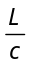 (c) 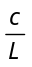 (d) 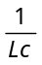

- If the amplitude ratio of two sources producing interference is 3 : 5, the ratio of intensities at maxima and minima is
(a) 25 : 16 (b) 5 : 3 (c) 16 : 1 (d) 25 : 9

- For constructive interference to take place between two monochromatic light waves of wavelength λ, the path difference should be
(a) 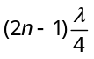 (b) 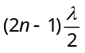 (c) 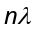 (d) 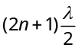

- If the ratio of amplitude of two waves is 4 : 3, then the ratio of maximum and minimum intensity is
(a) 16 : 18 (b) 18 : 16 (c) 49 : 1 (d) 94 : 1

- Two coherent sources have intensity in the ratio of 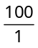. Ratio of (intensity) max/(intensity) min is
(a) 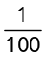 (b) 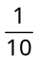 (c) 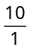 (d)
- If two waves represented by 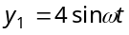 and 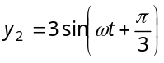 interfere at a point, the amplitude of the resulting wave will be about
(a) 7 (b) 6 (c) 5 (d)3.5

- Two beams of light having intensities I and 4I interfere to produce a fringe pattern on a screen. The phase difference between the beams is 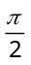 at point A and π at point B. Then the difference between the resultant intensities at A and B is
(a) 2I (b) 4I (c) 5I (d7I

- Two coherent sources of different intensities send waves which interfere. The ratio of maximum intensity to the minimum intensity is 25. The intensities of the sources are in the ratio
(a) 25 : 1 (b) 5 : 1 (c) 9 : 4 (d) 25 : 16

Youngs double slit experiment :
- In Young's double slit experiment, a glass plate is placed before a slit which absorbs half the intensity of light. Under this case
(a) The brightness of fringes decreases (b) The fringe width decreases
(c) No fringes will be observed (d) The bright fringes become fainter and the dark fringes have finite light intensity

- In a certain double slit experimental arrangement interference fringes of width 1.0 mm each are observed when light of wavelength 5000 Å is used. Keeping the set up unaltered, if the source is replaced by another source of wavelength 6000 Å, the fringe width will be
(a) 0.5 mm (b) 1.0 mm (c) 1.2 mm (d) 1.5 mm

- An oil flowing on water seems coloured due to interference. For observing this effect, the approximate thickness of the oil film should be
(a) 100 Å (b) 10000 Å (c) 1 mm d) 1 cm

- In a Young's double slit experiment, the fringe width is found to be 0.4 mm. If the whole apparatus is immersed in water of refractive index 4/3 without disturbing the geometrical arrangement, the new fringe width will be
(a) 0.30 mm (b) 0.40 mm (c) 0.53 mm (d)450 micron

- In Young's experiment, light of wavelength 4000 Å is used to produce bright fringes of width 0.6 mm, at a distance of 2 meters. If the whole apparatus is dipped in a liquid of refractive index 1.5, then fringe width will be
(a) 0.2 mm (b) 0.3 mm (c) 0.4 mm (d) 1.2 mm

- In Young's double slit experiment, the phase difference between the light waves reaching third bright fringe from the central fringe will be (λ =6000 Å )
(a) Zero (b) 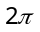 (c) 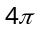 (d) 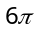

- In Young's double slit experiment, the fringe width is 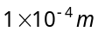if the distance between the slit and screen is doubled and the distance between the two slit is reduced to half and wavelength is changed from 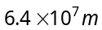 to 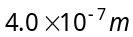, the value of new fringe width will be
(a) 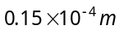 (b) 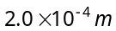 (c) 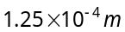 (d) 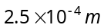

- A thin mica sheet of thickness 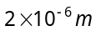and refractive index 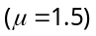 is introduced in the path of the first wave. The wavelength of the wave used is 5000 Å. The central bright maximum will shift
(a) 2 fringes upward (b) 2 fringes downward (c)10 fringes upward (d) None of these

- In Young's double slit experiment, the slits are 0.5 mm apart and interference pattern is observed on a screen placed at a distance of 1.0 m from the plane containing the slits. If wavelength of the incident light is 6000 Å, then the separation between the third bright fringe and the central maxima is
(a) 4.0 mm (b) 3.5 mm (c) 3.0 mm (d) 2.5 mm

- In Young's double slit experiment using sodium light (λ = 5898 Å), 92 fringes are seen. If given colour (λ = 5461 Å) is used, how many fringes will be seen
(a) 62 (b) 67 (c) 85 (d) 99

- In Young’s experiment, the distance between slits is 0.28 mm and distance between slits and screen is 1.4 m. Distance between central bright fringe and third bright fringe is 0.9 cm. What is the wavelength of used light
(a) 5000 Å (b) 6000 Å (c) 7000 Å (d) 9000 Å

- If a transparent medium of refractive index μ = 1.5 and thickness t = 2.5 × 10^{–5} m is inserted in front of one of the slits of Young’s Double Slit experiment, how much will be the shift in the interference pattern? The distance between the slits is 0.5 mm and that between slits and screen is 100 cm
(a) 5 cm (b) 2.5 cm (c) 0.25 cm (d) 0.1 cm

- In a Young’s double slit experiment, 12 fringes are observed to be formed in a certain segment of the screen when light of wavelength 600 nm is used. If the wavelength of light is changed to 400 nm, number of fringes observed in the same segment of the screen is given by
(a) 12 (b) 18 (c) 24 (d) 30

- The two slits at a distance of 1 mm are illuminated by the light of wavelength 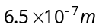. The interference fringes are observed on a screen placed at a distance of 1m. The distance between third dark fringe and fifth bright fringe will be (a) 0.65 mm (b ) 1.63 mm (c) 3.25 mm (d) 4.88 mm

- In Young’s double slit experiment, distance between two sources is 0.1 mm. The distance of screen from the sources is 20 cm. Wavelength of light used is 5460 Å. Then angular position of the first dark fringe is
(a) 0.08° (b) 0.16° (c) 0.20° (d) 0.313°

Diffraction of light :
- A slit of width a is illuminated by white light. For red light (λ = 6500 Å), the first minima is obtained at 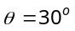. Then the value of a will be
(a) 3250 Å (b) 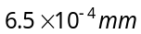 (c) 1.24 microns (d) 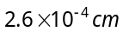

- A slit of size 0.15 cm is placed at 2.1 m from a screen. On illuminated it by a light of wavelength 5 × 10^{–5} cm. The width of central maxima will be
(a) 70 mm (b) 0.14 mm (c) 1.4 mm (d) 0.14 cm

- Light of wavelength 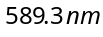 is incident normally on the slit of width 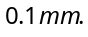 What will be the angular width of the central diffraction maximum at a distance of 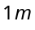 from the slit
(a) (b) (c) (d) None of these

- A beam of light of wavelength 600 nm from a distant source falls on a single slit 1 mm wide and the resulting diffraction pattern is observed on a screen 2 m away. The distance between the first dark fringes on either side of the central bright fringe is
(a) 1.2 mm (b) 1.2 cm (c) 2.4 cm (d) 2.4 mm

- A light wave is incident normally over a slit of width 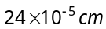. The angular position of second dark fringe from the central maxima is 30º. What is the wavelength of light
(a) 6000 Å (b) 5000 Å (c) 3000 Å (d) 1500 Å

- Light of wavelength λ = 5000 Å falls normally on a narrow slit. A screen placed at a distance of 1 m from the slit and perpendicular to the direction of light. The first minima of the diffraction pattern is situated at 5 mm from the centre of central maximum. The width of the slit is
(a) 0.1 mm (b) 1.0 mm (c) 0.5 mm (d) 0.2 mm

- A single slit of width a is illuminated by violet light of wavelength 400 nm and the width of the diffraction pattern is measured as y. When half of the slit width is covered and illuminated by yellow light of wavelength 600 nm, the width of the diffraction pattern is
(a) The pattern vanishes and the width is zero (b) y / 3
(c) 3y (d) None of these

Polarization of light :
- The angle of polarisation for any medium is 60º, what will be critical angle for this
(a) 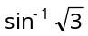 (b) 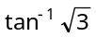 (c) 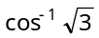 (d) 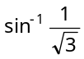

- A polaroid is placed at 45º to an incoming light of intensity . Now the intensity of light passing through polaroid after polarisation would be
(a) (b) 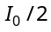 (c) 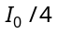 (d) Zero

- Polarising angle for water is 53°4'. If light is incident at this angle on the surface of water and reflected, the angle of refraction is
(a) 53°4' (b) 126°56' (c) 36°56' (d) 30°4'

- Unpolarized light falls on two polarizing sheets placed one on top of the other. What must be the angle between the characteristic directions of the sheets if the intensity of the final transmitted light is one-third the maximum intensity of the first transmitted beam
(a) 75° (b) 55° (c) 35° (d) 15°
- Unpolarized light of intensity 32Wm^{–2} passes through three polarizers such that transmission axes of the first and second polarizer makes and angle 30° with each other and the transmission axis of the last polarizer is crossed with that of the first. The intensity of final emerging light will be
(a) 32 Wm^{–2} (b) 3 Wm^{–2} (c) 8 Wm^{–2} (d) 4 Wm^{–2}

- When the angle of incidence on a material is 60°, the reflected light is completely polarized. The velocity of the refracted ray inside the material is (in ms^{–1})
(a) 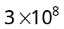 (b) 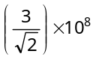 (c) 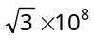 (d) 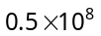

- Two polaroids are placed in the path of unpolarized beam of intensity such that no light is emitted from the second polaroid. If a third polaroid whose polarization axis makes an angle θ with the polarization axis of first polaroid, is placed between these polaroids then the intensity of light emerging from the last polaroid will be
(a) 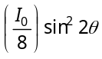 (b) 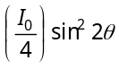 (c) 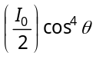 (d) 