- (c) 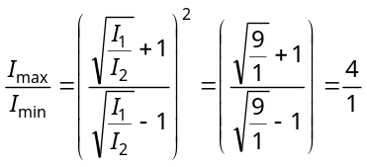
- (d) 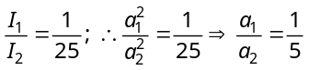
- (b) Coherent time 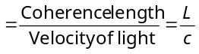
- (c) 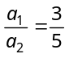 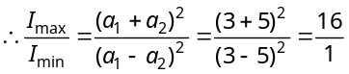
- (c) For constructive interference path difference is even multiple of .
- (c) 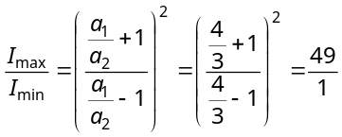
- (d) 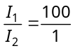 Now 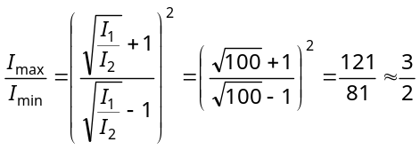
- (b) 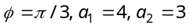 So, 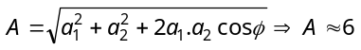
- (b) At point A, resultant intensity
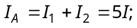and at point B 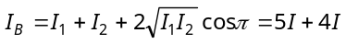 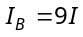 so 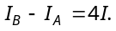
- (c) 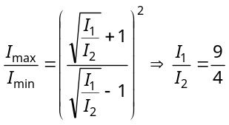
- (d)
- (c) 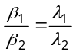or 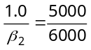or 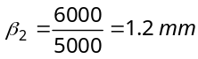.
- (b)
- (a) 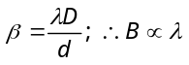 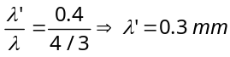.
- (c) 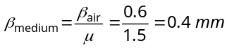.
- (d) 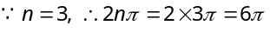
- (d) 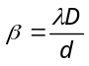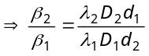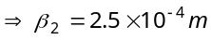.
- (a) Shift 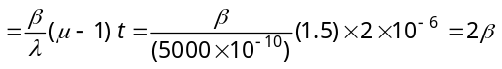 i.e., 2 fringes upwards.
- (b) Separation 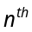bright fringe and central maxima is 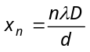 So, 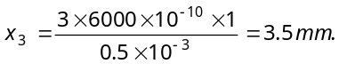
- (d) 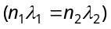 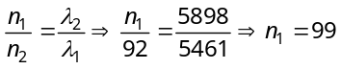
- b) Position of 3rd bright fringe 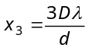
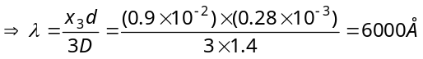
- (b) Shift in the fringe pattern 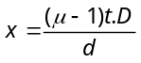 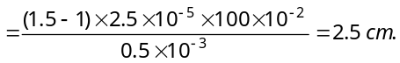
- (b) 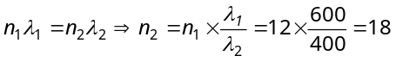
- (b) Distance between 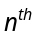 Bright fringe and 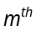 dark fringe 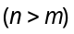 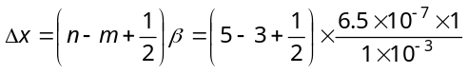
=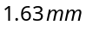
- (d) Angular position of first dark fringe 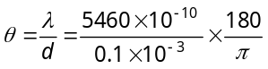 (in degree) = 0.313°
- (c) For first minima 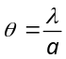 or 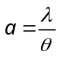 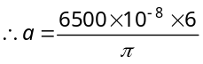 (As 30º = 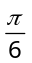radian)
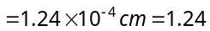microns
- (c) Width of central maxima 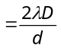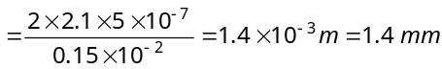
- (a) Angular width of central maxima 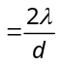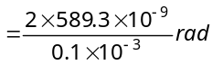 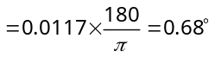
- (d) Distance between the first dark fringes on either side of central maxima = width of central maxima = 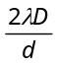= 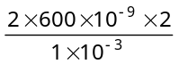 = 2.4 mm.
- (a) For second dark fringe 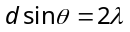 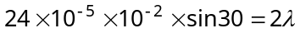
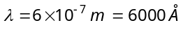
- (a) Position of n^{th} minima 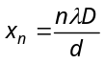 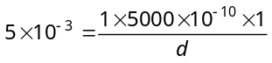 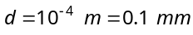.
- (c) In single slit experiment,
Width of central maxima (y) = 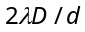 ⇒ 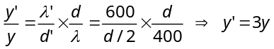.
- (d) By using 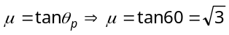, also 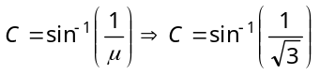
- (b) 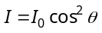= I₀ cos² 45 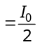
- (c) 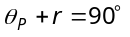 or r = 90º – θ_{P} = 90° – 53°4' = 36°56'.
- (a)
- (c) Intensity of polarized light from first polarizer 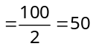 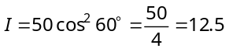
- (a) According to Brewster’s law, when a beam of ordinary light (i.e. unpolarised) is reflected from a transparent medium (like glass), the reflected light is completely plane polarised at certain angle of incidence called the angle of polarisation.
- (a) When the plane-polarised light passes through certain substance, the plane of polarisation of the light is rotated about the direction of propagation of light through a certain angle.

