- A particle is moving in a circle of radius with a uniform speed . is the centre of the circle and is a diameter. When passing through B the angular velocity of about and are in the ratio
(a) 1 : 1 (b) 1 : 2 (c) 2 : 1 (d) 4 : 1

- If the over bridge is concave instead of being convex, the thrust on the road at the lowest position will be
(a) 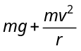 (b) 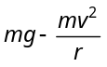 (c) 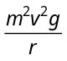 (d) 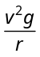

- An aircraft executes a horizontal loop with a speed of 150 m/s with its, wings banked at an angle of 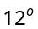. The radius of the loop is 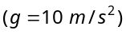
(a) 10.6 km (b) 9.6 km (c) 7.4 km (d) 5.8 km

- A motor cyclist moving with a velocity of 72 km/hour on a flat road takes a turn on the road at a point where the radius of curvature of the road is 20 meters. The acceleration due to gravity is 10 m/sec². In order to avoid skidding, he must not bend with respect to the vertical plane by an angle greater than
(a) 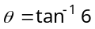 (b) 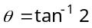 (c) 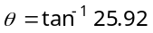 (d) 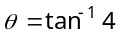

- A mass of 100 gm is tied to one end of a string 2 m long. The body is revolving in a horizontal circle making a maximum of 200 revolutions per min. The other end of the string is fixed at the centre of the circle of revolution. The maximum tension that the string can bear is (approximately)
(a) 8.76 N (b) 8.94 N (c) 89.42 N (d) 87.64 N

- What is the value of linear velocity, if 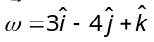 and 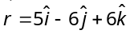
(a) 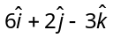 (b) 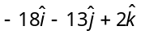 (c) 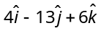 (d) 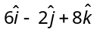

- A 100 kg car is moving with a maximum velocity of 9 m/s across a circular track of radius 30 m. The maximum force of friction between the road and the car is
(a) 1000 N (b) 706 N (c) 270 N (d) 200 N

- Three identical particles are joined together by a thread as shown in figure. All the three particles are moving in a horizontal plane. If the velocity of the outermost particle is v₀, then the ratio of tensions in the three sections of the string is

- (a) 3 : 5 : 7 (b) 3 : 4 : 5
l
l
l
O
A
B
C
(c) 7 : 11 : 6 (d) 3 : 5 : 6

- A bucket tied at the end of a 1.6 m long string is whirled in a vertical circle with constant speed. What should be the minimum speed so that the water from the bucket does not spill, when the bucket is at the highest position (Take 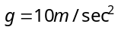)
(a) 4 m/sec (b) 6.25 m/sec (c)16 m/sec (d) None of the above

- The string of pendulum of length is displaced through 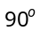 from the vertical and released. Then the minimum strength of the string in order to withstand the tension, as the pendulum passes through the mean position is a) (b) 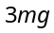 (c) 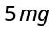 (d) 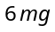

- A hollow sphere has radius 6.4 m. Minimum velocity required by a motor cyclist at bottom to complete the circle will be
(a) 17.7 m/s (b) 10.2 m/s (c) 12.4 m/s (d) 16.0 m/s

- As per given figure to complete the circular loop what should be the radius if initial height is 5 m
(a) 4 m
h = 5 m
(b) 3 m
(c) 2.5 m
(d) 2 m

- An aeroplane is flying horizontally with a velocity of 600 km/h at a height of 1960 m. When it is vertically at a point A on the ground, a bomb is released from it. The bomb strikes the ground at point B. The distance AB is
(a) 1200 m (b) 0.33 km (c) 3.33 km (d) 33 km

- A body is thrown horizontally from the top of a tower of height 5 m. It touches the ground at a distance of 10 m from the foot of the tower. The initial velocity of the body is (g = 10 ms^{–2})
(a) 2.5 ms^{–1} (b) 5 ms^{–1} (c) 10 ms^{–1} (d) 20 ms^{–1}

- The range of a particle when launched at an angle of 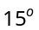 with the horizontal is 1.5 km. What is the range of the projectile when launched at an angle of 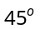 to the horizontal
(a) 1.5 km (b) 3.0 km (c)6.0 km (d) 0.75 km

- A cricketer hits a ball with a velocity  at 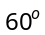 above the horizontal. How far above the ground it passes over a fielder 50 from the bat (assume the ball is struck very close to the ground)
(a) 8.2 m (b) 9.0 m (c) 11.6 m (d) 12.7 m

- A ball is projected with kinetic energy at an angle of to the horizontal. At the highest point during its flight, its kinetic energy will be
(a)Zero (b) 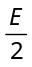 (c) 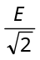 (d)

- A particle of mass is projected with velocity making an angle of with the horizontal. The magnitude of the angular momentum of the particle about the point of projection when the particle is at its maximum height is (where acceleration due to gravity)
(a) Zero (b) 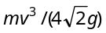 (c) 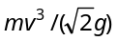 (d) 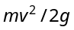

- A football player throws a ball with a velocity of 50 metre/sec at an angle 30 degrees from the horizontal. The ball remains in the air for 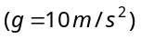
(a) 2.5 sec (b) 1.25 sec (c) 5 sec (d) 0.625 sec

- A ball is thrown from a point with a speed 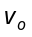 at an angle of projection . From the same point and at the same instant a person starts running with a constant speed 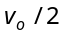 to catch the ball. Will the person be able to catch the ball? If yes, what should be the angle of projection
(a) Yes, 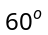 (b) Yes, 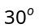 (c) No (d) Yes, 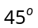

- The horizontal range of a projectile is 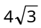 times its maximum height. Its angle of projection will be
(a) (b) (c) 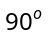 (d)

- The distance of the centres of moon and earth is D. The mass of earth is 81 times the mass of the moon. At what distance from the centre of the earth, the gravitational force will be zero
(a) 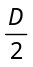 (b) 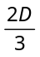 (c) 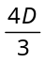 (d) 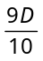

- Two planets have the same average density but their radii are 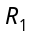 and 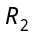. If acceleration due to gravity on these planets be 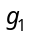 and 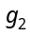 respectively, then
(a) 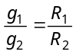 (b) 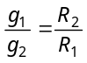 (c) 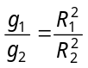 (d) 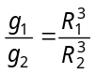

- R is the radius of the earth and is its angular velocity and 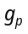 is the value of g at the poles. The effective value of g at the latitude 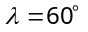 will be equal to
(a) 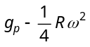 (b) 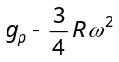 (c) 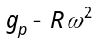 (d) 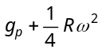

- The depth d at which the value of acceleration due to gravity becomes times the value at the surface, is [R = radius of the earth]
(a) 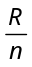 (b) 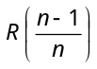 (c) 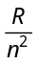 (d) 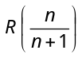

- At what height over the earth's pole, the free fall acceleration decreases by one percent (assume the radius of earth to be 6400 km)
(a) 32 km (b) 80 km (c) 1.253 km (d) 64 km

- The diameters of two planets are in the ratio 4 : 1 and their mean densities in the ratio 1 : 2. The acceleration due to gravity on the planets will be in ratio
(a) 1 : 2 (b) 2 : 3 (c) 2 : 1 (d) 4 : 1

- At what altitude in metre will the acceleration due to gravity be 25% of that at the earth's surface (Radius of earth = R metre)
(a) 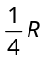 (b) R (c) 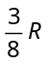 (d) 
- The change in potential energy, when a body of mass m is raised to a height nR from the earth's surface is (R = Radius of earth)
(a) 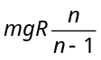 (b) nmgR (c) 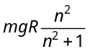 (d) 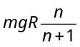

- The masses and radii of the earth and moon are 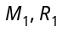 and 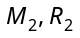 respectively. Their centres are distance d apart. The minimum velocity with which a particle of mass m should be projected from a point midway between their centres so that it escapes to infinity is
(a) 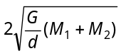 (b) 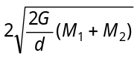 (c) 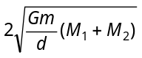 (d) 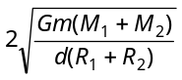

- If mass of earth is M, radius is R and gravitational constant is G, then work done to take 1 kg mass from earth surface to infinity will be
(a) 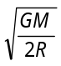 (b) 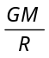 (c) 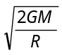 (d) 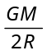

- Escape velocity of a body of 1 kg mass on a planet is 100 m/sec. Gravitational Potential energy of the body at the Planet is
(a) – 5000 J (b) – 1000 J (c) – 2400 J (d) 5000 J

- A body of mass m is placed on the earth’s surface. It is taken from the earth’s surface to a height . The change in gravitational potential energy of the body is
(a) 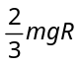 (b) 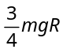 (c) 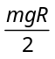 (d) 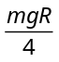

- A body of mass m kg. starts falling from a point 2R above the Earth’s surface. Its kinetic energy when it has fallen to a point ‘R’ above the Earth’s surface [R-Radius of Earth, M-Mass of Earth, G-Gravitational Constant]
(a) 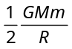 (b) 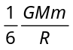 (c) 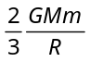 (d) 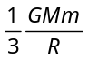

- The escape velocity for a rocket from earth is 11.2 km/sec. Its value on a planet where acceleration due to gravity is double that on the earth and diameter of the planet is twice that of earth will be in km/sec
(a) 11.2 (b) 5.6 (c) 22.4 (d) 53.6

- The escape velocity from the earth is about 11 km/second. The escape velocity from a planet having twice the radius and the same mean density as the earth, is
(a) 22 km/sec (b) 11 km/sec (c) 5.5 km/sec (d) 15.5 km/sec

- Four particles each of mass M, are located at the vertices of a square with side L. The gravitational potential due to this at the centre of the square is
(a) 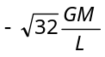 (b) 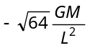 (c) Zero (d) 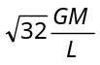

- The ratio of the K.E. required to be given to the satellite to escape earth's gravitational field to the K.E. required to be given so that the satellite moves in a circular orbit just above earth atmosphere is
(a) One (b) Two (c) Half (d) Infinity

- Two satellites A and B go round a planet P in circular orbits having radii 4R and R respectively. If the speed of the satellite A is 3V, the speed of the satellite B will be.
(a) 12 V (b) 6 V (c) 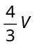 (d) 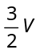

- The orbital velocity of an artificial satellite in a circular orbit just above the earth's surface is v. For a satellite orbiting at an altitude of half of the earth's radius, the orbital velocity is
(a) 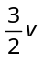 (b) 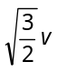 (c) 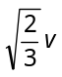 (d) 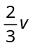

- A satellite with kinetic energy 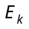 is revolving round the earth in a circular orbit. How much more kinetic energy should be given to it so that it may just escape into outer space
(a) (b) 2 (c) 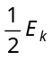 (d) 3

- Potential energy of a satellite having mass ‘m’ and rotating at a height of 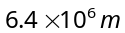 from the earth surface is
(a) 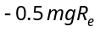 (b) 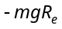 (c) 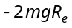 (d) 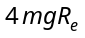

- Two satellites A and B go round a planet in circular orbits having radii 4R and R, respectively. If the speed of satellite A is 3v, then speed of satellite B is
(a) 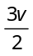 (b) 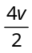 (c) (d)

- The largest and the shortest distance of the earth from the sun are and , its distance from the sun when it is at the perpendicular to the major axis of the orbit drawn from the sun
(a) 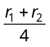 (b) 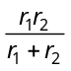 (c) 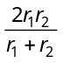 (d) 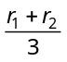

- The rotation period of an earth satellite close to the surface of the earth is 83 minutes. The time period of another earth satellite in an orbit at a distance of three earth radii from its surface will be
(a) 83 minutes (b) 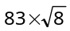 minutes (c) 664 minutes (d) 249 minutes

- A satellite of mass m is circulating around the earth with constant angular velocity. If radius of the orbit is 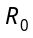 and mass of the earth M, the angular momentum about the centre of the earth is
(a) 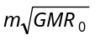 (b) 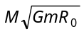 (c) 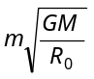 (d) 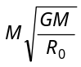

- A planet revolves around sun whose mean distance is 1.588 times the mean distance between earth and sun. The revolution time of planet will be
(a) 1.25 years (b) 1.59 years (c) 0.89 years (d) 2 years

- A satellite A of mass m is at a distance of r from the centre of the earth. Another satellite B of mass 2m is at a distance of 2r from the earth's centre. Their time periods are in the ratio of
(a) 1 : 2 (b) 1 : 16 (c) 1 : 32 (d) 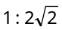

- The earth E moves in an elliptical orbit with the sun S at one of the foci as shown in figure. Its speed of motion will be maximum at the point
S
D
B
C
E
A

(a) C
(b) A
(c) B
(d) D

- The orbital angular momentum of a satellite revolving at a distance r from the centre is L. If the distance is increased to 16r, then the new angular momentum will be
(a) 16 L (b) 64 L (c)  (d) 4 L

