- (b) Angular velocity of particle P about point A,
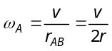
A
2r
r
v
B
C
P
Angular velocity of particle P about point C,
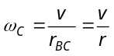
Ratio 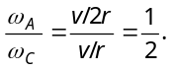
- (a) Thrust at the lowest point of concave bridge= 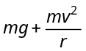
- (a) The angle of banking, 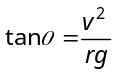 ⇒ 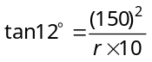 ⇒ 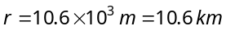
- (b) 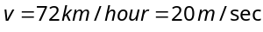 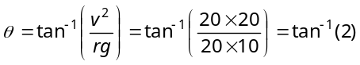
- (d) Maximum tension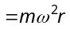= 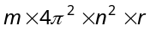 By substituting the values we get T_{max} 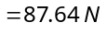
- (b) 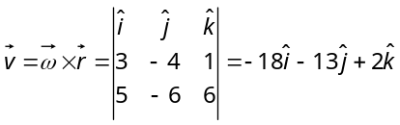
- (c) Maximum force of friction = centripetal force
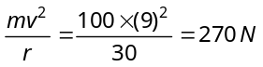
- (d) Let is the angular speed of revolution
O
T₁
A
T₂
B
T₃
C
l
l
l

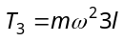
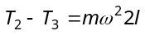 ⇒ 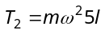
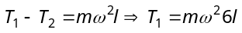
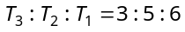
- (a) Critical velocity at highest point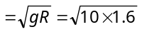=4m/s
- (b) 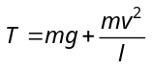 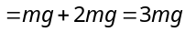 where 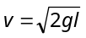 from 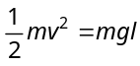
- (a) 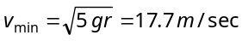
- (d) 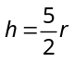 ⇒ 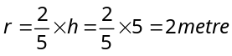
- (c) 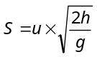 ⇒ 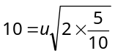 ⇒ 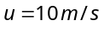
- (d)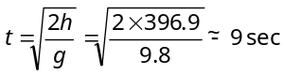and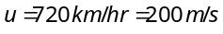 ∴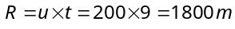
- (b) 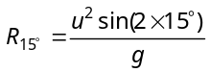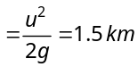
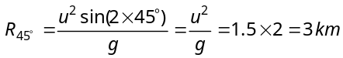
- (a) Horizontal component of velocity
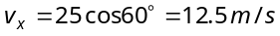
Vertical component of velocity
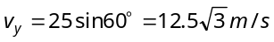
50 m
v = 25 m/s
60°
A
X
y
Y

Time to cover 50 m distance 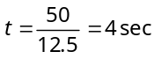
The vertical height y is given by
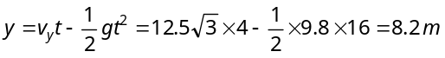
- (b) 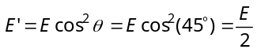
- (b)
- (c) Time of flight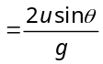=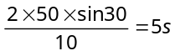
- (a) Person will catch the ball if its velocity will be equal to horizontal component of velocity of the ball.
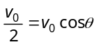⇒ 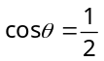 ⇒ 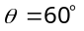
- (d) 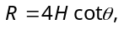if R =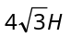then 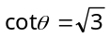⇒ 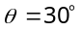
- (d)
m₁
m₂
x
d
P

Force will be zero at the point of zero intensity 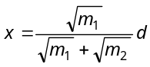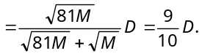
- (a) 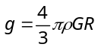. If = constant then 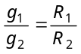
- (a) 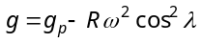=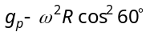 =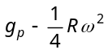
- (b) 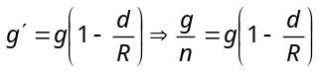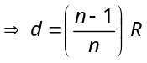
- (a) 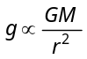∴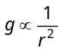or 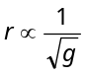
If g decrease by one percent then r should be increase by 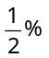i.e. R = 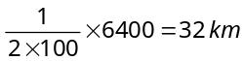
- (c) 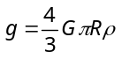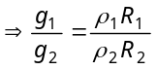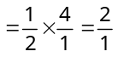
- (b) 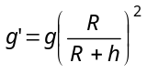⇒ 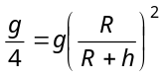⇒ 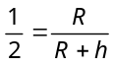
⇒∴
- (d) 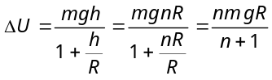
- (a) Gravitational potential at mid point
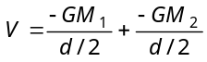
Now, 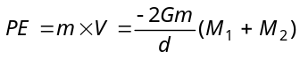
[m = mass of particle]
So, for projecting particle from mid point to infinity
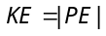
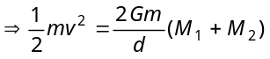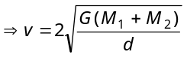
- (b) Potential energy of the 1 kg mass which is placed at the earth surface = 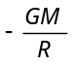
its potential energy at infinite = 0
∴ Work done = change in potential energy = 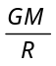
- (a) 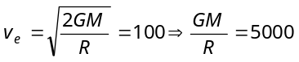
Potential energy 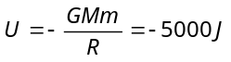
- (b) 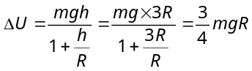
- (b) Potential energy 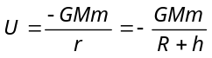
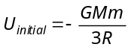 and 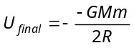
Loss in PE = gain in 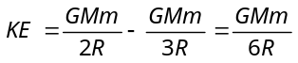

- (c) 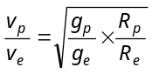= 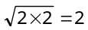
⇒ 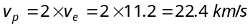
- (a) 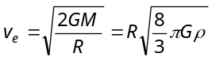∴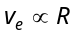 if ρ = constant
Since the planet having double radius in comparison to earth therefore the escape velocity becomes twice i.e. 22 km/s.

- (a) Potential at the centre due to single mass = 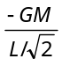
Potential at the centre due to all four masses
L√2
L
m
m
m
m
= 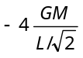 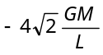
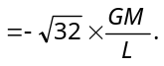
- (b) K.E. required for satellite to escape from earth's gravitational field 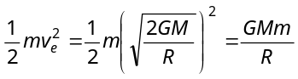
K.E. required for satellite to move in circular orbit
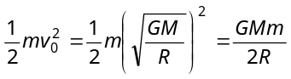
The ratio between these two energies = 2
- (b) 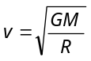⇒ 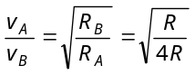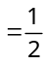∴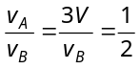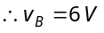
- (c) 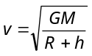
For first satellite , 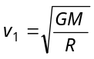
For second satellite 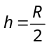, 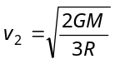
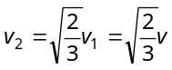

- (a) Binding energy = – kinetic energy
And if this amount of energy 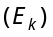 given to satellite then it will escape into outer space
- (a) Potential energy = 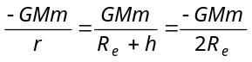
= 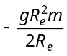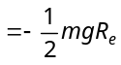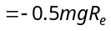
- (c) 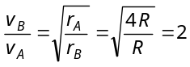
⇒ 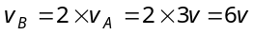
- (c) The earth moves around the sun is elliptical path. so by using the properties of ellipse
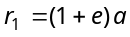 and 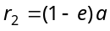
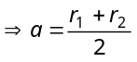 and 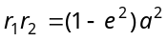
where a = semi major axis
b = semi minor axis
e = eccentricity
Now required distance = semi latusrectum 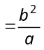
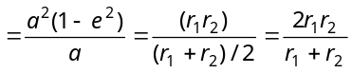
- (c) For first satellite 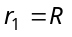 and 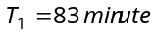
For second satellite 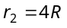
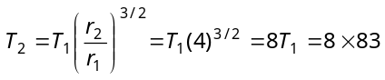=664 minutes
- (a) Angular momentum = Mass ×Orbital velocity ×Radius
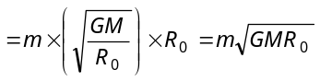
- (d)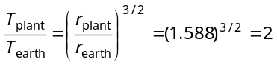 ∴ 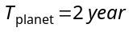
- (d)Mass of the satellite does not effects on time period
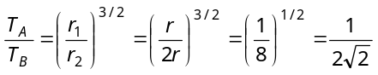
- (b)Speed of the earth will be maximum when its distance from the sun is minimum because constant
50. (d) 