Photo electric effect :
- The momentum of a photon ism/sec. Its frequency will be
(a) 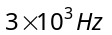 (b) 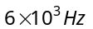 (c) 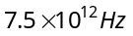 (d) 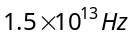

- The momentum of the photon of wavelength 5000Å will be
(a) m/sec (b) m/sec (c) m/sec (d) m/sec

- If the momentum of a photon is p, then its frequency is
(a) 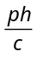 (b) 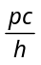 (c) 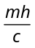 (d) 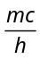

- An AIR station is broadcasting the waves of wavelength 300 meters. If the radiating power of the transmitter is 10 kW, then the number of photons radiated per second is
(a) 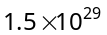 (b) 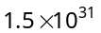 (c) 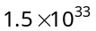 (d) 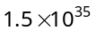

- A photon of wavelength 4400 Å is passing through vacuum. The effective mass and momentum of the photon are respectively
(a) 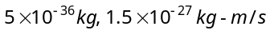 (b) 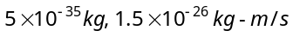
(c) Zero, 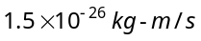 (d) 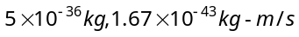

- A metal surface of work function 1.07 eV is irradiated with light of wavelength 332 nm. The retarding potential required to stop the escape of photo-electrons is
(a) 4.81 eV (b) 3.74 eV (c) 2.66 eV (d) 1.07 eV

- The work function of metal is 1 eV. Light of wavelength 3000 Å is incident on this metal surface. The velocity of emitted photo-electrons will be
(a) 10 m/sec (b) 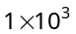m/sec (c) 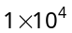m/sec (d) 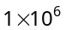m/sec

- The work function of a metal is J. When the metal surface is illuminated by the light of wavelength 6400 Å, then the maximum kinetic energy of emitted photo-electrons will be
(Planck's constant 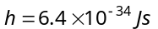)
(a) 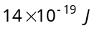 (b) 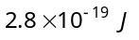 (c) 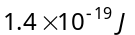 (d) 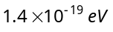

- In a photoelectric experiment for 4000 Å incident radiation, the potential difference to stop the ejection is 2 V. If the incident light is changed to 3000 Å, then the potential required to stop the ejection of electrons will be
(a) 2 V (b) Less than 2 V (c) Zero (d) Greater than 2 V

- A radio transmitter operates at a frequency of 880 kHz and a power of 10 kW. The number of photons emitted per second are
(a) 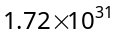 (b) 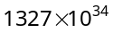 (c) 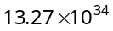 (d) 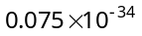

- Light of wavelength 4000 Å is incident on a sodium surface for which the threshold wave length of photo – electrons is 5420 Å. The work function of sodium is
(a) 4.58 eV (b) 2.29 eV (c) 1.14 eV (d) 0.57 eV

- The maximum wavelength of radiation that can produce photoelectric effect in a certain metal is 200 nm. The maximum kinetic energy acquired by electron due to radiation of wavelength 100 nm will be
(a) 12.4 eV (b) 6.2 eV (c) 100 eV (d) 200 eV

- Assuming photoemission to take place, the factor by which the maximum velocity of the emitted photoelectrons changes when the wavelength of the incident radiation is increased four times, is
(a) 4 (b) (c) 2 (d)

- When a point source of light is at a distance of one metre from a photo cell, the cut off voltage is found to be V. If the same source is placed at 2 m distance from photo cell, the cut off voltage will be
(a) V (b) V/2 (c) V/4 (d) 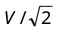

- The work function of a substance is 4.0 eV. The longest wavelength of light that can cause photoelectron emission from this substance is approximately
(a) 540 nm (b) 400 nm (c) 310 nm (d) 220 nm

- Work function of a metal is 2.1 eV. Which of the waves of the following wavelengths will be able to emit photoelectrons from its surface
(a) 4000 Å, 7500 Å (b) 5500 Å, 6000 Å (c)4000 Å, 6000 Å (d) None of these

- The work functions for sodium and copper are and . Which of them is suitable for a photocell with 4000 Å light
(a) Copper (b) Sodium (c) Both (d) Neither of them

- For intensity I of a light of wavelength 5000Å the photoelectron saturation current is 0.40 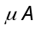 and stopping potential is 1.36 V, the work function of metal is
(a) 2.47 eV (b) 1.36 eV (c) 1.10 eV (d) 0.43 eV

- The work functions of metals A and B are in the ratio 1 : 2. If light of frequencies and 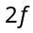 are incident on the surfaces of A and B respectively, the ratio of the maximum kinetic energies of photoelectrons emitted is (f is greater than threshold frequency of A, 2f is greater than threshold frequency of B)
(a) 1 : 1 (b) 1 : 2 (c) 1 : 3 (d) 1 : 4

- When a metal surface is illuminated by light of wavelengths 400 nm and 250 nm, the maximum velocities of the photoelectrons ejected are and respectively. The work function of the metal is (h = Planck’s constant, c = velocity of light in air)
(a) 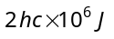 (b) 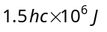 (c) 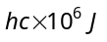 (d) 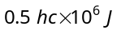

- Light of two different frequencies whose photons have energies and respectively, successively illuminates a metal of work function . The ratio of maximum kinetic energy of the emitted electron will be
(a) 1 : 5 (b) 1 : 4 (c) 1 : 2 (d) 1 : 1

- Sodium and copper have work functions 2.3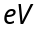and 4.5 respectively. Then the ratio of their threshold wavelengths is nearest to
(a) 1: 2 (b) 4 : 1 (c) 2 : 1 (d) 1 : 4

- Two identical photo-cathodes receive light of frequencies and . If the velocities of the photo electrons (of mass ) coming out are respectively and 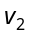, then
(a) 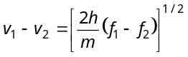(b) 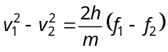 (c) 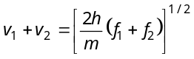 (d) 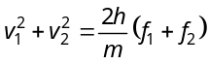

- A photosensitive metallic surface has work function 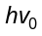. If photons of energy 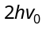 fall on this surface the electrons come out with a maximum velocity of 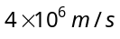. When the photon energy is increases to 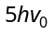 then maximum velocity of photo electron will be
(a) 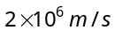 (b) 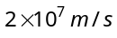 (c) 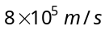 (d) 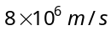

- A photocell is illuminated by a small bright source placed 1 m away. When the same source of light is placed 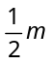 away, the number of electrons emitted by photo cathode would
(a) Decrease by a factor of 2 (b) Increase by a factor of 2
(c) Decrease by a factor of 4 (d) Increase by a factor of 4

Matter waves
- If the de-Broglie wavelengths for a proton and for a particle are equal, then the ratio of their velocities will be
(a) 4 : 1 (b) 2 : 1 (c) 1 : 2 (d) 1 : 4

- An electron of mass m when accelerated through a potential difference V has de-Broglie wavelength . The de-Broglie wavelength associated with a proton of mass M accelerated through the same potential difference will be
(a) 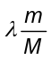 (b) 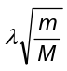 (c) 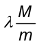 (d) 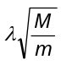

- What will be the ratio of de-Broglie wavelengths of proton and particle of same energy
(a) 2 : 1 (b) 1 : 2 (c) 4 : 1 (d) 1 : 4

- The energy that should be added to an electron, to reduce its de-Broglie wavelengths from 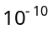m to 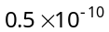m, will be
(a) Four times the initial energy (b) Thrice the initial energy
(c) Equal to the initial energy (d) Twice the initial energy

- The de-Broglie wavelength of an electron having of energy is nearly
(1eV = 1.6 × 10^{–19} J, Mass of electron = 9 × 10^{–31}kg Plank’s constant = 6.6 × 10^{–34} J-sec)
(a) 140 Å (b) 0.14 Å (c) 14 Å (d) 1.4 Å

- The de-Broglie wavelength of a particle moving with a velocity 2.25 × 10⁸ m/s is equal to the wavelength of photon. The ratio of kinetic energy of the particle to the energy of the photon is (velocity of light is 3 × 10⁸ m/s)
(a) 1/8 (b) 3/8 (c) 5/8 (d) 7/8

- The de-Broglie wavelength of a particle accelerated with 150 volt potential is 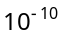m. If it is accelerated by 600 volts p.d., its wavelength will be
(a) 0.25 Å (b) 0.5 Å (c) 1.5 Å (d) 2 Å

- When the momentum of a proton is changed by an amount P₀, the corresponding change in the de-Broglie wavelength is found to be 0.25%. Then, the original momentum of the proton was
(a) p₀ (b) 100 p₀ (c) 400 p₀ (d) 4 p₀

- The de-Broglie wavelength of a neutron at 27ºC is λ. What will be its wavelength at 927ºC
(a) λ / 2 (b) λ / 3 (c) λ / 4 (d) λ / 9

- A proton and an α-particle are accelerated through a potential difference of 100 V. The ratio of the wavelength associated with the proton to that associated with an α-particle is
(a) 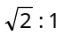 (b) (c) 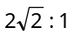 (d) 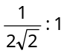

- de-Broglie wavelength of a body of mass 1 kg moving with velocity of 2000 m/s is
(a) 3.32 × 10^{–27} Å (b) 1.5 × 10⁷ Å (c) 0.55 × 10^{–22} Å (d) None of these

- If the kinetic energy of a free electron doubles, its de-Broglie wavelength changes by the factor
(a) 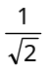 (b) 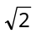 (c) (d) 2

Atoms:
- In the following atoms and molecules for the transition from n= 2 to n = 1, the spectral line of minimum wavelength will be produced by
(a) Hydrogen atom (b) Deuterium atom (c)Uni-ionized helium (d)di-ionized lithium

- The energy required to knock out the electron in the third orbit of a hydrogen atom is equal to
(a) 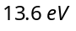 (b) 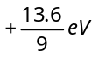 (c) 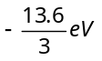 (d) 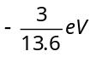

- An electron has a mass of 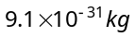. It revolves round the nucleus in a circular orbit of radius 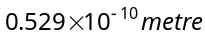at a speed of 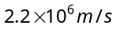. The magnitude of its linear momentum in this motion is
(a) 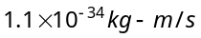 (b) 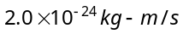 (c) 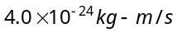 (d) 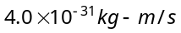

- The energy required to remove an electron in a hydrogen atom from state is
(a) 13.6 eV (b) 1.36 eV (c) 0.136 eV (d) 0.0136 eV

- Every series of hydrogen spectrum has an upper and lower limit in wavelength. The spectral series which has an upper limit of wavelength equal to 18752 Å is
(a) Balmer series (b) Lyman series (c)Paschen series (d) Pfund series
(Rydberg constant 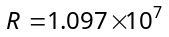per metre)

- Ionization potential of hydrogen atom is 13.6 V. Hydrogen atoms in the ground state are excited by monochromatic radiation of photon energy 12.1 eV. The spectral lines emitted by hydrogen atoms according to Bohr's theory will be (a) One (b) Two (c) Three (d) Four

- Energy levels A, B, C of a certain atom corresponding to increasing values of energy i.e. 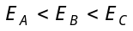. If 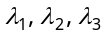are the wavelengths of radiations corresponding to the transitions C to B, B to A and C to A respectively, which of the following statements is correct
λ₁
λ₂
λ₃
C
B
A
(a) 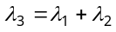 (b) 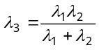
(c) 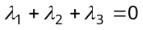 (d) 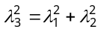

- The ratio of the energies of the hydrogen atom in its first to second excited state is
(a) 1/ 4 (b) 4/9 (c) 9/ 4 (d) 4

- An electron jumps from the 4th orbit to the 2nd orbit of hydrogen atom. Given the Rydberg's constant 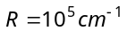. The frequency in Hz of the emitted radiation will be
(a) 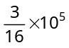 (b) 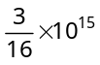 (c) 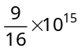 (d) 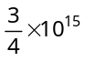

- If the wavelength of the first line of the Balmer series of hydrogen is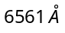, the wavelength of the second line of the series should be
(a) 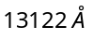 (b) 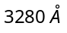 (c) 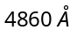 (d) 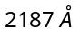
2E
4/3E
E
- The following diagram indicates the energy levels of a certain atom when the system moves from 2E level to E, a photon of wavelength is emitted. The wavelength of photon produced during its transition from 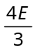 level to E i
(a) 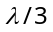 (b) 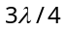 (c) 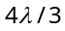 (d) 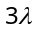

- If m is mass of electron, v its velocity, r the radius of stationary circular orbit around a nucleus with charge Ze, then from Bohr's first postulate, the kinetic energy 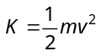of the electron in C.G.S. system is equal to
(a) 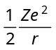 (b) 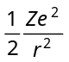 (c) 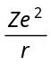 (d) 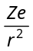

- In any Bohr orbit of the hydrogen atom, the ratio of kinetic energy to potential energy of the electron is
(a) 1/2 (b) 2 (c) 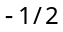 (d) – 2

- The figure indicates the energy level diagram of an atom and the origin of six spectral lines in emission (e.g. line no. 5 arises from the transition from level B to A). The following spectral lines will also occur in the absorption spectrum
1
2
3
4
5
6
X
A
B
C

(a) 1, 4, 6 (b) 4, 5, 6
(c) 1, 2, 3 (d) 1, 2, 3, 4, 5, 6

- The ratio of the frequencies of the long wavelength limits of Lyman and Balmer series of hydrogen spectrum is
(a) 27 : 5 (b) 5 : 27 (c) 4 : 1 (d) 1 : 4

- Hydrogen atoms are excited from ground state of the principal quantum number 4. Then the number of spectral lines observed will be
(a) 3 (b) 6 (c) 5 (d) 2

- Hydrogen atom excites energy level from fundamental state to n = 3. Number of spectrum lines according to Bohr, is
(a) 4 (b) 3 (c) 1 (d) 2

- The wavelength of the energy emitted when electron come from fourth orbit to second orbit in hydrogen is 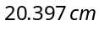. The wavelength of energy for the same transition in 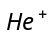is
(a) 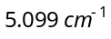 (b) 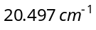 (c) 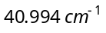 (d) 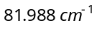

- The wavelength of radiation emitted is 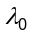when an electron jumps from the third to the second orbit of hydrogen atom. For the electron jump from the fourth to the second orbit of the hydrogen atom, the wavelength of radiation emitted will be
(a) 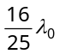 (b) 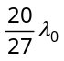 (c) 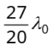 (d) 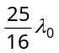

- When an electron in hydrogen atom is excited, from its 4th to 5th stationary orbit, the change in angular momentum of electron is (Planck’s constant: 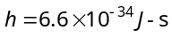)
(a) 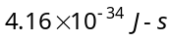 (b) 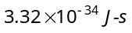 (c) 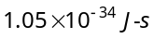 (d) 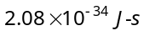

- The first member of the Paschen series in hydrogen spectrum is of wavelength 18,800 Å. The short wavelengths limit of Paschen series is
(a) 1215 Å (b) 6560 Å (c) 8225 Å (d) 12850 Å

- The ratio of the wavelengths for 2 → 1 transition in Li⁺⁺, He⁺ and H is
(a) 1 : 2 : 3 (b) 1 : 4 : 9 (c) 4 : 9 : 36 (d) 3 : 2 : 1

- Which state of triply ionised Baryllium 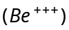 has the same orbital radius as that of the ground state of hydrogen
(a) n = 4 (b) n = 3 (c) n = 2 (d) n = 1

- The diagram shows-the energy levels for an electron in a certain atom. Which transition shown represents the emission of a photon with the most energy
n = 4
n = 3
n = 2
n = 1
I
II
III
IV

(a) I (b) II
(c) III (d) IV

