Detailed Solutions:
- (d) 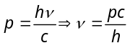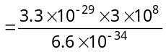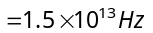
- (a) 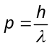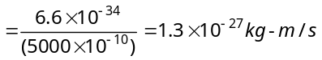
- (b) 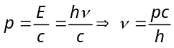
- (b) 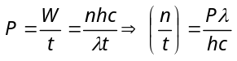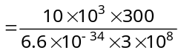 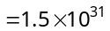
- (a) 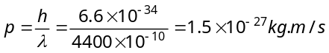 and mass 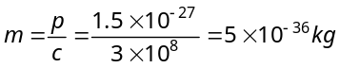
- (c) Energy of incident light 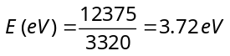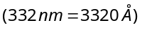
According to the relation 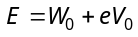 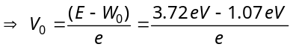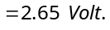
- (d) 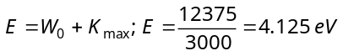 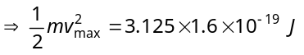
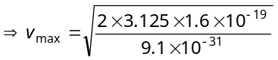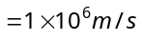
- (c) 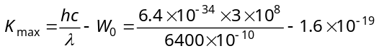 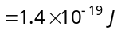
- (d) According to Einstein's photoelectric equation 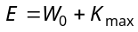 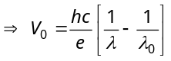 Hence if λ decreases 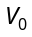 increases.
- (a) Number of photons emitted per second 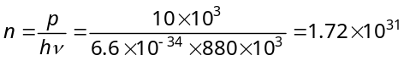
- (b) 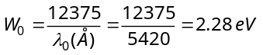
- (b) 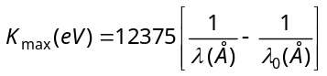 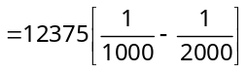 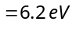
- (d) 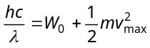 Assuming 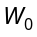 to be negligible in comparison to 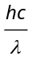
i.e. 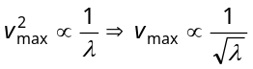. (On increasing wavelength λ to 4λ, v_{max} becomes half).
- (a) By changing distance of source, photoelectric current changes. But there is no change in stopping potential.
- (c) 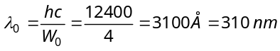
- (d) Threshold wavelength 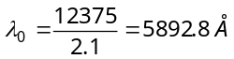
- (b) Threshold wavelength for Na, 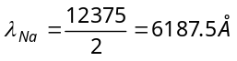 Also 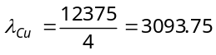
Since 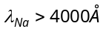; So Na is suitable.
- (c) By using 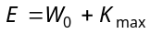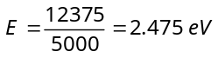 and 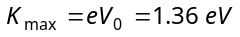 So 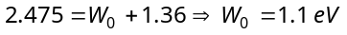.
- (b) …..(i)
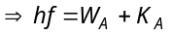 …..(ii) and 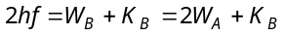 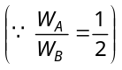
Dividing equation (i) by (ii) 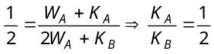
- (a) By using 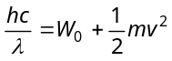
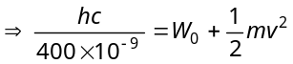 …..(i) and 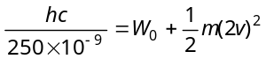 …..(ii)
On solving (i) and (ii) 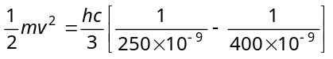 …..(iii) From equation (i) and (iii) 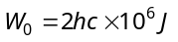.
- (b) By using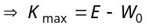 Hence, 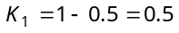 and 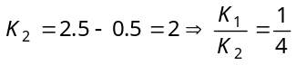.
- (c) 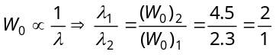.
- (b) Using Einstein photoelectric equation
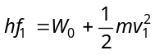 …..(i)
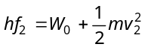 …..(ii) 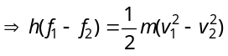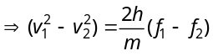
- (d) From 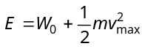
⇒ 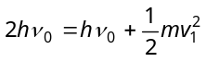 ⇒ 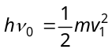 .....(i) and 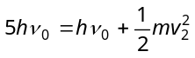 ⇒ 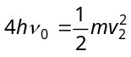 .....(ii)
Dividing equation (ii) by (i) 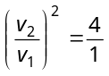 ⇒ 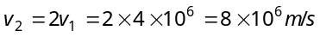
- (d) Number of photoelectrons ∝ 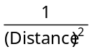.
- (a) 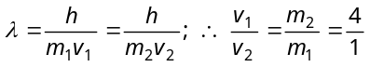
- (b) 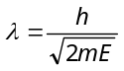 ⇒ 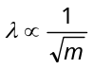 (E = same)
- (a) 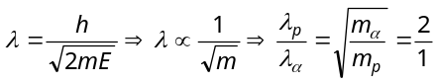
- (b) 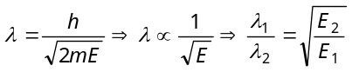 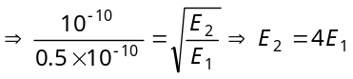 Hence added energy 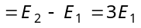
- (d) 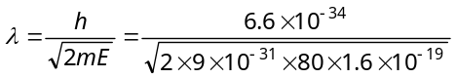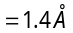
- (b) 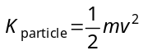 also 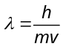
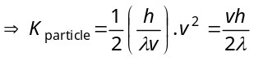 ...(i) 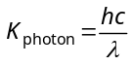 ...(ii)
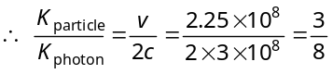
- (b) By using 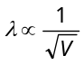 ⇒ 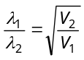 ⇒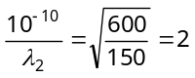 ⇒ λ₂ = 0.5 Å.
- (c) 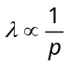 ⇒ 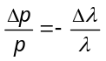 ⇒ 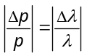 ⇒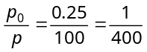 ⇒ p = 400 p₀ .
- (a) 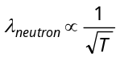 ⇒ 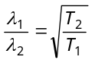 ⇒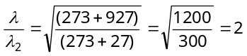 ⇒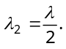
- (c) 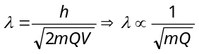 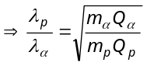 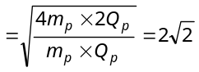
- (a) 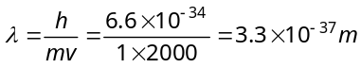 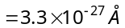
- (a) 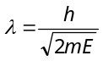 ⇒ 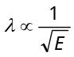.

Detailed Solutions :
- (d) 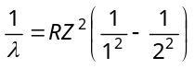 For di-ionised lithium the value of Z is maximum.
- (b) Energy required to knock out the electron in the n^{th} orbit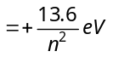 ⇒ 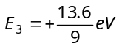.
- (b) Linear momentum 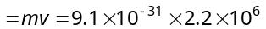 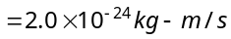
- (c) Energy required 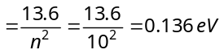
- (c) 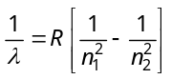 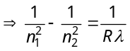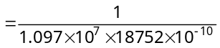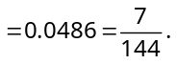 But
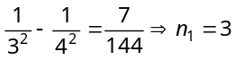 and n₂ = 4 (Paschen series)

- (c) Final energy of electron 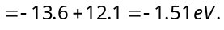 which is corresponds to third level i.e. . Hence number of spectral lines emitted 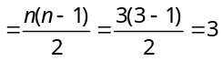
λ₁
λ₂
λ₃
C
B
A
- (b) Let the energy in A, B and C state be E_{A}. E_{B} and E_{C}, then from the figure
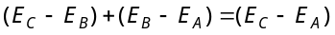or 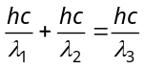
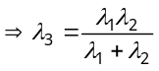
- (c) First excited state i.e. second orbit (n = 2) Second excited state i.e. third orbit (n = 3)
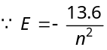 ⇒ 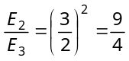
- (c) 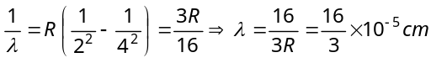 Frequency 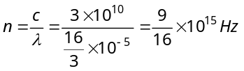
- (c) The wavelength of spectral line in Balmer series is given by 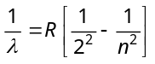
For first line of Balmer series, n = 3 ⇒ 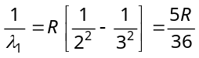; For second line n = 4.
⇒ 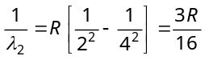 ∴ 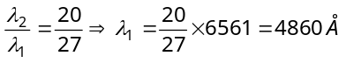
- (d) 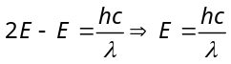 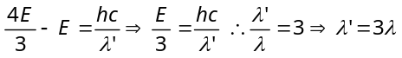
- (a) In the revolution of electron, coulomb force provides the necessary centripetal force
⇒ 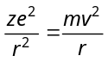 ⇒ 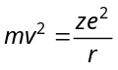
r
e
+
∴ K.E.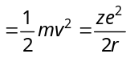
- (c) 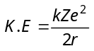 and 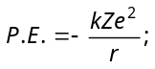 ∴ 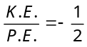.
- (c) The absorption lines are obtained when the electron jumps from ground state (n = 1) to the higher energy states. Thus only 1, 2 and 3 lines will be obtained.
- (a) For Lyman series
n=6
n=5
n=4
n=3
n=2
n=1
E₂
E₁
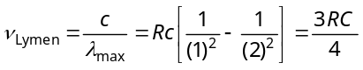
For Balmer series
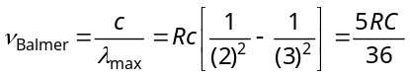 ∴ 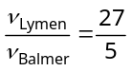

- (b) Number of spectral lines 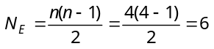
- (b) No. of lines 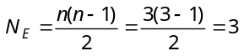
- (a) 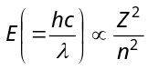 ⇒ 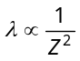 Hence 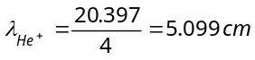
- (b) ⇒ 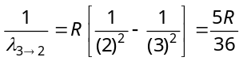 and 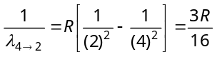
∴ 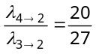 ⇒ 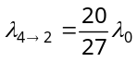
- (c) Change in the angular momentum
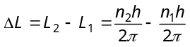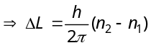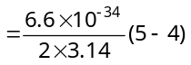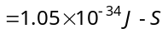
- (c) For Paschen series 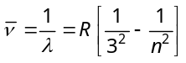 ; n=4, 5, 6....
For first member of Paschen series n = 4
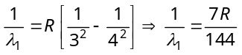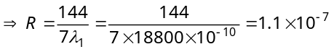
For shortest wave length
So 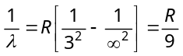 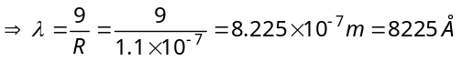
- (c) 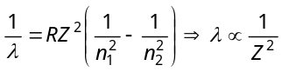 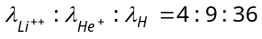
- (c) Radius of n^{th} orbit for any hydrogen like atom
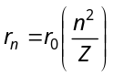 (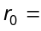radius of first orbit of 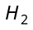-atom) If 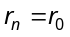 ⇒ 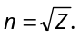 For Be⁺⁺⁺, Z = 4 ⇒ n = 2
- (c) Emitted energy 

