MASTERS PRE-UNIVERSITY COLLEGE, HASSAN 573201.
PRACTICE QUESTIONS
Subject: BIOLOGY Reproduction in Organisms

- Whatever be the life span, death of every individual organisms is a certainty, i.e no individual is immortal,expect
- Human beings b) amoeba and paramoecium c) single called organisms d) both B and C
- Match the columns I and II and choose the choose the correct combination from the options given
a) b-1, a-2,e-3,c-4,d-5,f-6
 | Column I |  | Column II
1. | Drosophila | a. | 1-2 weeks
2 | butterfly | b. | 2 weeks
3 | Crow | c. | 15 years
4 | Parrot | d. | 60 years
5 | Tortoise | e. | 140years
6 | crocodile | f. | 100-150 years
- a-1,b-2,c-3,e-4,f-5,d-6
- a-1,b-2,e-3,c-4,d-5,f-6
- b-1,a-2,c-3,e-4,f-5,d-6
- In the life span of any organism there is a cycle of
- Birth, growth and death
- Birth , fertilisation and death
- Juvenile ,reproduction and senescence
- Pre-fertilization, fertilisation and post-fertilisation
- Read the following statements and find out the incorrect statement
- Asexual reproduction is common among single-called organisms and in plants and animals with relatively complex organisations.
- In yeast, the division is unequal and small buds are produced that remain attached initially to the parent cell which eventually gets separated and mature into new yeast organism (cells).
- Vegetative reproduction is also a type of asexual reproduction.
- While in animals and other simple organisms the term vegetative reproduction is used unambiguously, in plants the term asexual reproduction is frequently used.
- Water hyacinth is also called ‘terror of Bengal’.
- A and d b) b and c c) a and e d) b and d
- In plants the vegetative progration such as runner, rhizome, sucker tuber, offset,bulb are all capable of giving rise to new offspring. These structures are called
- Clones b) grafts c) vegetative propagules d) adventitious buds
- Recognise the figure and find out the correct matching
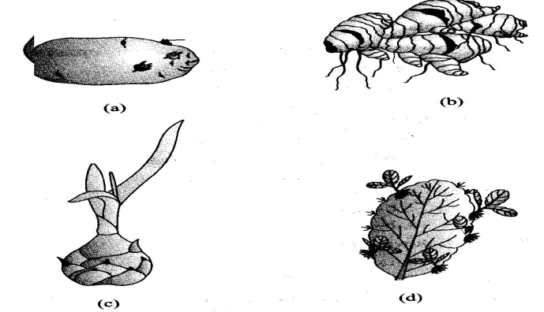
- A-rhizome, b-eyes, c-leaf buds, d- bulbils
- B-rhizome, a-eyes, d-leaf buds, c- bulbils
- c-rhizome, d-eyes, a-leaf buds, b- bulbils
- b-rhizome, a-eyes, c-leaf buds, d- bulbils
- in potato ,sugarcane, banana ,ginger and dahlia the new planets invariably arises from
- the nodes present in the modified stems
- the nodes present in the modified roots
- the internodes presents in the modified stems
- the margin of the leaves
- In broyophyllum, the buds that arises from the notches of margins of leaves are called
- Apical buds b) axiliary buds
c) adventitious buds d) terminal buds
- Match the columns and select the correct options
 | Column I |  | Column II
a | Gemmule | p | Agave
b | Leaf buds | q | Penicillium
c | Bulbil | r | Water hyacinth
d | Offset | s | Sponges
e | conidia | t | bryophyllum
- a-s, b-t,c-p,d-r,e-q b) a-s, b-r,c-q,d-p,e-t c) a-r, b-t,c-s,d-q,e-p d) a-s, b-p,c-t,d-r,e-q
- which is not an example of vegetative propagule in angiosperms?
- Zoospores of chlamydomonas b) Eyes of potato
- Rhizome of ginger d) Bulbil of agave
- In several fungi and plants the bisexual condition is denoted by
- Homothallic and monoecious
- Heterothallic and monoecious
- Homothallic and dioecious
- d) Heterothallic and dioecious
- if male (staminate) and female (pistillate) flowers are present on the same plant /individual this condition is called
- Monoecious b) dioecious c) unisexual d) bisexual
- Organisms belonging of pteridophytes, gymnosperms, angiosperms and most of the animals including human being
- Produce gametes by meiosis
- Produce gametes by mitosis
- Have diploid parental body
- Both A and C
- As compared to the sexual reproduction , the sexual reproduction is
- Elaborate, complex and slow process
- Elaborate ,simple and fast process
- Diffused, complex and slow process
- Elaborate, simple and fast process
- all organisms have to reach a certain stage of growth and maturity in their life, before they can reproduce sexually. That period of growth is called the
- Reproductive phase
- b) Senescent phase
- Vegetative phase in animals and juvenile phase in plants
- Vegetative phase in plants and juvenile phase in animals
- In some algae, the two gametes are so similar in appearance that is not possible to categorise them into male and female gametes. These gametes are called
- Isogametes b) heterogametes c) homogametes d) both A and C
- match the columns I and II and choose the correct combination from the options given
 | Name |  | Chromosome number  In gamete
1 | Butterfly | a. | 6
2 | Housefly | b. | 39
3 | Dog | c. | 21
4 | Cat | d. | 19
5 | Rat | e. | 190
- a-1 ,b-2,c-3 ,e-4,d-5
- b-1,e-2,d-3,c-4,a-5
- e-1,a-2,b-3,d-4,c-5
- e-1,a-2,c-3,b-4,d-5
- An angiospermic plants starts producing flower. This is the beginning of
- Juvenile phase b) vegetative phase c) reproductive phase d) senescent phase
- Strobilanthus kunthiana flowers once in
- 50-100 years b) 6 years c) 12 years d) 18 years
- Many mammals,especially those living in natural, wild conditions exhibit reproductive cycles only during favourable seasons in their reproductive phase and are therefore called
- Continuous breeders b) seasonal breeders c) reflex breeders d) spontaneous breeders
- Recognise the figure and find out the correct matching
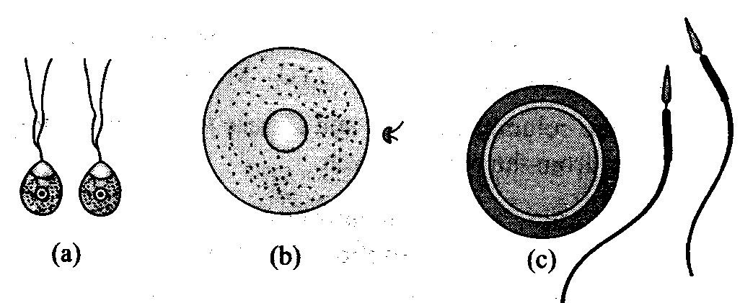

- a-heterogametes of cladophora ,b-heterogametes of homo sapiens,c-isogametes of fucus
- a-isogametes of fucus, b-heterogamtes of cladophora,c-heterogametes of humans
- a-isogametes of cladophora , b-heterogametes of homo sapiens ,a-heterogametes of fucus
- a-isogametes of cladophora , b-heterogametes of fucus , a- heterogametes of human being
- The sequential events in the sexual reproduction may be grouped into
- Two stages gametogenesis and gamete transfer
- Three stages gametogenesis and gamete transfer and fertilisation
- Two stages gametogenesis and gamete embryogenesis
- Three stages –pre fertilisation, fertilisation and post fertilisation events
- Which of the following group uses water as medium for gamete transport ?
- Algae b) bryophytes c) pteridophytes d) gymnosperms
- a,b and c b) b, c and d c) c,d and e d) b and c only
- The most vital and critical event of the sexual reproduction is
- Gamete formation b) gamete transport
c) gametic fusion d) embryogenesis
- Which is the vital link that ensures continuity of species between organisms of one generation and the next ?
- Sexual reproduction b) embryo c) zygote d) fertilisation
- During embryogenesis ,zygote undergoes
- Cell division b) cell differentiation c) meiosis /reduction division d) both A and B
- Recognise the figure and find out the correct matching
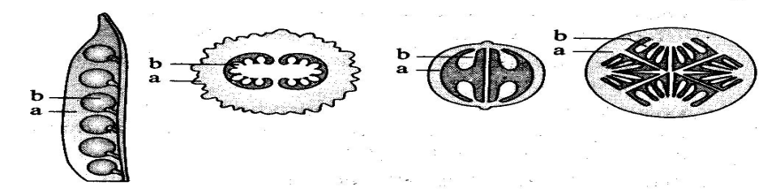

- A-testa, b-tegmen b) a-seed, coat, b-seed c) a-fruit , b-seed d) a- pericarp , b-seed
- Fertilised eggs covered by calcareous shells are found in
- Fishes and amphibians b) Reptiles, birds and mammals
- Amphibians, reptiles and birds d) Reptiles and birds
- Which is incorrect about flowering plant
- After fertilisation the ovary develops into fruit and ovules develops into seed
- The ovary wall after syngamy converted into pericarp which is protective in function
- The zygote is formed inside the ovule
- None of the above
- External water is not required for fertilisation of
- Pteridophytes b) bryophytes c) thallophytes d) spermatophytes

