Detailed Solutions :
Electrical resistance , Ohms law and conductivity :
- (a) Number of electrons flowing per second 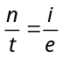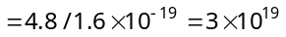
- (a) 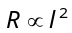 ⇒ 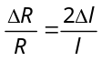 ⇒ 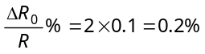
- (a) Resistivity of some material is its intrinsic property and is constant at particular temperature. Resistivity does not depend upon shape.
- (d) 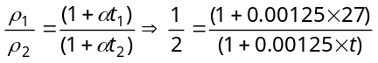 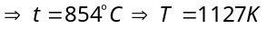
- (b) i = qν 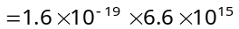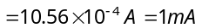
- (b) Net current 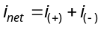
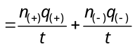
i_{net}
+2e
+
–
– e
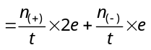
= 3.2 × 10¹⁸ × 2 × 1.6 × 10^{–19} + 3.6 × 10¹⁸ × 1.6 × 10^{–19} = 1.6 A (towards right)
100 cm
1 cm
1 cm
- (b) Length l = 1 cm 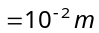
Area of cross-section A = 1 cm × 100 cm
= 100 cm² = 10^{–2} m²
Resistance R = 3 × 10^{–7} 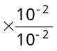= 3 × 10^{–7} Ω
- (c) 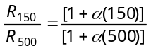. Putting 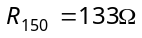 and 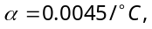 we get 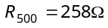
- (c) 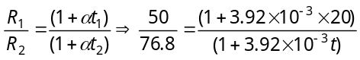 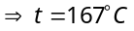
- (c) From 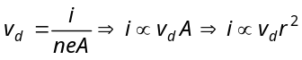
- (d) 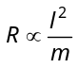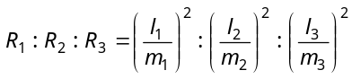 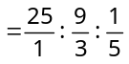 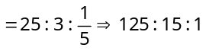.
- (b) 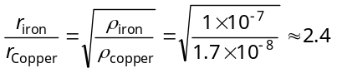.
- (d) 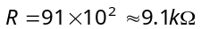.
- (d) For conductors, resistance ∝ Temperature and for semi-conductor, resistance ∝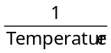
- (c) 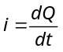 ⇒ 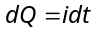 ⇒ 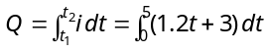 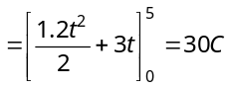
- (a) 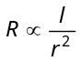. For highest resistance 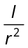 should be maximum, which is correct for option (a)
- (c) The given circuit can be simplified as follows
A
B
C
D

∴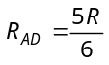
- (a) Initially : Resistance of given cable
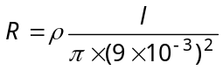 ... (i)
Finally : Resistance of each insulated copper wire is
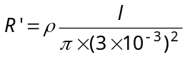. Hence equivalent resistance of cable 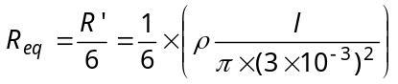….(ii)
l
ρ
9 mm
l
ρ

On solving equation (i) and (ii) we get R_{eq} = 7.5 Ω

Different measuring instruments :
- (d) 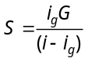 ⇒ 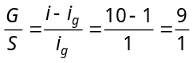
- (c) Shunt resistances 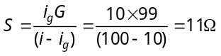
- (a) Potential gradient = Change in voltage per unit length ∴ 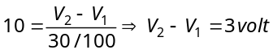
- (a) 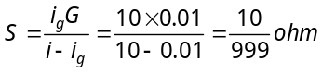
- (a) Wheatstone bridge is balanced, therefore 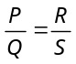 or 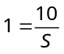 ⇒ 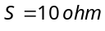
- (b) 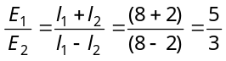
- (d) 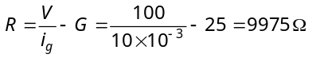
- (a) 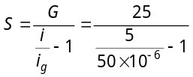 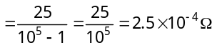
998 Ω
i
+
–
2Ω
2V
V
- (c) Error in measurement = Actual value – Measured value

Actual value = 2V
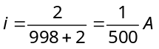 Since ⇒ 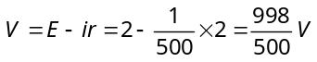
∴ Measured value 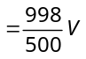 ⇒ Error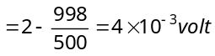
- (b) In general, ammeter always reads less than the actual value because of its resistance.
- (b) 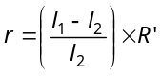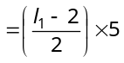 ... (i) and 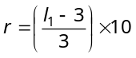 ... (ii)
On solving (i) and (ii) r = 10 Ω
- (b) 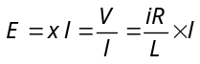⇒ 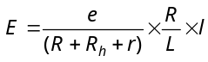 ⇒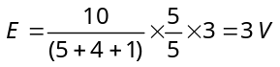
- (c) 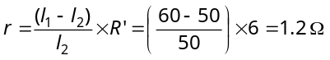
- (c) Potential gradient 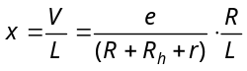 ⇒ 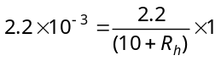 ⇒ 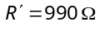
- (c) Total resistance of the circuit 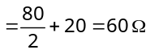
⇒ Main current 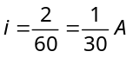
Combination of voltmeter and 80Ω resistance is connected in series with 20Ω, so current through 20Ω and this combination will be same 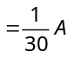.
Since the resistance of voltmeter is also 80Ω, so this current is equally distributed in 80Ω resistance and voltmeter (i.e.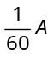through each)
P.D. across 80Ω resistance 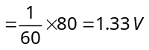
- (a) 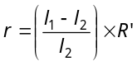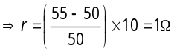.
- (c) 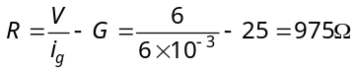(In series).
5V
C
6Ω
4Ω
X
6Ω
A
B
G
- (c)
Resistance of the part AC
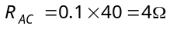 and 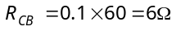
In balanced condition 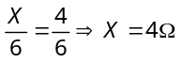
Equivalent resistance 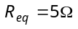 so current drawn from battery 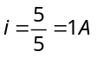.
- (d) 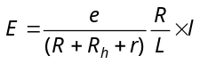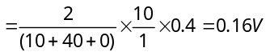.
Grouping of resistors :
- (c) The given circuit can be redrawn as follows
5Ω
5Ω
5Ω
C
D
A
5Ω
5Ω
5Ω

B

2/3V

2/3V

2/3V

2V

C

A

For identical resistances, potential difference distributes equally among all. Hence potential difference across each resistance is 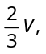 and potential difference between A and B is 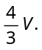

- (c) 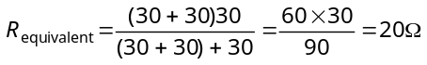 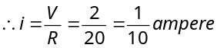
A
R₂ = 2Ω
R
B
X
Y
R₁ = 1Ω
- (c) Let the resultant resistance be R. If we add one more branch, then the resultant resistance would be the same because this is an infinite sequence.
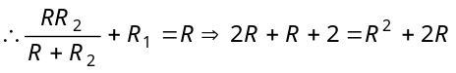
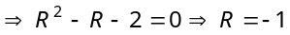 or 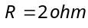
A
B
3Ω
3Ω
3Ω
- (d) The network can be redrawn as follows ⇒ 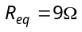
- (d) Three resistances are in parallel.
∴ 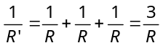 The equivalent resistance 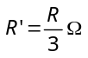
- (c)

- (c) Current through 6Ω resistance in parallel with 3Ω resistance = 0.4 A
So total current = 0.8 + 0.4 = 1.2 A
Potential drop across 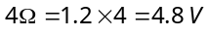
- d) After simplifying the network, equivalent resistance obtained between A and B is 8Ω.
- (c)
1Ω
1Ω
1Ω
1Ω
1Ω
A
B

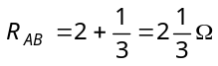.
- (b) By balanced Wheatstone bridge condition 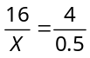
⇒ 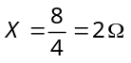

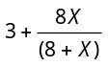
- (c) Potential difference between B and D is zero, it means Wheatstone bridge is in balanced condition
B
X
C
4Ω
6Ω
15Ω
15Ω
4Ω
D
A
3Ω
8Ω
6Ω
6Ω
4Ω
6Ω
18Ω
21Ω

So ⇒ 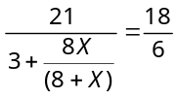⇒
- (d) The equivalent circuits are as shown below
B
D
A
C
⇒
C
B
A
D
2Ω
2Ω
2Ω
2Ω
B
D
A
C
⇒

Clearly, the circuit is a balanced Wheatstone bridge. So effective resistance between A and B is 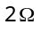.
- (c)
R
R
R
R
R
R
R
R
R
R
R
R
R
A
B
⇒
2R/3
2R/3
2R/3
R
B
A
2R/3

Hence 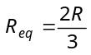.
- (c) Given circuit can be redrawn as follows
1.5Ω
6Ω
3Ω
2Ω
6V
⇒
1.5Ω
3Ω
6V
1.5Ω
3Ω
6V
3Ω
⇒

⇒ 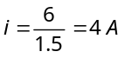
- (c) The voltmeter is assumed to have infinite resistance. Hence (1 + 2 + 1) + 4 = 8Ω.
- (c)
i
30V
10kΩ
i/2
A
10kΩ
10kΩ
B
i/2

Equivalent resistance 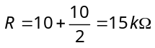 Current i = 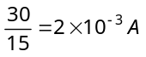
Hence, potential difference between A and B 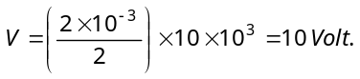

- (d) Potential difference across PQ i.e. p.d. across the resistance of 20Ω, which is V = i × 20
and 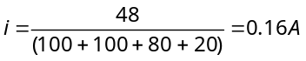
∴ .

Kirchoff law and Cells :
2A
2A
1A
1.3A
t
A
C
B
- (a) According to Kirchhoff's first law
At junction A, 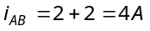 At junction B, 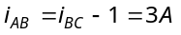
At junction C, 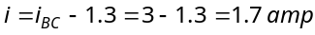
- (d) In open circuit of a cell V = E
- (a) Applying Kirchhoff law 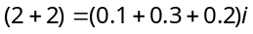 ⇒ 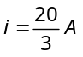
Hence potential difference across A 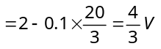 (less than 2V)
Potential difference across 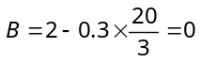
- (d) 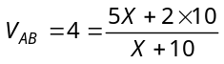 ⇒
- (a) Applying Kirchoff's voltage law in the given loop.
1Ω
9Ω
2Ω
i
4V
8V
4V
i
Q
P

⇒ 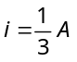
Potential difference across PQ 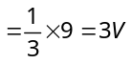
- (b) 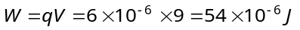.
- (a) Given problem is the case of mixed grouping of cells
So total current produced 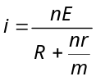
Here 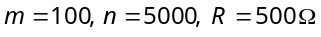 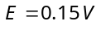 and 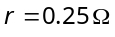 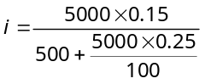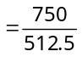 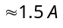
- (c) Total cells = m × n = 24 .... (i)
For maximum current in the circuit 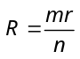 ⇒ 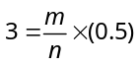 ⇒ m = 6n ..... (ii)
On solving equation (i) and (ii), we get m = 12, n =2
- (a) 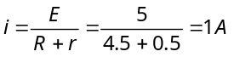
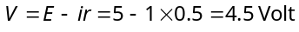
- (b) In parallel combination 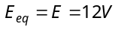
- (c) In series 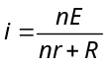 ⇒ 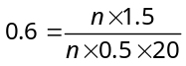⇒ n = 10
- (b) Here two cells are in series.
Therefore total emf = 2E.
Total resistance = R + 2r
∴ 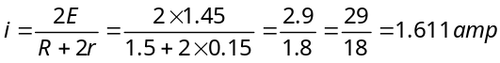
- (a) Since both the resistors are same, therefore potential difference ⇒ 