Electric conduction, Ohms law and resistance :
- Every atom makes one free electron in copper. If 1.1 ampere current is flowing in the wire of copper having 1 mm diameter, then the drift velocity (approx.) will (Density of copper 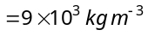 and atomic weight = 63)
(a)  (b)  (c)  (d) 

- If a 0.1 % increase in length due to stretching, the percentage increase in its resistance will be
(a) 0.2 % (b) 2 % (c) 1 % (d) 0.1 %

- The resistivity of iron is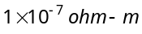. The resistance of a iron wire of particular length and thickness is 1 ohm. If the length and the diameter of wire both are doubled, then the resistivity in will be
(a) 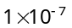 (b) 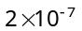 (c) 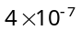 (d) 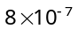

- The temperature coefficient of resistance for a wire is 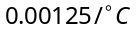. At 300K its resistance is 1 ohm. The temperature at which the resistance becomes 2 ohm is
(a) 1154 K (b) 1100 K (c) 1400 K (d) 1127 K

- In hydrogen atom, the electron makes 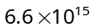 revolutions per second around the nucleus in an orbit of radius 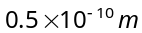. It is equivalent to a current nearly
(a) 1 A (b) 1 mA (c) 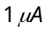 (d) 

- In an electrolyte 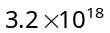 bivalent positive ions drift to the right per second while 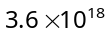 monovalent negative ions drift to the left per second. Then the current is
(a) 1.6 amp to the left (b) 1.6 amp to the right (c) 0.45 amp to the right (d) 0.45 amp to the left

- Dimensions of a block are 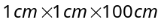. If specific resistance of its material is 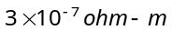, then the resistance between the opposite rectangular faces is
(a) 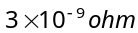 (b) 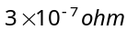 (c) 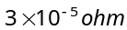 (d) 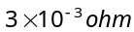

- Resistance of tungsten wire at is 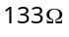. Its resistance temperature coefficient is 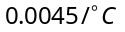. The resistance of this wire at will be
(a) 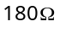 (b) 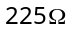 (c) 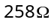 (d) 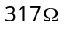

- A platinum resistance thermometer has a resistance of 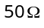 at . When dipped in a liquid the resistance becomes 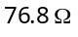. The temperature coefficient of resistance for platinum is 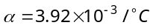. The temperature of the liquid is
(a) (b) 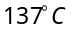 (c) 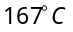 (d)

- In a wire of circular cross-section with radius r, free electrons travel with a drift velocity V when a current I flows through the wire. What is the current in another wire of half the radius and of the same material when the drift velocity is 2V
(a) 2I (b) I (c) 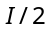 (d) 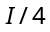
- Masses of three wires of copper are in the ratio of 1 : 3 : 5 and their lengths are in the ratio of The ratio of their electrical resistances are
(a) 1 : 3 : 5 (b) 5 : 3 : 1 (c) 1 : 15 : 125 (d) 125 : 15 : 1

- Equal potentials are applied on an iron and copper wire of same length. In order to have the same current flow in the two wires, the ratio r (iron)/r (copper) of their radii must be (Given that specific resistance of iron = 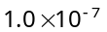ohm–m and specific resistance of copper = 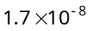ohm-m)
(a) About 1.2 (b) About 2.4 (c) About 3.6 (d) About 4.8

- In the figure a carbon resistor has bands of different colours on its body as mentioned in the figure. The value of the resistance is
White
Brown
Red
Silver
(a) 2.2 k Ω
(b) 3.3 k Ω
(c) 5.6 k Ω
(d) 9.1 k Ω

- A strip of copper and another of germanium are cooled from room temperature to 80 K. The resistance of
(a) Each of these increases (b) Each of these decreases
(c) Copper strip increases and that of germanium decreases
(d) Copper strip decreases and that of germanium increases

- A source of e.m.f. E = 15 V and having negligible internal resistance is connected to a variable resistance so that the current in the circuit increases with time as i = 1.2 t + 3. Then, the total charge that will flow in first five second will be
(a) 10 C (b) 20 C (c) 30 C (d) 40 C

- The following four wires are made of the same material and are at the same temperature. Which one of them has highest electrical resistance
(a) Length = 50 cm, diameter = 0.5 mm (b) Length = 100 cm, diameter = 1 mm
(c) Length = 200 cm, diameter = 2 mm (d)Length = 300 cm, diameter = 3 mm

- Twelve wires of equal length and same cross-section are connected in the form of a cube. If the resistance of each of the wires is , then the effective resistance between the two diagonal ends would be
(a) 2
(b) 12
(c) 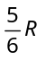
(d) 8
- In an electrical cable there is a single wire of radius 9 mm of copper. Its resistance is 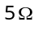. The cable is replaced by 6 different insulated copper wires, the radius of each wire is 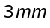. Now the total resistance of the cable will be
(a) 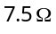 (b) 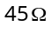 (c) 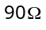 (d) 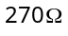
Different measuring instruments :
- An ammeter gives full scale deflection when current of 1.0 A is passed in it. To convert it into 10 A range ammeter, the ratio of its resistance and the shunt resistance will be
(a) 1 : 9 (b) 1 : 10 (c) 1 : 11 (d) 9 : 1

- In order to pass 10% of main current through a moving coil galvanometer of 99 ohm, the resistance of the required shunt is (a) 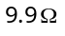 (b)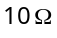 (c) 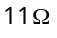 (d) 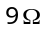

- The potential gradient along the length of a uniform wire is 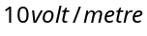. and are the two points at 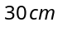 and 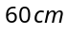 point on a meter scale fitted along the wire. The potential difference between and will be
(a) 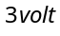 (b) 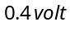 (c) 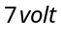 (d) 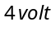

- A galvanometer of 10 ohm resistance gives full scale deflection with 0.01 ampere of current. It is to be converted into an ammeter for measuring 10 ampere current. The value of shunt resistance required will be
(a) 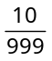ohm (b) 0.1 ohm (c) 0.5 ohm (d) 1.0 ohm

- In an experiment of meter bridge, a null point is obtained at the centre of the bridge wire. When a resistance of 10 ohm is connected in one gap, the value of resistance in other gap is
(a) 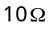 (b) (c) 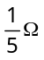 (d) 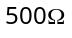
- Two cells when connected in series are balanced on 8m on a potentiometer. If the cells are connected with polarities of one of the cell is reversed, they balance on 2m. The ratio of e.m.f.'s of the two cells is
(a) (b) (c) (d)

- A galvanometer of resistance 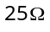 gives full scale deflection for a current of 10 milliampere, is to be changed into a voltmeter of range 100 V by connecting a resistance of ‘R’ in series with galvanometer. The value of resistance R in is
(a) 10000 (b) 10025 (c) 975 (d) 9975

- The resistance of a galvanometer is 25 ohm and it requires 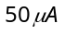 for full deflection. The value of the shunt resistance required to convert it into an ammeter of 5 amp is
(a) 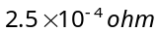 (b) 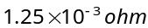 (c) 0.05 ohm (d) 2.5 ohm

- A voltmeter having a resistance of 998 ohms is connected to a cell of e.m.f. 2 volt and internal resistance 2 ohm. The error in the measurement of e.m.f. will be
(a) 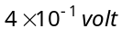 (b) 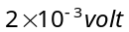 (c) 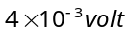 (d) 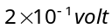

- An ammeter with internal resistance reads 1.85 A when connected in a circuit containing a battery and two resistors 700 and 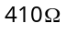 in series. Actual current will be
(a) 1.85 A (b) Greater than  (c) Less than 1.85 A (d) None of these
- In an experiment to measure the internal resistance of a cell by potentiometer, it is found that the balance point is at a length of 2m when the cell is shunted by a resistance; and is at a length of 3m when the cell is shunted by a resistance. The internal resistance of the cell is, then
(a) 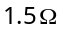 (b) (c) 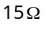 (d) 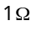

- A resistance of 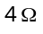 and a wire of length 5 metres and resistance 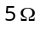 are joined in series and connected to a cell of e.m.f. 10 V and internal resistance 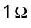. A parallel combination of two identical cells is balanced across 300 cm of the wire. The e.m.f. E of each cell is
10V
E
3m
4Ω
E
1Ω
5Ω, 5m
G

(a) 1.5 V
(b) 3.0 V
(c) 0.67 V
(d) 1.33 V

- In a potentiometer experiment, the galvanometer shows no deflection when a cell is connected across 60 cm of the potentiometer wire. If the cell is shunted by a resistance of 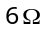, the balance is obtained across 50 cm of the wire. The internal resistance of the cell is
(a) 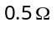 (b) 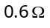 (c) 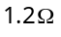 (d)

- The resistance of 10 metre long potentiometer wire is 1ohm/meter. A cell of e.m.f. 2.2 volts and a high resistance box are connected in series to this wire. The value of resistance taken from resistance box for getting potential gradient of 2.2 millivolt/metre will be
(a) 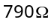 (b) 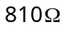 (c) 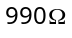 (d) 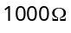

- In the adjoining circuit, the e.m.f. of the cell is 2 volt and the internal resistance is negligible. The resistance of the voltmeter is 80 ohm. The reading of the voltmeter will be
+
–
2V
80 Ω
20 Ω
80 Ω
V
(a) 0.80 volt
(b) 1.60 volt
(c) 1.33 volt
(d) 2.00 volt

- In the given figure, battery E is balanced on 55 cm length of potentiometer wire but when a resistance of 10 Ω is connected in parallel with the battery then it balances on 50 cm length of the potentiometer wire then internal resistance r of the battery is
A
2 V
r
E
B
1 m
(a) 1 Ω
(b) 3 Ω
(c) 10 Ω
(d) 5 Ω
- A galvanometer of 25 Ω resistance can read a maximum current of 6mA. It can be used as a voltmeter to measure a maximum of 6 V by connecting a resistance to the galvanometer. Identify the correct choice in the given answers
(a) 1025 Ω in series (b) 1025 Ω in parallel (c)975 Ω in series (d)975 Ω in parallel
- In the circuit shown, a meter bridge is in its balanced state. The meter bridge wire has a resistance 0.1 ohm/cm. The value of unknown resistance X and the current drawn from the battery of negligible resistance is
B
A
60 cm
40 cm
X
6Ω
5V
G
(a) 6 Ω, 5 amp
(b) 10 Ω, 0.1 amp
(c) 4 Ω, 1.0 amp
(d) 12 Ω, 0.5 amp

- AB is a potentiometer wire of length 100 cm and its resistance is 10 ohms. It is connected in series with a resistance R = 40 ohms and a battery of e.m.f. 2 V and negligible internal resistance. If a source of unknown e.m.f. E is balanced by 40 cm length of the potentiometer wire, the value of E is
R
A
B
2 V
40 cm
E
(a) 0.8 V
(b) 1.6 V
(c) 0.08 V
(d) 0.16 V

Grouping of Resistors :
D
A
5Ω
5Ω
5Ω
5Ω
5Ω
5Ω
2V
B
C
- The potential difference between points and of adjoining figure is
(a) 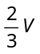 (b) 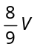
(c) 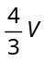 (d)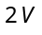
30Ω
30Ω
30Ω
2V
i
- The current in the adjoining circuit will be
(a) 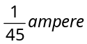 (b)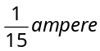
(c) 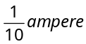 (d)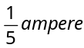

- An infinite sequence of resistance is shown in the figure. The resultant resistance between A and B will be, when 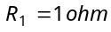 and 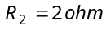
A
B
R₁
R₂
R₁
R₂
R₁
R₁
R₁
R₂
R₂
R₂

(a) Infinity (b)
(c) 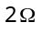 (d) 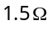

- In the network of resistors shown in the adjoining figure, the equivalent resistance between A and B is
A
3Ω
3Ω
3Ω
3Ω
3Ω
3Ω
3Ω
3Ω
3Ω
3Ω
3Ω
3Ω
B
(a) 54 ohm (b) 18 ohm
(c) 36 ohm (d) 9 ohm

- Three equal resistances each of value R are joined as shown in the figure. The equivalent resistance between M and N is
L
R
M
R
N
R
Z
(a) R (b) 2R
(c)  (d) 

- For what value of R the net resistance of the circuit will be 18 ohms
(a) 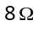
10Ω
10Ω
10Ω
10Ω
10Ω
10Ω
A
R
B
(b) 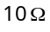
(c) 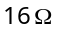
(d) 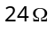

- In the figure, current through the 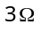 resistor is 0.8 ampere, then potential drop through 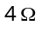 resistor is
6 Ω
4 Ω
3 Ω
+
–
(a) 9.6 V
(b) 2.6 V
(c) 4.8 V
(d) 1.2 V

- What is the equivalent resistance between A and B in the figure below if 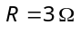
R
R
R
R
R
A
B
(a) 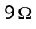
(b) 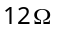
(c) 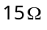
(d) None of these

- Equivalent resistance between the points A and B is (in Ω)
B
1Ω
A
1Ω
1Ω
1Ω
1Ω
(a) (b) 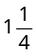
(c) 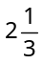 (d) 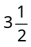

- In the circuit shown in the adjoining figure, the current between B and D is zero, the unknown resistance is of
B
X
C
1Ω
1Ω
4Ω
12Ω
1Ω
3Ω
D
A

(a)
(b)
(c)
(d) em.f. of a cell is required to find the value of X

- In the figure given the value of resistance will be, when the p.d. between B and D is zero
B
X
C
4Ω
4Ω
6Ω
15Ω
15Ω
4Ω
D
A
3Ω
8Ω
6Ω
6Ω

(a) 4 ohm (b) 6 ohm
(c) 8 ohm (d) 9 ohm

- In the network shown in the figure, each of the resistance is equal to . The resistance between the points A and B is
A
B
(a)
(b) 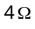
(c)
(d)

- Thirteen resistances each of resistance R ohm are connected in the circuit as shown in the figure below. The effective resistance between A and B is
R
R
R
R
R
R
R
R
R
R
R
R
R
B
A
(a) 2R Ω (b) 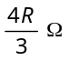
(c) 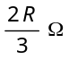 (d) R Ω

- The total current supplied to the circuit by the battery is
6V
2Ω
6Ω
1.5Ω
3Ω
(a) 1 A
(b) 2 A
(c) 4 A
(d) 6 A

- What is the equivalent resistance of the circuit
+
–
4V, 1 Ω
2Ω
2Ω
2Ω
4Ω
A
V
(a) 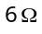
(b) 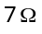
(c)
(d)
- In the given figure, potential difference between A and B is
(a) 0
30 V
10KΩ
10KΩ
10KΩ
A
B
D
(b) 5 volt
(c) 10 volt
(d) 15 volt

- In the circuit, the potential difference across PQ will be nearest to
48 V
100 Ω
80 Ω
20 Ω
P
100 Ω
Q
(a) 9.6 V
(b) 6.6 V
(c) 4.8 V
(d) 3.2 V

Kirchoff laws and cells :
- The figure below shows currents in a part of electric circuit. The current i is
(a) 1.7 amp
2amp
2amp
1amp
1.3amp
i
(b) 3.7 amp
(c) 1.3 amp
(d) 1 amp

- In the circuit shown, potential difference between X and Y will be
(a) Zero
20Ω
X
Y
40Ω
120V
(b) 20 V
(c) 60 V
(d) 120 V

- The internal resistances of two cells shown are 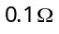 and 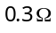. If 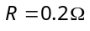, the potential difference across the cell
A
B
2V, 0.1Ω

2V, 0.3Ω

0.2Ω

(a) B will be zero
(b) A will be zero
(c) A and B will be 2V
(d) A will be and B will be

- If 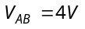 in the given figure, then resistance X will be
A
2V
X
B
5V
10Ω
(a)
(b)
(c) 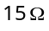
(d) 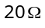

- Two batteries of e.m.f. 4V and 8 V with internal resistances 1 Ω and 2 Ω are connected in a circuit with a resistance of 9 Ω as shown in figure. The current and potential difference between the points P and Q are
Q
2 Ω
1 Ω
8 V
4 V
P
9 Ω
r₁
r₂
(a) 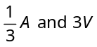
(b) 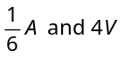
(c) 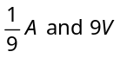
(d) 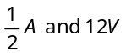
- How much work is required to carry a 6 μC charge from the negative terminal to the positive terminal of a 9 V battery
(a) 54 × 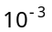J (b) 54 × 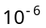J (c)54 × 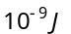 (d) 54 × 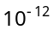J

- Eels are able to generate current with biological cells called electroplaques. The electroplaques in an eel are arranged in 100 rows, each row stretching horizontally along the body of the fish containing 5000 electroplaques. The arrangement is suggestively shown below. Each electroplaques has an emf of 0.15 V and internal resistance of 0.25 Ω
500 Ω
100 rows
5000 electroplaques per row
0.25 Ω
0.15 V
+
–
+
–
+
–
+
–
+
–
+
–
+
–
+
–
+
–
The water surrounding the eel completes a circuit between the head and its tail. If the water surrounding it has a resistance of 500 Ω, the current an eel can produce in water is about
(a) 1.5 A (b) 3.0 A
(c) 15 A (d) 30 A

- The n rows each containing m cells in series are joined in parallel. Maximum current is taken from this combination across an external resistance of 3Ω resistance. If the total number of cells used are 24 and internal resistance of each cell is 0.5 Ω then
(a) 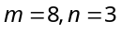 (b) 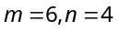 (c) 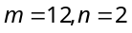 (d) 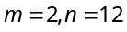

- A battery having e.m.f. 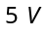 and internal resistance 0.5 Ω is connected with a resistance of 4.5 Ω then the voltage at the terminals of battery is
(a) 4.5 V (b) 4 V
(c) 0 V (d) 2 V

- Four identical cells each having an electromotive force (e.m.f.) of 12V, are connected in parallel. The resultant electromotive force (e.m.f.) of the combination is
(a) 48 V (b) 12 V (c) 4 V (d) 3 V

- The number of dry cells, each of e.m.f. 1.5 volt and internal resistance 0.5 ohm that must be joined in series with a resistance of 20 ohm so as to send a current of 0.6 ampere through the circuit is
(a) 2 (b) 8 (c) 10 (d) 12

- A torch battery consisting of two cells of 1.45 volts and an internal resistance 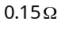, each cell sending currents through the filament of the lamps having resistance 1.5ohms. The value of current will be
(a) 16.11 amp (b) 1.611 amp (c) 0.1611 amp (d) 2.6 amp

- The e.m.f. of a cell is E volts and internal resistance is ohm. The resistance in external circuit is also ohm. The p.d. across the cell will be
(a) E/2 (b) 2E (c) 4E (d) E/4

