- (a) B.E.= Δmc²
- (c) We have 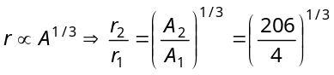 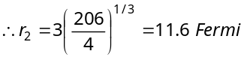.
- (a) Let the percentage of 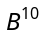atoms be x, then Average atomic weight
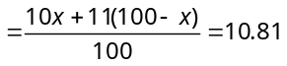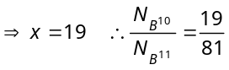
- (b) A = 238 – 4 = 234 and Z = 92 – 2 = 90.
- (b) x+1= 24 + 4 ⇒ x = 27.
- (b) 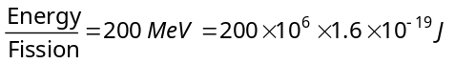 Fission rate 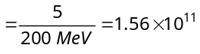fission/sec.
- (b) 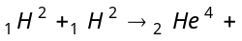energy
Binding energy of a 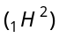deuterium nuclei 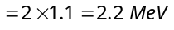
Total binding energy of two deuterium nuclei 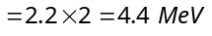
Binding energy of a 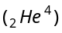nuclei 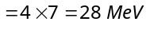 So, energy released in fusion 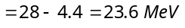
- (a) 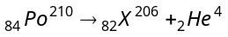
Using conservation of linear moments 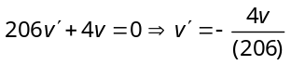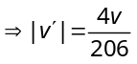
- (d) Fraction 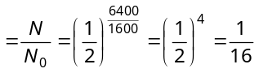
- (c) Average life 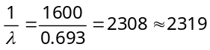 years.
- (d) Fraction of atoms remains after five half lives
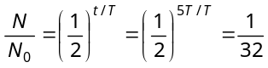 ⇒ Percentage atom remains 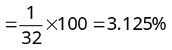
- (b) 20 gm substance reduces to 10 gm (i.e. becomes half in 4 min. So 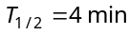. Again 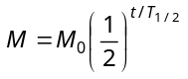
⇒ 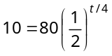⇒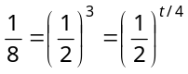⇒ t = 12 min.
- (c) 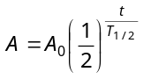⇒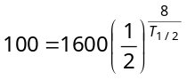⇒ 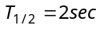 Again at t = 6 sec, 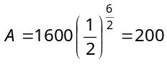counts/sec
- (d) In the given case, 12 days = 3 half lives Number of atoms left after 3 half lives.
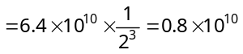
- (c) For 80 minutes, number of half lives of sample 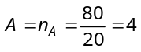 and number of half lives of sample 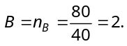Also by using 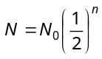 ⇒ 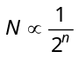⇒ 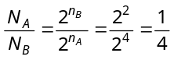
- (c)
- (d) Using conservation of momentum 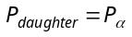 ⇒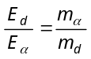⇒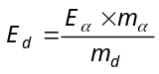 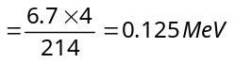
- (c) At closest distance of approach
Kinetic energy = Potential energy 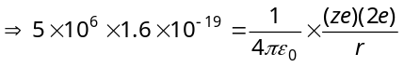
For uranium z= 92, so 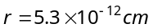

- (a)
Rest
A – 4
v′
A
m′
4
v
+
m

According to conservation of momentum 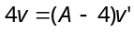 ⇒ 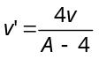.
- (d) 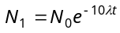and 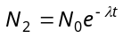 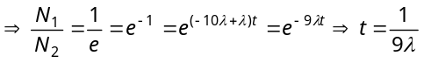.
- (b) 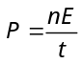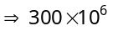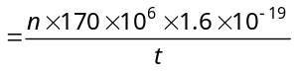
∴ Number of atoms per sec 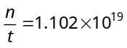
Number of atoms per hour = 1.02 × 10¹⁹ × 3600 = 3.97 × 10²².

- (a)
- (c)
- (a) 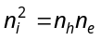⇒ 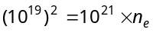 ⇒ 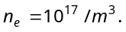
- (a) 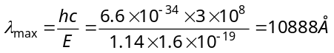
- (b) Current flow is possible and 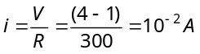
- (a) The potential of P-side is more negative that of N-side, hence diode is in reverse biasing. In reverse biasing it acts as open circuit, hence no current flows
- (a) In the given condition diode is in reverse biasing so it acts as open circuit. Hence potential difference between A and B is 6V
- (d) By using 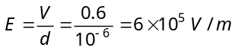
- (c) The given circuit is full wave rectifier.
- (a) The diode is in reverse biasing so current through it is zero.
- (c)

- (d) Given 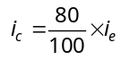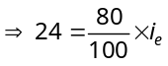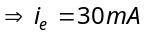 By using 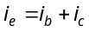 ⇒ i_{b} = 30 – 24 = 6 mA.
- (b) 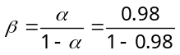=49.
- (b) 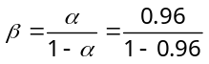=24.
- (c) 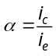=0.96 and i_{e} = 7.2 mA
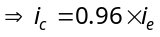= 0.96 × 7.2 = 6.91 mA
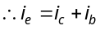⇒ 7.2 = 6.91 + i_{b} ⇒ i_{b} = 0.29 mA.
- (d) 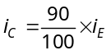⇒ 10 = 0.9 × i_{E} = 11mA
Also 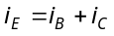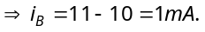
- (b)
- (a)
C
A
B

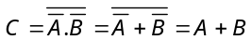 (De morgan’s theorem)
Hence output C is equivalent to OR gate.
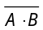
A
B
C

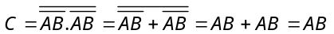
In this case output C is equivalent to AND gate.
- (b) In ‘NOR’ gate 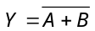
i.e. 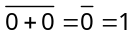, 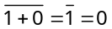
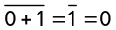, 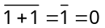
- (c) For ‘XNOR’ gate 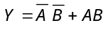
i.e. 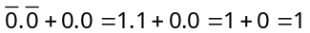
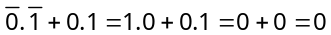
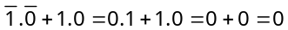
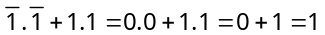
- (d) The output D for the given combination
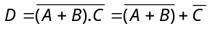
If then 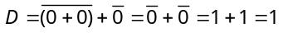
If ,then 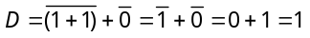
- (b) Two ‘NAND’ gates are required as follows
A
B
Y

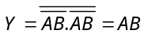
- (c) For ‘NAND’ gate (option c), output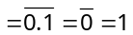
- (a) The given Boolean expression can be written as
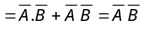
A | B | Y
0 | 0 | 1
1 | 0 | 0
0 | 1 | 0
1 | 1 | 0

- (b) For ‘AND’ gate, if output is 1 then both inputs must be 1.
- (a)
- (c) The Boolean expression for the given combination is
output 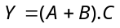
The truth table is
A | B | C | Y =(A+B).C
0 | 0 | 0 | 0
1 | 0 | 0 | 0
0 | 1 | 0 | 0
0 | 0 | 1 | 0
1 | 1 | 0 | 0
0 | 1 | 1 | 1
1 | 0 | 1 | 1
1 | 1 | 1 | 1
Hence , ,
- (b)
A
B
Y

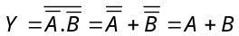
This output equation is equivalent to OR gate.
- (c)
Y
A
B

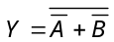
According to De morgan’s theorem
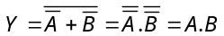
This is the output equation of ‘AND’ gate.

- (c) Voltage gain 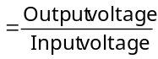
⇒ V_{out} = V_{in} × Voltage gain
⇒ V_{out} = V_{in} × Current gain × Resistance gain
= V_{in} × β × 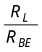= 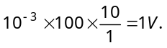
- (a) At knee point voltage across the diode is 0.7V.
Hence voltage across resistance R is 5 – 0.7 = 4.3 V.
⇒ using V = iR ⇒ 4.3 = 1 × 10^{–3} × R ⇒ R = 4.3 kΩ.
- (d) In positive half cycle one diode is in forward biasing and other is in reverse biasing while in negative half cycle their polarity reverses, and direction of current is opposite through R for positive and negative half cycles so out put is not rectified.
Since R₁ and R₂ are different hence the peaks during positive half and negative half of the input signal will be different.
- c) (i) V_{A} = –10V and V_{B} = –5V
Diodes D₁ and D₃ are reveres biased and D₂ is forward biased.
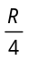
R
R
R
A
B
– 10 V
– 5 V

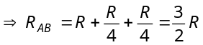.
(ii) When V_{A} = – 5V and V_{B} = – 10V
Diodes D₂ is reverse biased D₁ and D₃ are forward biased
R
R
R
A
B
– 5 V
– 10 V

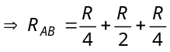=R.
(iii) In this case equivalent resistance between A and B is also R.
Hence (ii) = (iii) < (i).

- (c) 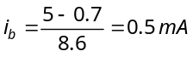 ⇒ 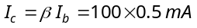
By using
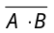
- (b)
A
B
(A + B)
G₁
G₂
G₃
Y
A
B

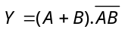
The given output equation can also be written as
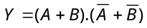 (De morgan’s theorem)
This is the expression for XOR gate.
- (c)
Y
X
R
X
Y
Q
P

The truth table can be written as
X | Y |  |  | 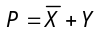 | 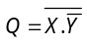 | 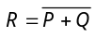
0 | 1 | 1 | 0 | 1 | 1 | 0
1 | 1 | 0 | 0 | 1 | 1 | 0
1 | 0 | 0 | 1 | 0 | 0 | 1
0 | 0 | 1 | 1 | 1 | 1 | 0
Hence X = 1, Y = 0 gives output R =1
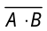
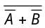
- (d)
A
B
NOR
= AB
NOT
NOT
NOT

Hence option (d) is correct.
- (b) The truth table of the circuit is given
A | B | C | 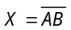 | 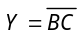 | 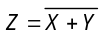
0 | 0 | 0 | 1 | 1 | 0
1 | 0 | 0 | 1 | 1 | 0
0 | 0 | 1 | 1 | 1 | 0
1 | 0 | 1 | 1 | 1 | 0
0 | 1 | 0 | 1 | 1 | 0
1 | 1 | 0 | 0 | 1 | 0
0 | 1 | 1 | 1 | 0 | 0
1 | 1 | 1 | 0 | 0 | 1

Output Z of single three input gate is that of AND gate.

- (c) Output of upper OR gate = W + X
Output of lower OR gate = W + Y
Net output F = (W + X) (W + Y)
= WW + WY + XW + XY (Since WW = W)
= W(1 + Y) + XW + XY (Since 1 + Y= 1)
= W + XW + XY = W (1 + X) + XY = W + XY

