KEY

1 | 2 | 3 | 4 | 5 | 6 | 7 | 8 | 9 | 10 | 11 | 12 | 13 | 14 | 15
B | A | D | C | A | C | B | B | B | B | B | D | D | B | C
16 | 17 | 18 | 19 | 20 | 21 | 22 | 23 | 24 | 25 | 26 | 27 | 28 | 29 | 30
C | D | B | A | A | A | B | B | C | B | B | B | C | C | A

HINTS AND SOLUTIONS

- (b) Applying L-Hospital’s rule, we get 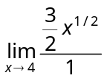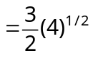 = 3.

- (a) 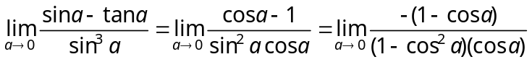 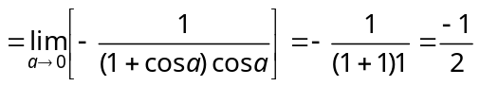

- (d) 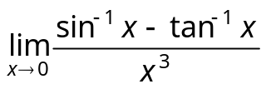, 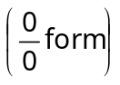Applying L-Hospital’s rule,
=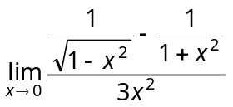, 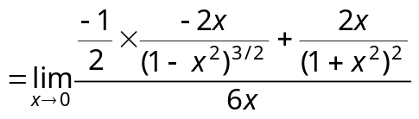
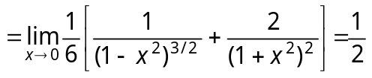.

- (c) 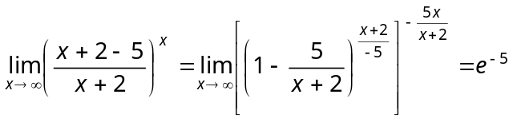 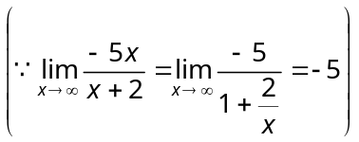.

- (a) Applying L-Hospital’s rule, 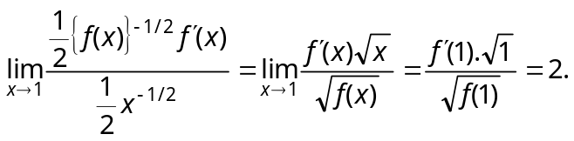

- (c) Given limit 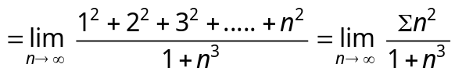 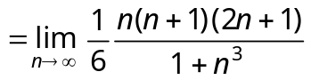
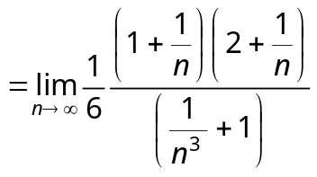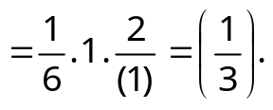

- (b) 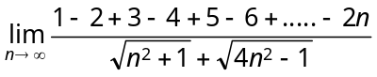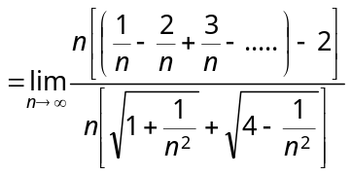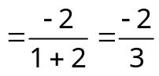.

- (b) 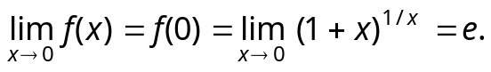

- (b) Since limit of a function is 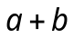as 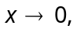 therefore to be continuous at a function, its value must be 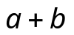 at 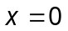 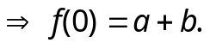

- (b) 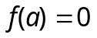 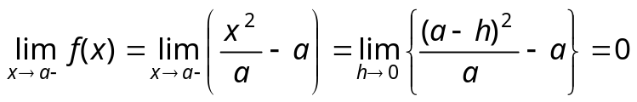
and 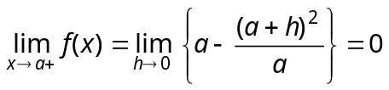 Hence it is continuous at 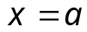.

- (b) 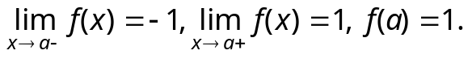

- (d) As we are given 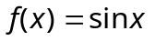, if 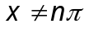 i.e., 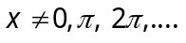= 2 otherwise
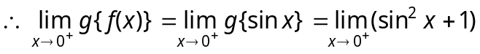 = 1
Similarly, 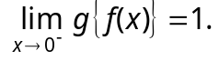

- (d) 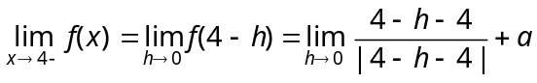 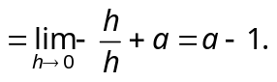
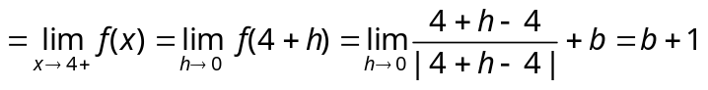 and 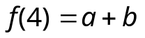
Since 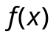 is continuous at 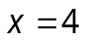 Therefore 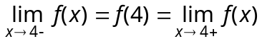
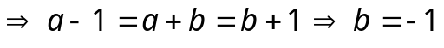 and 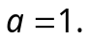

- (b) 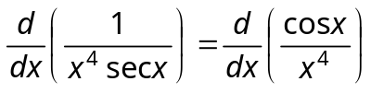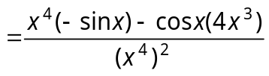
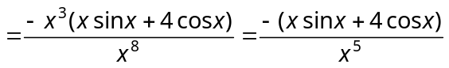.

- (c) 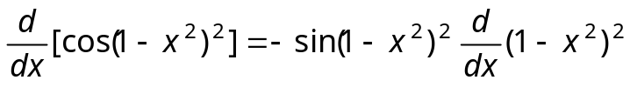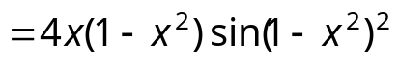.

- (c) Putting 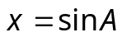 and 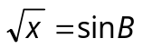 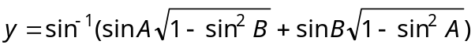
⇒ 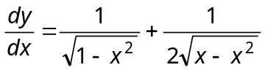.

- (d) 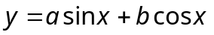Differentiating with respect to x, we get
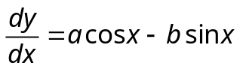Now 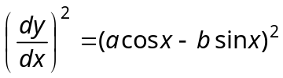
and 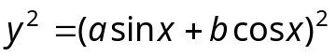
So, 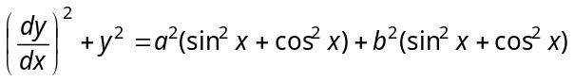
Hence 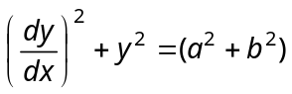= constant.

- (b) 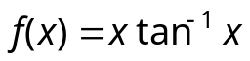Differentiating w.r.t x, we get 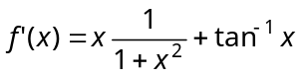
Now put , then 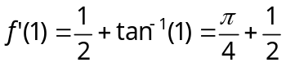.

- (a) 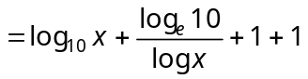
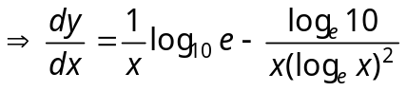.

- (a) 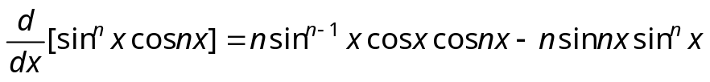
.

- (a) 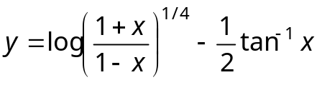 Differentiating w.r.t. x of y, we get
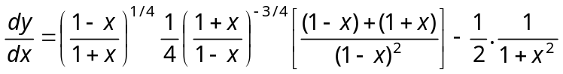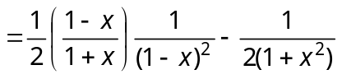
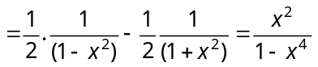.

- (b) 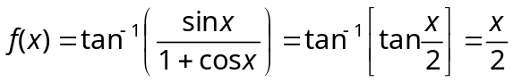 ⇒ 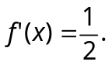 Hence 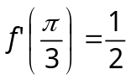.

- (b) 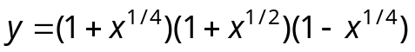⇒ 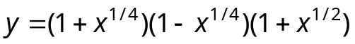
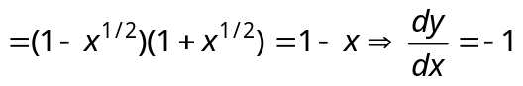.

- (c) 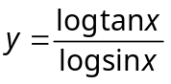⇒ 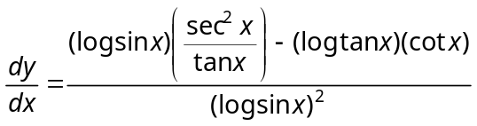
⇒ 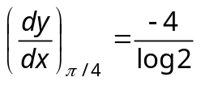 (On simplification).

- (b) 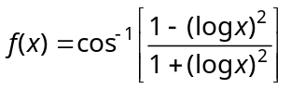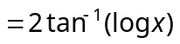⇒ 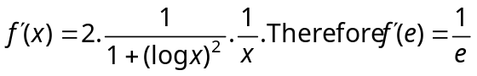.

- (b) Trick: By option (b), 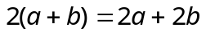.
- (b) 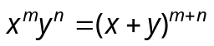, 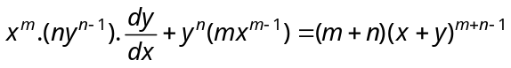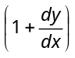
After solving, we find 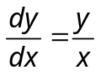 and 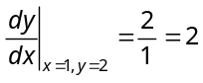.

- (c) Let 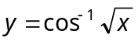and 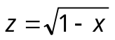 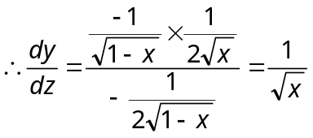.

- (c) 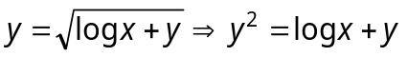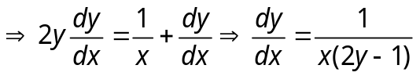

- (a) 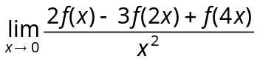 Using L-Hospital’s rule twice, we get
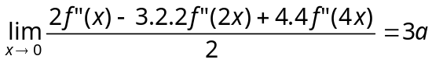 {Given 

