- 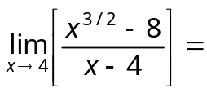
- (a) 3/2 (b) 3 (c) 2/3 (d) 1/3

- The value of 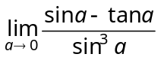will be
- (a) 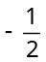 (b) (c) 1 (d) –1
- 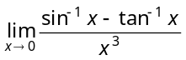 is equal to
- (a) 0 (b) 1 (c) 1 (d) 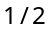

- For 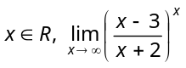 is equal to
(a) e (b) 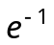 (c) 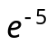 (d) 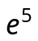

- If 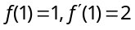, then 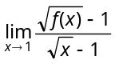 is
(a) 2 (b) 4 (c) 1 (d)

- 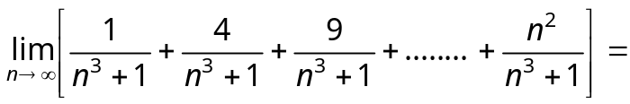
(a) (b) (c) (d)

- If 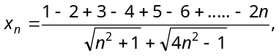 then 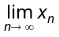 is equal to
(a) (b) 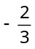 (c) (d) 1

- The function 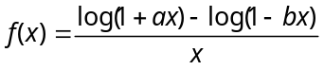is not defined at 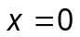. The value which should be assigned to f at x =0 so that it is continuos at ,
(a) 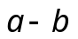 (b) 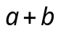 (c) 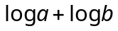 (d) 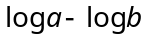

- In order that the function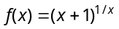is continuous at , 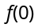must be defined as
- (a) 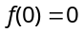 (b) 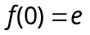 (c) 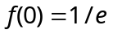 (d) 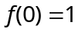

- If 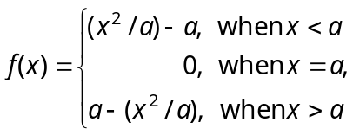 then
- (a) 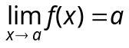 (b) 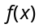is continuous at
(c) is discontinuous at (d) None of these

- If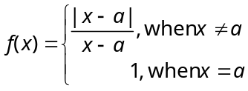,then
- (a) is continuous at (b) is discontinuous at
(c) 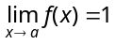 (d) None of these

- If 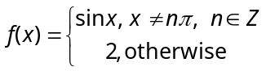 and 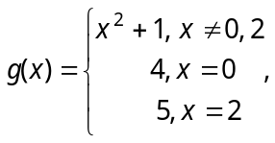 then 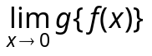 is
- (a) 5 (b) 6 (c) 7 (d) 1

- Let 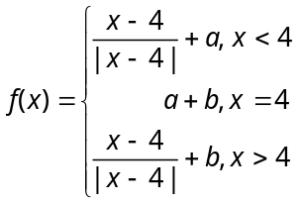. Then is continuous at when
- (a) 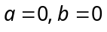 (b) 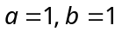 (c) 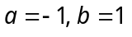 (d) 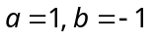

- 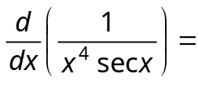
(a) 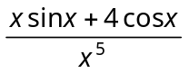 (b) 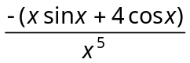
(c) 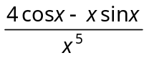 (d) None of these

- 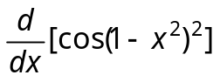=
(a) 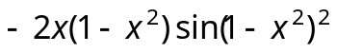 (b) 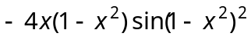
(c) 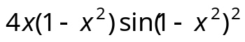 (d) 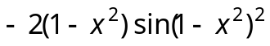
- If 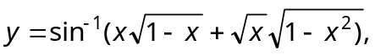then 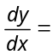
(a) 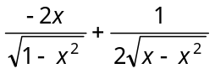 (b) 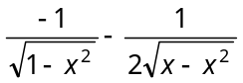
(c) 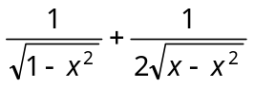 (d) None of these

- If 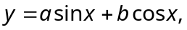then 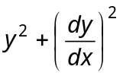is a
(a) Function of x (b) Function of y (c) Function of x and y (d) Constant

- If 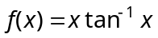, then 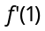=
(a) 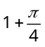 (b) 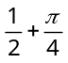 (c) 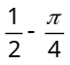 (d) 2

- If then 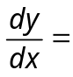
(a) 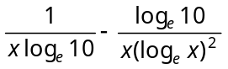 (b) 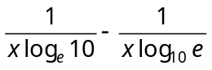
(c) 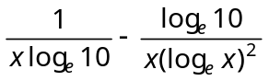 (d) None of these

- 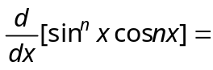
(a) 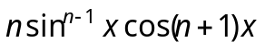 (b) 
(c) 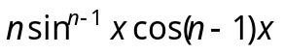 (d) 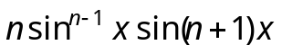

- If 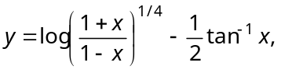then
(a) 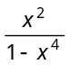 (b) 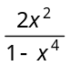 (c) 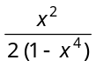 (d) None of these

- If 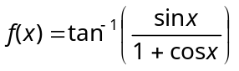,then 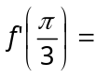
(a) 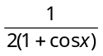 (b) (c) (d) None of these

- If 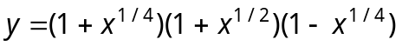, then 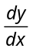=
(a) 1 (b) – 1 (c) x (d) 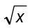

- If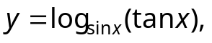 then 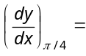
(a) 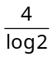 (b) 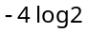 (c) 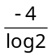 (d) None of these

- If 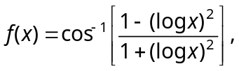then the value of 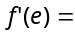
(a) 1 (b) 1/e (c) 2/e (d) 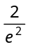
- Given that 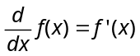. The relationship 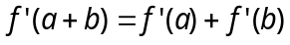 is valid if is equal to
(a) (b) 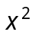 (c) 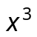 (d) 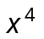

- If 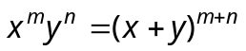then 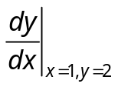 is equal to
(a) 1/2 (b) 2 (c) 2m/n (d) m/ 2n

- Differential coefficient of 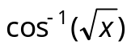with respect to 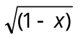 is
(a) (b) 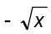 (c) 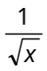 (d) 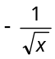

- If 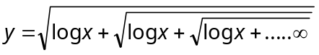, then
(a) 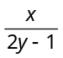 (b) 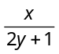 (c) 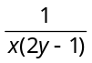 (d) 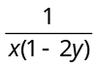

- If is a differentiable function and 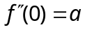 then 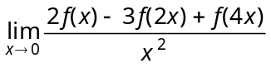 is
(a) 3a (b) 2a (c) 5a (d) 4a

