KEY

1 | 2 | 3 | 4 | 5 | 6 | 7 | 8 | 9 | 10 | 11 | 12 | 13 | 14 | 15
A | B | D | D | B | A | B | A | D | C | C | D | D | D | C
16 | 17 | 18 | 19 | 20 | 21 | 22 | 23 | 24 | 25 | 26 | 27 | 28 | 29 | 30
A | D | B | A | C | A | A | B | A | A | D | D | C | D | B

HINTS AND SOLUTIONS

- (a) 1radian = 57 degrees lies in 1st quadrant 2radians = 114 degrees lies in 2nd quadrant so tan1 > tan2

- (b) 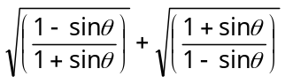 is the sum of two positive quantities and hence the result must be positive. But for 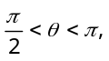 we have the sum equal to 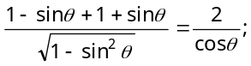 which is negative.
( 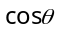 is negative for θ lying in 2nd quadrant). So the required positive value 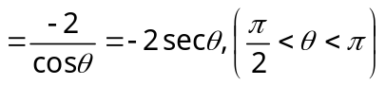.

- (d) 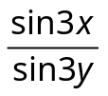 = 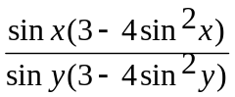= 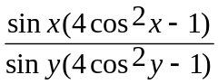= 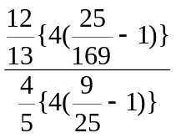= 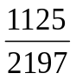.

- (d) The expression can be written as
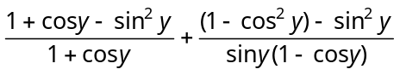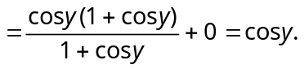

- (b) We know that 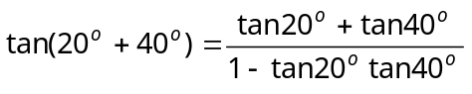
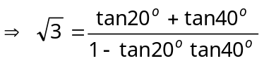

- (a) We have
⇒ 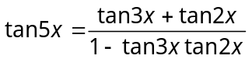
⇒
⇒ .

- (b) 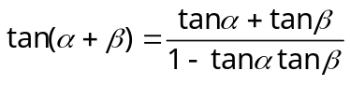
⇒ 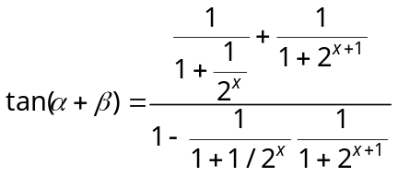
⇒ 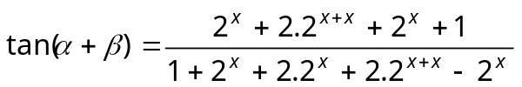
⇒ 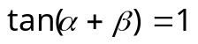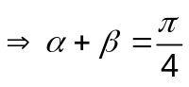.

- (a) 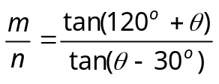
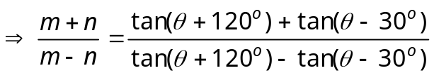
(By componendo and dividendo)
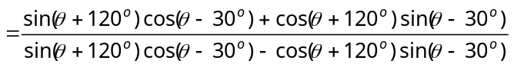
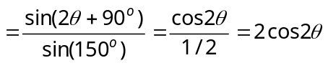.

- (d) A.M. G.M.
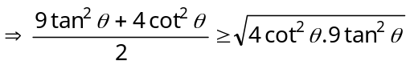
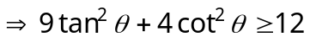
Therefore, the minimum value is 12.

- (c)
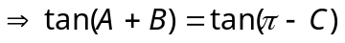
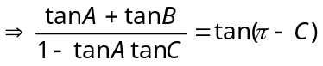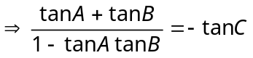
Then 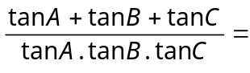1.

- (c) 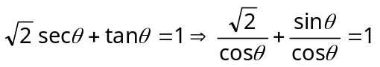
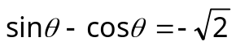
Dividing by 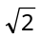 on both sides, we get
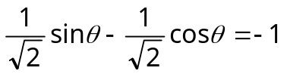
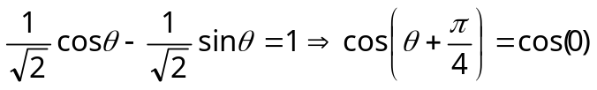
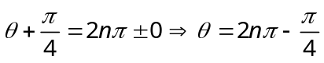.

- (d) No solution as 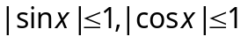 and both of them do not attain their maximum value for the same angle.
Alter : Since the maximum value of 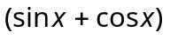 = 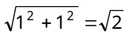.
Hence there is no 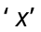 satisfying 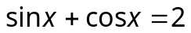.

- (d) We have 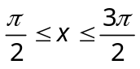
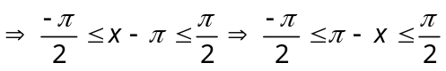
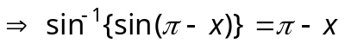.

- (d) 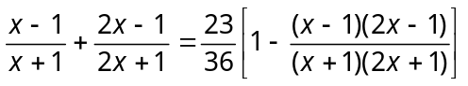
⇒ .
Hence the result.

- (c)
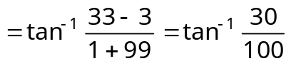⇒ 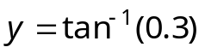.

- (a) Let 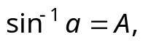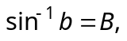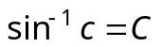 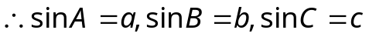
and 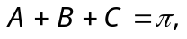then 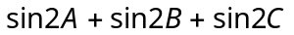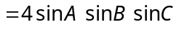 …..(i)
⇒ = 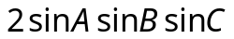
⇒ 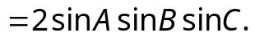 ……(ii)
⇒ 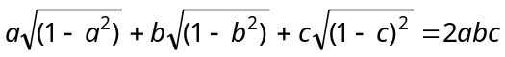,
while 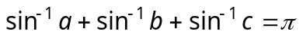.

- (d) Let 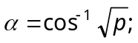 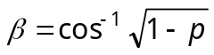
and and 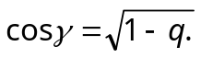
Therefore 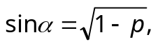 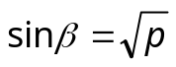 and 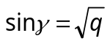.
The given equation may be written as 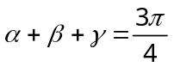 or 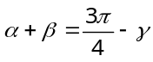 or 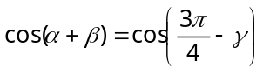
⇒ 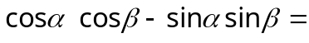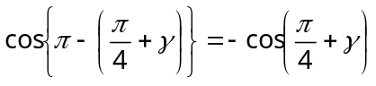
⇒ 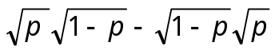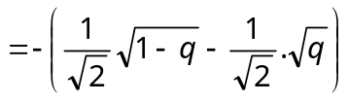
⇒ 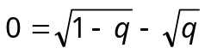 ⇒ 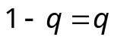 ⇒ 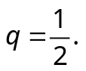

- (b) 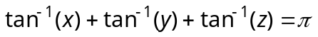
⇒ 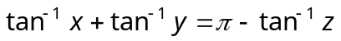 ⇒ 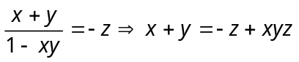 ⇒ 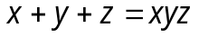
Dividing by xyz, we get 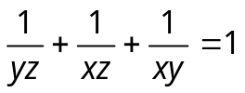.

- (a) 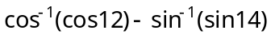 ⇒ 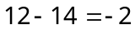.

- (c) Given that 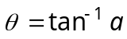 and 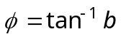 and 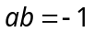.
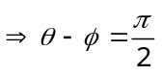.

- (a) We have 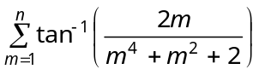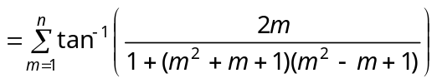
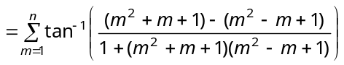=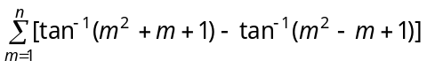 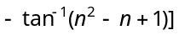
= 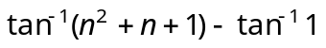= 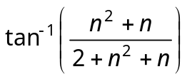.

- (a) 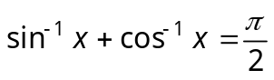⇒ 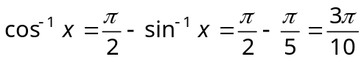 .

- (b) We have 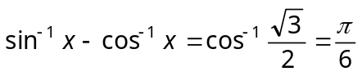 But
∴ 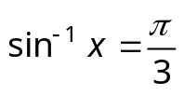and 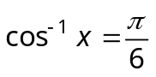⇒ 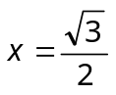is the unique solution.

- (a) Given equation is 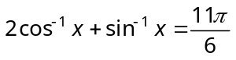
⇒ 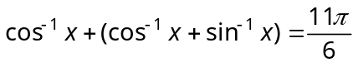⇒ 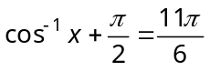 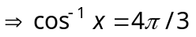
which is not possible as 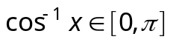.

- (a) 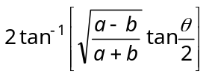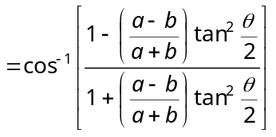 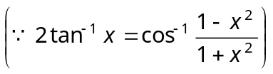
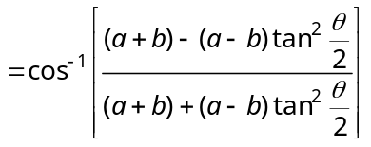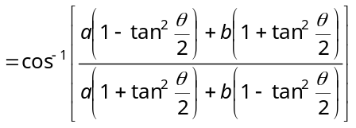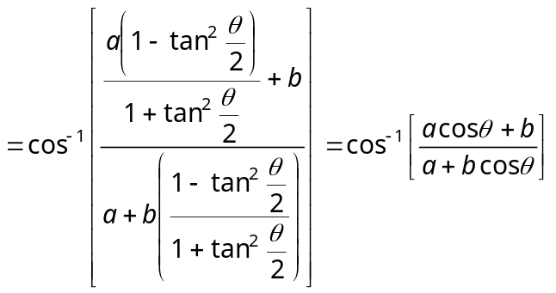

- (d) 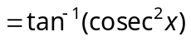⇒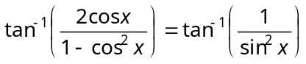 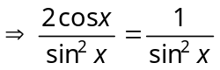⇒ 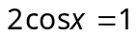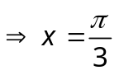.

- (d) Put 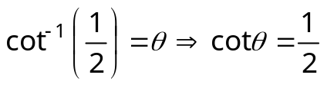 ∴ 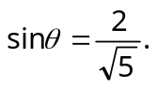 Put 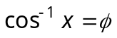, ∴ 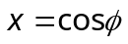
Also, 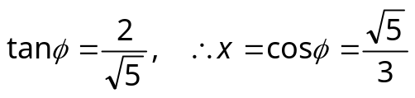.

- (c) Given that 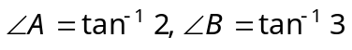 We know that 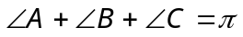
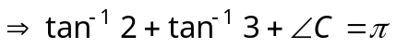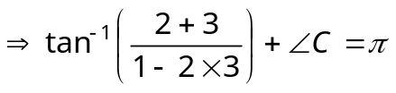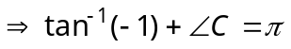
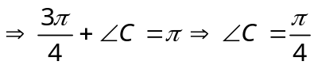.

- (d) 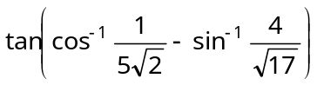 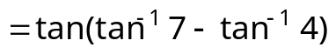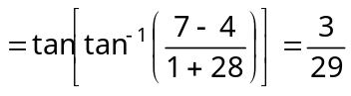.

- (b) 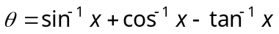= 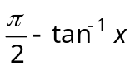

we know 

