- Which of the following is correct
- 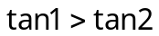 (b) 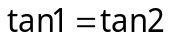 (c) 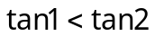 (d) 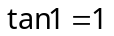

- If 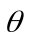 lies in the second quadrant, then the value of 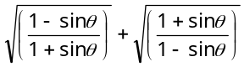
(a) 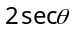 (b) 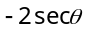 (c) 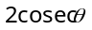 (d) None of these

- If 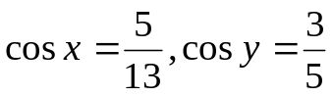 then the value of 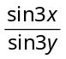 is
(a) 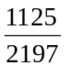 (b) 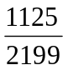 (c) 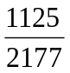 (d) None of these

- The value of the expression 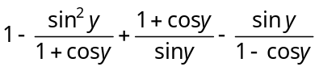 is equal to
(a) 0 (b) 1 (c) 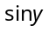 (d) 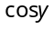

- 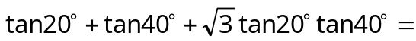
(a) 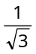 (b) 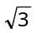 (c) 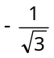 (d) 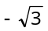

- 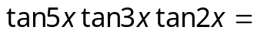
(a) 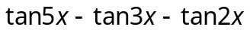 (b) 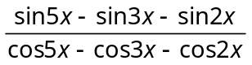
(c) 0 (d) None of these

- If 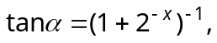 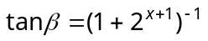, then 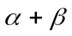 equals
(a) 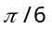 (b) 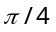 (c) 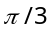 (d) 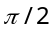
- If 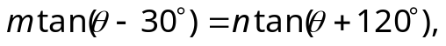 then 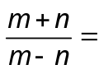
(a) 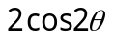 (b) 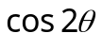 (c) 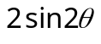 (d) 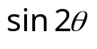

- The minimum value of 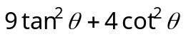is
(a) 13 (b) 9 (c) 6 (d) 12

- If 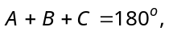 then 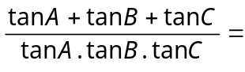
(a) 0 (b) 2 (c) 1 (d) –1

- If 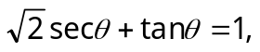 then the general value is

(a) 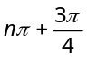 (b) 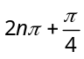 (c) 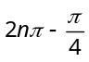 (d) 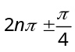
- The equation 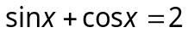has
(a) One solution (b) Two solutions
(c) Infinite number of solutions (d) No solutions

- If 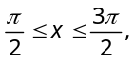then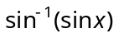is equal to
(a) x (b) (c) (d)

- If 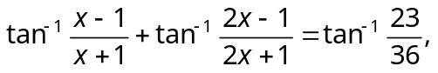then x =
(a) 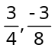 (b) 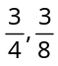 (c) 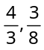 (d) None of these

- If 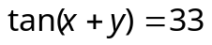and 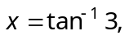then y will be
(a) (b) 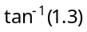 (c) 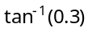 (d) 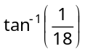

- If 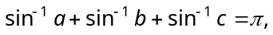 then the value of 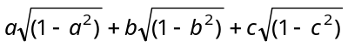 will be
(a) (b) (c) 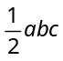 (d) 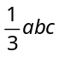

- If 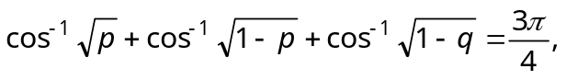 then the value of q is
(a) 1 (b) 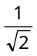 (c) (d)

- If 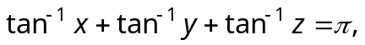 then 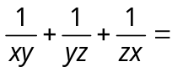
(a) 0 (b) 1 (c) 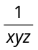 (d)

- The value of 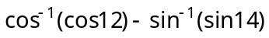 is
(a) – 2 (b) 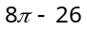 (c) 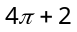 (d) None of these

- If 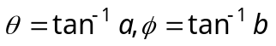 and 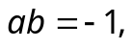 then 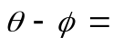
(a) 0 (b) 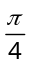 (c) 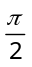 (d) None of these

- 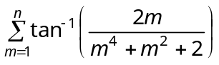is equal to
(a) 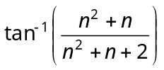 (b) 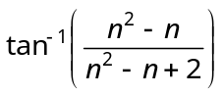
(c) 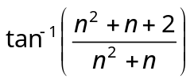 (d) None of these

- If 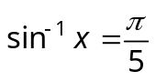 for some 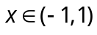, then the value of 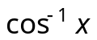 is
(a) 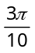 (b) 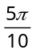 (c) 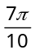 (d) 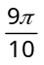

- The equation 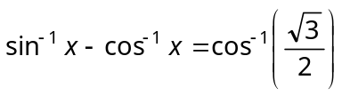has
(a) No solution (b) Unique solution
(c) Infinite number of solutions (d) None of these

- The equation 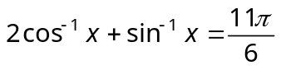has
(a) No solution (b) Only one solution
(c) Two solutions (d) Three solutions

- 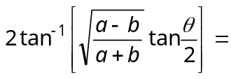
(a) 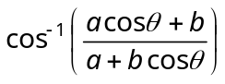 (b) 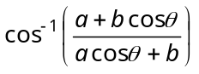
(c) 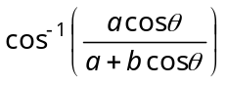 (d) 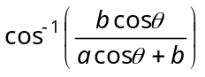

- 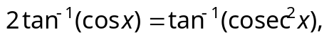 then x =
(a) (b) (c) 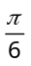 (d) 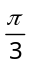

- Considering only the principal values, if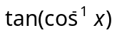 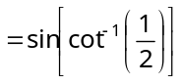, then x is equal to
(a) 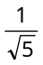 (b) 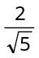 (c) 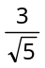 (d) 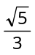

- If in a triangle ABC, 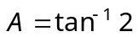 and 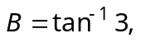 then angle C is equal to
(a) 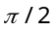 (b) 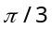 (c) 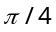 (d) None of these

- If we consider only the principal values of the inverse trigonometric functions, then the value of 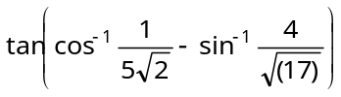 is
(a) 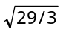 (b) 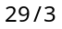 (c) 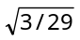 (d) 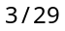

- If 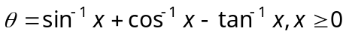, then the smallest interval in which lies is given by
(a) 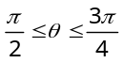 (b) 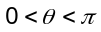 (c) 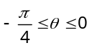 (d) 