- (a) 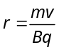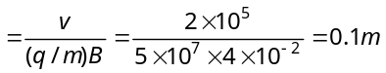
- (b) 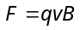 and 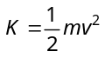 ⇒ 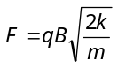 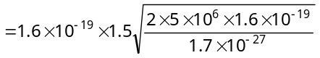 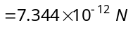
- (d) 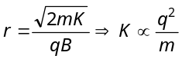 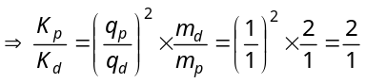 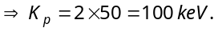
- (b) 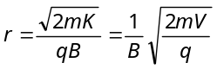 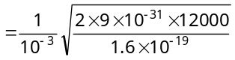=0.367 m = 36.7 cm
- (d)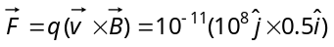 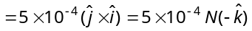
- c) For no deflection in mutually perpendicular electric and magnetic field 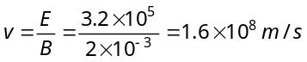.
If electric field is removed then due to only magnetic field radius of the path described by electron 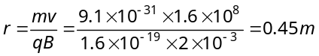
- (a)
Direction can be found by Fleming's left hand rule.
- (d) Current sensitivity 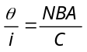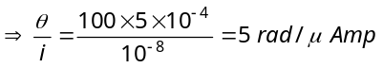
- (d) Since θ = 90° Hence 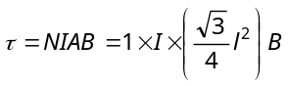 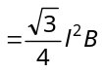
- (b) 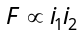, so force on B due to C will be greater than that due A. Hence net force on B acts towards C.
- (c) 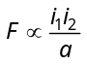; Since one of the current increase two times and distance increases three times, so force become times. Also due to the reversal of direction of current force becomes negative.
- (b) Because for inside the pipe 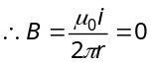
- (b) The given shape is equivalent to the following diagram
The field at due to straight part of conductor is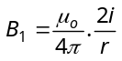. The field at due to circular coil is 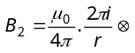. Both fields will act in the opposite direction, hence the total field at O.
i
i
2
r
O
1
i.e. 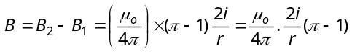
- (d) 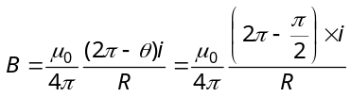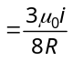
- (a) Tesla
- (a) 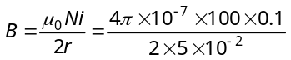 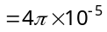 Tesla
- (a) In the following figure, magnetic fields at O due to sections 1, 2, 3 and 4 are considered as 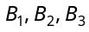 and 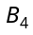 respectively.
R₁
O
R₂
2
1
3
4

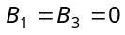
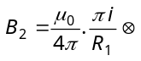
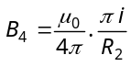 As 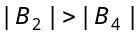
So 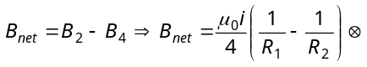
- (d) The magnetic induction at due to the current in portion will be zero because lies on when extended.
- (c) The magnetic induction due to both semicircular parts will be in the same direction perpendicular to the paper inwards.
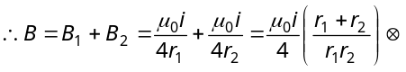
- (b) 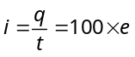
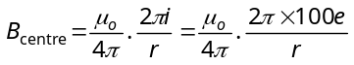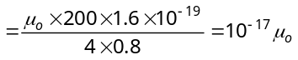
- (c) 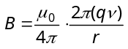 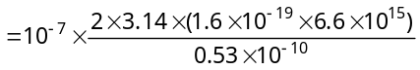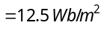
- (a)
- (d) The magnetic field at any point on the axis of wire be zero.
- (b) If a wire of length l is bent in the form of a circle of radius r then 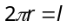 ⇒ 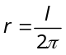
l = π²m

i = 2A

r

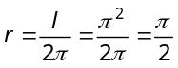
Magnetic field due to straight wire 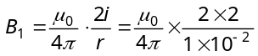 also magnetic field due to circular loop 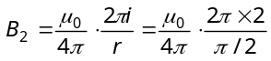⇒ 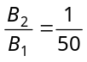
- (b) 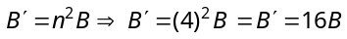
- (a)
- (d) 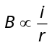
- (a) Magnetic field due to one side of the square at centre O 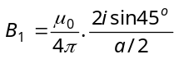⇒ 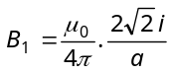
Hence magnetic field at centre due to all side 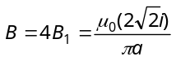
Magnetic field due to n turns 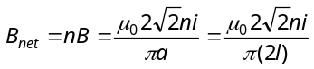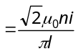 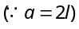
- (a) 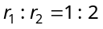 and 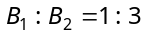 We know that 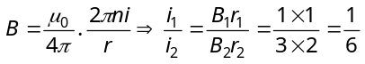
- (b)
- (b) Use Right hand palm rule or Maxwell’s Cork screw rule.
- (c) At P
P
r
r
i
i
1
2
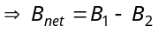
Since 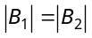
So, B_{net} = 0

- (c) The given circuit can be considered as follows
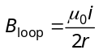
i
A
B
i
r
i
O
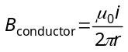
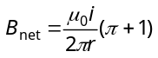
- (b) 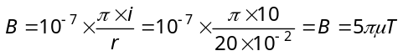
- (d) 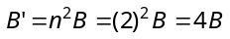
- (c) 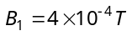
2cm
B₁
B_{net}
B₂
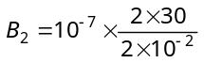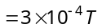
∴ 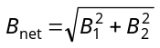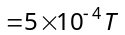
- (a)
- (c) Magnetic field due to different parts are
1
O
2
3
r
B₁ = 0
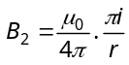
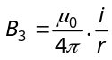
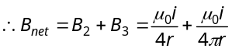
- (a)
i
B
→
N
E
W
S

- (b) Magnetic field at the center of single turn loop 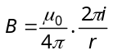, magnetic field at the center of n-turn loop
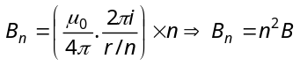
- (a) Magnetic field due to revolution of electron
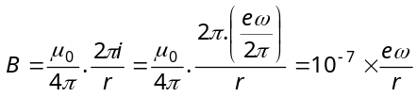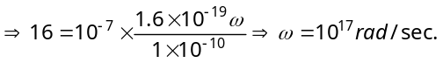
- (d) In the following figure magnetic field at mid point M is given by
M

P

Q

2.5 A

5 A

5 M

2.5 M

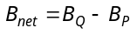
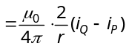
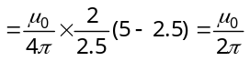
(a) Case 1 : 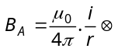
(A)
r
i
O
(B)
(C)
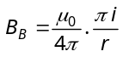
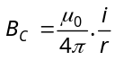
So net magnetic field at the centre of case 1
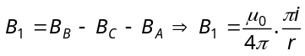 ..... (i)
Case 2 : As we discussed before magnetic field at the centre O in this case
r
O
i
(C)
(B)
(A)
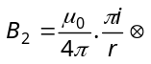 ..... (ii)

Case 3 : 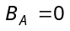
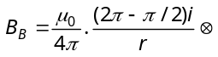
(B)
O
90º
r
i
(C)
(A)
◉
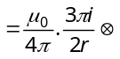
So net magnetic field at the centre of case 3
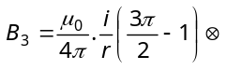 ..... (iii)
From equation (i), (ii) and (iii)
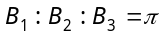 : 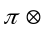 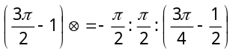
- (c) 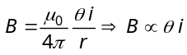 (but 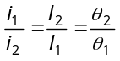)
1A
i₂
300º
1
2
60º
i₁
O
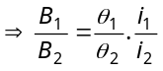
So, 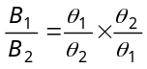
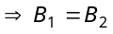
- (c) Number of turns per unit width 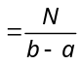
Consider an elemental ring of radius x and with thickness dx Number of turns in the ring 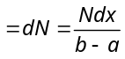
Magnetic field at the centre due to the ring element
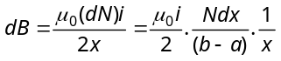
dx
a
b
x
Field at the centre
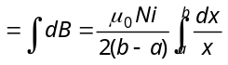
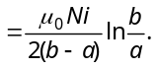
- (d) The magnetic field at 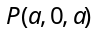 due to the loop is equal to the vector sum of the magnetic fields produced by loops ABCDA and AFEBA as shown in the figure.
Magnetic field due to loop ABCDA will be along and due to loop AFEBA, along . Magnitude of magnetic field due to both the loops will be equal.
C

D

A

B

P(a,0, a)

E

F

Therefore, direction of resultant magnetic field at P will be 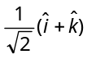.

- (a, b, d) Kinetic energy of the particle at point 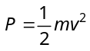
P
2a
a
2v
Q
X
Y
E
→
◉
B
→

K.E. of the particle at point 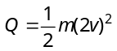
Increase in K.E. 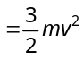
It comes from the work done by the electric force qE on the particle as it covers a distance 2a along the x-axis. Thus 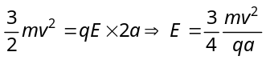. The rate of work done by the electric field at P 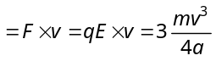
At 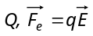 is along x-axis while velocity is along negative y-axis. Hence rate of work done by electric field 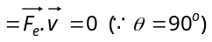 Similarly, according to equation 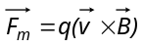
Force 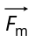is also perpendicular to velocity vector .
Hence the rate of work done by the magnetic field = 0
- (b) In the figure, the z-axis points out of the paper, and the magnetic field is directed into the paper, existing in the region between PQ and RS. The particle moves in a circular path of radius r in the magnetic field. It can just enter the region x > b for 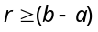
Q
S
y
x
R
P
v
O
x > b
x = b
x = a
⊗ B

Now, 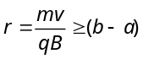
or 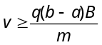 ⇒ 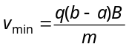
- (d) In P and R loops, currents are divided in same proportion because the branches have equal resistance. Hence magnetic field produced at centre due to each segment is of equal magnitude but of opposite direction, so net field is zero.
B = 0
B ≠ 0
B = 0

- (a) 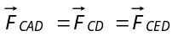
∴ Net force on frame 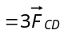 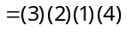 (F = ilB)
= 24 N
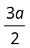
- (b)
O
5
3
X
4
2
1
a/2
Y
Z
Y
Z
X
(B₂–B₄)
(B₃ B₅)

Magnetic field at 0 due to
Part (1) : 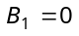
Part (2): 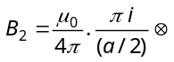 (along –Z-axis)
Part (3): 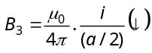 (along – Y-axis)
Part (4): 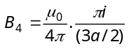 (along +Z-axis)
Part (5): 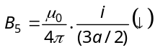 (along – Y-axis)
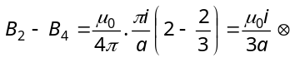 (along – Z-axis)
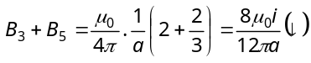 (along – Y-axis)
Hence net magnetic field
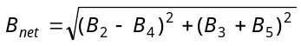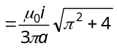
- b) Magnetic field at the centre due to one side
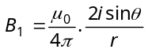where 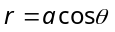
θ
θ
r
O
a
So 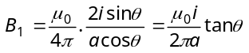
Hence net magnetic field
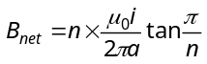.
- (d) The field at 0 due to AB is 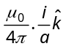 and that due to DE is also .
i
i
a
O
a
A
B
C
D
E
However the field due to BCD is 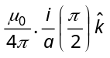.
Thus the total field at O is 