- A beam of ions with velocity 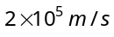 enters normally into a uniform magnetic field of 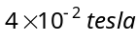. If the specific charge of the ion is 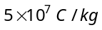, then the radius of the circular path described will be
(a) 0.10 m (b) 0.16 m (c) 0.20 m (d) 0.25 m

- An particle travels in a circular path of radius 0.45 m in a magnetic field 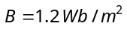 with a speed of 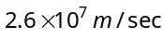. The period of revolution of the particle is
(a) 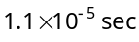 (b) 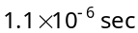 (c) 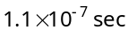 (d) 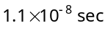

- A uniform magnetic field B is acting from south to north and is of magnitude 1.5 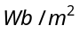. If a proton having mass 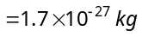 and charge 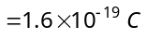 moves in this field vertically downwards with energy 5 MeV, then the force acting on it will be (a) 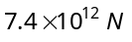 (b) 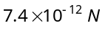 (c) 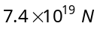 (d) 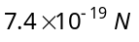

- A charged particle of mass m and charge q describes circular motion of radius r in a uniform magnetic field of strength B. The frequency of revolution is
(a) 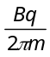 (b) 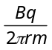 (c) 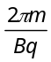 (d) 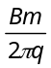

- An electron is accelerated by a potential difference of 12000 volts. It then enters a uniform magnetic field of 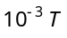 applied perpendicular to the path of electron. Find the radius of path. Given mass of electron 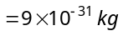 and charge on electron
(a) 36.7 m (b) 36.7 cm (c) 3.67 m (d) 3.67 cm

- Two particles A and B of masses 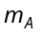 and 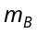 respectively and having the same charge are moving in a plane. A uniform magnetic field exists perpendicular to this plane. The speeds of the particles are  and 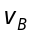 respectively, and the trajectories are as shown in the figure. Then
•
•
•
•
•
•
•
•
•
•
•
•
•
•
•
•
•
•
•
•
•
•
•
•
•
•
•
•
•
•
•
•
•
•
•
•
•
•
•
•
B
A
(a) 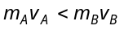
(b) 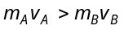
(c) 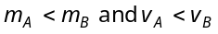
(d) 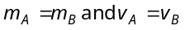

- Three long, straight and parallel wires carrying currents are arranged as shown in figure. The force experienced by 10 cm length of wire Q is
10cm
2cm
R
Q
10 A
20 A
30 A
P

(a) 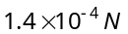 towards the right
(b) towards the left
(c) 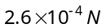 to the right
(d) to the left

- A 100 turns coil shown in figure carries a current of 2 amp in a magnetic field 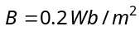. The torque acting on the coil is
N
S
A
B
D
C
10 cm
8 cm

(a) 0.32 Nm tending to rotate the side AD out of the page
(b) 0.32 Nm tending to rotate the side AD into the page
(c) 0.0032 Nm tending to rotate the side AD out of the page
(d) 0.0032 Nm tending to rotate the side AD into the page

- The coil of a galvanometer consists of 100 turns and effective area of 1 square cm. The restoring couple is 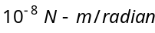. The magnetic field between the pole pieces is 5 T. The current sensitivity of this galvanometer will be
(a) 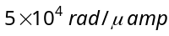 (b) 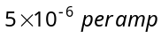 (c) 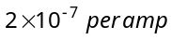 (d) 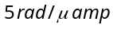

- What is the net force on the square coil
(a) 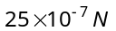 moving towards wire
2 cm
2 A
1 A
15 cm
10 cm
(b) moving away from wire
(c) 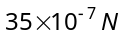 moving towards wire
(d) moving away from wire

- There long straight wires A, B and C are carrying current as shown figure. Then the resultant force on B is directed .....
1A
2A
3A
d
d
A
B
C
(a) Towards A
(b) Towards C
(c) Perpendicular to the plane of paper and outward
(d) Perpendicular to the plane of paper and inward

- If a long hollow copper pipe carries a direct current, the magnetic field associated with the current will be
(a) Only inside the pipe (b) Only outside the pipe
(c) Neither inside nor outside the pipe (d) Both inside and outside the pipe

- An infinitely long straight conductor is bent into the shape as shown in the figure. It carries a current of i ampere and the radius of the circular loop is r metre. Then the magnetic induction at its centre will be
r
O
i
(a) 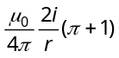
(b) 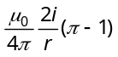 (c) Zero (d) Infinite
- A current i ampere flows in a circular arc of wire whose radius is R, which subtend an angle 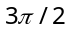 radian at its centre. The magnetic induction B at the centre is
O
R
π/2
i
(a) 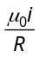
(b) 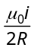
(c) 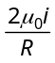 (d) 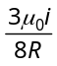

- A solenoid of 1.5 metre length and 4.0 cm diameter posses 10 turn per cm. A current of 5 ampere is flowing through it. The magnetic induction at axis inside the solenoid is
(a) 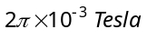 (b) 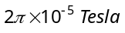 (c)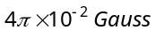 (d) 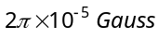

- A current of 0.1 A circulates around a coil of 100 turns and having a radius equal to 5 cm. The magnetic field set up at the centre of the coil is 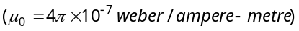
(a) 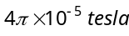 (b) 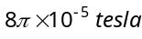 (c) 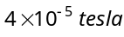 (d) 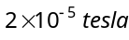

- The magnetic induction at the centre O in the figure shown is
(a) 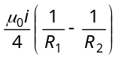
(b) 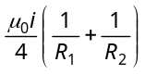
R₁
O
R₂
(c) 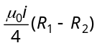
(d) 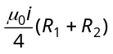

- In the figure, shown the magnetic induction at the centre of there arc due to the current in portion AB will be
(a) 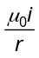
O
A
B
C
D
r
(b) 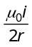
(c) 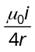
(d) Zero
- In the figure shown there are two semicircles of radii and in which a current i is flowing. The magnetic induction at the centre O will be
(a) 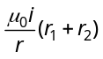
r₁
O
r₂
(b) 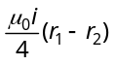
(c) 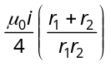
(d) 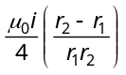

- A particle carrying a charge equal to 100 times the charge on an electron is rotating per second in a circular path of radius 0.8 metre. The value of the magnetic field produced at the centre will be 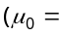 permeability for vacuum)
(a) 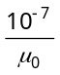 (b) 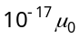 (c) 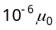 (d) 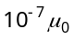
- In hydrogen atom, an electron is revolving in the orbit of radius 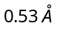 with 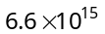rotations/second. Magnetic field produced at the centre of the orbit is (a)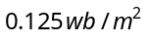 (b) 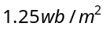 (c) 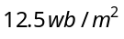 (d) 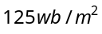

- A cell is connected between two points of a uniformly thick circular conductor. The magnetic field at the centre of the loop will be
(a) Zero (b) 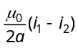 (c) 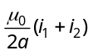 (d) 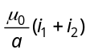

- A current of 1 ampere is passed through a straight wire of length 2.0 metres. The magnetic field at a point in air at a distance of 3 metres from either end of wire and lying on the axis of wire will be
(a) 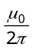 (b) 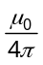 (c) 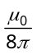 (d) Zero

- A straight wire of length 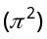 metre is carrying a current of 2A and the magnetic field due to it is measured at a point distant 1 cm from it. If the wire is to be bent into a circle and is to carry the same current as before, the ratio of the magnetic field at its centre to that obtained in the first case would be
(a) 50 : 1 (b) 1 : 50 (c) 100 : 1 (d) 1 : 100

- One metre length of wire carries a constant current. The wire is bent to form a circular loop. The magnetic field at the centre of this loop is B. The same is now bent to form a circular loop of smaller radius to have four turns in the loop. The magnetic field at the centre of this new loop is
(a) 4 B (b) 16 B (c) 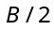 (d) 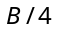

- A uniform wire is bent in the form of a circle of radius R. A current I enters at A and leaves at C as shown in the figure :
If the length ABC is half of the length ADC, the magnetic field at the centre O will be
(a) Zero
A
B
C
D
O
(b) 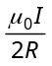
(c) 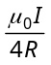
(d) 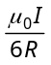

- A circular coil ‘A’ has a radius R and the current flowing through it is I. Another circular coil ‘B’ has a radius 2R and if 2I is the current flowing through it, then the magnetic fields at the centre of the circular coil are in the ratio of (i.e.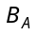 to 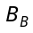)
(a) 4 : 1 (b) 2 : 1 (c) 3 : 1 (d) 1 : 1

- The magnetic field at the centre of coil of n turns, bent in the form of a square of side 2l , carrying current i, is
(a) 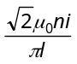 (b) 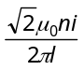 (c) 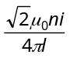 (d) 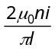

- A and B are two concentric circular conductors of centre O and carrying currents and as shown in the adjacent figure. If ratio of their radii is 1 : 2 and ratio of the flux densities at O due to A and B is 1 : 3, then the value of 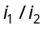 is (a)
i₁
i₂
r₁
r₂
B
A
O
(b)
(c)
(d)

- PQRS is a square loop made of uniform conducting wire the current enters the loop at P and leaves at S. Then the magnetic field will be
P
Q
R
S
(a) Maximum at the centre of the loop
(b) Zero at the centre of loop
(c) Zero at all points inside the loop
(d) Zero at all points outside of the loop

- A wire carrying current i is shaped as shown. Section AB is a quarter circle of radius r. The magnetic field is directed
i
B
A
C

(a) At an angle 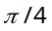 to the plane of the paper
(b) Perpendicular to the plane of the paper and directed in to the paper
(c) Along the bisector of the angle ACB towards AB
(d) Along the bisector of the angle ACB away from AB

- Two long straight wires are set parallel to each other. Each carries a current i in the same direction and the separation between them is 2r. The intensity of the magnetic field midway between them is
(a) 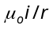
P
(b) 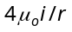
(c) Zero
(d) 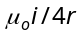

- A part of a long wire carrying a current i is bent into a circle of radius r as shown in figure. The net magnetic field at the centre O of the circular loop is
i
i
i
r
O
i
B
A
(a) 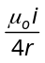
(b) 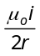
(c) 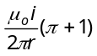 (d) 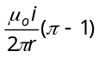

- A current of 10A is passing through a long wire which has semicircular loop of the radius 20cm as shown in the figure. Magnetic field produced at the centre of the loop is

(a) 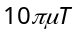
20 cm
P
10 A
(b) 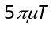
(c) 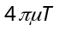
(d) 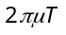

- A wire in the form of a circular loop of one turn carrying a current produces a magnetic field B at the centre. If the same wire is looped into a coil of two turns and carries the same current, the new value of magnetic induction at the centre is
(a) (b) (c) (d)

- A long straight wire carrying current of 30A is placed in an external uniform magnetic field of induction 4 × 10^{–4}T. The magnetic field is acting parallel to the direction of current. The magnitude of the resultant magnetic induction in tesla at a point 2.0 cm away from the wire is
(a) 10^{–4} (b) 3 × 10^{–4} (c) 5 × 10^{–4} (d) 6 × 10^{–4}

- A coil having N turns carry a current I as shown in the figure. The magnetic field intensity at point P is
I
x
P
R
(a) 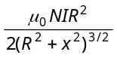
(b) 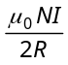
(c) 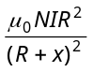
(d) Zero

- In the figure, what is the magnetic field at the point O
I
O
r
(a) 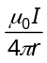
(b) 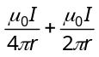
(c) 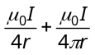
(d) 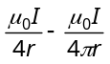

- A current flows in a conductor from east to west. The direction of the magnetic field at a points above the conductor is .....
(a) Towards north (b) Towards south (c)Towards east (d)Towards west

- A long wire carries a steady current. It is bent into a circle of one turn and the magnetic field at the centre of the coil is B. It is then bent into a circular loop of n turns. The magnetic field at the centre of the coil will be
(a) nB (b) n²B (c) 2nB (d) 2n²B

- An electron is revolving round a proton, producing a magnetic field of 16 weber/m² in a circular orbit of radius 1Å. It’s angular velocity will be
(a) 10¹⁷ rad/sec (b) 1/2π × 10¹² rad/sec (c)2 π × 10¹² rad/sec (d) 4 π × 10¹² rad/sec

- The magnetic field at the centre of a circular coil of radius r is times that due to a long straight wire at a distance r from it, for equal currents. Figure here shows three cases : in all cases the circular part has radius r and straight ones are infinitely long. For same current the B field at the centre P in cases 1, 2, 3 have the ratio
P
(1)
P
(3)
P
(2)

(a) 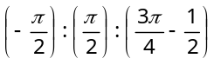 (b) 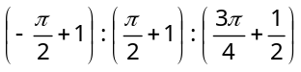 (c)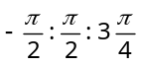 (d) 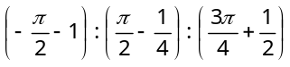

- A cell is connected between the points A and C of a circular conductor ABCD of centre O with angle A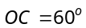. If 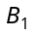 and 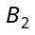 are the magnitudes of the magnetic fields at O due to the currents in ABC and ADC respectively, the ratio 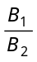 is
1A
i₂
300º
B
C
A
D
60º
i₁
O
(a) 0.2
(b) 6
(c) 1
(d) 5

- A coil having N turns is wound tightly in the form of a spiral with inner and outer radii a and b respectively. When a current I passes through the coil, the magnetic field at the centre is
(a) 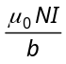 (b) 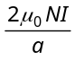 (c) 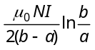 (d) 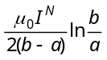

- A non-planar loop of conducting wire carrying a current I is placed as shown in the figure. Each of the straight sections of the loop is of length 2a. The magnetic field due to this loop at the point P (a,0,a) points in the direction
z
y
x
i
2a
(a) 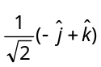
(b) 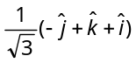
(c) 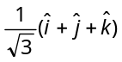
(d) 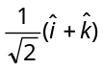

- A particle of charge +q and mass m moving under the influence of a uniform electric field 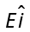 and a uniform magnetic field 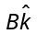 follows trajectory from P to Q as shown in figure. The velocities at P and Q are and 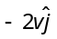 respectively. Which of the following statement(s) is/are correct
P
O
2a
a
2v
Q
X
Y
v
→
E
→
(a)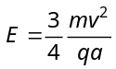
(b) Rate of work done by electric field at P is 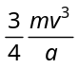
(c) Rate of work done by electric field at P is zero
(d) Rate of work done by both the fields at Q is zero

- A particle of mass m and charge q moves with a constant velocity v along the positive x direction. It enters a region containing a uniform magnetic field B directed along the negative z direction, extending from x = a to x = b. The minimum value of v required so that the particle can just enter the region is
(a) 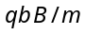 (b) 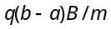 (c) 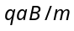 (d) 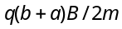

- Two thick wires and two thin wires, all of the same materials and same length form a square in the three different ways P, Q and R as shown in fig with current connection shown, the magnetic field at the centre of the square is zero in cases
P
Q

R

(a) In P only (b) In P and Q only (c)In Q and R only (d) P and R only
- Same current i = 2A is flowing in a wire frame as shown in figure. The frame is a combination of two equilateral triangles ACD and CDE of side 1m. It is placed in uniform magnetic field B = 4T acting perpendicular to the plane of frame. The magnitude of magnetic force acting on the frame is
(a) 24 N
(b) Zero
×
×
×
×
×
×
×
×
×
×
×
×
×
×
×
×
×
×
×
×
×
×
×
×
×
×
×
×
×
×
×
×
×
×
×
×
×
×
×
×
C
D
E
A
(c) 16 N
(d) 8 N

- In the given figure net magnetic field at O will be
(a) 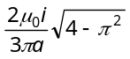
(0,0)
O
i
(a, 0)
i
(2a,0)
(3a,0)
i
(b) 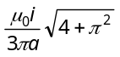
(c) 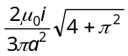
(d) 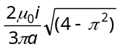

- In the following figure a wire bent in the form of a regular polygon of n sides is inscribed in a circle of radius a. Net magnetic field at centre will be
(a) 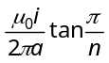
θ
θ
θ = π/n
i
(b) 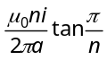
(c) 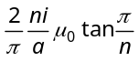
(d) 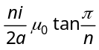

- The unit vectors 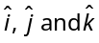 are as shown below. What will be the magnetic field at O in the following figure
i
i
a
O
a
j
^
k
^
i
^
(a) 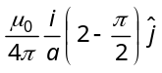
(b) 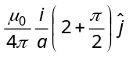
(c) 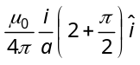
(d) 