KEY

1 | 2 | 3 | 4 | 5 | 6 | 7 | 8 | 9 | 10 | 11 | 12 | 13 | 14 | 15
C | B | B | A | D | D | D | C | A | B | C | B | A | A | A
16 | 17 | 18 | 19 | 20 | 21 | 22 | 23 | 24 | 25 | 26 | 27 | 28 | 29 | 30
D | C | A | D | A | C | A | A | A | A | B | A | C | A | C

HINTS AND SOLUTIONS
- (c) Since 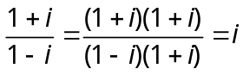
Therefore 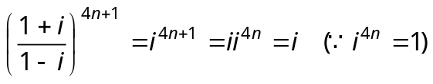
- (b) 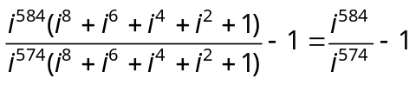 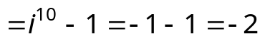

- (b) 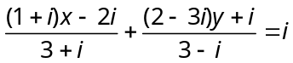 ⇒ 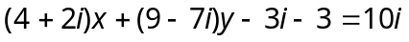
Equating real and imaginary parts, we get 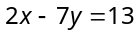 and 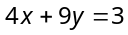. Hence and 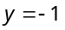.

- (a) 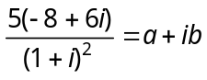⇒ 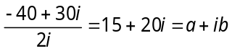
Equating real and imaginary parts, we get and .

- (d) 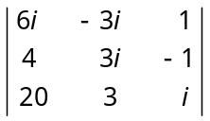=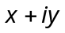 ⇒ 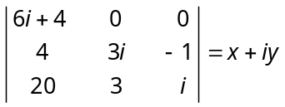 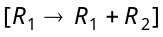
⇒ 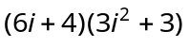= ⇒ 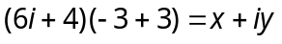⇒ 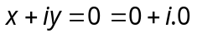 ⇒ 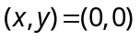.

- (d) 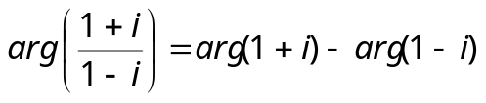 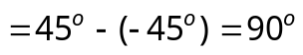
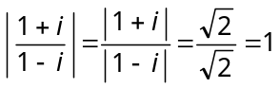.

- (d)
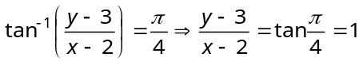 ⇒ 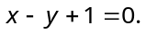

- (c) We have 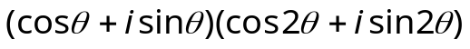......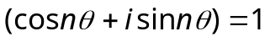
⇒
⇒ 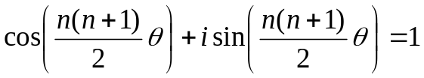⇒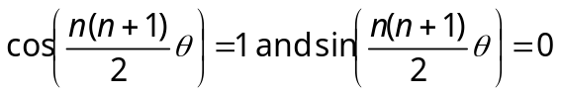
⇒ 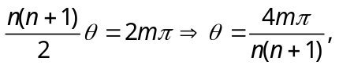where 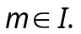

- (a) 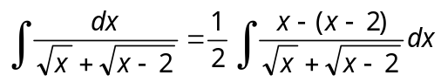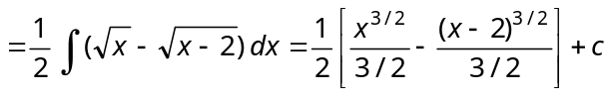 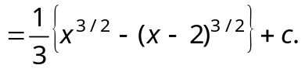

- (b) 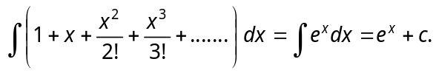

- (c) 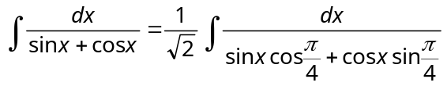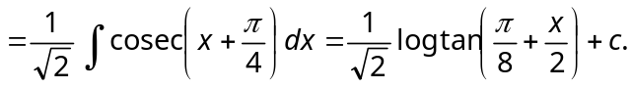

- (b) 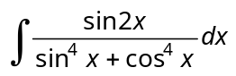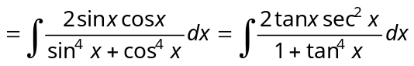
Put 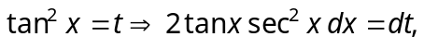 then it reduced to 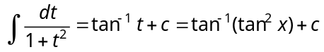.

- (a) Put 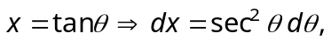 then
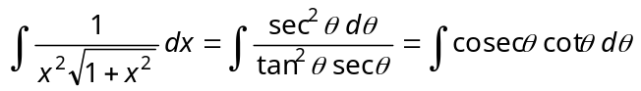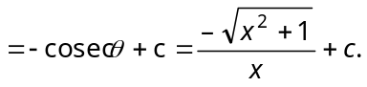

- (a) 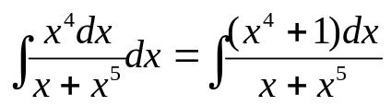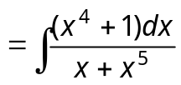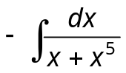
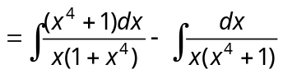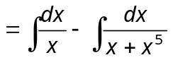
Where 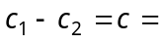a new constant.

- (a) 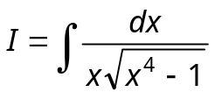
Put 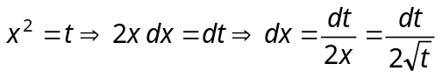 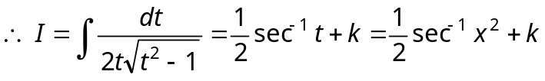

- (d) 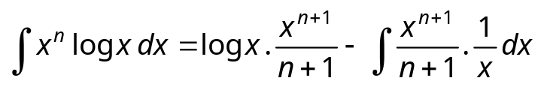
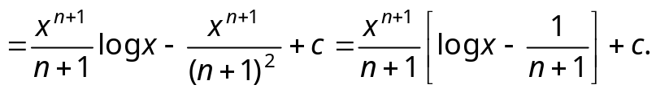

- (c) 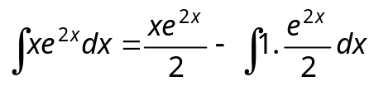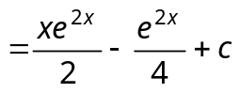 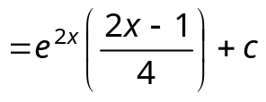
⇒ 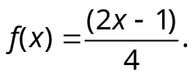

- (a) 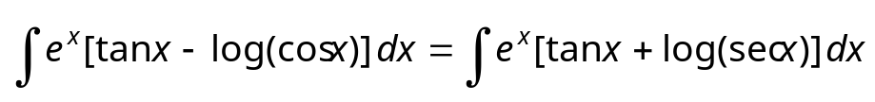
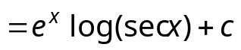 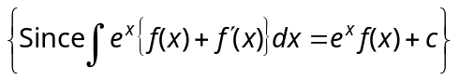.

- (d) 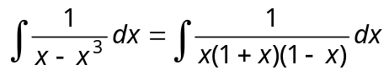 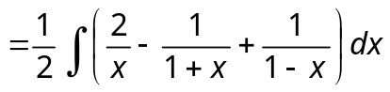
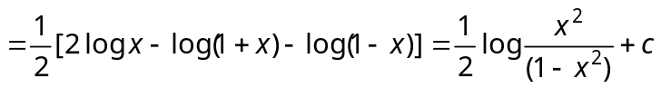.

- (a) Put 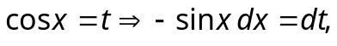 then
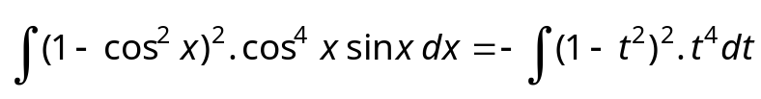
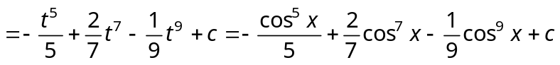.

- (c) 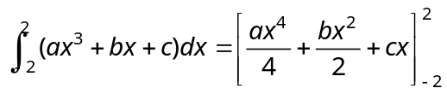= 4c. Hence depends on 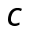.

- (a) Put 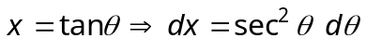 Also as 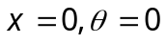and 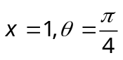
Therefore, 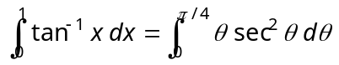 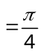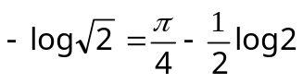.

- (a) Put 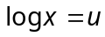in 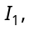so that 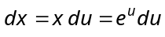 Also as 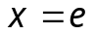to 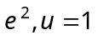to 2
Thus, 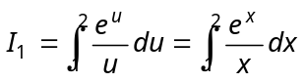. Hence, 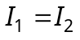.

- (a) 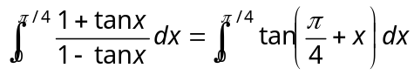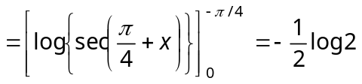.

- (a) Divide 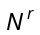 and 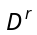by 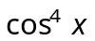
∴ 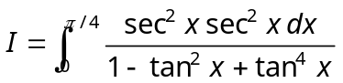
Put 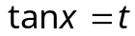and 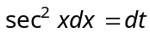and adjust the limits, we get 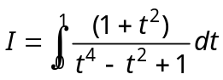
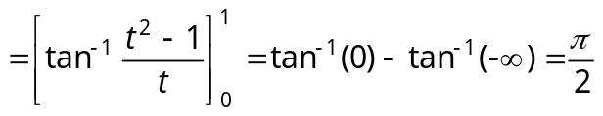.

- (b) 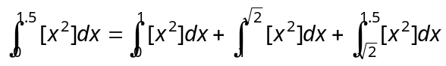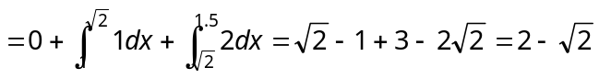.

- (a) 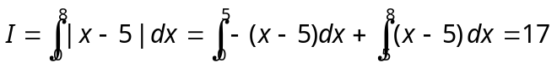.

- (c) 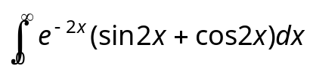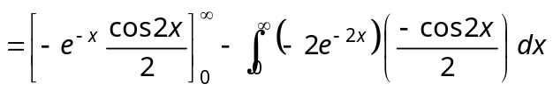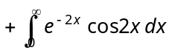
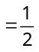.
- (a) 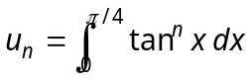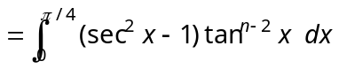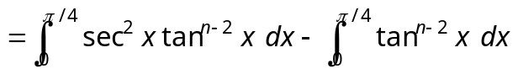
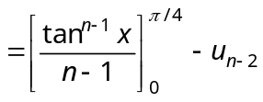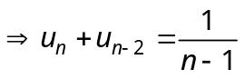.

- (c) For 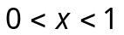, we have 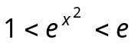, so that 