KEY

1 | 2 | 3 | 4 | 5 | 6 | 7 | 8 | 9 | 10 | 11 | 12 | 13 | 14 | 15
B | C | D | A | B | D | B | C | D | D | D | A | B | C | C
16 | 17 | 18 | 19 | 20 | 21 | 22 | 23 | 24 | 25 | 26 | 27 | 28 | 29 | 30
B | A | A | A | C | A | D | C | C | A | D | A | C | B | C

HINTS AND SOLUTIONS
- (b) p : examination is difficult, q : I shall pass, r : I study hard
Given result is : 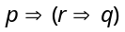 Now 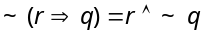
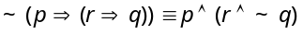
The examination is difficult and I study hard but I shall not pass.

- (c) is false, when p is true and q is false.
Since q, r are false ∴ is false.
Since r is false ∴ ~r is true.
Since 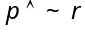 is true ∴ p is true.

- (d)
p | q | ~q | p⋀~q | ~(p⋀~q) | 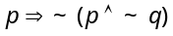
T | T | F | F | T | T
T | F | T | T | F | F
F | T | F | F | T | T
F | F | T | F | T | T
Result is neither tautology nor contradiction.

- (a) means FF = F, ~r means F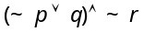 means F
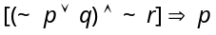 means T [ in we have FTT]

- (b) .

- (d) Let p : Ram is in Class X, q : Rahim is in class XII
Given proposition is
Its negation is 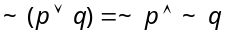
i.e. Ram is not in class X and Rahim is not in class XII.

- (b) We have 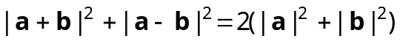
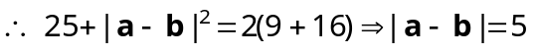.

- (c) Since 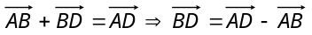
Hence unit vector in the direction of 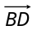 is
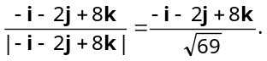

- (d) 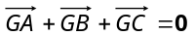 and 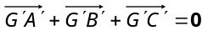
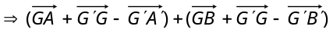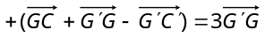
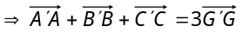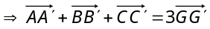.

- (d) 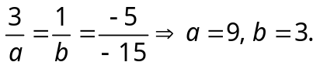

- (d) 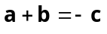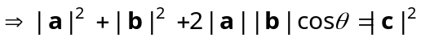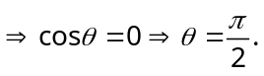

- (a) 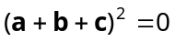 ⇒
⇒ ⇒ 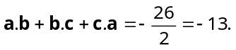

- (b) Required value 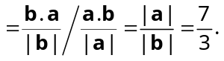

- (c) 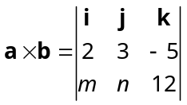 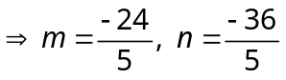.

- (c) We know that 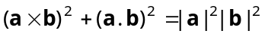 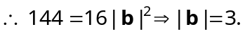

- (b) If angle between and is and 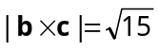⇒ 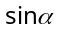 = 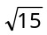
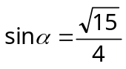 ; 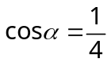
= 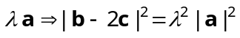
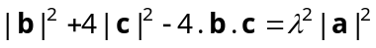
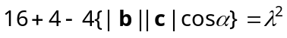
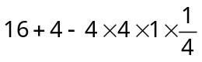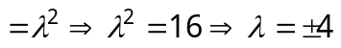.

- (a) Let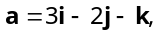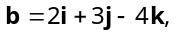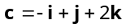 and 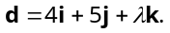
Since the points are coplanar,
So, 
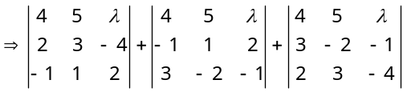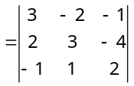
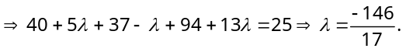

- (a) 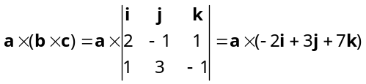
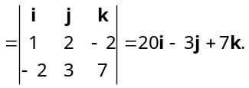

- (a) Since 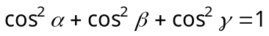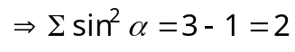.

- (c) Direction ratio of normal to the plane
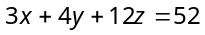 is 3, 4, 12.
D.c's are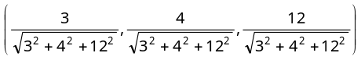 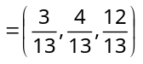.

- (a) Trick : Both lines are satisfied by (–1,–1, –1).

- (d) S.D.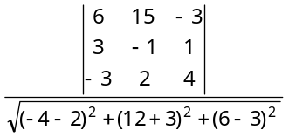 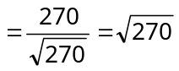 = 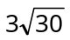.

- (c) Lines are perpendicular if 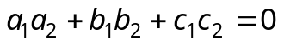
Hence, 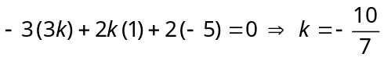.

- (c) 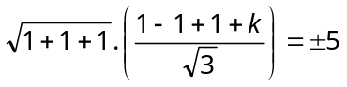 or 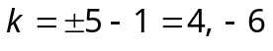.

- (a) Plane passing through (1, 1, 1) is 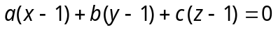
It also passes through (1, – 1, 1) and (–7, – 3, – 5), then 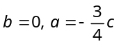
Hence the required equation is .
Trick : Since the plane passes through given three points.

- (d) The plane will be or 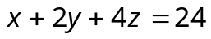.

- (a) 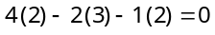 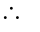Line is parallel to the plane.

- (c) 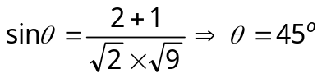.

- (b) Any plane through given line is
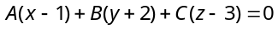.....(i) and …..(ii)
Since, plane (i) passes through (4, 3, 7), we get .....(iii)
Solving (ii) and (iii), we get 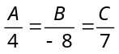
Equation of required plane is 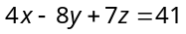.

- (c) Since the line lies on the given plane, therefore any point on the line will satisfy the plane i.e., the points (3, 4, 5) and (5, 7, 9) will lie on the plane. Hence 