- Negation of the compound proposition : If the examination is difficult, then I shall pass if I study hard
(a) The examination is difficult and I study hard and I shall pass
(b) The examination is difficult and I study hard but I shall not pass
(c) The examination is not difficult and I study hard and I shall pass
(d) None of these

- If p and q are simple propositions, then is false when
(a) p is true and q is true (b) p is false and q is true
(c) p is true and q is false (d) Both p and q are false

- The proposition 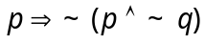 is
(a) Contradiction (b) A tautology
(c) Either (a) or (b) (d) Neither (a) nor (b)

- If p, q, r are simple propositions with truth values T, F, T, then the truth value of 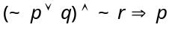 is
(a) True (b) False (c) True if r is false (d) True if q is true

- 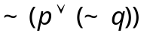 is equal to
(a) (b) 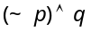 (c) 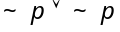 (d) 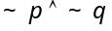

- Negation of “Ram is in Class X or Rashmi is in Class XII” is
(a) Ram is not in class X but Ram is in class XII
(b) Ram is not in class X but Rashmi is not in class XII
(c) Either Ram is not in class X or Ram is not in class XII
(d) None of these

- If 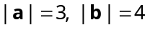 and 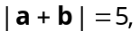 then 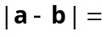
(a) 6 (b) 5 (c) 4 (d) 3

- If ABCD is a parallelogram, 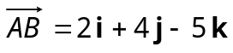 and 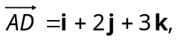 then the unit vector in the direction of BD is
(a) 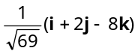 (b) 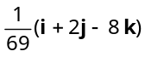 (c) 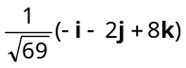 (d) 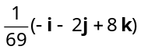

- If G and G' be the centroids of the triangles ABC and respectively, then 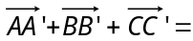
(a) 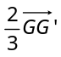 (b) 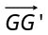 (c) 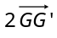 (d) 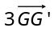

- The vectors 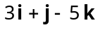 and 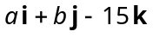are collinear, if
(a) 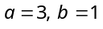 (b) 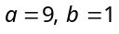 (c) 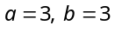 (d) 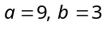

- If 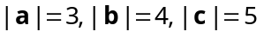 and 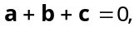 then the angle between a and b is
(a) 0 (b) 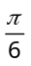 (c) 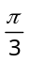 (d) 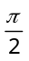

- If 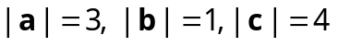 and 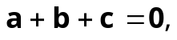 then 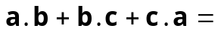
(a) – 13 (b) – 10 (c) 13 (d) 10

- If vector 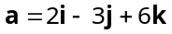 and vector 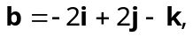 then 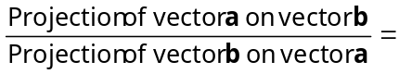
(a) (b) (c) 3 (d) 7

- If 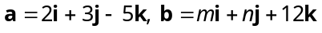 and 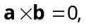 then 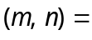
(a) 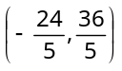 (b) 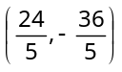 (c) 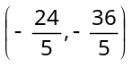 (d) 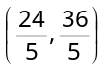

- If 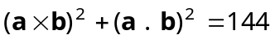 and 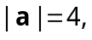 then 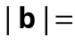
(a) 16 (b) 8 (c) 3 (d) 12

- Let 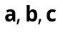 be three vectors such that 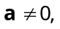 and 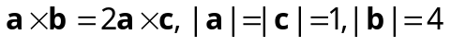 and 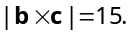 If 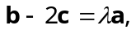 then λ equals to
(a) 1 (b) 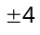 (c) 3 (d) – 2

- If the points whose position, vectors are 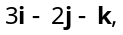 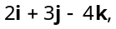 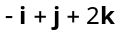and 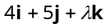 lie on a plane, then 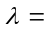
(a) 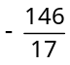 (b) 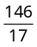 (c) 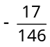 (d) 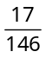

- If 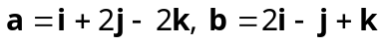and 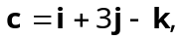 then 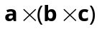 is equal to
(a)  (b) 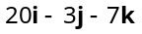 (c)  (d) None of these

- If 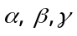be the angles which a line makes with the positive direction of co-ordinate axes, then 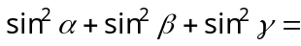
(a) 2 (b) 1 (c) 3 (d) 0

- The direction cosines of the normal to the plane 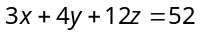 will be
(a) 3, 4, 12 (b) – 3, – 4, – 12 (c) 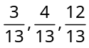 (d) 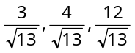

- The point of intersection of lines 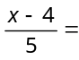 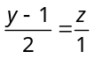 and 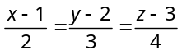 is
(a) (–1, –1, –1) (b) (–1, –1, 1) (c) (1, –1, –1) (d) (–1, 1, –1)

- The shortest distance between the lines 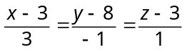 and 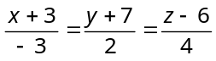 is
(a) 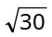 (b) 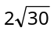 (c) 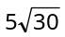 (d) 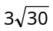

- If the lines 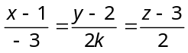, 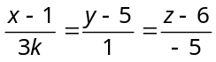 are at right angles, then k =
(a) –10 (b) 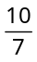 (c) 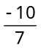 (d) 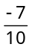

- If the product of distances of the point (1, 1, 1) from the origin and the plane 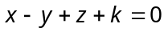 be 5, then k =
(a) – 2 (b) –3 (c) 4 (d) 7

- The equation of the plane through the three points (1, 1, 1), (1, –1, 1) and (–7,–3,–5), is
(a) (b) 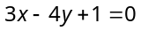 (c) 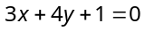 (d) None of these

- The equation of the plane through (2, 3, 4) and parallel to the plane 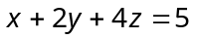is
(a) 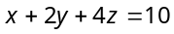 (b) 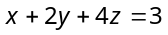 (c) 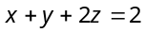 (d) 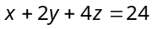

- If the equation of a line and a plane be 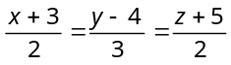and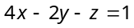respectively, then
(a) Line is parallel to the plane (b) Line is perpendicular to the plane
(c) Line lies in the plane (d) None of these

- The angle between the line 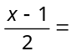 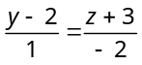 and the plane 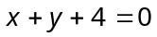, is
(a) (b) (c) (d)

- The equation of the plane passing through the line 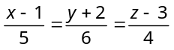and the point (4, 3, 7) is
(a) 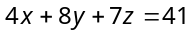 (b) 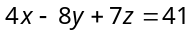 (c) 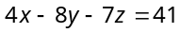 (d) 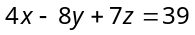

- The line 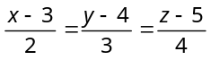 lies in the plane 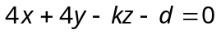. The values of k and d are
(a) 4, 8 (b) –5, – 3 (c) 5, 3 (d) – 4, – 8

