- (c) As it is seen from the magnet side induced current will be anticlockwise.
- (a) 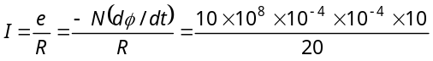= 5 A
- (d) 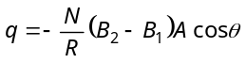 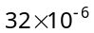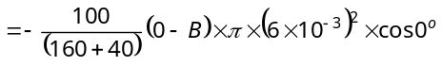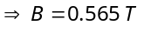
- (d) 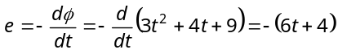
- (c) 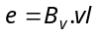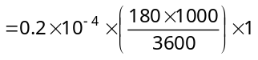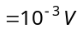
- (b) 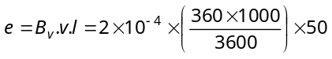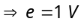
- (d) No flux change is taking place because magnetic field exists everywhere and is constant in time and space.
- (c) Peak value of 
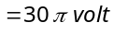
- (c) 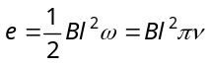
- (d) 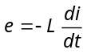 but e =4V and 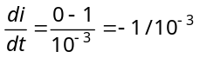 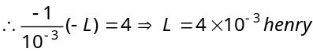
- (d) Induced emf 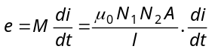
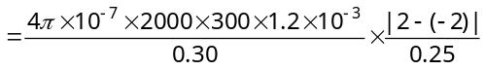
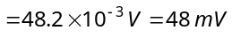
- (b) In steady state current passing through solenoid 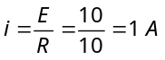
- (d) 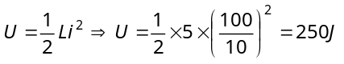
- (d) 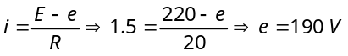
- (a) Efficiency 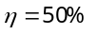So 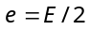 and 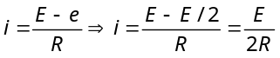
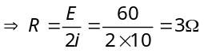
- (c) 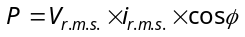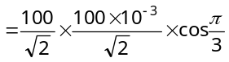 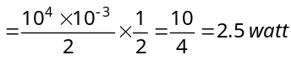
- (c) Hot wire ammeter reads rms value of current. Hence its peak value 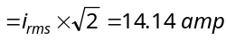
- (b) 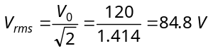
- (b) 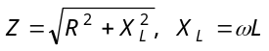and 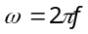 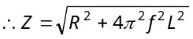
- (c) 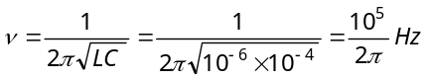
- (b) 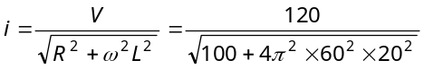=0.016 A
- (b) Reactance 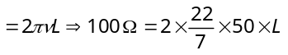 
- (b)
- (a) Current in LC circuit becomes maximum when resonance occurs. So
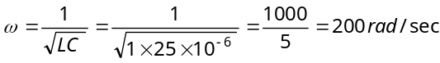
- (a) 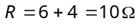
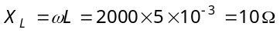
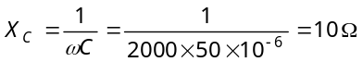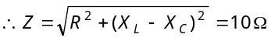
Amplitude of current 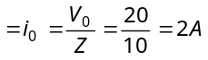
- (c) 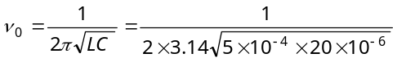 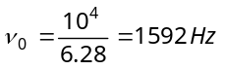
- (a) 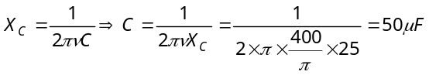
- (d) 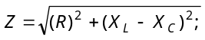
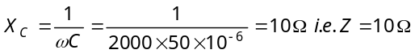
Maximum current 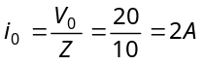 Hence 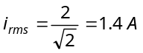
and 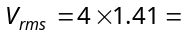5.64 V
- (a) At angular frequency ω, the current in RC circuit is given by
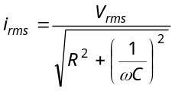 ......(i) Also 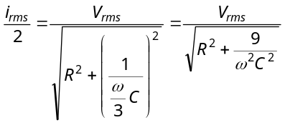 ......(ii)
From equation (i) and (ii) we get
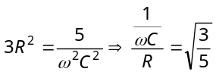⇒ 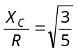
- (d) 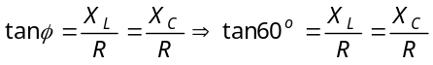
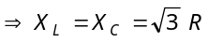 i.e. 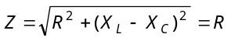
So average power 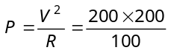= 400 W
- (b) 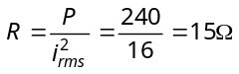
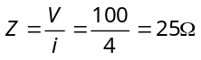
Now 