- A metallic ring is attached with the wall of a room. When the north pole of a magnet is brought near to it, the induced current in the ring will be
a
N
S
(a) First clockwise then anticlockwise
(b) In clockwise direction
(c) In anticlockwise direction
(d) First anticlockwise then clockwise

- In a coil of area 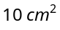 and 10 turns with a magnetic field directed perpendicular to the plane and is changing at the rate of 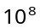gauss/second. The resistance of the coil is 20 ohm. The current in the coil will be
(a) 5 amp (b) 0.5 amp (c) 0.05 amp (d) 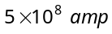

- A coil of 40 Ω resistance has 100 turns and radius 6 mm is connected to ammeter of resistance of 160 ohms. Coil is placed perpendicular to the magnetic field. When coil is taken out of the field, 32 μ C charge flows through it. The intensity of magnetic field will be
(a) 6.55 T (b) 5.66 T (c) 0.655 T (d) 0.566 T

- The magnetic flux linked with a coil, in webers, is given by the equations 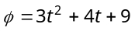. Then the magnitude of induced e.m.f. at t = 2 second will be
(a) 2 volt (b) 4 volt (c) 8 volt (d) 16 volt

- Two rails of a railway track insulated from each other and the ground are connected to a milli voltmeter. What is the reading of voltmeter, when a train travels with a speed of 180 km/hr along the track. Given that the vertical component of earth's magnetic field is 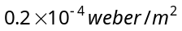 and the rails are separated by 1 metre
(a) 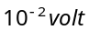 (b) 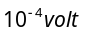 (c) 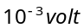 (d) 1 volt

- An aeroplane in which the distance between the tips of wings is 50 m is flying horizontally with a speed of 360 km/hr over a place where the vertical components of earth magnetic field is 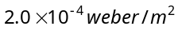. The potential difference between the tips of wings would be
(a) 0.1 V (b) 1.0 V (c) 0.2 V (d) 0.01 V

- A conducting square loop of side L and resistance R moves in its plane with a uniform velocity v perpendicular to one of its sides. A magnetic induction B constant in time and space, pointing perpendicular and into the plane of the loop exists everywhere. The current induced in the loop is

(a) 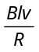clockwise
×
×
×
×
×
×
×
×
×
×
×
×
×
×
×
×
×
×
×
×
×
×
×
×
A
B
C
D
v
→
B
→
(b) anticlockwise
(c) 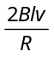anticlockwise
(d) Zero

- A rectangular coil of 300 turns has an average area of average area of 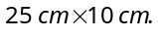 The coil rotates with a speed of 50 cps in a uniform magnetic field of strength 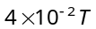 about an axis perpendicular of the field. The peak value of the induced e.m.f. is (in volt)
(a) 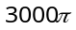 (b) 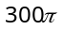 (c) 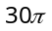 (d) 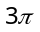

- A rod of length 20 cm is rotating with angular speed of 100 rps in a magnetic field of strength 0.5 T about it’s one end. What is the potential difference between two ends of the rod
(a) 2.28 V (b) 4.28 V (c) 6.28 V (d) 2.5 V

- A solenoid has 2000 turns wound over a length of 0.30 metre. The area of its cross-section is 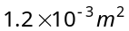. Around its central section, a coil of 300 turns is wound. If an initial current of 2 A in the solenoid is reversed in 0.25 sec, then the e.m.f. induced in the coil is
(a) 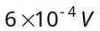 (b) 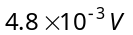 (c) 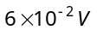 (d) 48 mV

- A coil is wound as a transformer of rectangular cross-section. If all the linear dimensions of the transformer are increased by a factor 2 and the number of turns per unit length of the coil remain the same, the self inductance increased by a factor of
(a) 16 (b) 12 (c) 8 (d) 4

- When current in a coil changes to 2 ampere from 8 ampere in 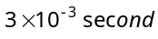, the e.m.f. induced in the coil is 2 volt. The self inductance of the coil in millihenry is
(a) 1 (b) 5 (c) 20 (d) 10

- A coil of resistance 10 Ω and an inductance 5H is connected to a 100 volt battery. Then energy stored in the coil is
(a) 125 erg (b) 125 J (c) 250 erg (d) 250 J

- The armature of dc motor has 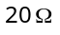 resistance. It draws current of 1.5 ampere when run by 220 volts dc supply. The value of back e.m.f. induced in it will be
(a) 150 V (b) 170 V (c) 180 V (d) 190 V

- An electric motor operating on a 60 V dc supply draws a current of 10 A. If the efficiency of the motor is 50%, the resistance of its winding is
(a) (b) (c) (d)

- In an ac circuit, V and I are given by V = 100 sin (100 t) volts, 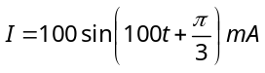. The power dissipated in circuit is
(a) 10⁴ watt (b) 10 watt (c) 2.5 watt (d) 5 watt

- In a circuit, the value of the alternating current is measured by hot wire ammeter as 10 ampere. Its peak value will be
(a) 10 A (b) 20 A (c) 14.14 A (d) 7.07 A

- The frequency of an alternating voltage is 50 cycles/sec and its amplitude is 120V. Then the r.m.s. value of voltage is
(a) 101.3V (b) 84.8V (c) 70.7V (d) 56.5V
- An alternating current of frequency 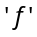 is flowing in a circuit containing a resistance R and a choke L in series. The impedance of this circuit is
(a) R + 2πfL (b) 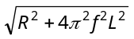 (c) 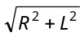 (d) 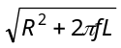

- A resonant ac circuit contains a capacitor of capacitance 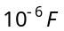 and an inductor of 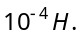 The frequency of electrical oscillations will be
(a) 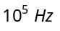 (b) 10 Hz (c) 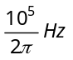 (d) 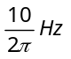

- An inductive circuit contains resistance of 10 Ω and an inductance of 20 H. If an ac voltage of 120 V and frequency 60 Hz is applied to this circuit, the current would be nearly
(a) 0.32 amp (b) 0.016 amp (c) 0.48 amp (d) 0.80 amp

- The reactance of a coil when used in the domestic ac power supply (220 volt, 50 cycles) is 100 ohm. The self inductance of the coil is nearly
(a) 3.2 henry (b) 0.32 henry (c) 2.2 henry (d) 0.22 henry

- In a series LCR circuit, operated with an ac of angular frequency , the total impedance is
(a) 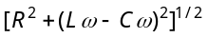 (b) 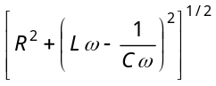
(c) 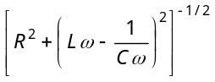 (d) 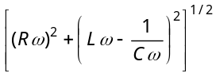

- A series ac circuit consists of an inductor and a capacitor. The inductance and capacitance is respectively 1 henry and 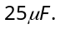 If the current is maximum in circuit then angular frequency will be
(a) 200 (b) 100 (c) 50 (d) 200/2

- In the circuit shown below, the ac source has voltage 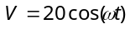 volts with = 2000 rad/sec. the amplitude of the current will be nearest to
6 Ω
50 μF
5 mH, 4Ω
(a)
(b)
(c) 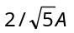
(d) 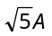

- An oscillator circuit consists of an inductance of 0.5mH and a capacitor of 20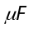. The resonant frequency of the circuit is nearly
(a) 15.92 Hz (b) 159.2 Hz (c)1592 Hz (d)15910 Hz

- Reactance of a capacitor of capacitance 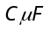 for ac frequency 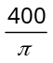 Hz is . The value C is
(a) 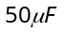 (b) 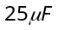 (c) 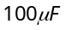 (d) 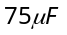

- In the circuit shown in the figure, the ac source gives a voltage 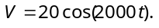 Neglecting source resistance, the voltmeter and ammeter reading will be
V
A
5mH
50μF
6Ω
4Ω

(a) 0V, 0.47A (b) 1.68V, 0.47A
(c) 0V, 1.4 A (d) 5.6V, 1.4 A

- An ac source of angular frequency ω is fed across a resistor r and a capacitor C in series. The current registered is I. If now the frequency of source is changed to ω/3 (but maintaining the same voltage), the current in then circuit is found to be halved. Calculate the ratio of reactance to resistance at the original frequency ω
(a) 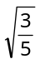 (b) 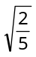 (c) 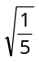 (d) 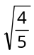

- An LCR series circuit with a resistance of 100 ohm is connected to an ac source of 200 V (r.m.s.) and angular frequency 300 rad/s. When only the capacitor is removed, the current lags behind the voltage by 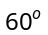. When only the inductor is removed the current leads the voltage by . The average power dissipated is
(a) 50 W (b) 100 W (c) 200 W (d) 400 W

- A virtual current of 4A and 50 Hz flows in an ac circuit containing a coil. The power consumed in the coil is 240 W. If the virtual voltage across the coil is 100 V its inductance will be
(a) 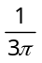H (b) 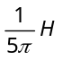 (c) 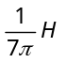 (d) 