- (b) Distance between object and image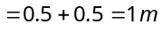

- (b) Relative velocity of image man
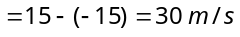
Image
Man
15m/s
15m/s

- (c) 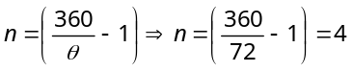
- (c)
60°
30°
30°
Incident ray
Reflected ray
Surface
30°

- (a) Subtract the given time from 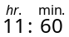
60°
50°
40°
β
α
(90°–θ)
θ
A
B
C
D
- (c) Let required angle be θ

From geometry of figure
In Δ ABC; α = 180° – (60° + 40°) = 80°
⇒ β = 90° – 80° = 10°
In Δ ABD; ∠A = 60°, ∠B = (α + 2β)
= (80 + 2 × 10) = 100° and ∠D = (90° – θ)
∠A + ∠B + ∠D =180° ⇒ 60° + 100° + (90° – θ) = 180° ⇒ θ = 70°
- (b) Size is 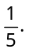 It can’t be plane and concave mirror, because both conditions are not satisfied in plane or concave mirror. Convex mirror can meet all the requirements
- (a) Let distance Now 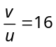 and 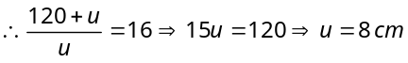.
- (b) 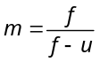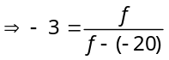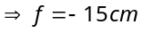
- (c) To see the container half-filled from top, water should be filled up to height so that bottom of the container should appear to be raised upto height (21–x).
As shown in figure apparent depth 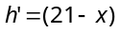
Real depth
(21 – x )
x
Bottom
Raised bottom
(21 – x )
21 cm

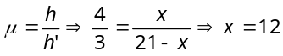cm
- (b)  ∠ i > ∠ r, it means light ray is going from rarer medium (A) to denser medium.
So 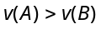 and 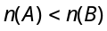
- (b) 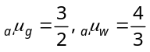 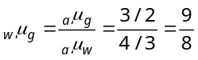

- (a) 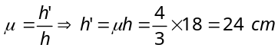
- (d) When total internal reflection just takes place from lateral surface i.e. 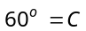
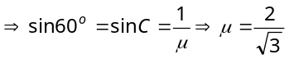
Time taken by light to traverse some distance in a medium 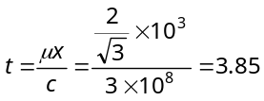μ sec.
- (b) At point A, by Snell’s law
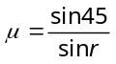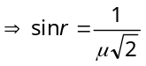 .....(i)
45°
A
μ
90°
B
i₁
r
Air
At point B, for total internal reflection 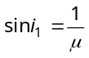
From figure, 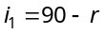
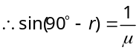
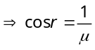 .....(ii)
Now 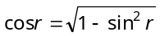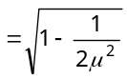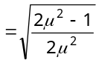 .....(iii)
From equation (ii) and (iii) 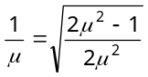 Squaring both side and then solving we get 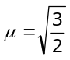
- (d) 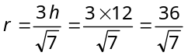.
- (b) In each case two plane-convex lens are placed close to each other, and 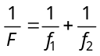.
- (b) 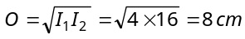
- (d) 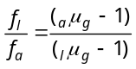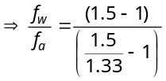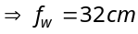
- (b) Since aperture of lens reduces so brightness will reduce but their will be no effect on size of image
- (c) Total power 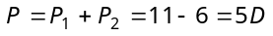 Also 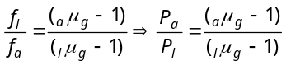 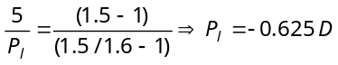
- (b) According to lens makers formula 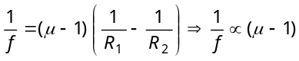 Since 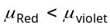 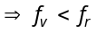and 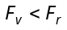
- (a) Total deviation = 0
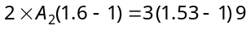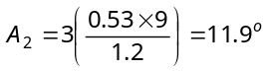
- (a) The dispersive power for crown glass 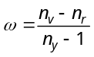 = 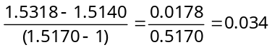
and for flint glass 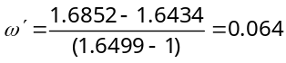
45°
r
A
B
C
- (c) 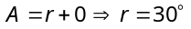
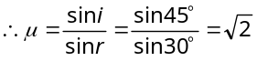

- (c) By formula 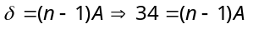 and in the second position 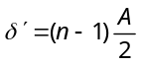 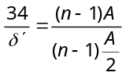 or 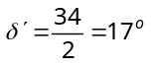
- (a) From figure it is clear that TIR takes place at surface AC
45º
45º
45º
90º
A
C
B
and BC
i.e. 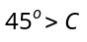
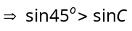
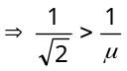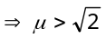 Hence 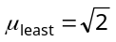
- (b) 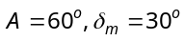so 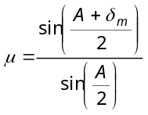 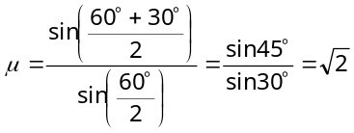
Also 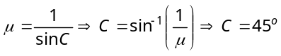
- (a) 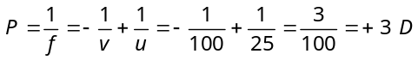
- (a) For improving near point, convex lens is required and for this convex lens
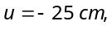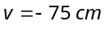
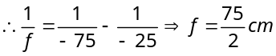 So power 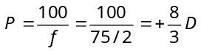
- (b) For improving far point, concave lens is required and for this concave lens 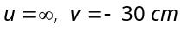
So 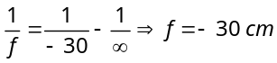 for near point 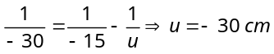
- (c) For lens u = want’s to see 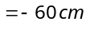
v = can see 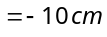 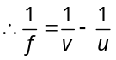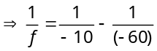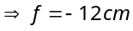
- (c) For correcting myopia, concave lens is used and for lens.
u = wants to see 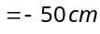
v = can see 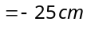 From 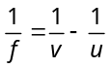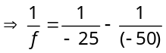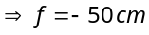 So power 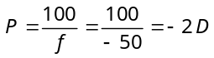
- (a) For lens u = wants to see = – 30 cm and v = can see = – 10 cm
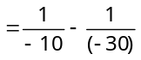
- (a) 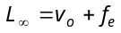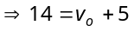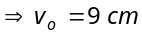
Magnifying power of microscope for relaxed eye 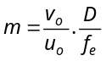 or 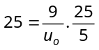 or 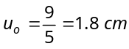
- (c) If nothing is said then it is considered that final image is formed at infinite and 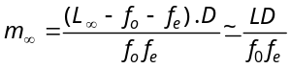
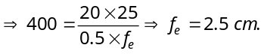
- (a) When final image is formed at infinity,
length of the tube 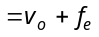 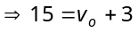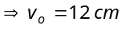
For objective lens 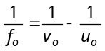 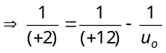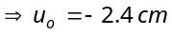
- (c) 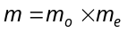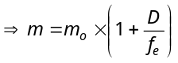 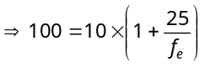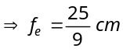
- (b) 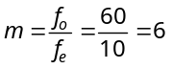.
- (a) Limit of resolution 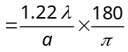 (in degree) 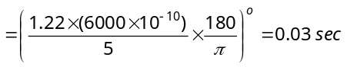
- (b) For normal vision (relaxed eye), the image is formed at infinity. Hence the magnifying power of Gallilean telescope 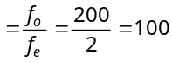.
- (a) Resolving power 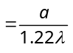
- (d) 

