MASTERS PRE-UNIVERSITY COLLEGE, HASSAN 573201.
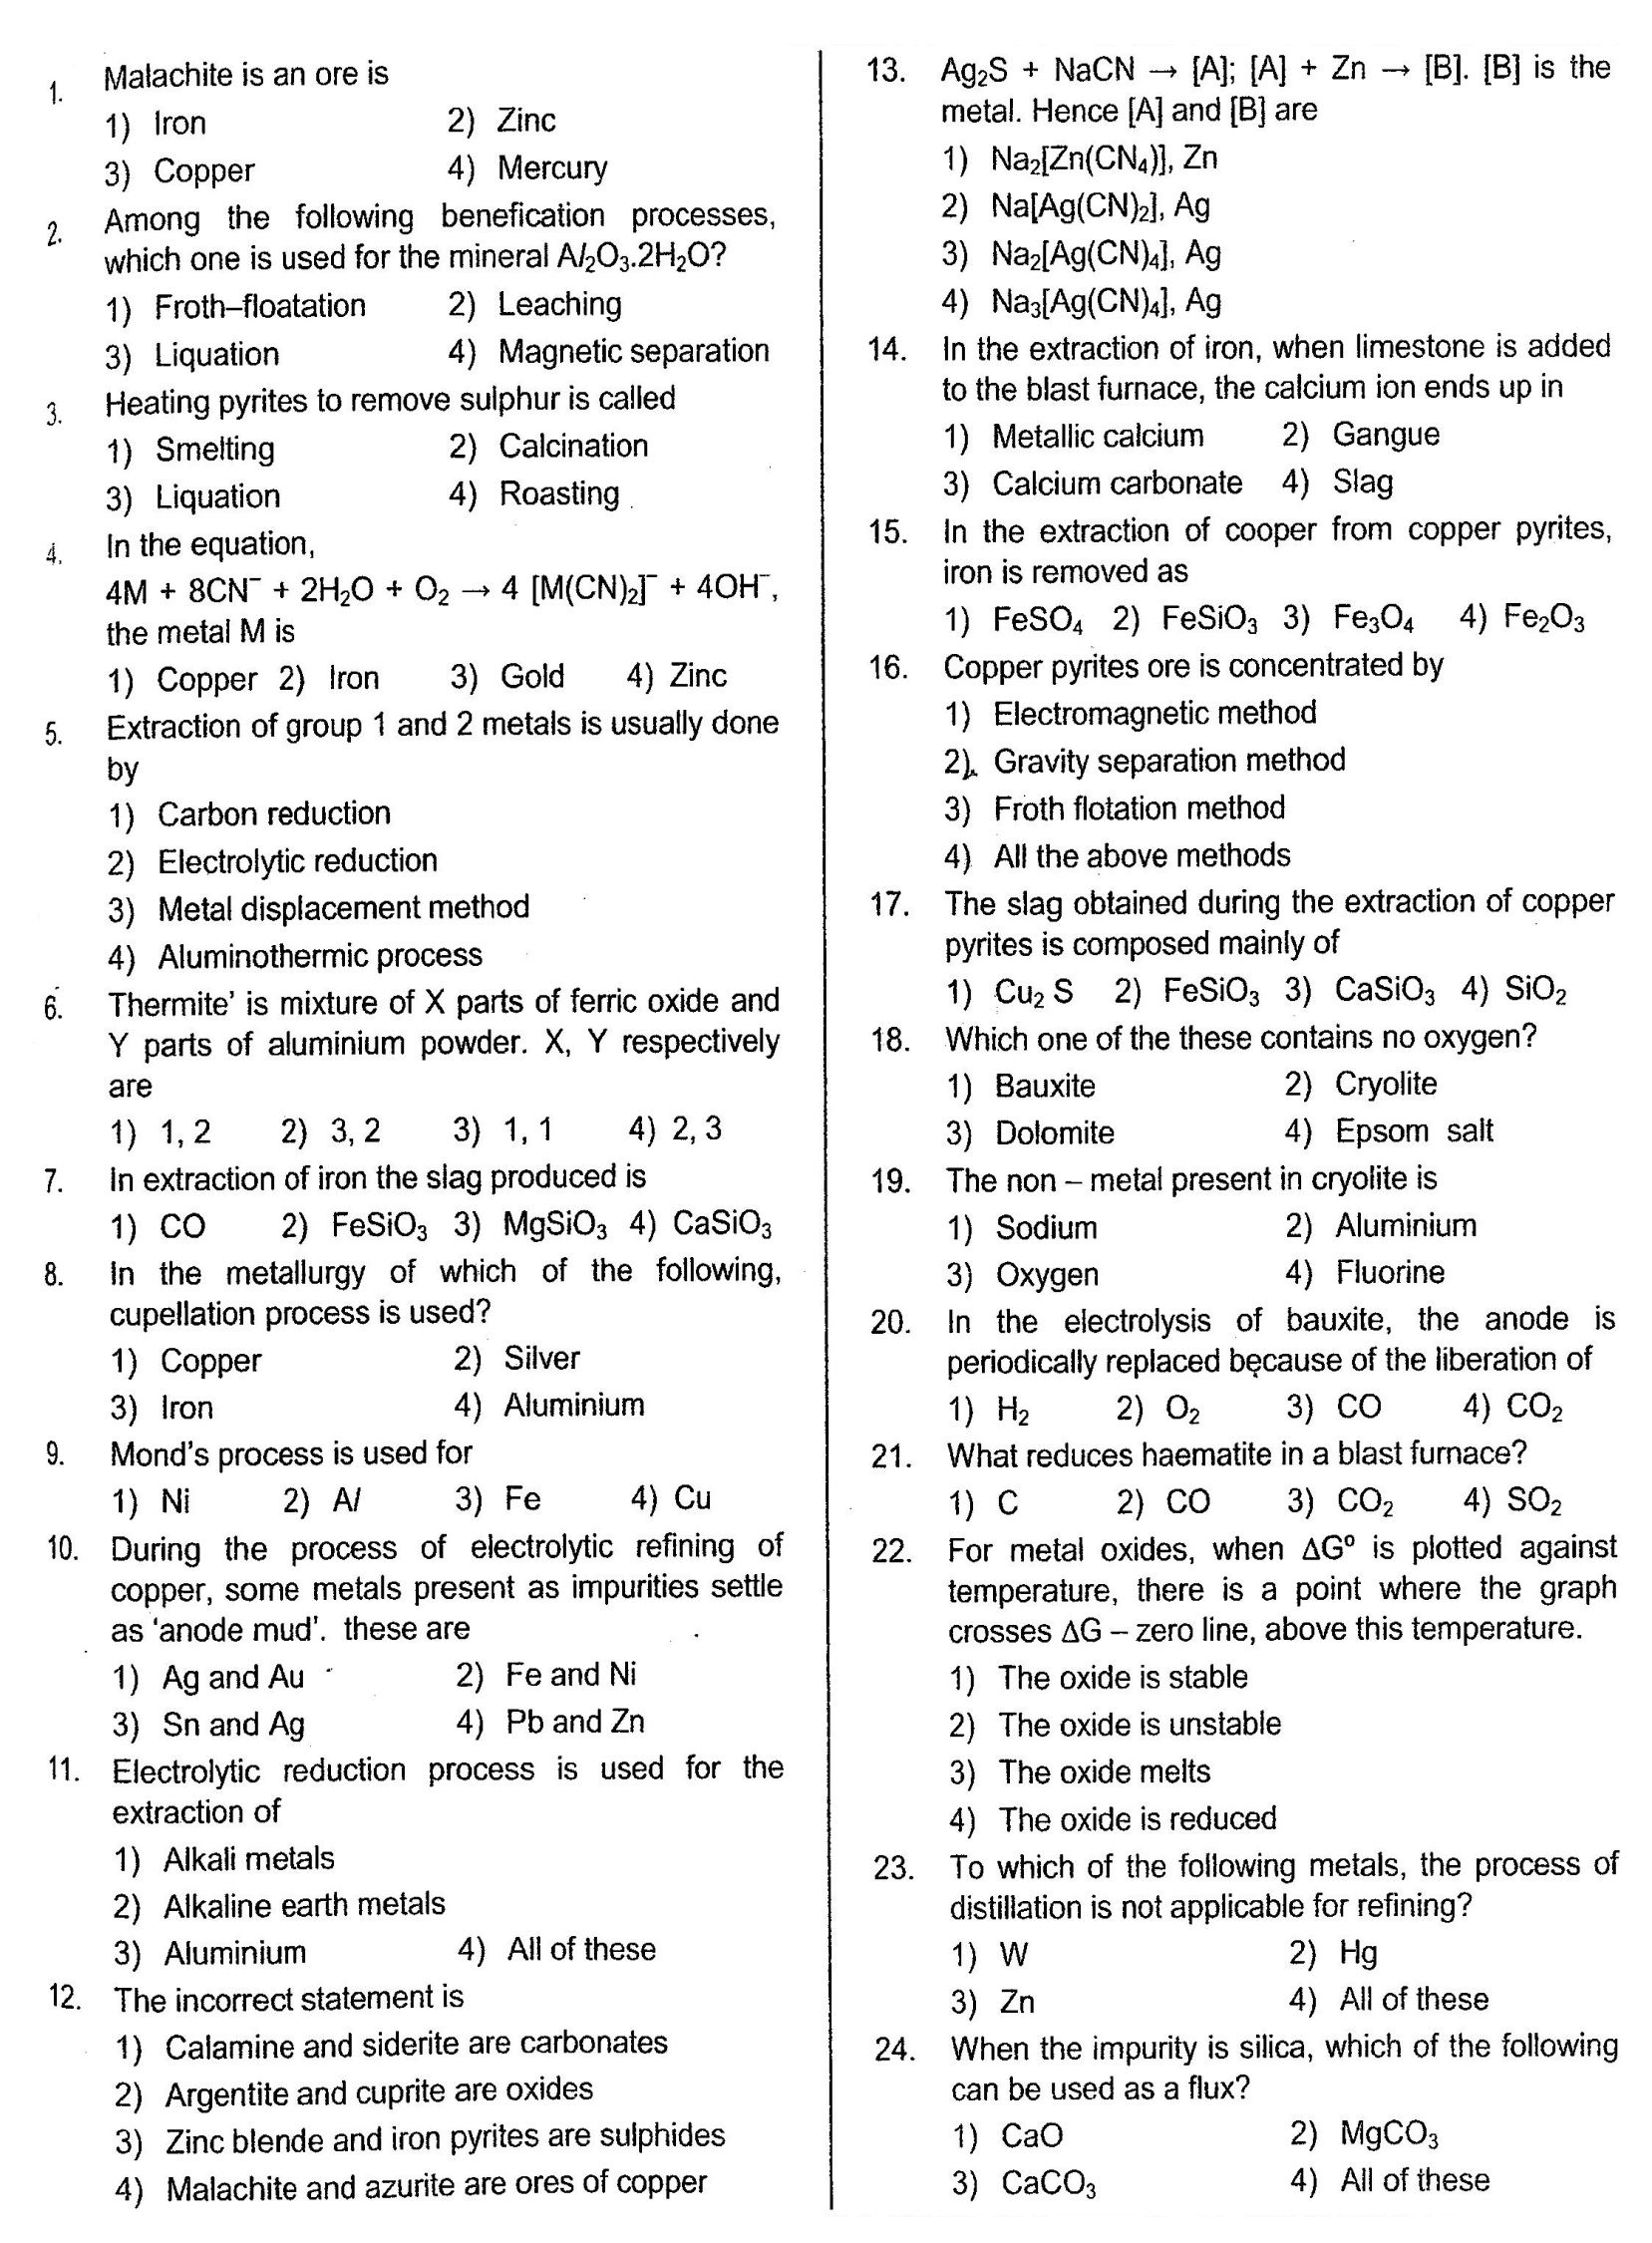
CHEMISTRY: Topic:- Principles and processes of Extraction of Elements
