MASTER’S P.U COLLEGE, HASSAN, 573201.
KCET ONLINE TEST-10, APRIL-2020 MATHEMATICS TIME: 45Mins
TOPIC: COMPLETE TRIGONOMETRY & I.T.F MARKS: 30

KEY

1 | 2 | 3 | 4 | 5 | 6 | 7 | 8 | 9 | 10 | 11 | 12 | 13 | 14 | 15
C | B | B | B | C | D | B | B | D | C | B | B | A | B | A
16 | 17 | 18 | 19 | 20 | 21 | 22 | 23 | 24 | 25 | 26 | 27 | 28 | 29 | 30
B | C | C | D | A | C | B | C | A | D | B | C | A | A | D

HINTS AND SOLUTIONS

- (c) (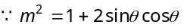)
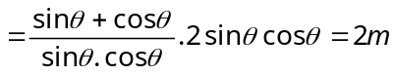.

- (b) We have 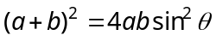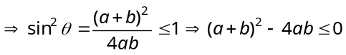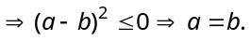

- (b) 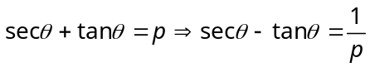
Subtracting second from first, we get 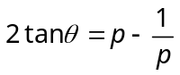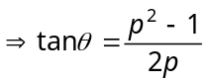.

- (b) 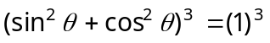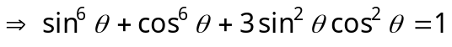
and 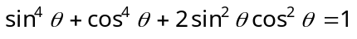
Both gives,
.

- (c) 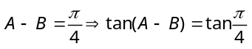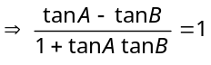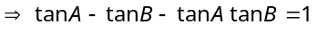
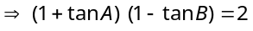 ⇒ 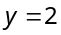
Hence, 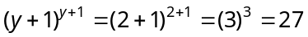.
Trick : Put suitable A and B as 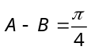
i.e.,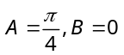 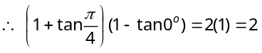.

- (d) 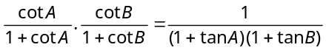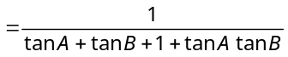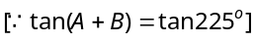
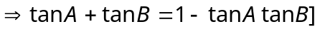 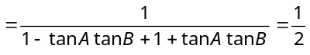.

- (b) 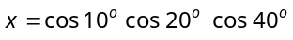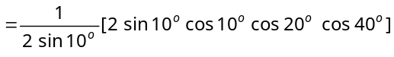
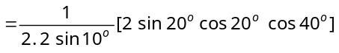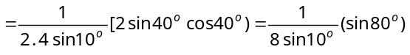
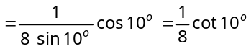.

- (b) 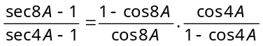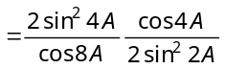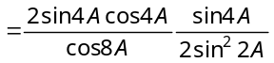
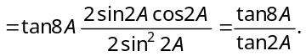

- (d) The minimum value of is 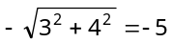
Hence the minimum value of .

- c) The greatest value of 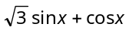 is 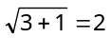 and obviously it will be at .
Aliter : 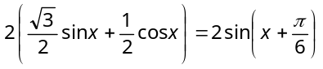
As is maximum at 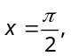 so 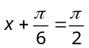 or 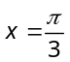.

- (b) 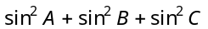
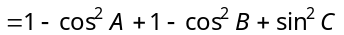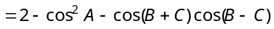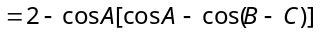
∴ .

- (b) We have 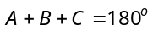 ⇒ 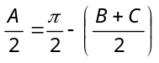 ∴ 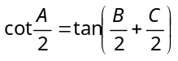 ⇒ 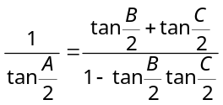
⇒ 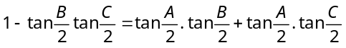
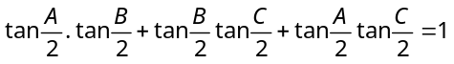 i.e., 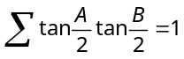.

- (a) 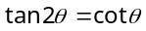 ⇒ 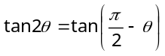
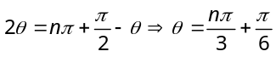.

- (b) 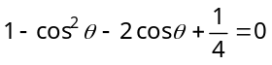 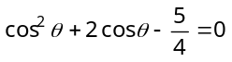 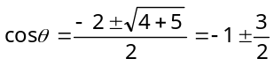
Since 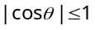, hence 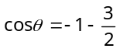 is ruled out.
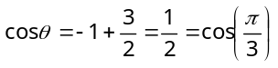 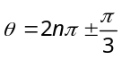.

- (a) 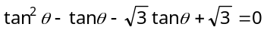 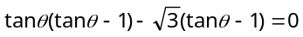
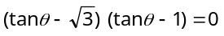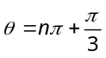, 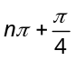.

- (b) Obviously 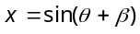 and 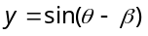
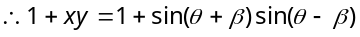
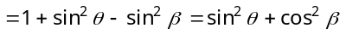.

- (c) We have 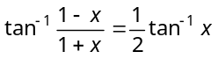
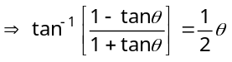 (Putting 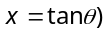
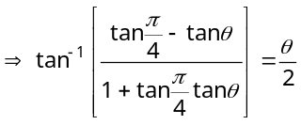
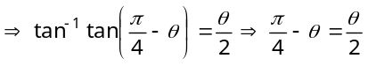
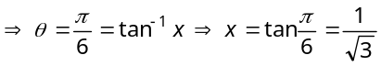.

- (c) 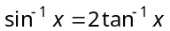 ⇒ 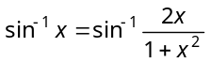
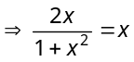 ⇒ 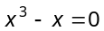
⇒ 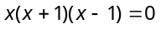 ⇒ 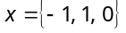.

- (d) 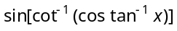
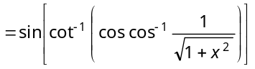
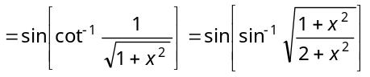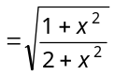.

- (a) 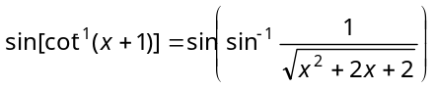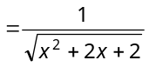
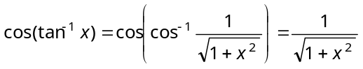
Thus, 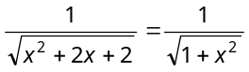
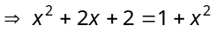 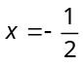.

- (c) Given equation is 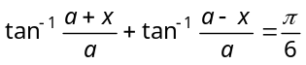
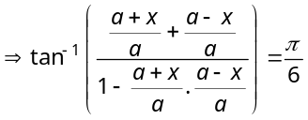
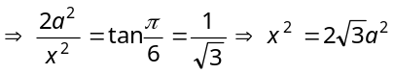.

- (b) Putting 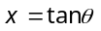
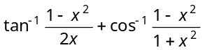
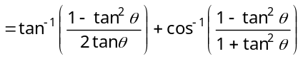
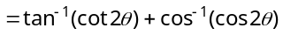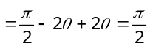.

- (c) Given that 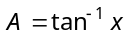
Now 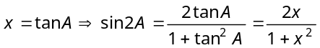.

- a) If 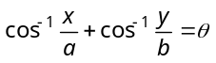
Then 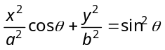
Here 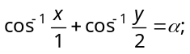
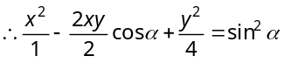
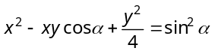
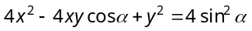.

- (d) 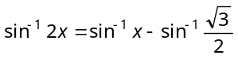
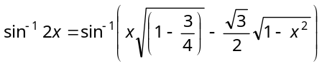
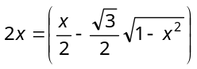
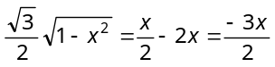
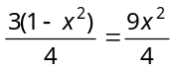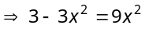⇒ 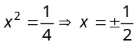.

- (b) 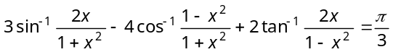
Putting
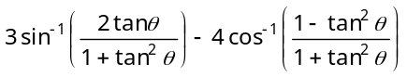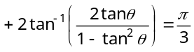
⇒ 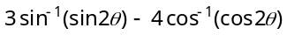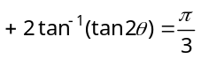
⇒ 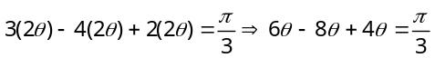
⇒ 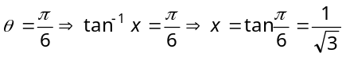

- (c) 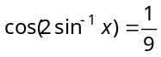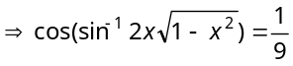⇒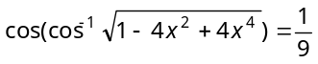
⇒ 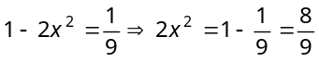⇒ 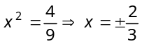.

- (a) We have 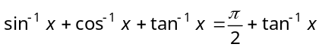
Since 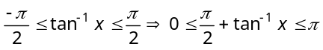
∴ 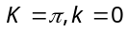.

- (a) From previous solution 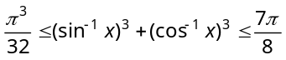
Here 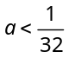. So, number of solution is zero.

- (d)
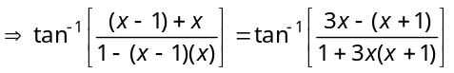
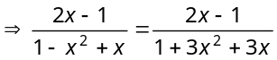
On simplification 