MASTER’S P.U COLLEGE, HASSAN, 573201.
KCET ONLINE TEST-12, APRIL-2020 MATHEMATICS TIME: 45Mins MARKS: 30
TOPIC: VECTORS, PERMUTATIOS &COMBINATIONS, BINOMIAL THEOREM, PROBABILITY, RANDOM VARIABLES, STATASTICS.
KEY

1 | 2 | 3 | 4 | 5 | 6 | 7 | 8 | 9 | 10 | 11 | 12 | 13 | 14 | 15
B | C | B | B | A | C | C | B | D | B | B | B | B | C | B
16 | 17 | 18 | 19 | 20 | 21 | 22 | 23 | 24 | 25 | 26 | 27 | 28 | 29 | 30
A | B | D | C | A | B | A | C | B | D | A | B | B | D | D

HINTS AND SOLUTIONS
- (b) Total number of arrangements of books 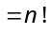.
If two specified books always together then number of ways 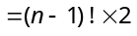
Hence required number of ways 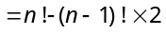.

- (c) Required number of ways = 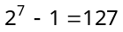.{Since the case that no friend be invited i.e., 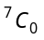 is excluded}.

- (b) 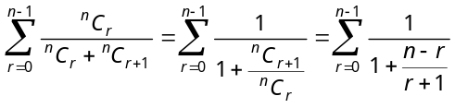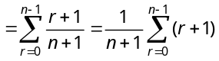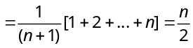.

- (b) For number of term, 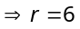
Thus coefficient of x^{–7} is 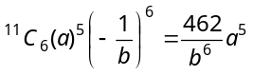

- (a) Let the given series be identical with the expansion of 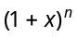 i.e. with 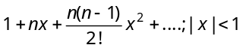. Then, 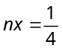 and 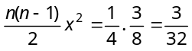 Solving these two equations for n and x. We get 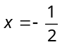 and 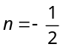.
∴ Sum of the given series = 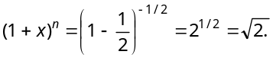

- (c) Putting the values of 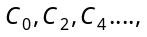we get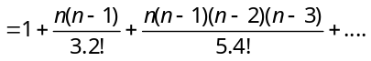 =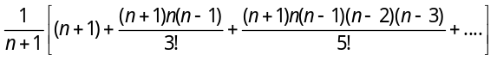
Put =N = 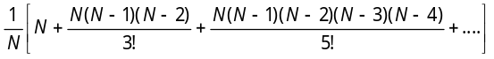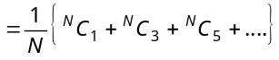
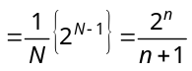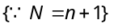

- (c) We know that, Mean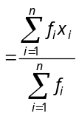
i.e., 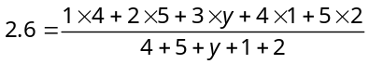
or 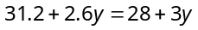 or 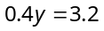 ⇒ 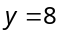.

- (b) We know that,
Mode = 3 Median – 2 Mean = 3(22) – 2(21) = 66 – 42 = 24.

- (d) When each item of a data is multiplied by , variance is multiplied by 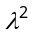.
Hence, new variance 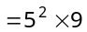.

- (b) Trick : Here is the only vector 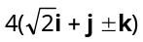, whose length is 8.

- (b) Position vectors of the points which divides internally is, 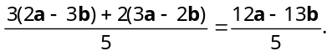

- (b) 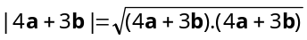 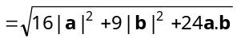 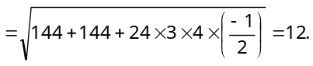

- (b) Projection of a on b 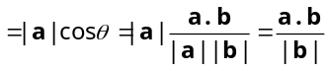 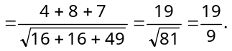

- (c) 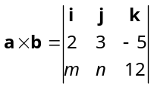
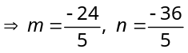.

- (b) 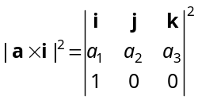, 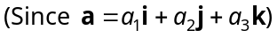 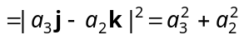
Similarly, 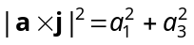 and 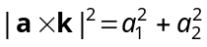
Hence the required result can be given as 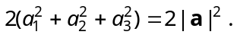

- (a) Adjacent sides of parallelogram are 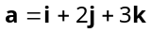 and 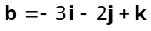. We know that vector area of parallelogram.
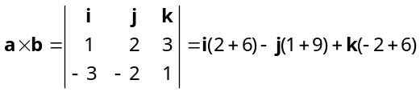 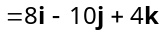.
Therefore area of parallelogram 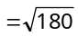 sq. unit.

- (b) 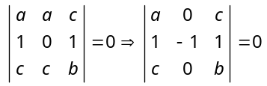{Applying 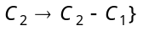
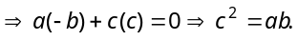
Hence is the geometric mean of and

- (d) Volume of parallelopiped 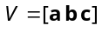
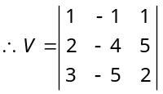
V 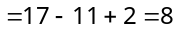 unit.

- (c) Probability of getting 1 in first throw 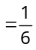
Probability of not getting 1 in second throws 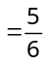
Both are independent events, so the required probability 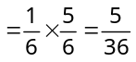.

- (a) Required probability is (no ace of heart)
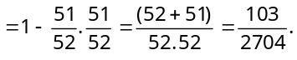

- (b) Favourable cases for one are three i.e. 2, 4 and 6 and for other are two i.e. 3, 6.
Hence required probability 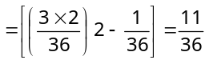
{As same way happen when dice changes numbers among themselves}

- (a) Required probability 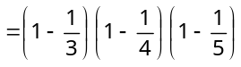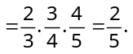

- (c) Required probability is (they go in concerned envelopes) 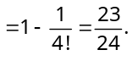

- (b) Let denote the event that the stranger succeeds at the 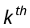 trial. Then
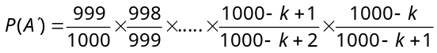
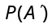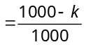 ⇒ 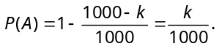

- (d) The probability of getting an even number in first draw 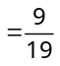. The probability of getting an even number in second draw 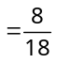. Both are independent event and so required probability 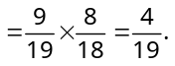

- (a) We have ratio of the ships A, B and C for arriving safely are 2 : 5, 3 : 7 and 6 : 11 respectively.
∴The probability of ship A for arriving safely 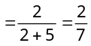
Similarly, for 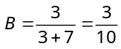 and for C = 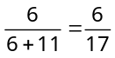
Probability of all the ships for arriving safely
= 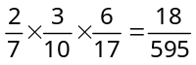.

- (b) We define the following events :
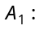 Selecting a pair of consecutive letter from the word LONDON.
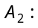 Selecting a pair of consecutive letters from the word CLIFTON.
E : Selecting a pair of letters ‘ON’.
Then 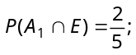 as there are 5 pairs of consecutive letters out of which 2 are ON.
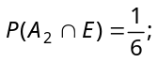 as there are 6 pairs of consecutive letters of which one is ON.
∴ The required probability is
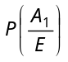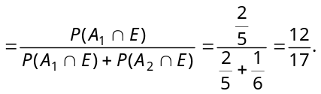

- (b) Probability that head occurs 6 times 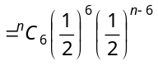 and probability that head occurs 8 times 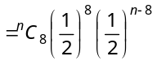
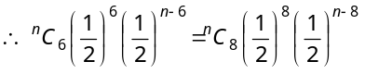
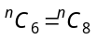 ⇒ 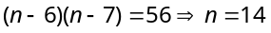.

- (d) Suppose the coin tossed times. Let be the number of heads obtained. Then follows a binomial distribution with parameters and 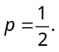
We have,
⇒ 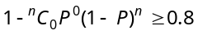
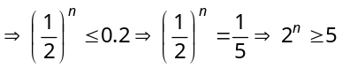
This shows that the least value of n is 3.

- (d) Probability of getting odd number 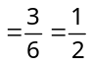
Hence required probability 