MASTER’S P.U COLLEGE, HASSAN, 573201.
KCET ONLINE TEST-12, APRIL-2020 MATHEMATICS TIME: 45Mins MARKS: 30
TOPIC: VECTORS, PERMUTATIOS &COMBINATIONS, BINOMIAL THEOREM, PROBABILITY, RANDOM VARIABLES, STATASTICS.

- In how many ways books can be arranged in a row so that two specified books are not together
(a) 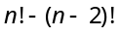 (b) 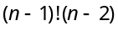 (c) 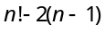 (d) 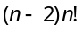

- A man has 7 friends. In how many ways he can invite one or more of them for a tea party
(a) 128 (b) 256 (c) 127 (d) 130

- The value of 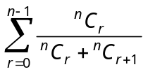 equals
(a) (b) (c) (d) None of these

- The coefficient of 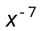 in the expansion of 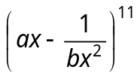 will be
(a) 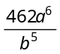 (b) 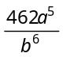 (c) 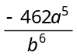 (d) 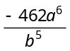

- 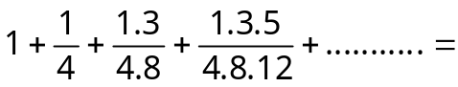
(a) 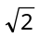 (b) 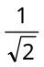 (c) 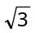 (d) 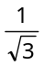

- 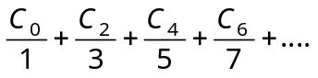=
(a) 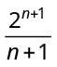 (b) 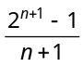 (c) 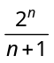 (d) None of these

- If the mean of the distribution is 2.6, then the value of y is
Variate x | 1 | 2 | 3 | 4 | 5
Frequency f of x | 4 | 5 | y | 1 | 2

(a) 24 (b) 13 (c) 8 (d) 3

- If in a frequency distribution, the mean and median are 21 and 22 respectively, then its mode is approximately
(a) 25.5 (b) 24.0 (c) 22.0 (d) 20.5

- The variance of α, β and γ is 9, then variance of 5α, 5β and 5γ is
(a) 45 (b) 9/5 (c) 5/9 (d) 225

- If OP = 8 and 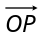 makes angles 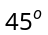 and 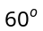 with OX-axis and OY-axis respectively, then 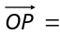
(a) 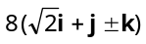 (b) 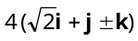 (c) 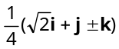 (d) 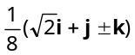

- The position vector of the points which divides internally in the ratio 2 : 3 the join of the points and 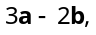 is
(a) 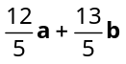 (b) 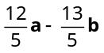 (c) 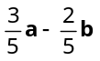 (d) None of these

- If 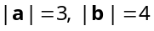 and the angle between a and b be 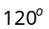, then 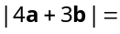
(a) 25 (b) 12 (c) 13 (d) 7

- The projection of the vector 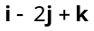 on the vector 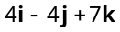 is
(a) 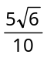 (b) 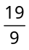 (c) 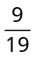 (d) 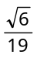

- If 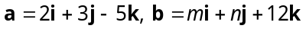 and 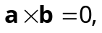 then 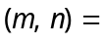
(a) 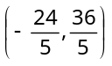 (b) 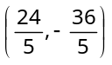 (c) 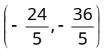 (d) 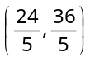

- 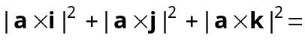
(a) 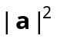 (b) 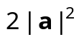 (c) 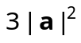 (d) 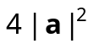

- The area of a parallelogram whose adjacent sides are given by the vectors 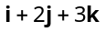 and 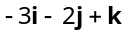 (in square unit) is
(a) 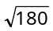 (b) 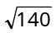 (c) 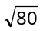 (d) 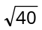

- Let a, b, c be distinct non-negative numbers. If the vectors 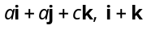 and 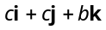 lie in a plane, then c is
(a) The arithmetic mean of a and b (b) The geometric mean of a and b
(c) The harmonic mean of a and b (d) Equal to zero.

- The volume of the parallelepiped whose conterminous edges are and 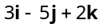 is
(a) 4 (b) 3 (c) 2 (d) 8

- If a dice is thrown twice, then the probability of getting 1 in the first throw only is
(a) 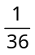 (b) 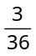 (c) 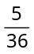 (d)

- One card is drawn from each of two ordinary packs of 52 cards. The probability that at least one of them is an ace of heart, is
(a) 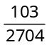 (b) 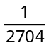 (c) 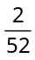 (d) 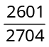.

- Two dice are thrown simultaneously. What is the probability of obtaining a multiple of 2 on one of them and a multiple of 3 on the other
(a) (b) 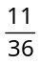 (c) (d)

- Three persons work independently on a problem. If the respective probabilities that they will solve it are 1/3, 1/4 and 1/5, then the probability that none can solve it
(a) (b) (c) (d) None of these

23. There are four letters and four addressed envelopes. The chance that all letters are not dispatched in the right envelope is
(a) 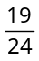 (b) 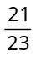 (c) 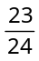 (d) 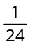

- A locker can be opened by dialing a fixed three digit code (between 000 and 999). A stranger who does not know the code tries to open the locker by dialing three digits at random. The probability that the stranger succeeds at the 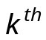trial is
(a) 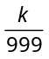 (b) 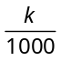 (c) 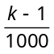 (d) None of these

- A bag contains 19 tickets numbered from 1 to 19. A ticket is drawn and then another ticket is drawn without replacement. The probability that both the tickets will show even number, is
(a) 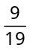 (b) 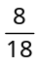 (c) 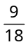 (d) 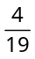

- Three ships A, B and C sail from England to India. If the ratio of their arriving safely are 2 : 5, 3 : 7 and 6 : 11 respectively then the probability of all the ships for arriving safely is
(a) 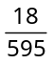 (b) 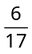 (c) 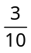 (d) .

- A letter is known to have come either from LONDON or CLIFTON; on the postmark only the two consecutive letters ON are legible. The probability that it came from LONDON is
(a) 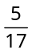 (b) 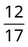 (c) 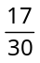 (d)

- A fair coin is tossed n times. If the probability that head occurs 6 times is equal to the probability that head occurs 8 times, then n is equal to
(a) 15 (b) 14 (c) 12 (d) 7.

- At least number of times a fair coin must be tossed so that the probability of getting at least one head is at least 0.8, is
(a) 7 (b) 6 (c) 5 (d) None of these.

- A dice is thrown two times. If getting the odd number is considered as success, then the probability of two successes is
(a) (b) (c) (d) .

