MASTER’S P.U COLLEGE, HASSAN, 573201.
KCET ONLINE TEST-13, APRIL-2020 MATHEMATICS TIME: 45Mins MARKS: 30
TOPIC: TOTAL GEOMETRY INCLUDING 3D-GEOMETRY.

- The equation of the line passing through the point 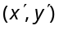 and perpendicular to the line 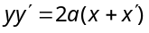 is
(a) 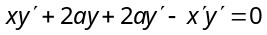 (b) 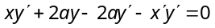
(c) 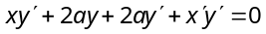 (d) 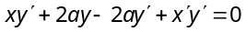

- The equations of the lines passing through the point (1, 0) and at a distance 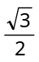 from the origin, are
(a) 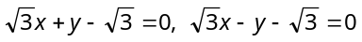 (b) 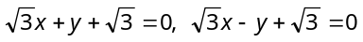
(c) 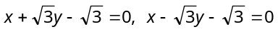 (d) None of these

- If the equation and 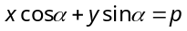 represents the same straight line, then
(a) 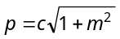 (b) 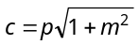 (c) 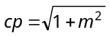 (d) 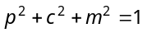

- If and 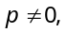 the lines 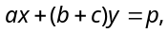 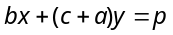 and 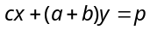are
(a) Do not intersect (b) Intersect (c) Are concurrent (d) None

- If the lines 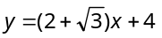 and 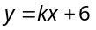are inclined at an angle 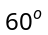to each other, then the value of k will be
(a) 1 (b) 2 (c) – 1 (d) – 2

- Which of the following lines is concurrent with the lines 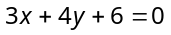and 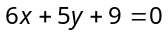
(a) 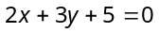 (b) 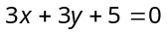 (c) 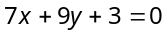 (d) None

- The reflection of the point (4,–13) in the line 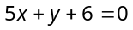 is
(a) 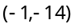 (b) (3 ,4) (c) (1, 2) (d) (– 4, 13)

- The number of circle having radius 5 and passing through the points (– 2, 0) and (4, 0) is
(a) One (b) Two (c) Four (d) Infinite

- For the circle 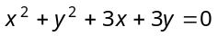, which of the following relations is true
(a) Centre lies on x-axis (b) Centre lies on y-axis
(c) Centre is at origin (d) Circle passes through origin

- The number of circles touching the lines , and 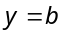 is
(a) One (b) Two (c) Four (d) Infinite

- If the line touches the circle 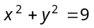, then the value of k is
(a) 2 but not – 2 (b) – 2 but not 2 (c) 3 (d) None

- The line will be a normal to the circle with radius r and centre at (a, b), if
(a) (b) (c) (d)

- The equations of the tangents to the circle 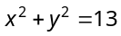at the points whose abscissa is 2, are
(a) 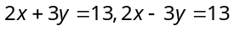 (b) 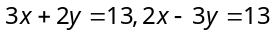
(c) 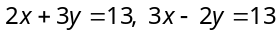 (d) None of these

- If 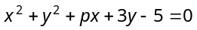 and 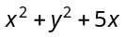 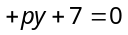 cut orthogonally, then p is
(a) (b) 1 (c) (d) 2

- 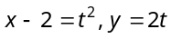 are the parametric equations of the parabola
(a) 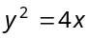 (b) 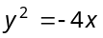 (c) 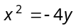 (d) 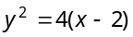

- The line 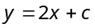 is a tangent to the parabola 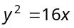, if c equals
(a) (b) (c) 0 (d) 2

- The line is tangent to the parabola , then
(a) 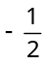 (b) (c) (d) 4

- If the distance between a focus and corresponding directrix of an ellipse be 8 and the eccentricity be 1/2, then length of the minor axis is
(a) 3 (b) 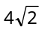 (c) 6 (d) None of these

- The equation 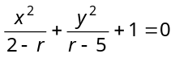 represents an ellipse, if
(a) (b) (c) (d) None of these

- If the line be a tangent to the ellipse 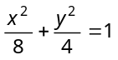, then
(a) (b) (c) (d)

- If the latus rectum of an hyperbola be 8 and eccentricity be 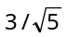, then the equation of the hyperbola is
(a) 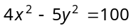 (b) 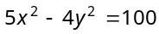 (c) 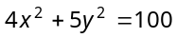 (d) 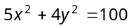

- The equation 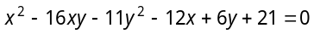 represents
(a) Parabola (b) Ellipse (c) Hyperbola (d) Two straight lines

- If e and e’ are the eccentricities of the ellipse 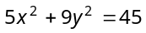 and the hyperbola 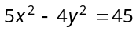 respectively, then
(a) 9 (b) 4 (c) 5 (d) 1

- The point of intersection of the line joining the points (3, 4, 1) and (5, 1, 6) and the xy-plane is
(a) 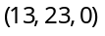 (b) 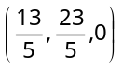
(c) (–13, 23, 0) (d) 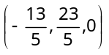

- The straight lines 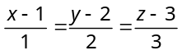
and 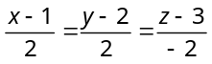 are
(a) Parallel lines (b) Intersecting at
(c) Skew lines (d) Intersecting at right angle

- The line 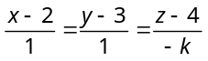 and 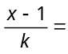 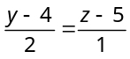 are coplanar, if
(a) or –1 (b) or 1
(c) or –3 (d) or –3

- If the lines 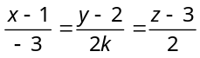, 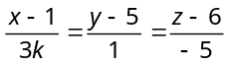 are at right angles, then k =
(a) –10 (b) 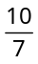
(c) 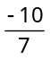 (d) 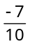

- The equation of the plane which is parallel to xy-plane and cuts intercept of length 3 from the z-axis is
(a) (b) 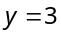
(c) (d) 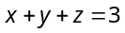

- The equation of the plane passing through the point (–1, 3, 2) and perpendicular to each of the planes 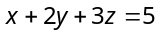 and 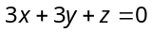, is
(a) 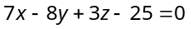 (b) 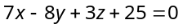
(c) 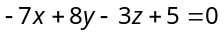 (d) 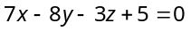

- The value of k such that 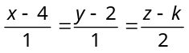 lies in the plane 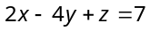, is
(a) 7 (b) – 7
(c) No real value (d) 4

