- A bird weighs 2 kg and is inside a closed cage of 1 kg. If it starts flying, then what is the weight of the bird and cage assembly
(a) 1.5 kg (b) 2.5 kg (c) 3 kg (d) 4 kg

- A man weighing 80 kg is standing in a trolley weighing 320 kg. The trolley is resting on frictionless horizontal rails. If the man starts walking on the trolley with a speed of 1 m / s, then after 4 sec his displacement relative to the ground will be
(a) 5 m (b) 4.8 m (c) 3.2 m (d) 3.0 m

- An object with a mass 10 kg moves at a constant velocity of 10 m/sec. A constant force then acts for 4 second on the object and gives it a speed of 2 m/sec in opposite direction. The acceleration produced in it, is
(a) 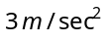 (b) 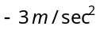 (c) 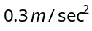 (d) 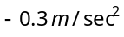

- A machine gun is mounted on a 2000 kg car on a horizontal frictionless surface. At some instant the gun fires bullets of mass 10 gm with a velocity of 500 m/sec with respect to the car. The number of bullets fired per second is ten. The average thrust on the system is
(a) 550 N (b) 50 N (c) 250 N (d) 250 dyne

- In a rocket of mass 1000 kg fuel is consumed at a rate of 40 kg/s. The velocity of the gases ejected from the rocket is 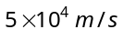. The thrust on the rocket is
(a) 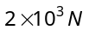 (b) 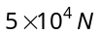 (c)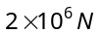 (d) 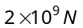

- A man is standing on a weighing machine placed in a lift. When stationary his weight is recorded as 40 kg. If the lift is accelerated upwards with an acceleration of 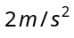, then the weight recorded in the machine will be 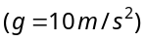
(a) 32 kg (b) 40 kg (c)42 kg (d) 48 kg

- The time period of a simple pendulum measured inside a stationary lift is found to be T. If the lift starts accelerating upwards with an acceleration g/3, the time period is
(a) 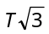 (b) 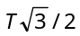 (c) 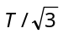 (d) 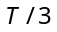

- A cork is submerged in water by a spring attached to the bottom of a pail. When the pail is kept in a elevator moving with an acceleration downwards, the spring length
(a) Increases (b) Decreases (c)Remains unchanged (d)Data insufficient

- A monkey of mass 20kg is holding a vertical rope. The rope will not break when a mass of 25 kg is suspended from it but will break if the mass exceeds 25 kg. What is the maximum acceleration with which the monkey can climb up along the rope 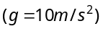
(a) 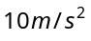 (b) 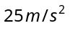 (c) 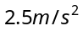 (d)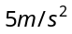

- A block of mass m is placed on a smooth wedge of inclination . The whole system is accelerated horizontally so that the block does not slip on the wedge. The force exerted by the wedge on the block (g is acceleration due to gravity) will be
(a) 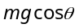 (b) 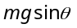 (c) (d) 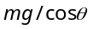

- With what minimum acceleration can a fireman slides down a rope while breaking strength of the rope is of his weight
(a) 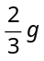 (b) g (c) 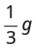 (d) Zero

- A ladder rests against a frictionless vertical wall, with its upper end 6m above the ground and the lower end 4m away from the wall. The weight of the ladder is 500 N and its C. G. at 1/3rd distance from the lower end. Wall's reaction will be, (in Newton)
(a) 111 (b) 333 (c) 222 (d) 129

- A man is at rest in the middle of a pond on perfectly smooth ice. He can get himself to the shore by making use of Newton's
(a) First law (b) Second law (c) Third law (d) All the laws

- A man is carrying a block of a certain substance (of density 1000 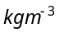) weighing 1 kg in his left hand and a bucket filled with water and weighing 10 kg in his right hand. He drops the block into the bucket. How much load does he carry in his right hand now
(a) 9 kg (b) 10 kg (c) 11 kg (d) 12 kg

- A body of mass 5kg is suspended by a spring balance on an inclined plane as shown in figure. The spring balance measure
M
30°

(a) 50 N
(b) 25 N
(c) 500 N
(d) 10 N

- A lift is going up. The total mass of the lift and the passenger is 1500 kg. The variation in the speed of the lift is as given in the graph. The tension in the rope pulling the lift at t = 11th sec will be

(a) 17400 N
3.6
speed in m/sec
2
10
12
(b) 14700 N
(c) 12000 N
(d) Zero

- Two blocks are connected by a string as shown in the diagram. The upper block is hung by another string. A force F applied on the upper string produces an acceleration of 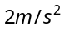 in the upward direction in both the blocks. If T and 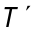 be the tensions in the two parts of the string, then
F
T
2 kg
4 kg
T'

(a) 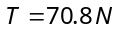 and 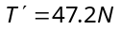
(b) and
(c) and
(d) and

- Consider the following statements about the blocks shown in the diagram that are being pushed by a constant force on a frictionless table
A. All blocks move with the same acceleration
B. The net force on each block is the same Which of these statements are/is correct
3 kg
2 kg
1 kg
F
(a) A only (b) B only
(c) Both A and B (d) Neither A nor B

- A block is kept on a frictionless inclined surface with angle of inclination 'α'. The incline is given an acceleration 'a' to keep the block stationary. Then a is equal to
(a) g
a
α
(b) g tan α
(c) g / tan α
(d) g cosec α

- A rope of length L is pulled by a constant force F. What is the tension in the rope at a distance x from the end where the force is applied
(a) 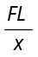 (b) 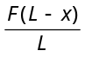 (c) 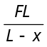 (d) 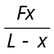

- Three equal weights A, B and C of mass 2 kg each are hanging on a string passing over a fixed frictionless pulley as shown in the figure The tension in the string connecting weights B and C is
A
B
C

(a) Zero
(b) 13 N
(c) 3.3 N
(d) 19.6 N

- Two masses of 4 kg and 5 kg are connected by a string passing through a frictionless pulley and are kept on a frictionless table as shown in the figure. The acceleration of 5 kg mass is
(a) 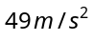
(b) 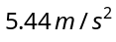
(c) 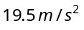
4kg
5kg
(d) 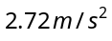

- Two masses 2 kg and 3 kg are attached to the end of the string passed over a pulley fixed at the top. The tension and acceleration are
(a) 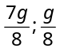 (b) 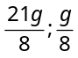 (c) 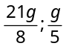 (d) 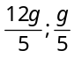

- Three blocks A, B and C weighing 1, 8 and 27 kg respectively are connected as shown in the figure with an inextensible string and are moving on a smooth surface. 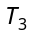 is equal to 36 N. Then 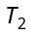 is
(a) 18 N
A
T₁
B
C
T₂
T₃
(b) 9 N
(c) 3.375 N
(d) 1.25 N

- A 2 kg block is lying on a smooth table which is connected by a body of mass 1 kg by a string which passes through a pulley. The 1 kg mass is hanging vertically. The acceleration of block and tension in the string will be
(a) 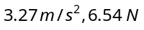 (b) 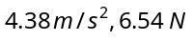 (c)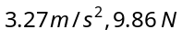 (d)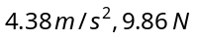

- A light string passes over a frictionless pulley. To one of its ends a mass of 6 kg is attached. To its other end a mass of 10 kg is attached. The tension in the thread will be
10 kg
6 kg

(a) 24.5 N
(b) 2.45 N
(c) 79 N
(d) 73.5 N

- Two masses of 5kg and 10kg are connected to a pulley as shown. What will be the acceleration of the system 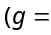acceleration due to gravity)
(a)
(b)
(c)
10 kg
5 kg
(d)

- A block A of mass 7 kg is placed on a frictionless table. A thread tied to it passes over a frictionless pulley and carries a body B of mass 3 kg at the other end. The acceleration of the system is (given g = 10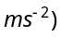
A
B
(a) 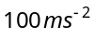
(b) 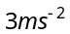
(c) 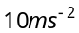
(d) 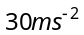

- Three blocks of masses 2 kg, 3 kg and 5 kg are connected to each other with light string and are then placed on a frictionless surface as shown in the figure. The system is pulled by a force 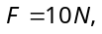 then tension 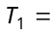

(a) 1N
T₁
3kg
T₂
10N
2kg
5kg
(b) 5 N
(c) 8 N
(d) 10 N

- Two masses 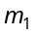 and 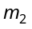 are attached to a string which passes over a frictionless smooth pulley. When 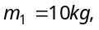 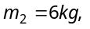the acceleration of masses is
m₂
m₁
(a) 20 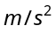
(b)
(c) 2.5
- 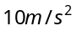

- A body of weight 2kg is suspended as shown in the figure. The tension in the horizontal string (in kg wt) is
30°
T₁
2 kg-wt

(a) 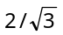
(b) 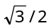
(c) 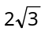
(d)

- One end of a massless rope, which passes over a massless and frictionless pulley P is tied to a hook C while the other end is free. Maximum tension that the rope can bear is 360 N. with what value of minimum safe acceleration (in can a monkey of 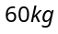 move down on the rope
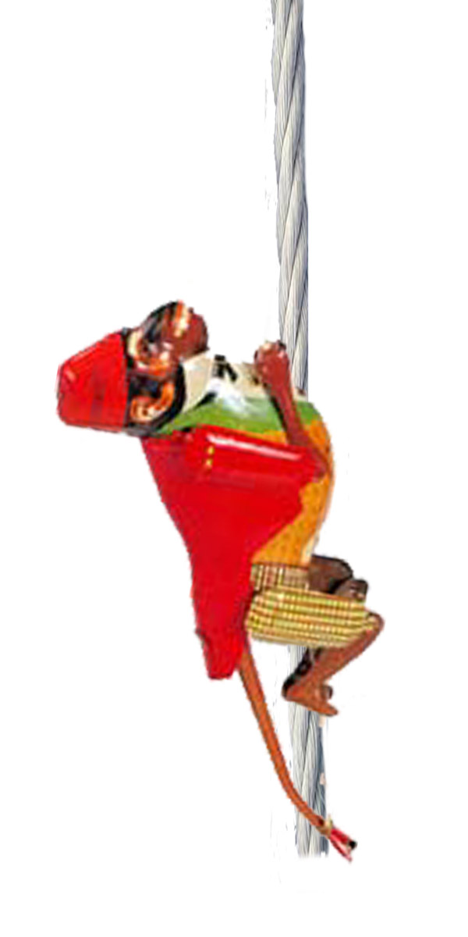
P
C

(a) 16
(b) 6
(c) 4
(d) 8

- A block of mass 4 kg is suspended through two light spring balances A and B. Then A and B will read respectively
4kg
B
A
(a) 4 kg and zero kg
(b) Zero kg and 4 kg
(c) 4 kg and 4 kg
(d) 2 kg and 2 kg

- Two masses M and M/2 are joint together by means of a light inextensible string passes over a frictionless pulley as shown in figure. When bigger mass is released the small one will ascend with an acceleration of
M
M/2

(a) g/3
(b) 3g/2
(c) g/2
(d) g

