- (c) 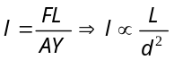⇒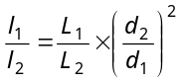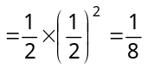
- (c) 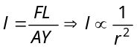 (F, L and Y are constant) 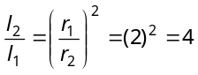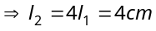
- (d) 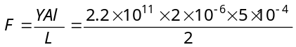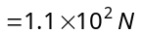
- (a) 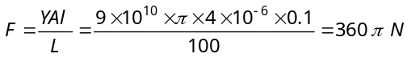
- (d) Energy stored per unit volume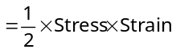 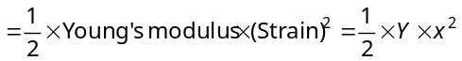
- (b) 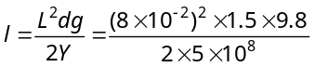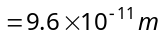
- (d) Increase in tension of wire 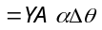
- (c) 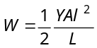⇒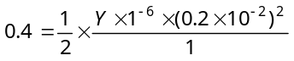 ∴ Y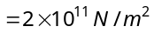
- (b) 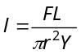∴ 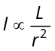 Ratio of 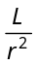 is maximum for wire in option (b).
- (d) From the ideal gas equation 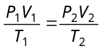
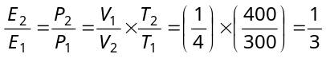⇒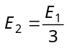i.e. elasticity will become times.
- (a) 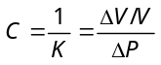⇒
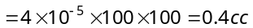
- (d) 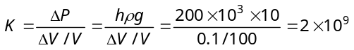
- (b) Angle of shear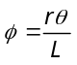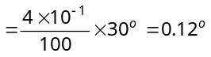
- (b)
- (b) 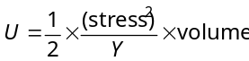= 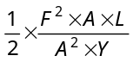=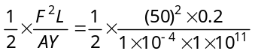= 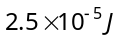
- (c) Work done in stretching a wire
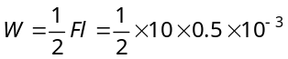= 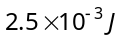
Work done to displace it through 1.5 mm
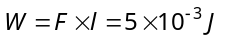
The ratio of above two work = 1 : 2
- (b) If two liquid of equal masses and different densities are mixed together then density of mixture
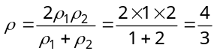
- (c) 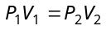⇒ 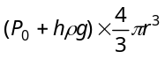=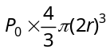
Where, h = depth of lake ⇒ 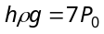⇒ 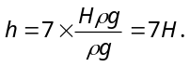
- (c) 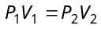⇒ 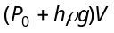=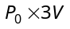 ⇒ 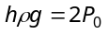⇒ 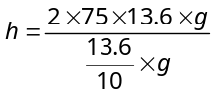= 15 m
- (d) Tension in spring T = upthrust – weight of sphere
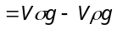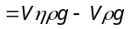 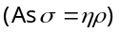 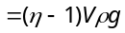= 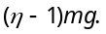
- (b) The velocity of ball before entering the water surface
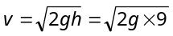
When ball enters into water, due to upthrust of water the velocity of ball decreases (or retarded)
The retardation, a = 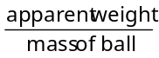 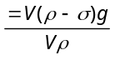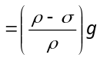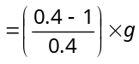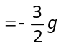
If h be the depth upto which ball sink, then, 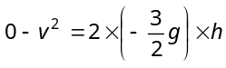⇒ 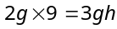∴ h = 6 cm.
- (c) If the liquid is incompressible then mass of liquid entering through left end, should be equal to mass of liquid coming out from the right end.
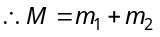 ⇒ 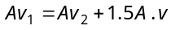
⇒  ⇒ 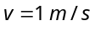
- (d) Upthrust – weight of body = apparent weight
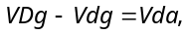
Where a = retardation of body ∴ 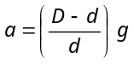
The velocity gained after fall from h height in air, 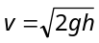
Hence, time to come in rest, 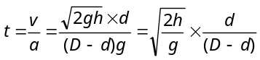
- (d) 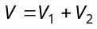
⇒ 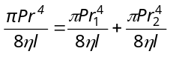⇒ 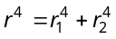 ∴ 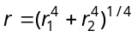
- (d) Given, 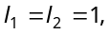and 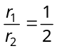
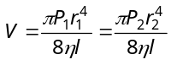⇒ 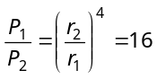 ⇒ 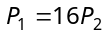
Since both tubes are connected in series, hence pressure difference across combination,
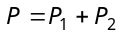⇒ 1 = 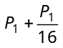 ⇒ 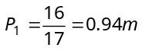
- (a) Weight of cylinder = upthrust due to both liquids
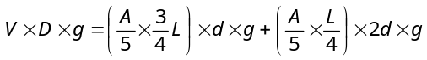 ⇒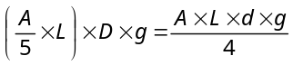⇒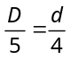 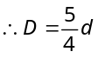
- (c) 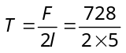
∴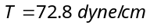
- (c)
θ
T
θ
T
Weight of metal disc = total upward force
= upthrust force + force due to surface tension
= weight of displaced water + T cos θ (2π r)
= W + 2π rT cos θ
- (a) 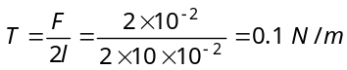
- (c) The length of the water column will be equal to full length of capillary tube.
- (b) 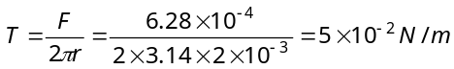
- (c) 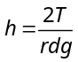 ⇒ 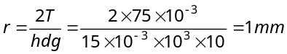

- (b)
x
b
h

Let the width of each plate is b and due to surface tension liquid will rise upto height h then upward force due to surface tension
= 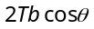 …(i)
Weight of the liquid rises in between the plates
= 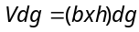 …(ii)
Equating (i) and (ii) we get ,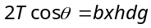
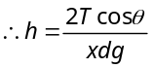
- (d) 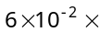Circumference = Force Circumference 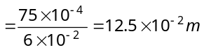
- (b) 