- (c) When the bird flies, it pushes air down to balance its weight. So the weight of the bird and closed cage assembly remains unchanged.
- (c) If the man starts walking on the trolley in the forward direction then whole system will move in backward direction with same momentum.
v
1m/s

Momentum of man in forward direction = Momentum of system (man + trolley) in backward direction
⇒ 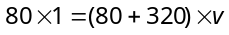⇒ 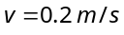
So the velocity of man w.r.t. ground 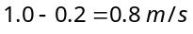
Displacement of man w.r.t. ground 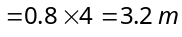
- (b) 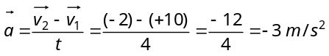
- (b) u = velocity of bullet
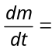Mass thrown per second by the machine gun
= Mass of bullet × Number of bullet fired per second
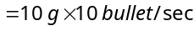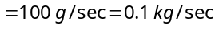
Thrust 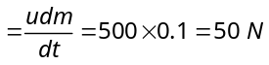
- (c) Thrust 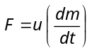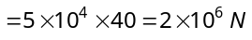
- (d) In stationary lift man weighs 40 kg i.e. 400 N.
When lift accelerates upward it's apparent weight 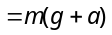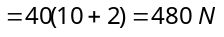 i.e. 48 kg
For the clarity of concepts in this problem kg-wt can be used in place of kg.
- (b) 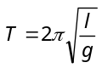 and 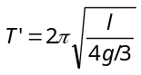
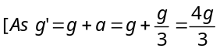]
∴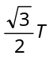
- (b) Density of cork = d, Density of water = ρ
Resultant upward force on cork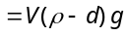
This causes elongation in the spring. When the lift moves down with acceleration a, the resultant upward force on cork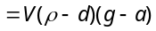 which is less than the previous value. So the elongation decreases.
Cork
- (c) Tension the string 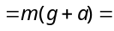Breaking force
⇒ 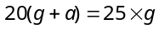 ⇒ 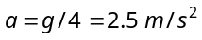
- d)
When the whole system is accelerated towards left then pseudo force (ma) works on a block towards right.
For the condition of equilibrium
mg sin θ
ma cosθ
ma
mg
mg cosθ
+
ma sin θ
a
θ
R
θ
θ
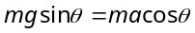 ⇒ 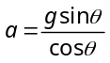
Force exerted by the wedge on the block
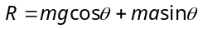 R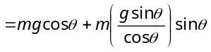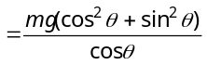
R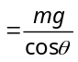
- (c) If man slides down with some acceleration then its apparent weight decreases. For critical condition rope can bear only 2/3 of his weight. If a is the minimum acceleration then,
Tension in the rope 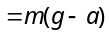= Breaking strength
⇒ 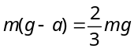 ⇒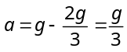
- (a)
- (c)
- (c) Total weight in right hand = 10 + 1 = 1 kg
- (b) Since downward force along the inclined plane
=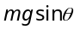=
- (c) At 11th second lift is moving upward with acceleration
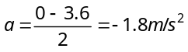
Tension in rope,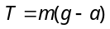 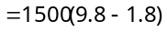=
- (a) FBD of mass 2 kg FBD of mass 4kg
2 kg
4 N
20 N
T
T′
8 N
T′
40 N
4 kg

….(i) …(ii)
By solving (i) and (ii) 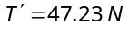 and 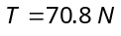
- (a)
- (b)
a
α
ma
α
mg
mg sin α
α
mg cos α
α

Let the mass of a block is m. It will remains stationary if forces acting on it are in equilibrium i.e, 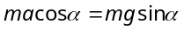⇒ 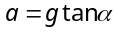
Here = Pseudo force on block, mg = Weight.
- (b)
T
m₂
m₃
m₁
- (b) Tension between 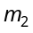 and 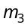 is given by
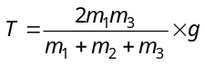
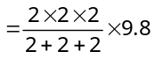= 13 N

- (b) 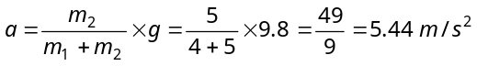
- (d) 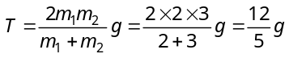
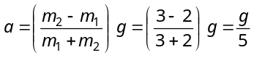
- (b) 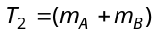×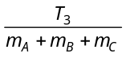
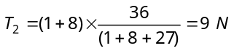
- (a) Acceleration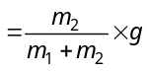 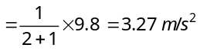
and 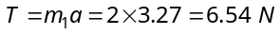
- (d) 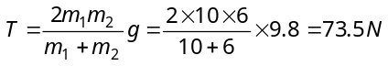
- (c) 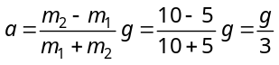
- (b) 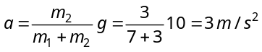
- (c) 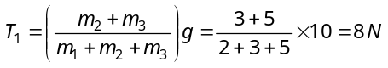
- (c) 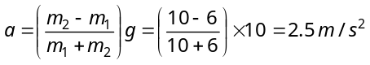
- (c) 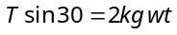
T
30º
2 kg-wt
30º
T₁
T cos 30
T sin 30
⇒ 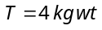
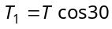°
°
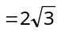
- (c) If monkey move downward with acceleration a then its apparent weight decreases. In that condition
Tension in string 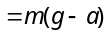
This should not be exceed over breaking strength of the rope i.e. 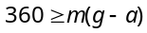⇒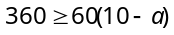
⇒ 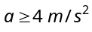
- (a) 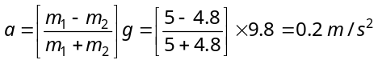
- (c) As the spring balances are massless therefore the reading of both balance should be equal.
- (a) 