- (b) Work done by centripetal force is always zero, because force and instantaneous displacement are always perpendicular. 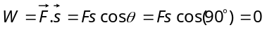
- (c) ⇒ 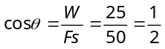 ⇒ 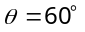
- (a) 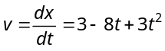 ∴ 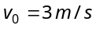 and 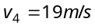
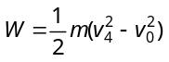 (According to work energy theorem) 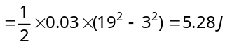
- (b)  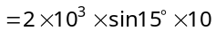 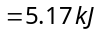
- (c) 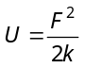⇒ 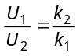 (if force are same) ∴ 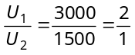
- (d) Here 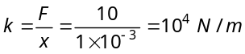 W 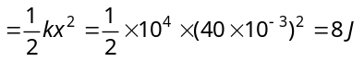
- (d) As the initial momentum of bomb was zero, therefore after explosion two parts should possess numerically equal momentum
4kg
8kg
A
B
v_{A}
v_{B}

i.e. 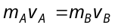⇒ ⇒ 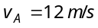
∴ Kinetic energy of other mass A, = 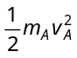 = 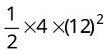= 288 J.
- (c) Let the thickness of one plank is s
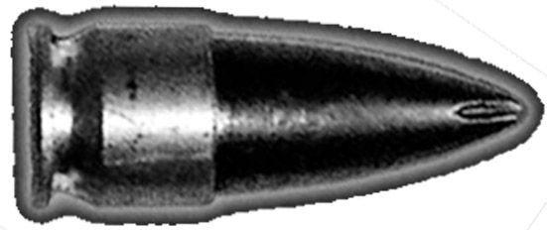
if bullet enters with velocity u then it leaves with velocity
u
v=
19
20
u
s
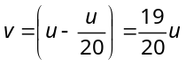
from 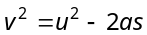
⇒ 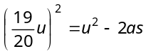⇒ 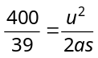
Now if the n planks are arranged just to stop the bullet then again from 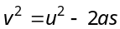
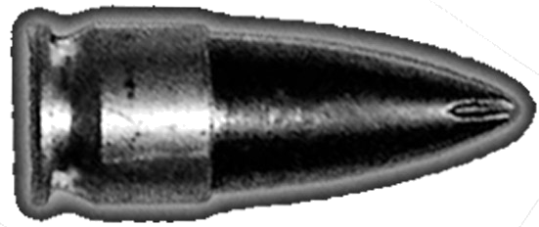
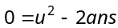
u
v=0
ns
⇒ 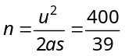
⇒
As the planks are more than 10 so we can consider n = 11

- (a)

By the conservation of linear momentum
V
m
M
m
h
Initial momentum of sphere
= Final momentum of system 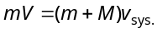 …(i)
If the system rises up to height h then by the conservation of energy
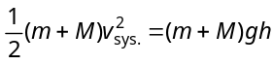 …(ii)
⇒ 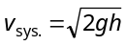
Substituting this value in equation (i) 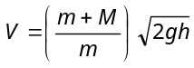
- (d) Condition for vertical looping 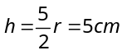 ∴ r = 2 cm
- (b)
- (a) For first condition
Initial velocity = u, Final velocity = u/2, s = 3 cm
From 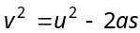⇒ 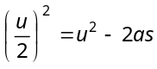⇒ 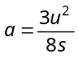
Second condition
Initial velocity = u/2, Final velocity = 0
From 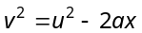⇒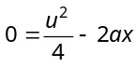
∴ 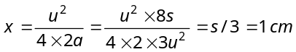
- (c)
20 m
30 m
100 m
v

Ball starts from the top of a hill which is 100 m high and finally rolls down to a horizontal base which is 20 m above the ground so from the conservation of energy 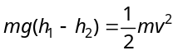
⇒ 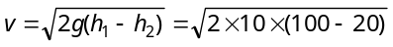
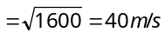.
- (c) When block of mass M collides with the spring its kinetic energy gets converted into elastic potential energy of the spring.
From the law of conservation of energy
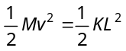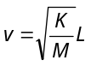
Where v is the velocity of block by which it collides with spring. So, its maximum momentum
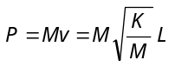 = 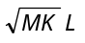
After collision the block will rebound with same linear momentum.

- (d) 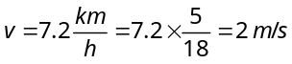
R
θ
θ
mg cos θ
P
F
mg
mg sin θ
Slope is given 1 in 20
∴ 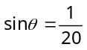

When man and cycle moves up then component of weight opposes it motion i.e. 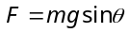
So power of the man 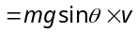
=
- (a) 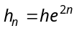= 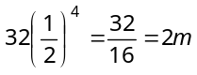 (here n = 2, e = 1/2)
- (b) In elastic head on collision velocities gets interchanged.
- (a) Impulse = change in momentum = 2 mv
=
- (b)
m
m
v=45√2
2m
V
v=45√2

Initial momentum
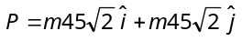⇒ 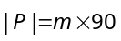
Final momentum
By conservation of momentum
∴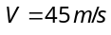
- (b) 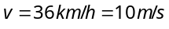
By law of conservation of momentum
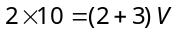 ⇒ 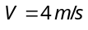
Loss in K.E.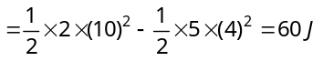
- (d) Initial momentum = 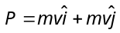
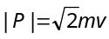
Final momentum =
By the law of conservation of momentum
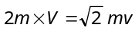⇒ 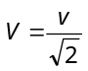
In the problem 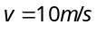 (given) ∴ 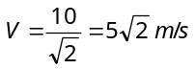
- (d) Velocity of combined mass, 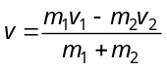
= 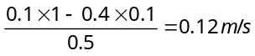
∴ Distance travelled by combined mass
= 0.12 × 10 = 1.2 m.
- (c) Loss in K.E. = 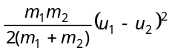
= 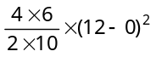= 172.8 J
24. C
25. C
26. B
27.C
28. B

