- A body of mass m is moving in a circle of radius r with a constant speed v. The force on the body is 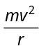 and is directed towards the centre. What is the work done by this force in moving the body over half the circumference of the circle
(a) 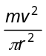 (b) Zero (c) 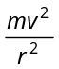 (d) 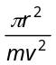

- A body moves a distance of 10 m along a straight line under the action of a force of 5 N. If the work done is 25 joules, the angle which the force makes with the direction of motion of the body
(a) 0° (b) 30° (c) 60° (d) 90°

- A force acts on a 30 gm particle in such a way that the position of the particle as a function of time is given by 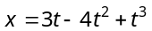, where x is in metres and t is in seconds. The work done during the first 4 seconds is
(a) 5.28 J (b) 450 mJ (c) 490 mJ (d) 530 mJ

- The work done in pulling up a block of wood weighing 2 kN for a length of 10m on a smooth plane inclined at an angle of 15° with the horizontal is
(a) 4.36 kJ (b) 5.17 kJ (c) 8.91 kJ (d) 9.82 kJ

- Two springs of spring constants 1500 N/m and 3000 N/m respectively are stretched with the same force. They will have potential energy in the ratio
(a) 4 : 1 (b) 1 : 4 (c) 2 : 1 (d) 1 : 2

- A spring 40 mm long is stretched by the application of a force. If 10 N force required to stretch the spring through 1 mm, then work done in stretching the spring through 40 mm is
(a) 84 J (b) 68 J (c) 23 J (d) 8 J

- A bomb of 12 kg explodes into two pieces of masses 4 kg and 8 kg. The velocity of 8kg mass is 6 m/sec. The kinetic energy of the other mass is
(a) 48 J (b) 32 J (c) 24 J (d) 288 J

- A rifle bullet loses 1/20th of its velocity in passing through a plank. The least number of such planks required just to stop the bullet is
(a) 5 (b) 10 (c) 11 (d) 20

- A sphere of mass m, moving with velocity V, enters a hanging bag of sand and stops. If the mass of the bag is M and it is raised by height h, then the velocity of the sphere was
(a) 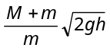 (b) 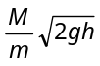 (c) 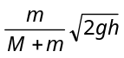 (d) 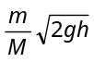

- A frictionless track ABCDE ends in a circular loop of radius R. A body slides down the track from point A which is at a height h = 5 cm. Maximum value of R for the body to successfully complete the loop is
(a) 5 cm
A
h
B
2R
E
D
C
(b) 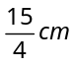
(c) 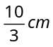
(d) 2 cm

- What is the velocity of the bob of a simple pendulum at its mean position, if it is able to rise to vertical height of (Take 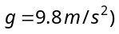
(a) 0.6 m/s
(b) 1.4 m/s
(c) 1.8 m/s
(d) 2.2 m/s

- If a body looses half of its velocity on penetrating 3 cm in a wooden block, then how much will it penetrate more before coming to rest
(a) 1 cm (b) 2 cm (c) 3 cm (d) 4 cm

- A spherical ball of mass 20 kg is stationary at the top of a hill of height 100 m. It slides down a smooth surface to the ground, then climbs up another hill of height 30 m and finally slides down to a horizontal base at a height of 20 m above the ground. The velocity attained by the ball is
(a) 10 m/s (b) 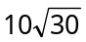m/s (c)40 m/s (d) 20 m/s

- The block of mass M moving on the frictionless horizontal surface collides with the spring of spring constant K and compresses it by length L. The maximum momentum of the block after collision is
(a) Zero
(b) 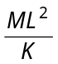
M
(c) 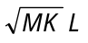
(d) 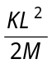

- A man is riding on a cycle with velocity 7.2 km/hr up a hill having a slope 1 in 20. The total mass of the man and cycle is 100 kg. The power of the man is
(a) 200 W (b) 175 W (c) 125 W (d) 98 W

- A metal ball falls from a height of 32 metre on a steel plate. If the coefficient of restitution is 0.5, to what height will the ball rise after second bounce
(a) 2 m (b) 4 m (c) 8 m (d) 16 m

- A billiard ball moving with a speed of 5 m/s collides with an identical ball originally at rest. If the first ball stops after collision, then the second ball will move forward with a speed of
(a) 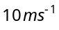 (b) 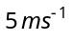 (c) 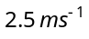 (d) 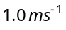

- If two balls each of mass 0.06 kg moving in opposite directions with speed 4 m/s collide and rebound with the same speed, then the impulse imparted to each ball due to other is
(a) 0.48 kg-m/s (b) 0.24 kg-m/s (c) 0.81 kg-m/s (d) Zero

- Two putty balls of equal mass moving with equal velocity in mutually perpendicular directions, stick together after collision. If the balls were initially moving with a velocity of 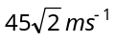 each, the velocity of their combined mass after collision is
(a) (b) 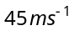 (c) 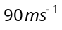 (d) 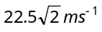

- A metal ball of mass 2 kg moving with a velocity of 36 km/h has an head on collision with a stationary ball of mass 3 kg. If after the collision, the two balls move together, the loss in kinetic energy due to collision is
(a) 40 J (b) 60 J (c) 100 J (d) 140 J

- A body of mass 2kg is moving with velocity 10 m/s towards east. Another body of same mass and same velocity moving towards north collides with former and coalsces and moves towards north-east. Its velocity is
(a)10 m/s (b) 5 m/s (c)2.5 m/s (d) 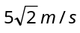

- Two bodies of masses 0.1 kg and 0.4 kg move towards each other with the velocities 1 m/s and 0.1 m/s respectively, After collision they stick together. In 10 sec the combined mass travels
(a) 120 m (b) 0.12 m (c) 12 m (d) 1.2 m

- A body of mass 4 kg moving with velocity 12 m/s collides with another body of mass 6kg at rest. If two bodies stick together after collision, then the loss of kinetic energy of system is
(a) Zero (b) 288 J (c) 172.8 J (d) 144 J

- The ratio of the radii of gyration of a circular disc and a circular ring of the same masses and radii about a tangential axis parallel to the their planes is
(A) √6 : √5 (B) 1 : √2 (C) √5 : √6 (D) none of these

25. A wheel of mass 2 kg having practically all the mass concentrated along the circumference of a circle of radius 20 cm, is rotating on its axis with an angular velocity of 100 rad/s. The rotational kinetic energy of the wheel is
(A) 4J (B) 70J (C) 400 J (D) 800 J

26. A rod of length L is hinged from one end. It is brought to a horizontal position and released. The angular velocity of the rod when it is in vertical position is
(A) 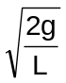 (B) 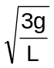 (C) 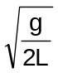 (D) 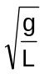

27. If a solid sphere, disc and cylinder are allowed to roll down an inclined plane from the same height
(A) cylinder will reach the bottom first (B)disc will reach the bottom first
(C) sphere will reach the bottom first (D) all will reach the bottom at the same time
28. A mass m is moving with a constant velocity parallel to the x axis. Its angular momentum w.r.t. the origin.
(A) 0 (B) remains constant (C) goes on increasing (D) goes on decreasing

