KEY

1 | 2 | 3 | 4 | 5 | 6 | 7 | 8 | 9 | 10 | 11 | 12 | 13 | 14 | 15
C | C | C | B | A | B | B | B | B | D | B | A | B | A | C
16 | 17 | 18 | 19 | 20 | 21 | 22 | 23 | 24 | 25 | 26 | 27 | 28 | 29 | 30
A | A | D | B | B | D | B | B | B | B | B | C | B | A | C

HINTS AND SOLUTIONS
- (c) 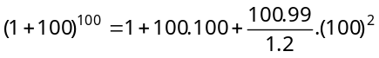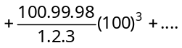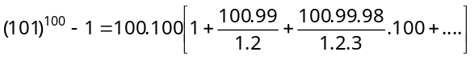
From above it is clear that,
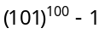is divisible by (100)² = 10000

- (c) 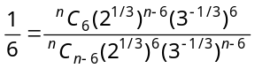or 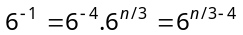
∴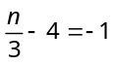 n = 9.

- (c) 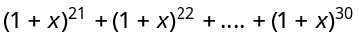
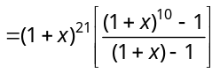= 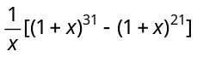
∴ Coefficient of x⁵ in the given expression
= Coefficient of x⁵ in 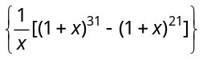
= Coefficient of x⁶ in 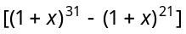
= 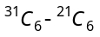.

- (b) 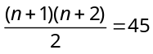 or 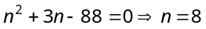..

- (a) 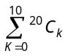 i.e., 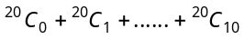
We know that,
Put ; 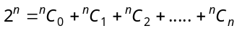
Put ; 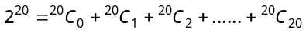
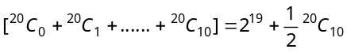
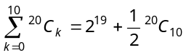.
- (b) Here 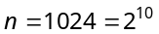, a power of 2, where as the power of 7 is 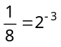
Now first term 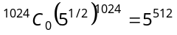(integer)
And after 8 terms, the 9th term 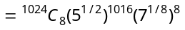 = an integer
Again, 17th term =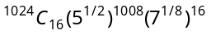
= An integer.
Continuing like this, we get an A.P. 1, 9, 17, ....
- (b) 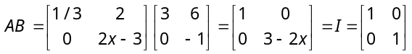 (As given)
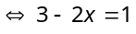 or .

- (b) 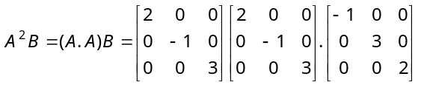
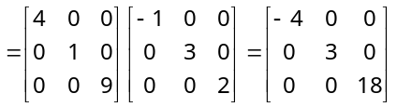.

- (b) Let 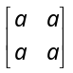be the identity element then
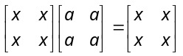
i.e., 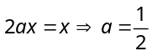, 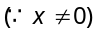
Identity element = 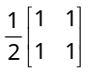.

- (d) 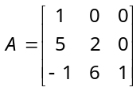
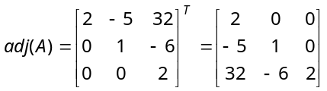.

- (b) Let 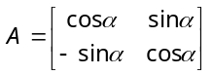
The matrix of cofactors of the elements of A, =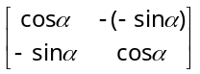
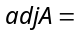the transpose of matrix of cofactors of A = 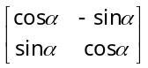
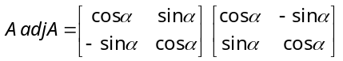
= 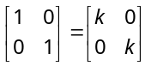 (as given) .

- (a)
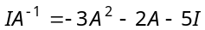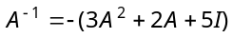

- (b) Let 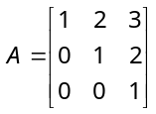 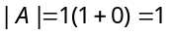
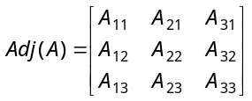
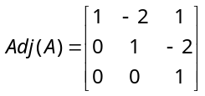

- (a) 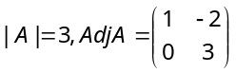; 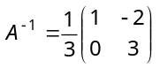
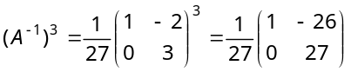.

- (c) By fundamental property, 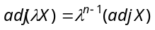.
Here
∴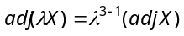
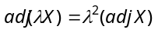.

- (a) 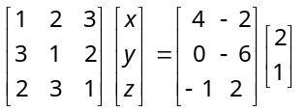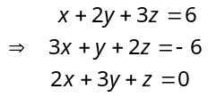
On Simplification the above equation, we get the required result i.e., 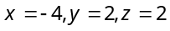.

- (a) 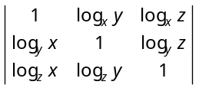
= 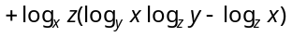
= {Since 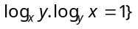.

- (d) 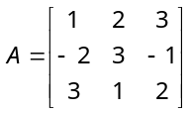⇒ 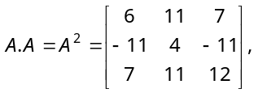
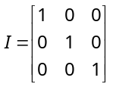, then, 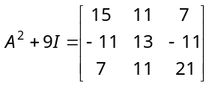.

- (b) 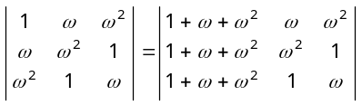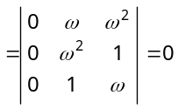.

- (b) 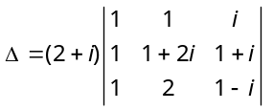
=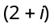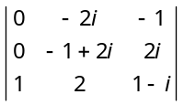 by 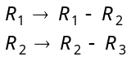
=
= 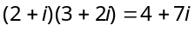.

- (d) 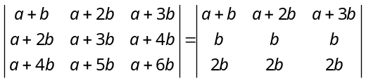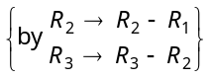
Trick: Putting. The determinant will be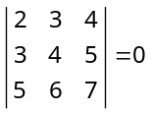. Obviously answer is (d)

- (b) 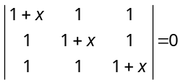 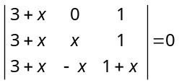, 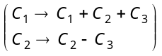
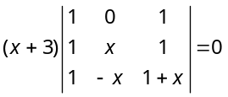 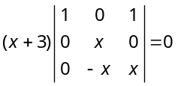, 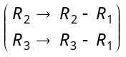
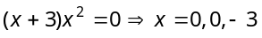.

- (b) 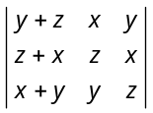= 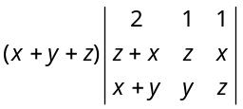 by 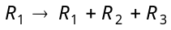
= 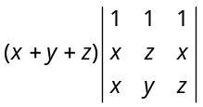 ; by 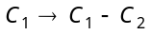
=
= 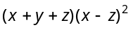 .
Trick:: Put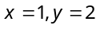, , then
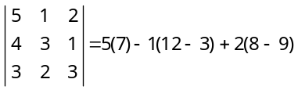
= & 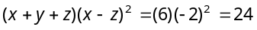
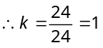.

- (b) Trick : Put , then we have
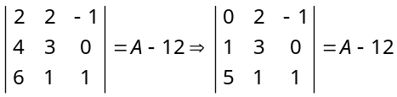 {Apply 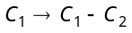}
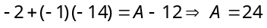.
- (b) 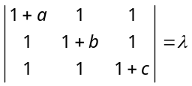
Applying 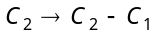 and 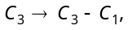
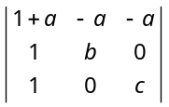
On expanding w.r.t. 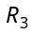,
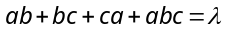 …….(i)
Given, 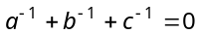
⇒ 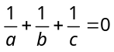 ⇒
⇒ 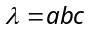, (From equation (i)).

- (b) 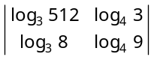 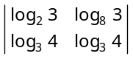
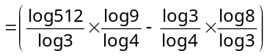 × 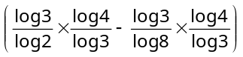
= 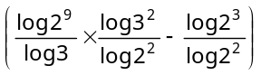 × 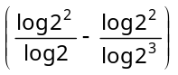
= 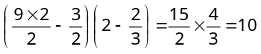.

- (c) It has a non-zero solution if 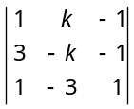=0 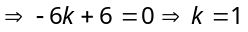.

- (b) 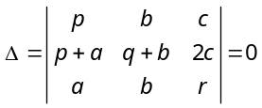 Applying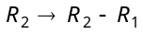 = 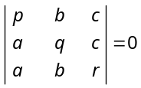
Applying and 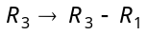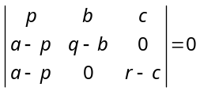
On expansion we get,
⇒ 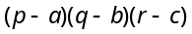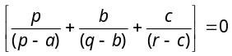
⇒ 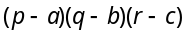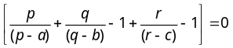
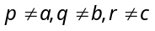
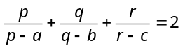.

- (a) If A is square matrix of order 3, then
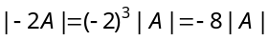.

- (c) The system of homogeneous equations
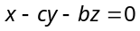
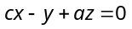
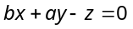
has a non-trivial solution (since 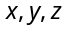 are not all zero)
If 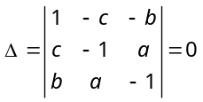
i.e., if 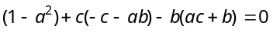
i.e., if 

