- The greatest integer which divides the number 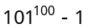, is
(a) 100 (b) 1000 (c) 10000 (d)100000

- In 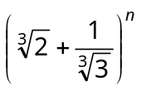 if the ratio of 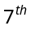 term from the beginning to the term from the end is ,
then
(a) 7 (b) 8 (c) 9 (d) None of these

- The coefficient of 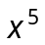 in the expansion of 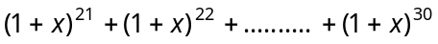 is
(a) 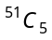 (b) 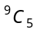 ` (c) 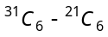 (d) 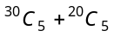

- If number of terms in the expansion of 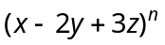are 45, then n=
(a) 7 (b) 8 (c) 9 (d) None of these

- 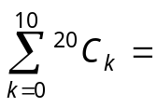
(a) 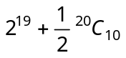 (b) 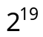 (c) 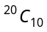 (d) None of these

- In the expansion of 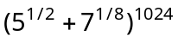, the number of integral terms is
(a) 128 (b) 129 (c) 130 (d) 131

- If 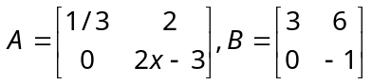and 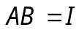, then x =

(a) –1 (b) 1 (c) 0 (d) 2

- If 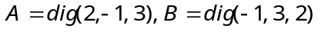, then 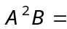
(a) dig (5, 4, 11) (b) dig (–4, 3, 18) (c) dig (3, 1, 8 ) (d) B

- The identity element in the group 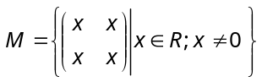 with respect to matrix multiplication is
(a) 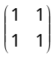 (b) 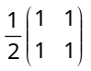 (c) 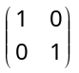 (d) 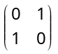

- Let 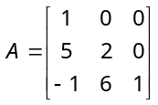, then the adjoint of A is
(a) 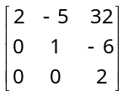 (b) 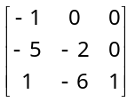 (c) 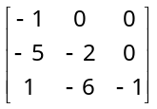 (d) None of these

- If 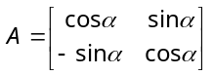 and 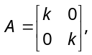 then k is equal to
(a) 0 (b) 1 (c) 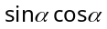 (d) 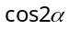

- If a matrix A is such that 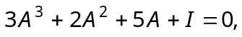 then its inverse is
(a) 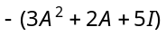 (b) 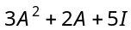 (c) 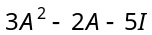 (d) None of these

- The inverse of 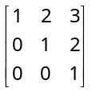is
(a) 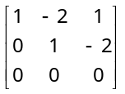 (b) 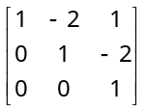 (c) 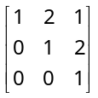 (d) None of these

- If 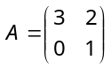, then 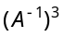is equal to
(a) 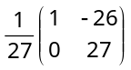 (b) 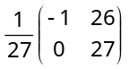 (c) 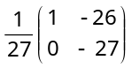 (d) 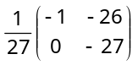

- If X is a square matrix of order 3 × 3 and is a scalar, then adj (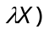 is equal to
(a) 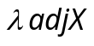 (b) 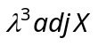 (c) 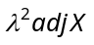 (d) 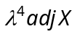

- If 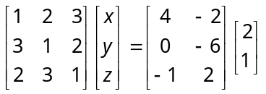, then 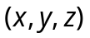=
(a) 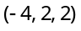 (b) 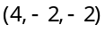 (c) 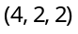 (d) 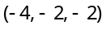

- For positive numbers and z the numerical value of the determinant 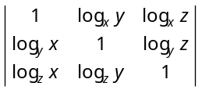is
(a) 0 (b) 1 (c) 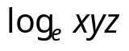 (d) None of these

- If 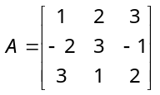and I is a unit matrix of 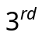order, then 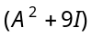 equals
(a) 2A (b) 4A (c) 6A (d) None of these

- If is the cube root of unity, then 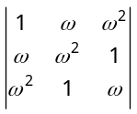=
(a) 1 (b) 0 (c) (d) 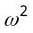

- 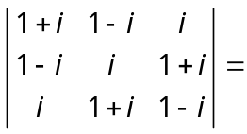
(a) 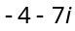 (b) 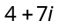 (c) 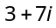 (d) 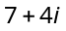

- 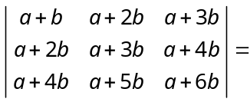
(a) 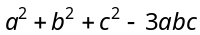 (b) (c) (d) 0

- The roots of the equation 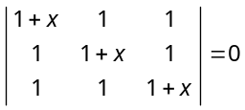are
(a) 0, – 3 (b) 0, 0, – 3 (c) 0, 0, 0, – 3 (d) None of these

- If 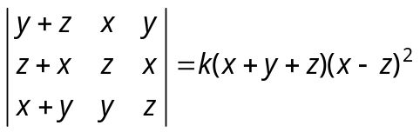, then
(a) 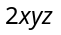 (b) 1 (c) (d) 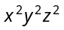

- If 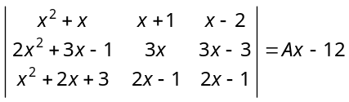, then the value of A is
(a) 12 (b) 24 (c) –12 (d) – 24

- If 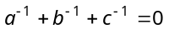 such that 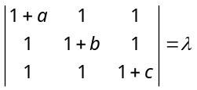, then the value of is
(a) 0 (b) abc (c) – abc (d) None of these

- 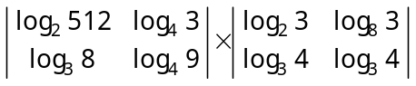=
(a) 7 (b) 10 (c) 13 (d) 17

- 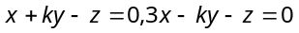and 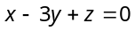 has non-zero solution for k =
(a) – 1 (b) 0 (c) 1 (d) 2

- If 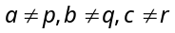 and 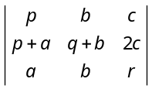 = 0, then 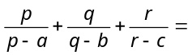
(a) 3 (b) 2 (c) 1 (d) 0

- If |A| denotes the value of the determinant of the square matrix A of order 3, then |– 2A|=
(a) 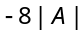 (b)  (c) 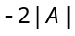 (d) None of these

- If 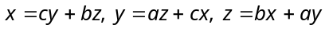 (where x, y, z are not all zero) have a solution other than , 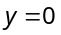, then a, b and c are connected by the relation
(a) 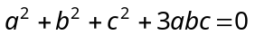 (b) 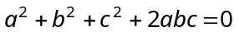
(c) 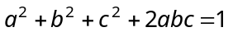 (d) 