**MASTERS PRE-UNIVERSITY COLLEGE, HASSAN 573201.**

**PRACTICE QUESTIONS**

**Subject: BIOLOGY**  **ANATOMY OF FLOWERING PLANTS**

1. **Read the following statements and find out the incorrect statement**
2. There is structural similarities and variations (differences ) in the external morphology and internal structure of the larger living organism, both plants and animals
3. Plants have cells as the basic unit which organised into tissues and in turn the tissues are organised into organs
4. A tissue is a group of cells having a common origin and usually performing different functions
5. Axiliary buds are present in the axils of leaves and are capable of forming a branch or a flower
6. **Which one consist of living cells**
7. Vessels b) tracheids c) companion cells d) sclerenchyma
8. **The sclerenchymatous sclereids are found in**
9. Fruit walls of legumes
10. Pulp of fruits like, guava, pear and sapota; leaves of tea
11. Seed coat of nuts
12. All of the above
13. **The meristem that occurs in the mature regions of roots and shoots in many plants, particularly those that produce woody axis and appear later than primary meristem is called**
14. Lateral meristem b) secondary meristem c) cylindrical meristem d) all of the above
15. 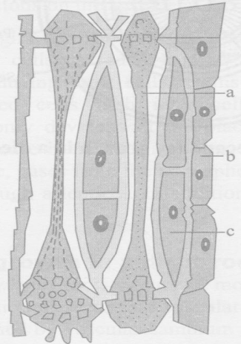 **Recognise the figure and find out the incorrect option.**

a) on maturation ‘a’ possesses a peripheral cytoplasm and large vacuole but lacks a nucleus

b) ‘b’ stores food material in the form of starch or fat, and other substances like tannins

c) ‘c’ helps in the maintaining the pressure gradient in ‘a’

d) ‘a’ and ‘c’ are not found in pteridophytes and gymnosperms. They have albuminous cells and

sieve cells.

1. **The meristems which is /are responsible for producing secondary tissues is/are**
2. Fascicular vascular cambium
3. Interfascicular cambium
4. Cork cambium
5. All of the above
6. **Intercalary meristem produces**
7. Secondary growth b)Primary growth c) apical growth d) secondary overgrowth
8. **Common feature in vessel elements and sieve tube elements is**
9. Enucleate condition b) non living nature

c) thick secondary wall d) pores on lateral walls

1. **Cells in which end walls are absent are**
2. Parenchyma b) sclerenchyma c) vessels d) sieve tubes
3. **Which one of the following comprises only simple tissues**
4. Parenchyma , collenchyma and sclerenchyma
5. Parenchyma ,xylem and collenchyma
6. Parenchyma ,xylem and sclerenchyma
7. Xylem and phloem
8. **Trichomes take part in**
9. Transpiration and exchange of gases
10. Protection and reduction of transpiration
11. Exudation of water drops
12. Desiccation
13. **Separate xylem and phloem bundles are known as**
14. Radial b) amphivasal c) collateral d) bicollateral
15. **Monocot root has**
16. Cambium ring , vascular bundles two to four pith is large and well developed
17. Radial vascular bundles, polyarch xylem,no secondary growth
18. Usually more than six xylem bundles, pith is small or inconspicuous,conjuctive tissue
19. Both b and c
20. **Monocot root differs from dicot root in having**
21. Open vascular bundles b) scattered vascular bundles
22. Well developed pith
23. Radially arranged vascular bundles
24. **Vascular bundles in dicot stem are**
25. Open, collateral, endarch
26. Closed, collateral, endarch
27. Open ,collateral, exarch
28. Closed, collateral, exarch
29. **Well developed pith is found in**
30. Monocot root and monocot stem
31. Monocot stem and dicot root
32. Monocot root and dicot stem
33. Dicot root and dicot stem
34. **Vascular bundles of monocot stem are**
35. Conjoint, collateral and open b) conjoint, collateral and closed
36. Conjoint ,bicollateral and open d) conjoint, concentric and closed
37. **Which of the following layer in dicot stem provides mechanical strength to the young stem?**
38. Epidermis b) hypodermis c) endodermis d) cortical layer
39. **Numerous vascular bundles occur scattered in the ground tissue of**
40. Monocot stem b) monocot root c) dicot stem d) dicot root
41. **In a dicot stem, there are a few layers of radially placed parenchymatous cells in between the vascular bundles called**
42. Medullary rays b) conjuctive tissue c) starch sheath d) casparian strip
43. **What is correct about monocot stem**
44. Hypodermis is sclerenchymatous, vascular bundles are closed,phloem parenchyma is absent
45. Hypodermis is sclerenchymatous, vascular bundles are open ,phloem parenchyma is absent
46. Hypodermis is collenchymatous , vascular bundles are closed,phloem parenchyma is present
47. Hypodermis is Sclerenchymatous , vascular bundles are closed,phloem parenchyma is present
48. 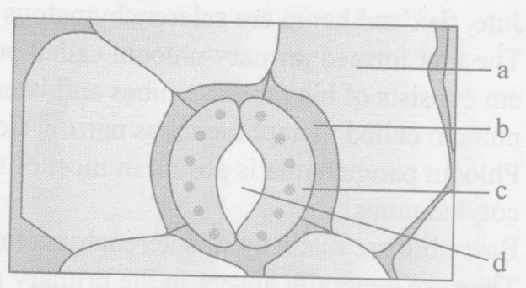 **Recognise the figures and find out the correct matching.**
49. a-subsidiary cell, d-guard cell, c-epidermal cell, d-stomatal pore
50. b-subsidiary cell, a-guard cell, c-epidermal cell, d-stomatal aperture
51. b-subsidiary cell, c-guard cell, a-epidermal cell, d-stomatal pore
52. a-subsidiary cell, d-guard cell, b-epidermal cell, a-stomatal aperture
53. **Cells** **of grass leaves which help in minimising transipiration are**
54. Bulliform cells b) guard cells c) subsidiary cells d) endodermal cells
55. **Mesophyll is differentiated into palisade and spongy tissues in**
56. Extremely xerophytic leaves b) hydrophytic leaves c) monocot leaves d) dicot leaves
57. **Function of cork cambium is to produce**
58. Secondary xylem and secondary phloem
59. Cork and secondary cortex
60. Secondary cortex and phloem d)cork
61. **During secondary growth at some places the cambium forms a narrow band of parenchyma which passes through the secondary xylem and the secondary phloem in the radial directions. These are called**
62. Medullary rays b) phelloderm c) secondary medullary rays d) fascicular cambium
63. **What is true about heartwood**
64. **It does not help in water conduction**
65. **It is also called alburnum**
66. **It is dark in colour but is very soft**
67. **It has treachery elements which are filled with tannins, resins, etc...**
68. b,c,d b) a,b,c c) b,d d) a,d
69. **Which is not a part of periderm**
70. Phellogen b) cork c) secondary cortex d) wood
71. **Cambium is a lateral meristem that takes part in**
72. Internodal growth b) axial growth c) growth of branches d) increasing girth of stem and root
73. **Vascular bundles in monocotyledons are considered closed because**
74. There are no vessels with perforations
75. Xylem is surrounded all around by phloem
76. A bundle sheath surrounds each bundle
77. Cambium is absent.