**MASTERS PRE-UNIVERSITY COLLEGE, HASSAN 573201.**

**PRACTICE QUESTIONS**

**Subject: BIOLOGY**  **MORPHOLOGY OF FLOWERING PLANTS**

1. **Pneumatophores are useful in**
2. Respiration b) transpiration c) guttation d) protein synthesis
3. **A root is adventitious when it is**
4. Swollen b) growing in marshy places c) formed from plumule d) modified for storage
5. **Underground parts of some plants spread to new niches and when older parts die new plants are formed. This condition is seen in**
6. Grass, Monstera and banyan b) mint and jasmine
7. banana, pineapple and chrysanthemum d) grass and strawberry
8. **A lateral branch with short internodes and each node bearing a rosette of leaves and a tuft of roots is found in aquatic plants like**
9. Pistia and Eichhornia b) Mint and Jasmine
10. Banana, pineapple and chrysanthemum d) Opuntia and Euphorbia
11. **Phylloclades are**
12. Leaf modification b) one internode long stems
13. modified petioles d) green succulent steams of indefinite growth
14. **A pair of insectivorous plants is**
15. Drosera and Rafflesia b) Nepenthes and bladderwort
16. Dionaea and viscum d) venus fly trap and Rafflesia
17. **A leaf is identified from**
18. Flat green lamina b) presence of leaf blade and petiole
19. presence of axillary bud d) occurrence of chlorophyll
20. **A typical flower has four different kinds of whorls arranged on end of the stalk or pedicel, called**
21. Peduncle b) Thalamus c) Receptacle d) both b and c
22. **The mode of arrangement of sepals or petals in a floral bud with respect to the other members of same whorl is known as**
23. Aestivation b) placentation c) cohesion d) adhesion
24. **Individual flowers are attached to inflorescence axis by**
25. Peduncle b) Petiole c) Pedicel d) Bract
26. **A flower which can be divided into two exactly equal halves by any vertical division passing through centre is**
27. Zygomorphic b) Hypogynous c)Actinomorphic d) Epigynous
28. **In a multilocular ovary, ovules are borne on the entire inner surface. This placentation is called**
29. Superficial b)Marginal c**)**Parietal d)Axile
30. **Match the columns I, II and III and choose the correct combination from the options given.**

|  |  |  |
| --- | --- | --- |
| **Column I** | **Column II** | **Column III** |
| **a.Actinomorphic** | **1.Bilateral symmetry** | **K. Gulmohur** |
| **b.Zygomorphic** | **2.Radial symmetry** | **L.Canna** |
| **c.Asymmetric** | **3.Irregular** | **M.Chilli** |

1. a-2-M, b-1-K, c-3-L b)a-1-M,b-2-K, c-3-L c)a-2-K,b-3-L,c-1-M d)a-1-K,b-2-M,c-3-L
2. **Drupe fruit is found in**
3. Mustard and Argemone b) sunflower and marigold c) mango and coconut d) pea and bean
4. **The outermost covering of a seed in a dicotyledonous seed is called seed coat. The seed has two layers. The outer layer is called ...1... and inner layer is called ....2...**
5. 1-Scutellum,2-Coleoptile b)1-Coleorhiza,2-Coleoptile
6. 1-Testa,2-Tegmen d) 1-Tegmen, 2-Testa
7. **In coconut fruit the hard shell is**
8. Endocarp
9. Fused structure of mesocarp and endocarp
10. Fused structure of epicarp and mesocarp
11. Epicarp
12. **Jack fruit is a multiple fruit formed from**
13. Single ripened ovary b) inflorescence
14. flower with many free carpels d) flower with many partially fused carpels
15. **pepo is a fruit of**
16. Cruciferae b) leguminosae c) Cucurbitaceae d)liliaceae
17. **Match the columns I and II, and choose the correct combination from the options given.**

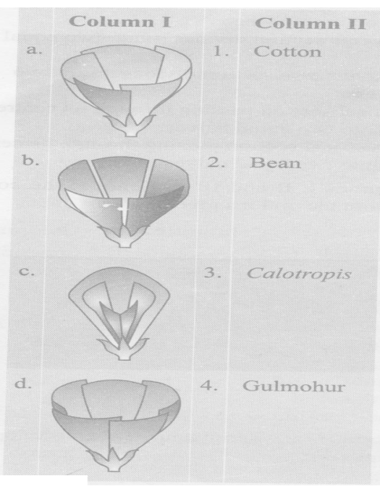

a)a-1,b-3,c-2,d-4 b)a-3,b-4,c-1,d-2 c)a-4,b-3,c-1d-2 d)a-1,b-4,c-2,d-3

1. **Perianth occurs in family**
2. Solanaceae b) Fabaceae c) Brassicaceae d)Liliaceae
3. **Match the columns I and II, and choose the correct combination from the options given.**

|  |  |
| --- | --- |
| **Column I** | **Column II** |
| **a.Sepals free** | **1.Gamopetalous** |
| **b.Petals united** | **2.Gamasepalous** |
| **c.Petals free** | **3.Polysepalous** |
| **d.Sepals united** | **4.Polypetalous** |

1. a-3,b-1c-2,d-4 b)a-3,b-4,c-1,d-2 c)a-2,b-1,c-4,d-3 d)a-3,b-1,c-4,d-2
2. **Match the columns I and II, and choose the correct combination from the options given.**

|  |  |
| --- | --- |
| **Column I** | **Column II** |
| **a.Colocasia** | **1.Flattened stem** |
| **b.Watermelon** | **2.Stem thorn** |
| **c.Opuntia** | **3.Storage stem** |
| **d.Euphorbia** | **4.Stem tendril** |
| **e.Bougainvillea** | **5.Fleshy cylindrical stem** |

1. a-3,b-4,c-5,d-1,e-2 b)a-3,b-2,c-1,d-5,e-4 c)a-4,b-2,c-5,d-1,e-3 d)a-3,b-4,c-1,d-5,e-2
2. **An example of Axile placentation is**
3. Marigold b) Dianthus c) Lemon d) Argemone
4. **Velamen is a tissue found in**
5. Parasites b) all epiphytes c) aerial roots of some orchids/vanda d) halophytes
6. **Whorled phyllotaxy with simple reticulate leaves occurs in**
7. Alstonia b)guava c) Calotropis d)mustard
8. **Recognise the figure and find out the correct matching**

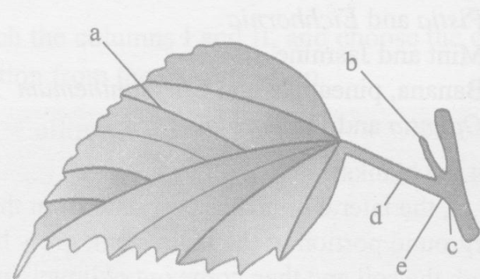

a)leaf base-c,petiole-d,lamina-a,stipule-b,auxillary bud-e

b) leaf base-e,petiole-b,lamina-a,stipule-d,axilary bud-c

c)leaf base-a,petiole-b,lamina-c,stipule-d, auxiliary bud-e

d)leaf base-e,petiole-d,lamina-a,stipule-b,axilary bud-c

1. **Match the columns I and II, and choose the correct combination from the options given**

|  |  |
| --- | --- |
| ***Column I*** | ***Column II*** |
| **a.Basal** | **1.Primrose** |
| **b.Marginal** | **2.Marigold** |
| **c.Free-central** | **3.Lemon** |
| **d.Axile** | **4.Argemone** |
| **e.Parietal** | **5.Pea** |

a)a-2,b-5,c-1,d-3,e-4 b)a-3,b-2,c-4,d-5,e-1 c)a-2,b-5,c-4,d-3,e-1 d)a-3,b-4,c-5,d-1,e-2

1. **Which is correctly matched**
2. Onion –bulb b) ginger –sucker c) chlamydomonas –conidia d) yeast-zoospores
3. **Colchicine is obtained from colchicum autumnale. It belongs to family**
4. Liliaceae b)Solanaceae c) Leguminaceae d)poaceae
5. **Placenta and pericarp are both edible portions in**
6. Potato b) apple c) banana d) tomato