**MASTERS PRE-UNIVERSITY COLLEGE, HASSAN 573201.**

**PRACTICE QUESTIONS**

**Subject: BIOLOGY**  **SEXUAL REPRODUCTION IN FLOWERING PLANTS**

1. **Both autogamy and geitonogamy cannot occur in**
2. Papaya b) Cucumber c) Castor d)Maize
3. **Match the option**

|  |  |  |  |
| --- | --- | --- | --- |
|  | **Structure** |  | **Shape** |
| **a** | **Anther** | **1** | **Spindle** |
| **b** | **Microsporangia** | **2** | **Spherical shaped** |
| **c** | **Pollen grain** | **3** | **Tetragonal(four sided)** |
| **d** | **Generative cell** | **4** | **Near circular in outline** |

1. a-4,b-3,c-1,d-2 b) a-3 ,b-4,c-2,d-1 c) a-1,b-2,c-3,d-4 d)a-2,b-1,c-4,d-3
2. **Recognise the figure and find out the correct matching**

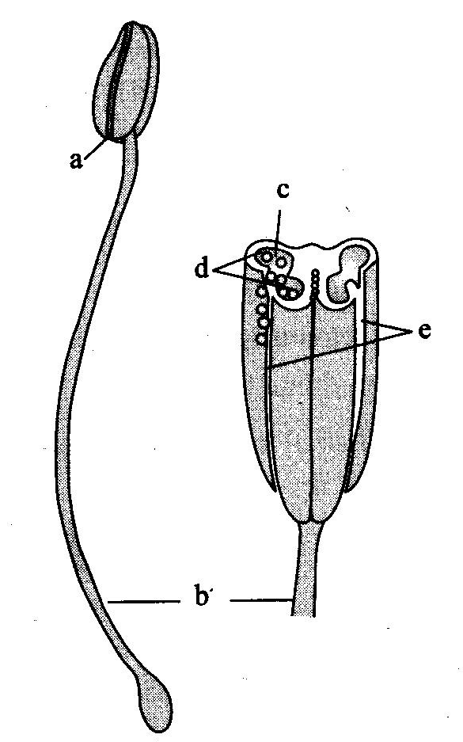

1. a-anther, b-filament, c-pollen sacs, d-pollen grains,e- line of dehiscence
2. b-anther, a-filament, c--pollen sacs, d-pollen grains,e- line of dehiscence
3. a-anther, b-filament,d-pollen sacs, c-pollen grains,e- line of dehiscence
4. b-anther, a-filament,e-pollen sacs, c-pollen grains,d- line of dehiscence
5. **Arrangement of four wall layers in microsporangium from inside to outside is as follows**:
6. epidermis, endothecium,tapetum,and middle layers
7. epidermis, middle layers, endothecium, and tapetum,
8. epidermis, endothecium, middle layers, and tapetum,
9. tapetum, , middle layers, endothecium, and epidermis,
10. **Recognise the figure and find out the correct matching**

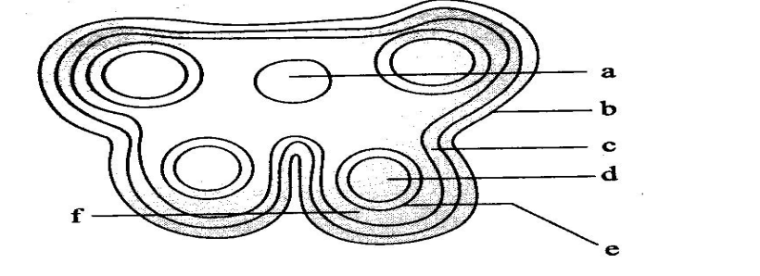

1. a-epidermis,b-endothecium,c-middle layer, d-tapetum,e-sporogenous tissue, f-connective
2. b-epidermis,c-endothecium,d-middle layer, e-tapetum,f-sporogenous tissue, a-connective
3. b-epidermis,c-endothecium,f-middle layer, e-tapetum, a-sporogenous tissue,d-connective
4. b-epidermis,c-endothecium,f-middle layer, e-tapetum,d-sporogenous tissue, a-connective
5. **The generative cell of a pollen grain**
6. Is small and floats in the cytoplasm of vegetative cell
7. Is spindle shaped
8. Has dense cytoplasm and a nucleus
9. All of the above
10. **Which of the following statements about sporopollenin is wrong?**
11. Exine is formed of sporopollenin
12. Sporopollenin is not degraded by any known enzyme
13. Sporopollenin occurs in the area of germ pores only
14. Sporopollenin is most resistant organic material
15. **Tapetal cells of stamens are**
16. Diploid uninucleate b) tetraploid binucleate

c) hexaploid tetranucleate d) polyploid multi nucleate

1. **A mature male gametophyte is formed from pollen mother cell by**
2. One meiotic division b) two meiotic division

c) one meiotic and two mitotic division d) three meiotic divisions

1. **In flowering plants, the male gametes are formed by**
2. Generative cell b) uninucleate microspore c) vegetative cell d) pollen tube
3. **The process of formation of microspores from pollen mother cell through meiosis is called**
4. Microgametogenesis b) microsporogenesis c) megagametogenesis d) megasporogenesis
5. **Match the columns I and II and choose the correct combination from the options given**

|  |  |  |  |
| --- | --- | --- | --- |
|  | **Column I** |  | **Column II** |
| **a** | **Male gametophyte** | **1** | **Ovule** |
| **b** | **Female gametophyte** | **2** | **Locule** |
| **c** | **Megasporangium** | **3** | **Pollen grain** |
| **d** | **Ovarian cavity** | **4** | **Embryo sac** |

1. a-3 ,b-4,c-1,d-2 b) a-4,b-3,c-2,d-1 c) a-3 ,b-4,c-2 ,d-1 d) a-4,b-3,c-1,d-2
2. **Read the following statements and find out the incorrect statement**
3. **Ovules generally differentiate a single megaspore mother cell(MMC) in the chalazal region of the nucellus.**
4. **The MMC undergoes reduction division and produce four megaspores**
5. **In majority of angiosperms one of the megaspore is degenerated while the other three remains functional**
6. **The nucleus of the functional megaspore divides mitotically three times and form 2- nucleate, 4-nucleate and later 8-nucleate stages of the embryo sac**
7. **These mitotic division are strictly free nuclear that is nuclear division are immediately followed by cell wall formation**
8. a,b and c b) b,c and d c) c,d and d d) a,c and e
9. **Embryo sac is monosporic when it develops from**
10. One of the four megaspore of megaspores mother cell
11. Three megaspores of megaspores tetrad
12. Two fuctional megaspores
13. The megaspore mother cell where meiosis has occurred but cytokinesis does not take place
14. **Type of division that occurs during formation of a megaspore is**
15. Meiosis b) mitosis c)meiosis followed by mitosis d) mitosis followed by meiosis
16. **Read the following statements and find out the incorrect statement**
17. **Majority of flowering plants use a range of animals as pollinating agents.**
18. **Bees, butterflies,flies,beetles,waps ants, moth,birds(sunbirds and humming birds) and bats are the comman pollinating agents**
19. **Among the animals,insects particularity bees are the dominant biotic pollinating agents**
20. **Even larger animals such as some primates (lemurs),arboreal (tree dwelling)rodent, or even reptiles (gecko lizard and garden lizard) have also been reported as pollinators in some species**
21. **Often flowers of animals pollinated plants are specifically adapted for a particular species of animal**
22. a and b b) b and c c) d and e d) none of the above
23. **Yucca plant is pollinated by**
24. A species of moth(pronuba) b)A species of wasp(blastophaga)
25. A species of beetle d) A species of insect.
26. **Which of the following in an outbreeding device**
27. **If pollen release and stigma receptivity are not synchronised**
28. **If the anther and stigma are placed at different positions so that pollen cannot come in contact with the stigma of the same flower**
29. **Self-incompatibility which prevents self-pollen (from the same plant) from fertilising the ovules by inhibiting pollen germination or pollen tube growth in the pistil**
30. **Production of the unisexual flower**
31. a ,b and c b) b, c and d c) a,c and d d) a, b, c and d
32. **For the unisexual flower the steps in artificial hybridisation are**
33. Bagging, pollination , rebagging
34. Pollination,bagging, rebagging
35. Emasculation, bagging, pollination, rebagging
36. Bagging ,emasculation,pollination, rebagging
37. **Pollination does not guarantee the transfer of the right type of pollen (compatible pollen ) if the pollen is of the wrong type (incompatible type), then the pistil rejects the pollen by preventing**
38. Pollen germination on the stigma b) Pollen tube growth in the style
39. Double fertilisation d) Both a and b
40. **Feathery stigma occurs in**
41. Pea b) wheat/jowar c) datura d) caesalpinia
42. **Recognise the figure and find out the correct matching**

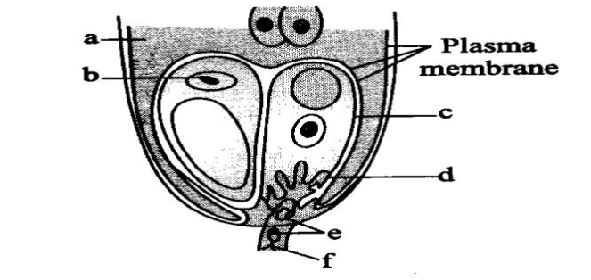

1. a-egg nucleus ,f-vegetative nucleus ,b-synergid, e-filiform apparatus, d-male gametes ,c-central cell
2. b-egg nucleus ,f-vegetative nucleus ,c-synergid, d-filiform apparatus, e-male gametes ,a-central cell
3. b-egg nucleus ,e-vegetative nucleus ,c-synergid, d-filiform apparatus, f-male gametes ,a-central cell
4. b-egg nucleus ,d-vegetative nucleus ,a-synergid, f-filiform apparatus, e-male gametes ,c-central cell
5. **The correct sequence of embryogeny in dicot is**
6. zygote, prombryo, globular, heart-shaped and mature embryo
7. zygote, globular, prombryo, heart-shaped and mature embryo
8. zygote,prombryo, , heart-shaped, globular and mature embryo
9. zygote, globular ,heart-shaped , prombryo,and mature embryo
10. **Select the correct and incorrect statements**
11. **Tapetum nourishes developing pollen grains**
12. **Hilum represent junction between ovule and funicle**
13. **In aquatic plants water hyacinth and water lily, pollination is by water**
14. **Primary endosperm nucleus is triploid**
15. a,b correct :c,d incorrect b) a,b,d correct: c incorrect
16. a,b,d correct : a incorrect d) a,d correct: b,c incorrect
17. **Function of suspensor of embryo is**
18. Absorption of nourishement
19. Push the embryo into nutritive endosperm region
20. Formation of secondary embryo
21. All the above
22. **Endosperm is formed in angiosperms due to double fertilization. It is however absent in certain seeds due to lack of**
23. Certain enzymes b) growth hormone c) dicotyledonous hormone d) nutrients
24. **The thousands of years old viable seed of lupines arcticus excavated from**
25. Arctic tundra
26. King herod’s palace near the dead sea
27. Rohtang pass near manali
28. Tropical pacific island
29. **Wind pollinated plants generally do not show the character**
30. Feathery stigmas b)Single ovule in the ovary

c)Well exposed stamens d) Flowers are large and colourful.

1. **Polyembryony /adventives polyembryony occurs in**
2. Carthamus b) citrus c) corchorus d) maize
3. **Nucellar embryo is**
4. Amphimictic haploid b) Amphimictic diploid c) apomictic haploid d) apomictic diploid