**MASTERS PRE-UNIVERSITY COLLEGE, HASSAN 573201.**

**PRACTICE QUESTIONS**

**Subject: BIOLOGY**  **LIVING WORLD**

1. **Among the following which can be a common feature exhibited by both living and non living**
2. Growth b) reproduction c) metabolism d) cellular organisation
3. **Select the incorrect statement about living processes**
4. All living phenomena is due to underlying interaction
5. Properties of tissues are not present in the constituent cells
6. Properties of cellular organelles are present in the molecular constituents of the organelles
7. The interactions result in emergent properties at a higher level of organisation
8. **Match the columns I and II choose the correct combination from the options given**

|  |  |  |  |
| --- | --- | --- | --- |
|  | **Column I** |  | **Column II** |
| **a** | **Fungi** | **i)** | **Asexual spore** |
| **b** | **Amoeba** | **ii)** | **Binary fission** |
| **c** | **Hydra and yeast** | **iii)** | **True regeneration** |
| **d** | **planaria** | **iv)** | **budding** |

1. A-i,b-ii,c-iii,d-iv b) a-i,b-ii,c-iv,d-iii c) a-ii,b-i,c-iv,d-iii d) none are correct
2. **Which of the following organisms are multiplied by fragmentation**
3. Fungi 2. All algae 3. Protonema of mosses
4. 1 and 2 b) 1,2 and 3 c) 2 and 3 d) 1 and 3
5. **Which of the following are basic processes of taxonomy**
6. Characterisation and classification
7. Identification and nomenclature
8. Both A and B
9. None of the above
10. **Nomenclature or naming is only possible when the organism is described correctly and we know to what organism the name is attached to this is**
11. Taxonomy b) classification c) identification d) binomial system
12. **In Magngifera indica, indica indicates**
13. Name of genus b) name of the species c) specific epithet d) both B and C
14. **There is a need to standardise the naming of living organisms such that a particular organisms is known by the same name all over the world. This process is called**
15. Systematic b) nomenclature c) cytotaxonomy d) taxonomy
16. **Recognise the following flow diagram and the find correct option according to taxonomic hierarchy**

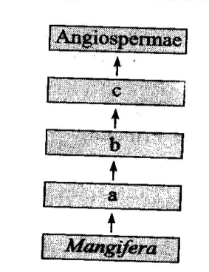

1. A is comparable to muscidae while b is at the same level as that primate
2. C includes all the angiosperms having two cotyledons in their seeds
3. For wheat a is poaceae, b is poales and c is monocotyledonae
4. All of the above are correct statements
5. **Lion and tiger are placed in same**
6. Genus b) family c) order d) all of the above
7. **In case of plants classes with a few similar characters are assigned to a higher category called**
8. Phylum b) division c) order d) kingdom
9. **The closet category of family is**
10. Phylum b) class c) order d) species
11. **Fishes, amphibians ,reptiles, birds and mammals constituent in the same category called**
12. Division b) phylum c) order d) class
13. 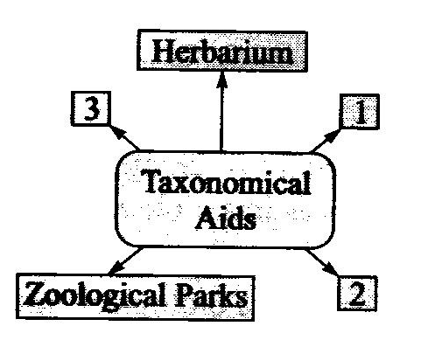 **Fill in the blanks according to taxonomical aids**
14. 1-flora, 2-kingdom, 3- botanical gardens
15. 1-catalogues,2-keys,3-species
16. 1-botanical garden,2-museum,3-kets
17. 1-monogrphs,2-order,3-manuals
18. **Taxonomical keys are**
19. Analytical in nature
20. Taxonomical aid used for identification of both plants and animals
21. Keys are based on the contrasting characters
22. All of the above
23. **Which of the following is are true with reference to taxonomical aids**
24. Separate taxonomic keys are required for each taxonomic category
25. Herbarium is a store house of collected plants and animals
26. Each statements in the key is called couplet
27. Keys are used for identification purpose
28. 1 and 2 b) 1 and 4 c) 1 and 3 d) 3 and 4
29. **Which is useful in providing information for identification of names of species found in an area ?**
30. Flora b) manuals c) monographs d) catalogues
31. **Which** **is essential and is the prime source of taxonomic studies of plants and animals**
32. Identification b) nomenclature c) classification d) collection of actual specimen
33. **Museum have the collection of**
34. Insects specimens b) larger animal specimens c) skeleton of animals d) all of the above
35. **Each plant is labelled indicating its botanical/scientific name and its family. The taxonomical aid used for this is**
36. Museum b) herbaria c) botanical garden d) all of the above
37. **Keys are developed by**
38. John Hutchinson b) john ray c) Julian Huxley d) Ernst haeckel
39. **Largest herbarium of India is at**
40. Royal botanical garden, kew
41. Indian botanical garden, lucknow
42. National botanical research institute lucknow
43. Indian botanical garden, howrah
44. **The total number of species that are known and described in ranges between**
45. 1.5-1.8 million b) 1.6-1.7 million c) 1.7-1.8 million d) 1.8-1.9 million
46. **“ Taxon” differs from “Taxa” due to**
47. This being a higher taxonomic category than taxa
48. This being lower taxonomic category than taxa
49. This being the singular of taxa
50. This being the plural of taxa
51. **Match the columns I and II and choose the correct combination from the options given**

|  |  |  |  |
| --- | --- | --- | --- |
|  | **Column I** |  | **Column II** |
|  | **(common name)** |  | **(taxonomic category order)** |
| **a** | **Wheat** | **i)** | **Primata** |
| **b** | **Mango** | **ii)** | **Diptera** |
| **c** | **Housefly** | **iii)** | **Sapindales** |
| **d** | **man** | **iv)** | **poales** |

1. A-1,b-2,c-4,d-3 b) a-4,b-3,c-2,d-1 c)a-2,b-4,c-1,d-3 d)a-3,b-4,c-2,d-1 e) a-4,b-2,c-3,d-1
2. **Which one of the following animals is correctly matched with its particular named taxonomic category**
3. Humans-primata the family b) Housefly –musca an order
4. Tiger-tigris the species d) Cuttlefish –mollusca a class
5. **True defining feature of living beings is**
6. They digest their food b)They can regenerate
7. They reproduce d)They respond to external stimuli
8. **Taxonomical hierarchy was firstly given by Linnaeus which of the following categories are not used by linnaeus**
9. Phylum,family and variety b)Family variety and order
10. Kingdom,phylum and family d)Class , order and phylum
11. **Match the columns I and II and choose the correct combination from the options given**

|  |  |  |  |
| --- | --- | --- | --- |
|  | **Column I** |  | **Column II** |
| **a** | **Man** | **1** | **Poaceae** |
| **b** | **Datura** | **2** | **Anacardiaceae** |
| **c** | **Mango** | **3** | **Solanaceae** |
| **d** | **wheat** | **4** | **homonidae** |

1. A-4,b-3,c-2,d-1 b) a-4,b-3,c-1,d-2 c) a-1,b-2,c-3,d-4 d)a-1,b-3,c-2,d-4 e)a-4,b-2,c-3,d-1
2. **Taxonomic categories showing correct hierarchical arrangement in ascending order is**
3. Kingdom $→$ order $→$ division $→$ class $→$ genus $→$ species
4. Species $→$ genus $→$ division $→$ class $→$ order $→$ kingdom
5. Kingdom $→$ division $→$ class $→$ order $→$ family $→$ genus $→$ species
6. Species $→$ genus $→$ family $→$ order $→$ class $→$ division $→$ kingdom