**MASTERS PRE-UNIVERSITY COLLEGE, HASSAN 573201.**

**Subject: BIOLOGY**

**Organism and Population**

1. **Geometric representation of age structure is a characteristic of**

1)biotic community 2)population 3)landscape 4)ecosystem

1. **The population of an insect species shows an explosive increase in numbers during rainy season followed by the disappearance at the end of the season. What does this show?**

1)S-shaped or sigmoid growth of this insect

2)The food plants mature and die at the end of rainy season

3)Its population growth curve is of J-type

4)The population of its predators increase enormously

1. **A high density of tiger population in an area can result in**

1)predation 2)interspecific competition

3)intraspecific competition 4)proto cooperation

1. **Biosphere refers to**

1)that part of earth and its atmosphere which inhabits living organisms

2)a community of organisms interacting with one another

3)the flora on land

4)the flora in an ocean

1. **Study the four statements given below and select the two correct ones out of them**

i)A lion eating a deer and a sparrow feeding on grain are ecologically similar in being consumers

ii)Predator star fish Disaster helps in maintaining species diversity of some invertebrates.

iii)Predators ultimately lead to the extinction of prey species.

iv)Production of chemicals such as nicotine, strychnine by the plants are metabolic disorders.

The two correct statements are

1)(i) and (ii) 2)(ii) and (iii) 3)(iii) and (iv) 4)(i) and (iv)

1. **The figure given below is a diagrammatic representation of response of organisms to abiotic factors. What do a, b and c represent respectively ?**

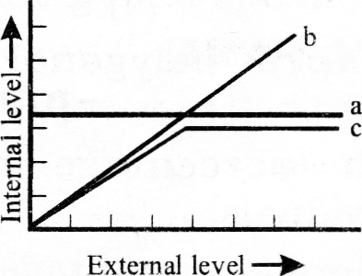

1)partial regulator, conformer, regulator 2)regulator, conformer, partial regulator

3)conformer, regulator, partial regulator 4)regulator partial, conformer, regulator

1. **Which one of the following is most appropriately defined ?**

1)Predator is an organism that catches and kills other organism for food.

2)Parasite is an organism which always lives inside the body of other organism and may kill it.

3)Host is an organism which provides food to another organism

4)Amensalism is a relationship in which one species is benefited whereas the other is unaffected

1. **A logistic growth curve depicting a population that is limited by a definite carrying capacity is shaped like the letter**

1)J 2)L 3)M 4)S

1. **Bell shaped polygonal pyramid indicates**

1)High percentage of young individuals 2)Moderate percentage of young individuals

3)Low percentage of young individuals 4)Low percentage of old individuals

1. **Consider the following four conditions (i – iv)and select the correct pair of them as adaption to environment in desert lizards. The conditions**

i)Burrowing in soil to escape high temperature.

ii)Losing heat rapidly from the body during high temperature .

iii)Bask in sun when temperature is low.

iv)Insulating body due to thick fatty dermis .

1)(iii), (iv) 2)(i), (iii) 3)(ii), (iv) 4)(i), (ii)

1. **Which one of the following is categorized as a parasite in true sense ?**

1)The female Anopheles bites and sucks blood from humans

2)Human foetus developing inside the uterus draws nourishment from the mother.

3)Head louse living on the human scalp as well as laying eggs on human hair.

4)The Cuckoo (koel)lay it eggs in crow’s nest

1. **Given is the age pyramid of a population. Decide which kind of growth status it reflects**

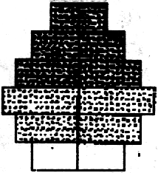1)Declining

2)Rapidly expanding

3)Expanding

4)stable

1. **A few organisms which can tolerate and thrive in a wide range of temperatures are called**

1)Stenothermal 2)Eurythermal 3)Homoiothermal 4)Poikilothermal

1. **Under unfavourable conditions many zooplanktons species in lakes and ponds are entered in a stage of suspended development is called**

1)Dormancy 2)Hibernation 3)Diapause 4)Menopause

1. **The number of individuals of the population who left the habitat and have gone elsewhere during the time period is called**

1)Immigration 2)Emigration 3)Migration 4)Natality

1. **In population interactions one species benefits and the other is neither harmed nor benefited, such type of interaction is called**

1)Amensalism 2)Commensalism 3)Predation 4)Mutualism

1. **The logistic population growth is expressed by the equation**

1) 2)

3) 4)

1. **The feature of the xerophytic plant leaves are ‘**

I)Leathery surface II) Large surface area III)Waxy cuticle IV)Sunken stomata on upper epidermis

1)I, II and IV 2)II and III 3)I, III and IV 4)I and IV

1. 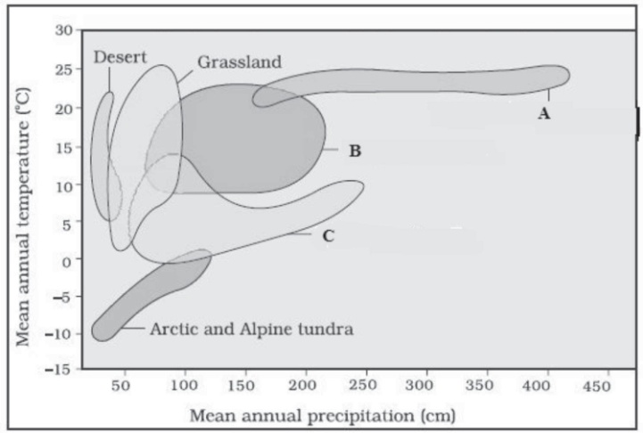**Mark the correct identiﬁcation from the following picture**

|  |  |  |  |
| --- | --- | --- | --- |
|  | (A) | (B) | (C) |
| (1) | Tropical forest | Temperate forest | Coniferous forest |
| (2) | Temperate forest | Tropical forest | Coniferous forest |
| (3) | Temperate forest | Coniferous forest | Tropical forest |
| (4) | Coniferous forest | Tropical forest | Temperate forest |

1. **The salinity in sea water in parts per thousand (ppt) ranges between**

(1) 5-15 % (2) 30-35%

(3) 50-75% (4) More than 100 %

1. **Gause’s competitive exclusion principle states that**
   1. Two unrelated species competing for the same resources cannot coexist indefinitely and competitively inferior one will be eliminated eventually.
2. Two closely related species competing for the same resources cannot coexist indefinitely and competitively inferior one will be eliminated eventually
3. Two unrelated species competing for the same resources can coexist indefinitely and can grow together.
4. Two closely related species competing for the same resources can coexist indefinitely and can grow together.
5. **Fill in the blanks A, B, C, and D respectively**.

|  |  |  |  |  |  |  |
| --- | --- | --- | --- | --- | --- | --- |
| **Species A** | **Species B** | **Name of Interaction** | | | | |
|  |  |  |  |  |  |  |
| + | + | Mutualism | | | | |
| – | – |  | A | | | |
| + | – |  |  | B |  |  |
| + | – | Parasitism | | | | |
| + | 0 |  |  | C |  |  |
| – | 0 |  |  | D | | |
|  |  |  |  |  |  |  |

(+) Beneficial (-)detrimental (0) Neutral

1. A: Commensalism, B: Predation, C: Amensalism, D: Competition
2. A: Predation, B: Parasitism, C: Commensalism, D: Amensalism
3. A: Competition, B: Predation, C: Commensalism, D: Amensalism
4. A: Competition, B: Predation, C: Amensalism, D: Commensalism
5. **A species whose distribution is restricted to a small geographical area because of the presence of a competitive superior species is found to expand its distributional range dramatically when the competing species is experimentally removed, This phenomenon is known as**

1)competitive exclusion 2)Competitive release

3)interference competition 4) Resource partitioning

1. **Opuntia does not have following adaptation**
   1. Its leaves are reduced to spines
   2. The functions of photosynthesis is taken over by succulent stem
   3. The stomata remain closed during the day
   4. The pathway of photosynthesis is through C3 cycle
2. ________is more meaningful measure of population size

1)Natality 2)Mortality 3)Biomass 4)Resources consumeol.

1. **If there are around 200 *Parthenium* plants and 1 huge banyan tree. What measure is more meaningful for the population size?**
   1. Population density (2) Relative density

(3) Biomass (4) Head count

1. **The association between clown ﬁsh and sea anemone is the same as between**
2. Egret and grazing cattle
   1. Cuckoo and crow
   2. Fig and wasp
   3. Cuscuta and hedge plant
3. Example of brood parasitism

1)cukoo (koel) and crow 2)Crow and Parrot

3)Parrot and pigeon 4)Koel and Parrot

1. **A population growth becomes asymptote when population density**

1)Crosses carrying capacity

2)Is in lag phase

3)Is in log phase

4)Reaches carrying capacity

1. **In ecological context the herbivores are considered as**
2. Hosts (2) Predators

(3) Parasites (4) Commensals