**MASTERS PRE-UNIVERSITY COLLEGE, HASSAN 573201.**

**Subject: BIOLOGY**

**Sexual Reproduction in Flowering Plants**

1. The innermost wall layer of anther
   1. Is nutritive in function (2) Helps in dehiscence of anther

(3) Is haploid and protective in function (4) Forms microspores

1. Choose the correct option w.r.t. the function of the germ pore.
   1. It allows growth of pollen tube (2) It allows water absorption in seed

(3) It helps dehiscence of pollen grain (4) More than one option is correct

1. The two-celled stage of mature pollen grain consists of
   1. Vegetative cell, generative cell (2) Vegetative cell, one male gamete

(3) Two male gametes (4) Generative cell, one male gamete

1. The pollen viability period of rice and pea respectively, is
   1. 30 minutes and several months (2) Several months and 30 minutes

(3) Few days and few months (4) Few days in both the cases

1. Which of the following plant provides safe place to insect for laying eggs?
   1. Sage plant (2) *Amorphophallus* (3) *Ophrys* (4) Mango
2. Examples of water pollinated flowers are
   1. *Zostera*, Lotus, water lily (2) Lotus, *Vallisneria*, *Hydrilla*

(3) *Potamogeton*, *Vallisneria*, Lotus (4) *Vallisneria*, *Hydrilla*, *Zostera*

1. Which of the following is not a characteristic feature of insect pollinated flowers?
   1. Fragrance (2) Nectaries

(3) Foul odour (4) Mucilaginous covering on pollen grains

1. The diploid and triploid product of double fertilization respectively are
   1. Zygote and primary endosperm nucleus (2) Endosperm and cotyledons

(3) Embryo and perisperm (4) Zygote and scutellum

1. The single cotyledon in monocots is
   1. Scutellum which is lateral in position (2) Aleurone layer which is terminal in position

(3) Scutellum which is centrally placed (4) Epiblast which is haploid and lateral in position

1. The sheath enclosing plumule and radicle respectively in monocot seed are
   1. Coleoptile and coleorhiza (2) Coleorhiza and coleoptile

(3) Scutellum and epiblast (4) Aleurone layer and pericarp

11. Pollen grains are generally in outline measuring micrometers in diameter.

(1) Spherical, 25-50 (2) Oblong, 25-50

(3) Oval, 10-25 (4) Spherical, 75-100

1. Choose the odd one w.r.t. gynoecium.
   1. Gynoecium represents the female reproductive part of flower
   2. The gynoecium may be syncarpous or apocarpous
   3. The number of ovules in papaya and mango is one
   4. The ovules are attached to placenta
2. Feathery stigma and versatile anthers are characteristic of

|  |  |  |
| --- | --- | --- |
| (1) Wind pollinated flowers | (2) | Insect pollinated flowers |
| (3) Water pollinated flowers | (4) | Bat pollinated flowers |

1. Pollen pistil interaction is

|  |  |  |
| --- | --- | --- |
| (1) Chemically mediated process | (2) | Dynamic process |
| (3) Genetically controlled process | (4) | More than one option is correct |
|  |  |  |

1. Suitable environmental conditions for seed germination are
   1. Adequate moisture, light, anaerobic conditions
   2. Adequate moisture, low temperature, light
   3. Adequate moisture, suitable temperature and oxygen
   4. Light, water, absence of oxygen
2. Which of the following statement is applicable for all flowering plants?
3. Monosiphonous pollen tube
4. Non-motile and morphologically dissimilar gametes
5. Presence of pollinium
6. Division of generative cell after pollination
7. Which is incorrect statement?
8. Each cell of sporogenous tissue in anther is capable of giving rise to microspore tetrad.
9. The pollen grain represent male gametophyte.
10. Pollen grains are usually triangular and 10-15 m in diameter.
11. Sporopollenin is one of the most resistance organic material which can be destroyed only by strong acids and alkali.

(1) I, II are incorrect but III, IV are correct (2) III, IV are incorrect but I, II are correct

(3) I, III are incorrect but II, IV are correct (4) II, IV are correct but I, III are incorrect

1. Which statement is incorrect?
   1. Intine is the inner wall of pollen grain and exhibit fascinating array of patterns and designs
   2. The mature pollen grains has two cells, the bigger is vegetative cell and the smaller is generative cell which floats in cytoplasm of vegetative cell
   3. Carrot grass pollens cause pollen allergy
   4. Pollen grains of pea and rose maintain viability for months
2. Examine the figure given below and select the right option giving all the four parts a, b, c and d. Correctly

identify

d

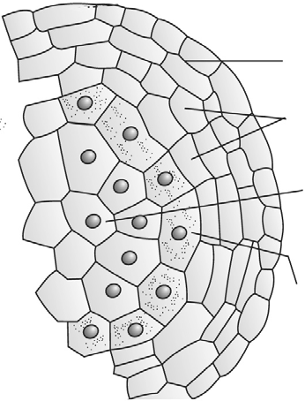

a

b

c

c

a b d

* 1. Endothecium Tapetum Microspore mother cell Middle layers
  2. Tapetum Endothecium Microspore mother cell Middle layers
  3. Endothecium Middle layer Tapetum Microspore mother cell
  4. Endothecium Microspore mother cell Middle layer Tapetum

1. Select incorrect statement regarding microsporogenesis in an anther
   1. Large number of microspore mother cells differentiate in one pollen sac
   2. Each microsporogenesis involves one meiosis and two mitosis
   3. Microspore tetrads may be tetrahedral or isobilateral
   4. It consumes tapetum and middle layers
2. An angiospermic plant is having 24 chromosomes in its leaf cells. The number of chromosomes present in synergid, pollen grain, nucellus & endosperm will be respectively

(1) 12, 12, 12, 72 (2) 8, 8, 12, 36

(3) 12, 12, 24, 36 (4) 12, 12, 12, 36

1. Examine the figure given below and select the right option giving all the four parts a, b, c and d. Correctly

identify

d

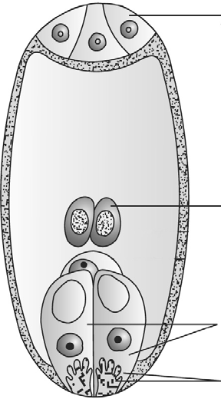

c

b a

|  |  |  |  |
| --- | --- | --- | --- |
| a | b | c | d |
| (1) Synergids | Antipodal cells | Polar nuclei | Filiform apparatus |
| (2) Filiform apparatus | Egg | Polar nuclei | Nucellus |
| (3) Filiform apparatus | Synergids | Polar nuclei | Antipodal cell |

1. Synergids Polar nuclei Filiform apparatus Antipodal cell
2. The devices to discourage self pollination are
3. Pollen release and stigma receptivity is not synchronised
4. Anther and stigma are placed at different position
5. Rejection of pollen by stigma of the same flowers

(4) All of these

1. Examine the figure given below and select the right option giving all the four parts a, b, c and d. Correctly

identify

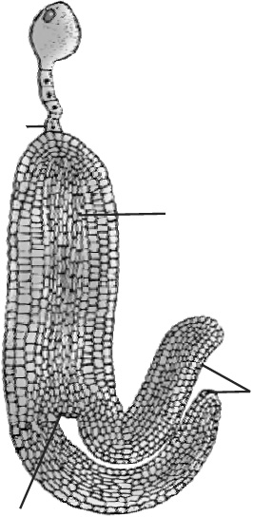

|  |  |  |  |  |  |
| --- | --- | --- | --- | --- | --- |
|  |  |  | a |  |  |
|  |  |  | b |
|  |  |  | c |
| a | b | d | c | d |
| (1) | Suspensor | Radicle |  | Cotyledons | Plumule |
| (2) | Plumule | Cotyledons |  | Radicle | Suspensor |
| (3) | Suspensor | Plumule |  | Radicle | Cotyledon |
| (4) | Radicle | Plumule |  | Cotyledons | Suspensor |

1. Choose the correct option from the following
2. Dehydration and dormancy of mature seed are crucial for seed storage.
3. Seed of *Lupinus arcticus* is the oldest one which germinated after 2000 year.
4. Orchid seed is one of largest seed in plant Kingdom.
5. Seeds of parasitic plants *Orobanche* and *Striga* are tiny seeds.

(1) I, II are correct but III, IV are incorrect (2) I, IV are correct but II, III are incorrect

(3) III, IV are correct but I, II are incorrect (4) II, III are correct but I, IV are incorrect

|  |  |  |  |
| --- | --- | --- | --- |
| 26. | Coconut water from a tender coconut is: |  |  |
|  | (1) Degenerated nucellus | (2) | Immature embryo |

(3) Free nuclear endosperm (4) Innermost layers of the seed coat

1. In angiosperms, microsporogenesis and megasporogenesis
   1. Occur in ovule (2) Occur in anther

(3) Form gametes without further divisions (4) Involve meiosis

1. The hilum is a scar on the
   1. Seed, where micropyle was present (2) Seed, where funicle was attached

(3) Fruit, where it was attached to pedicel (4) Fruit, where style was present

1. Function of filiform apparatus is to
   1. Recognize the suitable pollen at stigma (2) Stimulate division of generative cell

(3) Produce nectar (4) Guide the entry of pollen tube

1. What is common between vegetative reproduction and Apomixis?
   1. Both occur round the year (2) Both produces progeny identical to the parent

(3) Both are applicable to only dicot plants (4) Both bypass the flowering phase